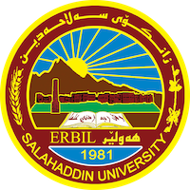
Academic Curriculum Vitae
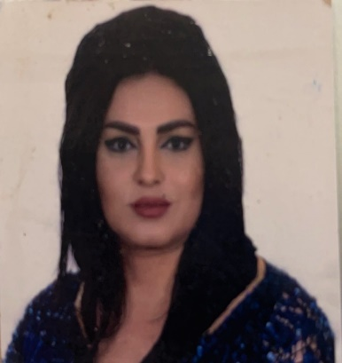
Personal Information:
Full Name: kanyaw Ismail Mahmud
Academic Title: lecturer
Email: (university email):kanyaw.mahmud@su.edu.krd
Mobile: 07503085441

Education:
- Ph.D. in animal nutrition and nutrigenomics at Yuzuncu Yil University -van –Turkey.2023
- Master’s degree in Animal Breeding (Duhok University- 2013)
- Bachelor of Animal resource (Salahaddin University-Erbil 2007)
- High School - Science branch (Gharebye Turkish High school 2004)

Employment:
- Assistant Researcher, (College of Agriculture engineering science-2007-2013)
- Assistant Lecturer, (College of Agriculture engineering science-2014-2017)
- Lecturer, (College of Agriculture engineering science-2018)

Qualifications
- Method Teaching qualifications
- IT qualifications
- English language efficiency qualifications
- Turkish language efficiency qualifications

Teaching experience:
-Teaching the subject of statistics 2014
- Teaching the subject of Experimental design 2016-2017
- Teaching the subject of Animal Breeding 2018-2019

Research and publications
Journal Articles:
Rabee A. Oramari, Jalal E. Alkass and Kanyaw I. Mahmud.2014.A Comparative Study on Growth, Carcass Traits and Tissue Distribution of Awassi and Hamdani Lambs. Journal of Biology, Agriculture and Healthcare.4 (1):36-43.
Raoof, S.O., Mahmud, I., K.2016.Effect of Lambing Interval on Production Characteristics in Kurdi Local Ewes of Kurdistan Region, Iraq. Jordan Journal of Agriculture Science. 12(2):459-466
Raoof, S.O., Mahmud, I., K., Mohamad, Y., A.2017. Effect of frequent kidding on reproductive and productive traits in Shami goats, The Iraqi Journal of Veterinary Medicine, 41(2):157-162.
Raoof, S.O., Mahmud, I., K., Kareem, A.A.A., Muhammad, K., G.2017.Estimation of the best linear unbiased prediction (Blup) of Kurdi Rams for average daily milk yield depending on their progeny. The Iraqi Journal of Agriculture Science. 48(6):1399-1404.
Raoof, S.O., Mahmud, I., K., Kareem, A.A.A., Muhammad, K., G.2017Estimation of the best linear unbiased production (BLUP) of rams depending on their progeny's birth and weaning weight. The Iraqi Journal of Agriculture Science. 48(6):1405-1411
Hermiz, H., Khoshnaw, H.H.A., Mahmud, I.K.2018.Study of some physical wool characterization in Arabi ewes in Erbil Governorate. ZJPAS, 30 (4); 23-38.
Mahmud, I.K., Hermiz, H., Khoshnaw, H.H.A 2018.A relationship between body weight and dimensions for Arabi ewes and their lambs at weaning age in Erbil Government. ZJPAS, 30 (3); 33-43.
F. T. Al-Rawi, Y. T. Abdul-Rahaman, Abdullah I.Noaman, Th. T. Mohammed, S. M Abdulateef, Nadia Jebril4 and K.I. Mahmud.2022.Role of ascorbic acid and appetite stimulants on a few blood serum bio-chemical characteristics in pregnant Iraqi ewes under heat stress.

Mahmud,K.I.and Kardas,F.(2023).Effects of the Melatonin and Vitamin E (Alpha-Tocopherol Acetate) as Antioxidants on Biochemical Blood Parameters, Lipid Profile, and Muscle Vitamin E Concentration in Awassi Lambs Fed a High-Energy Diet and Normal Diet. Archives of Razi institute.

Conferences and courses attended
As attendance 6th ICOWOBAS, 18-19 March 2017 Erbil-Iraq.
As attendance 2nd International Conference of Agriculture Science, 4th -5th April, 2018.Sulaimani-Iraq
(Participated as Reviewer) 1st International Collaborative Conference of Modern Agricultural Technologies (ICCMAT.2021) 25 March, 2021. Erbil – Iraq.

1st International Collaborative Conference of Modern Agricultural Technologies (ICCMAT2021) 24-25 March, 2021. Erbil – Iraq.

Professional memberships
Member of Quality Assurance (Technical Auditing) at Salahaddin University-Erbil 2015 until now.
Member of Quality Assurance committee at College of Agriculture and Engineering Science from 2014 until 2018
Kurdistan Agriculture Engineers Syndicate /Iraq
Kurdistan Teachers Union

Professional Social Network Accounts:

https://www.researchgate.net/profile/Kanyaw-Mahmod/research
https://academics.su.edu.krd/kanyaw.mahmud
https://scholar.google.com/citations?user=Eq19ZAcAAAAJ&hl=en

