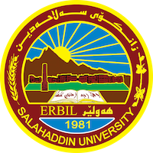
Academic Curriculum Vitae
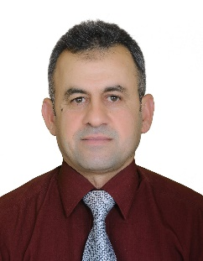
Personal Information:
Full Name: Kaim Ali Younis
Academic Title: Assistant Lecturer
Email: karim.younis@su.edu.krd
Mobile: +9647504790816

Education:
From- To | Degree | College-University | Country
2000-2002 | Master’s Degree Industrial Chemistry, Department of Chemistry | College of Science- University of Salahaddin | Iraq
1990-1995 | B.Sc. Chemistry, Department of Chemistry, | College of Science- University of Salahaddin | Iraq

Employment:
Assignments and Posts:
From- To | Post | Department -College | University
2002 to date | Assistant lecturer | Chemistry Department-College of Science | Salahaddin University
1996-2002 | Assistant chemistry | Chemistry Department-College of Science | Salahaddin University

Teaching experience:
- Teaching Activities
From- To | Subject | Stage-College | University
2021 to date | Petroleum Science | 3rd-year student- Environmental Department | Salahaddin University
2019- to date | Industrial Chemistry | 2nd-year students / Chemistry Department-College of Science | Salahaddin University
2012-2017 | Petroleum Chemistry | 3rd-year students / Chemistry Department-College of Science | Salahaddin University
2011 to date | Petroleum Chemistry-Practical | College of Science, University of Salahaddin | Salahaddin University
2002-2012 | Polymer Chemistry-Practical | College of Science, University of Salahaddin | Salahaddin University

Research and publications
Published articles, papers and researches:

- Pizo-catalytic desulfurization of model and real fuel samples over NiO/Mn_{x}O_{y} nano-composite at room temperature: Mechanism and kinetic behind it 2023, Fuel 344, 128065
- Evaluation of Gasoline Samples from Several Erbil Petrol Stations 2023, Zanco Journal of Pure and Applied Sciences 35 (2), 189-196
- Production and characterization of biodiesel from locally sourced sesame seed oil, used cooking oil and other commercial vegetable oils in Erbil-Iraqi Kurdistan 2014, American Journal of Applied Chemistry, 2 (6), 105-111

Conferences and courses attended

Professional memberships
- From 1999 to date member of Kurdistan chemistry syndicate

Professional Social Network Accounts:
ORCID ID: 0009-0003-5551-0657
Academic Profile: https://academics.su.edu.krd/karim.younis
LinkedIn: https://www.linkedin.com/in/karim-ali-82b75b123/
Scholar Account: https://scholar.google.com/citations?view_op=list_works&hl=en&user=Uiy904wAAAAJ
ResearchGate: https://www.researchgate.net/profile/Karim-Ali-4

