**Q1:** Two methanol-water mixtures are contained in separate flasks. The first mixture is 40.0 wt % methanol, and the second is 70.0 wt % methanol. If 200 g of the first mixture is combined with 150 g of the second, what will be the mass and composition of the resulting mixture?

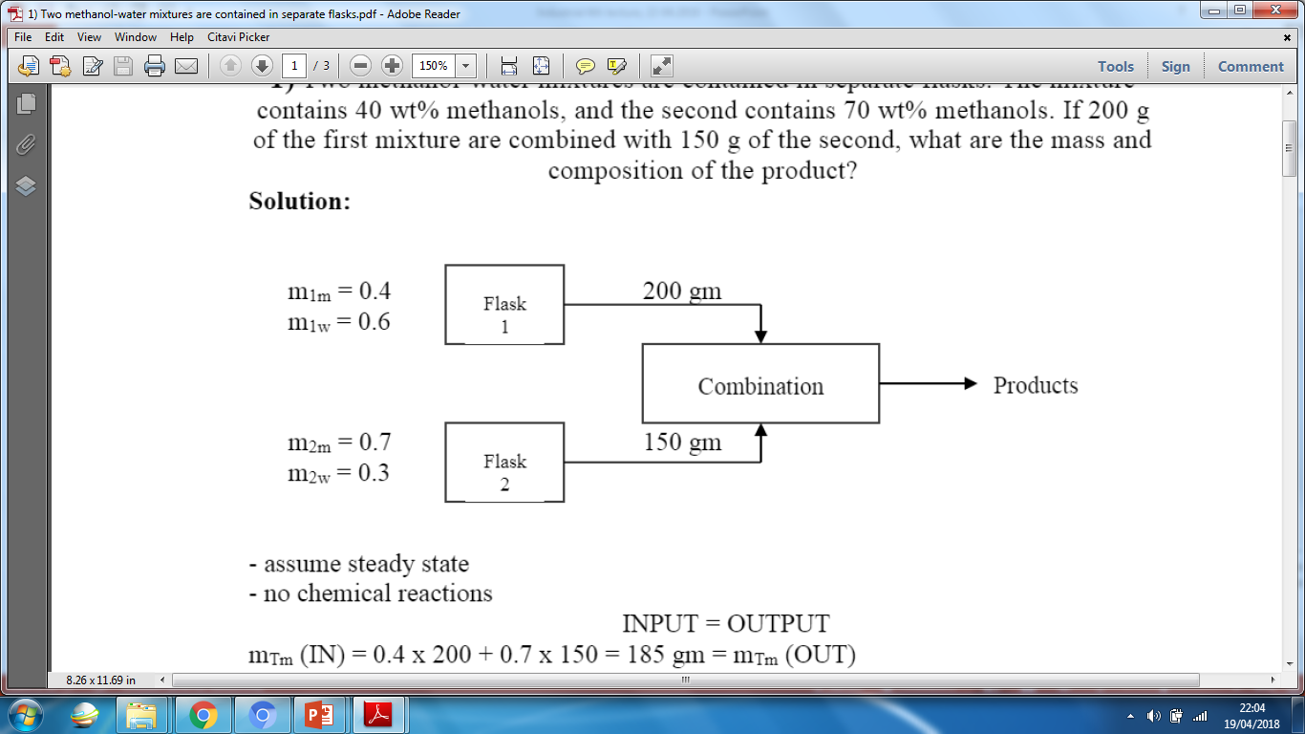

**Q2:** It is required to prepare 1250 kg of a solution composed of 12 wt.% ethanol and 88 wt.% water. Two solutions are available, the first contains 5 wt.% ethanol, and the second contains 25 wt.% ethanol. How much of each solution must be mixed to prepare the desired solution?



**Q3:** 2000 kg of a 5 percent slurry of calcium hydroxide in water is to be prepared by diluting a 20 percent slurry. Calculate the quantities required. The percentages are by weight.

**Q4:** Technical grade hydrochloric acid has a strength of 28 percent w/w, express this as a mol fraction.

**Q5:** You are asked to prepare a batch of 18.63% battery acid as follows. A tank of old weak battery acid (H2SO4) solution contains 12.43% H2SO4 (the remainder is pure water). If 200 kg of 77.7% H2SO4 is added to the tank, and the final solution is to be 18.63% H2SO4, how many kilograms of battery acid have been made?

**Q6:** A binary mixture consists of 35 % benzene and 65 % toluene are continuously fed to the distillation column at a rate of 1000 kg/hr. Whereas, the distillate flow rate was 10% from the feed flow rate. The distillate (top product) contains 85 % benzene. Calculate the quantity and compositions of the waste stream.



**Q7:** A gaseous mixture (F) consists of 16 mol% CS2 and 84 mol% air are fed to the absorption column at a rate of 1000 Ibmole/hr. Most of the CS2 input are absorbed by liquid benzene (L) which is fed to the top of the column. 1 % of benzene input are evaporated and out with the exit gas stream which consists of 96 mol% air, 2 mol% CS2 and 2 mol% benzene. The product liquid stream (P) consists of benzene and CS2. Calculate the mole flow rates of (G), (L) and (P) and the compositions.



**Q8:** one thousand kilograms per hour of a mixture of benzene and toluene that contains 50% by mass are separated by distillation into two fractions. The mass flow of benzene in the top steam is 450 kg (benzene/hour) and toluene in the bottom steam is 475kg (toluene/hour). Write the material balance on benzene and toluene to calculate the unknown components in the output stream.

**Q9:** The National Ambient Air Quality Standard for carbon monoxide (CO) is 35 ppmv measured over a one-hour averaging time. What is the equivalent concentration in (a) percentage, (b) mg/m3 under standard condition when its density is 1.145 kg/m3?

**Q10:** An SO2 concentration is given as 830 μg/m3 at 25°C and 1 atm. Express this concentration in parts per million (ppm).

**Q11:** The exhaust gas from automobile contains 8 ppmv of carbon monoxide (CO).  
A. What is the equivalent concentration in g/m3 at 1 atm and 25 °C?  
B. What is the concentration in exhaust pipe in g/m3 if it is at 220 °C and 1.2 atm?

**Q12:** Give the structure of the following dyes:

(A) C.I. Basic Green 4.

(B) C.I. Basic Red 9.

**Q13:** Write the chemical reaction for the preparation of **C.I. Acid Red 74**.

**Q14:** Explain the formation of photochemical smog with its effects.

**Q15:** Answer the following.

1. What are the factors affecting manufacturing costs?
2. Explain the methods used for the removal of water hardness.

**Q16:** Define the following terms.

1. Carboxilation.
2. Decomposition.
3. Isomerization.
4. Ammonolysis.
5. Electrolysis.

**Q17:** Explain the following:

**(A)** Acid rain with chemical equations.

**(B)** ***The fuel NOx*** mechanism from fuel combustion.

**Q18:** What are the causes of global warming?

**Q19:** Explain the formation of ozone layer.

**Q20:** Explain in details acid rain and its results on environment.

**Q21:** Show by table the severity of air pollution and the level of risk to health according to Air Quality index (AQI).

**Q22:** Explain the formation of ozone layer and its depletion.

**Q23:** Write the chemical reactions for the synthesis of the following compounds.

(A) MCPA.

(B) Thiram.

**Q24:** Classify colorants by their chemical structure with examples.

**Q25:** Explain the following:

1. Continuous stirred tank reactor (CSTR).
2. Plug flow reactor.