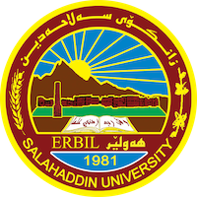
Academic Curriculum Vitae
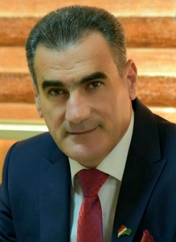
Personal Information:
Full Name: Karwan Jawhar Mohammad
Academic Title: assistant lecturer
Email: (karwan.mohammad@su.edu.krd)
Mobile:07504496419
Education:
- Bachelor degree at historical department { salahadin university college of arts} in 2011
- Master of history in middle century { salahadin university college of arts} in 2017
Employment:
- Sallahadin university college of arts
Qualifications
- Word , excel ,access, power point.
- Ihave 4 in IELTS xaminaton, and language English certificate, Computer certificate .
Teaching experience:
- I teached in first stage, second stage and thiard stage of college of arts in salahaddin uneversity.
Research and publications
- (Mumtaz Haidari and his role in Kurdish Newspaper)
- The phenomenon of captive from political parties in Southern Kurdistan between
1980 – 1988 namely (PDK) (PUK) and (PASOK)
- Aziz Aqrawi Biography and political and military role of 1924-1980

Conferences and courses attended
- I attended of conference about Erbil in Historcal Sources – Read and evaluate 2019/4/ 10 – 11 . 3rd Student Research Projects & Idea Grant Conference, 2nd February 2023

Professional memberships
- I membership in komallay mezhunusan. IFAD group.

Professional Social Network Accounts:

- https://scholar.google.co.uk/citations?hl=ar&view_op=list_works&gmla=AJsN-F7aHMQir_qTfMROLTBt5iCG0bcL0Z3k1_ccFbNFZt8oKBxKHQ_OtFCxuRuPlfrOnou8Fl6qWnzurDGBoDZOnA70Bs2kRo_e5DwNuGk5acU5OZ4fz_w&user=GDSd7jUAAAAJ
- https://www.researchgate.net/profile/Karwan-Mohammad

