Question
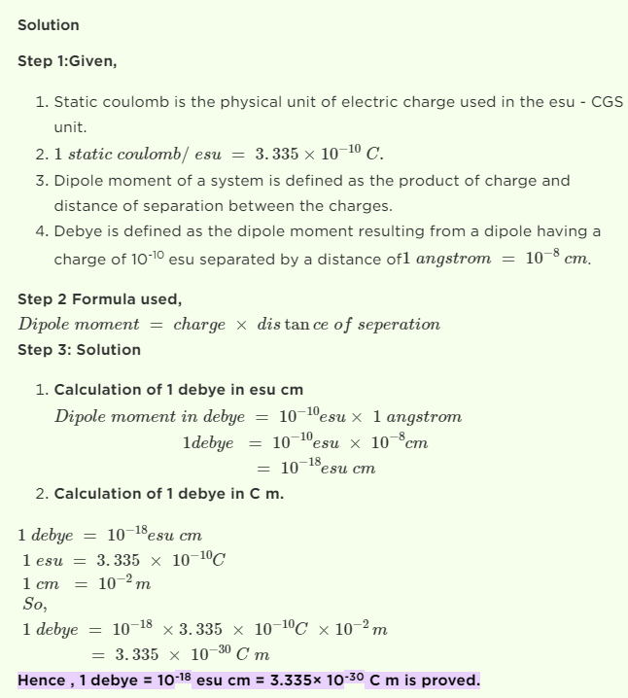

https://byjus.com/question-answer/1-debye-10-18-esu-cm-3-335-xx-10-30-c-m-coulomb-meter-prove-it/

