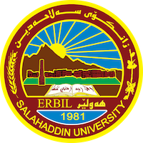
Academic Curriculum Vitae
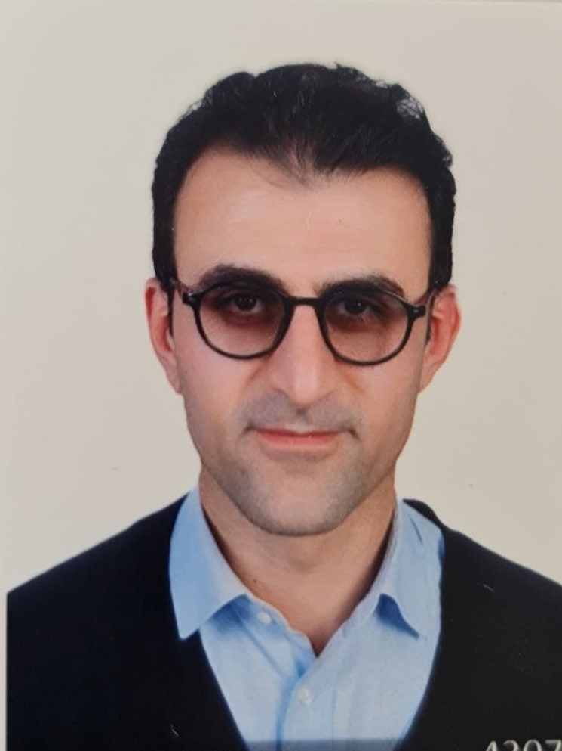
Personal Information:
Full Name: KARZAN KHALEEL HAMEED
Academic Title: Lecturer
Email: karzan.hameed@su.edu.krd
Mobile:+964(0)7504730224

Education:
2000 – 2004: BSc. Degree
Graduated in chemistry department-College of Science at Salahaddin University-Erbil-Iraq
2006 – 2008: I worked as assist. Lab. In Chemistry department.
October 2008 – November 2010. Master’s degree at Salahaddin University –College of Science - Department of Chemistry – Oragnic Lab. In Erbil/Iraq, the titile of thesis; Synthesis and Spectroscopic Studies of Some New 3,4-dihydropyrimidine- 2(1H)-one Derivatives, under supervission prof. Dr. Faiq HS. Hussain
March 2017 – July 2020 PhD Degree (PhD student with Split site-scholarship)
Between Salahaddin University –College of Science - Department of Chemistry, and University of Pavia – Department of Chemistry – Organic lab B1
I have spent three years as PhD student/ researcher in Pavia University-Chemistry department (supervisor: Prof. Paolo Quadrelli). The PhD project is focused on the synthesis and study of new organic molecules, with reference to the development of nucleoside as antiviral chemotherapy, and the title of dissertation is Design and characterization of Heterosubstituted-Cyclopentenones, N-Hydroxy-N-Cycloalkenyl Amides, and Isoxazolidine Nucleoside analogs.

Employment:
- I was an assist. chemist for a year 2005-2006 at Central Laboratory in ministry of health
- 2020 to date Lecturer (PhD ) at Salahaddin University, college of science, Chemistry department

Qualifications
2007 Computer training
Word, Excel, chemoffice draw-Salahaddin Univerity-Erbil/Iraq
2011 Teaching methods course
2013 Chemical safety and security Officer Training, Salahaddin University-sponsored by the United States of dept. of state
2013 TOT Session on Health and Safety European Technology and Training Center in Erbil/ Iraq, the training course covered: Why Health and Safety important? Risk Asse4ssment, Risk Control, Identifying Hazards, establishing a Safety Policy; Implementing the Safety Policy; Emergency Procedure; Designing a Training Program
2013 Personal Strategic Planning International Academy for PT and LD
LANGUAGES
Kurdish Native langauge
English All skills B2
Italy All skills B2
Arabic Medium

Teaching experience:
- 2011-2012 Soran Technical institute/ nursing department- 1st year- Biochemistry lecturer
- 2012-2013 Salahaddin University/ College of Science/Chem. dept. –3rd year- Practic Organic chemistry lecturer.
- 2013-2015 Salahaddin University/ College of Science/Chem. dept. –2nd year- Practic Organic chemistry lecturer.
- 2014-2015 Hawler Institute private- 1st year-Refinary Dept. - General Chemistry lecturer.
- 2015-2017 Hawler Institute private- 1st year-Refinary Dept. – as HSE lecturer.
- 2015-2017 Salahaddin University/ College of Science/Chem. dept. –3rd year- Practic Organic chemistry lecturer.
- 2016-2017 Soran University/ College of Science/Chem. dept. –1st year- Organic
chemistry lecturer.
Balla school private-grade 10 and 11-high school – as a chemistry teacher.
Salahaddin University/ College of Science/Biology. dept. –1st year- Organic chemistry lecturer.
2020-2021 Salahaddin University/ College of Science/Chem. dept. –1st year- safety and chemical hazard lecturer.
Shqlawa technical college/ MLT dept.- 1st year- General Chemistry lecturer.
Rwandz Private Technical Institute/ pharmacy dept- 2nd year- Pharmaceutical chemistry lecturer.
Salahaddin University/ College of Education/Biology. dept. –1st year- General chemistry lecturer.
2021-2022 Salahaddin University/ College of Science/Chem. dept. –1st year- Organic chemistry lecturer-first semester.
Salahaddin University/ College of Science/Chem. dept. –3rd year- Organic chemistry lecturer-second semester.
Paitaxt Technical Institute/ pharmacy dept- 2nd year- Pharmacognosy lecturer. Rwandz Private Technical Institute/ pharmacy dept- 2nd year- Pharmaceutical chemistry lecturer
2022-2023 Salahaddin University/ College of Science/Chem. dept. –4th year- Heterocyclic Compounds lecturer-first semester.
Salahaddin University/ College of Science/Chem. dept. –2nd year- Practical Organic chemistry lecturer
Research and publications
- Hameed, K.K., Dezaye, A.A., Hussain, F.H., Basile, T., Memeo, M.G. and Quadrelli, P., 2018. Synthesis of 2-heterosubstituted cyclopent-2-en-1-ones: a preliminary study of the strategic design of antiviral compounds. Organic Chemistry, (part vii), pp.201-213.
- Hameed, K.K., Amin, A.A., Hussain, F.H., Memeo, M.G., Moiola, M. and Quadrelli, P., 2019. The Easy Approach to N-Hydroxy-N-cycloalkenylamides through Nitrosocarbonyl ENE Reactions to Cycloalkenes: Valuable Compounds for Antiviral Syntheses. SYNTHESIS-STUTTGART, 51(6), pp.1383-1390.
- Aljaf, K.K., Amin, A.A., Hussain, F.H. and Quadrelli, P., 2020. DEAE-cellulose-catalyzed synthesis of 5-hydroxy-isoxazolidines and their synthetic uses towards nucleoside analogues. Organic Chemistry, (part vi), pp.73-83.
- Aljaf, K.K., Amin, A.A., Hussain, F.H. and Quadrelli, P., 2020. Diethylaminoethyl cellulose (DEAE-C): applications in chromatography and organic synthesis. ARKIVOC: Journal of Organic Chemistry, 2020.
- K Hameed, K. and HS Hussain, F., 2018. Ultrasound-Assisted Synthesis of Some New N-(Substituted Carboxylic Acid-2-yl)-6-Methyl-4-Substituted Phenyl-3, 4-Dihydropyrimidine-2 (1H)-One Carboxamides. Eurasian Journal of Science and Engineering, 4(2).

Conferences and courses attended.
28-30th June-2017 4th International Workshop on Pericyclic Reactions and Synthesis of Hetero- and Carbocyclic System-Milan/Italy
23rd june-2017 Design and Synthesis of Two-Proton Responsive Chromophore for uncage reactions-Prof. MANABU ABE from Hiroshima University-Pavia/Italy
11th October-2017 Organic Chemistry Day in Pavia- Pavia/Italy
11th October-2018 Organic Chemistry Day in Pavia- Pavia/Italy
10th july-2018 Sicurezza e salute nei luoghi di lavoro ai sensi del D.Lgs.81/08: Sicurezza nei laboratori chimici-safey and security in the chemical laboratory-( in italian language)- Pavia
26 November-2018 New Orientation in Organic synthesis-Milan/ Italy
16-18th september-2019 5th Edition of Global Conference on Catalysis, Chemical Engineering and Technology (CAT-2019)- London/UK
16-18th November-2019 XVII Annual Meeting of the Pericyclic Reaction Center-Collegio Fratelli Cairoli-PV-IT
20-21th Feb. 2020 XIX CINMPIS Days at the University of Pavia-italy
Funding and academic awards
-2017-2018 international collaboration ( PhD student-split site ) at Chimica Organica/Lab B1 in pavia University-italy
-16-18th september-2019 5th Edition of Global Conference on Catalysis, Chemical Engineering and Technology (CAT-2019)- London/UK.

Professional memberships
- Royal Society of Chemistry- member
- Kurdistan Chemist’s Syndicate

Professional Social Network Accounts:
Karzan Khaleel Hameed (researchgate.net)
Scholar account karzan khaleel hameed‬ - Google Scholar‬
karzan Khaleel | LinkedIn karzan Khaleel | LinkedIn
ORCID ID: 0000-0001-6665-4267

