Salahadin University

College of Science

Chemistry Department

Synthesis, Reaction and Application of Coumarin and it’s derivatives

A Research Project
Submitted to the Scientific Committee in The Chemistry Department in Partial Fulfillment of the Requirement for the Degree of Bachelor Science in Chemistry

Prepared by: Vin Sabah Yassin
Supervised by: Karzan Khaleel Hameed

April, 2024 Newroz, 2724 Ramaddan1445
Dedication

Dedication
This final project is dedicated to:
My country
My parent
My friends
My teachers
My dear supervisor
With my Love and Respect

Acknowledgment:

First of all I am thankful to Allah for providing me with this opportunity. And secondly I want to express my heartfelt thanks and express my sincere gratitude to my supervisor
Dr. karzan Kh.Hameed, for his invaluable guidance and support throughout the completion of this project. Additionally, I extend my thanks to my parents and friends for their unwavering support and assistance, which played a significant role in completing this project.

List of Content

Abstract
Chapter One
1.Introduction
1.1. Definition
1.2. Historical Background
1.3. Source and Classification
1.4. Toxicity of Coumarin compounds
Chapter Two
2. Chemical and Physical Properties
Chapter Three
3. Synthesis
3.1. Biosynthesis of coumarin
3.2. Synthesis of coumarins from phenols Friedel-Crafts condensation
3.3. Synthesis of Simple Coumarins from Classic method
3.3.1. Perkin Reaction
3.3.2. Pechmann Reaction
3.3.2.1. Pechmann-Duisberg
3.3.2.2. Using Gallium (III) triiodide as initiator
3.3.3. Knoevenagel Reaction
3.3.3.1. Doebner modification
3.3.3.2. Using syringaldehyde derivative
3.3.3.3. Using heterogeneous catalyst
3.3.3.4. Using IL catalyst
3.3.4. Wittig Reaction
3.3.5. Kostanecki-Robinson Reaction
3.3.6. Reformatsky Reaction
3.4. One-pot multistep reaction
3.5. Heck coupling reaction
3.6. Using Grubbs initiator in ring-closing metathesis
3.7. Coumarin as a central core to obtain simple coumarins
Chapter Four
4. Reactions
4.1. Etherification
4.2. Acylation
4.3. Metabolism of coumarin
Chapter Five
5. Application
5.1. Pharmacological Profile
5.1.1. Antimicrobial and Molluscicidal
5.1.2. Antiviral
5.1.3. Anticancer
5.1.4. Anti-inflammation
5.2. Coumarins Photoproperties
5.2.1. Fluorescent derivatization
5.2.2. Coumarins as Fluorescent Probes
Conclusion
Reference

Abstract

Coumarin is a simple scaffold widespread in Nature and it can be found in a considerable number of plants as well as in some fungi and bacteria. In the last years, these natural compounds have been gaining an increasing attention from the scientific community for their wide range of biological activities, mainly due to their ability to interact with diverse enzymes and receptors in living organisms. In addition, coumarin nucleus has proved to be easily synthetized and decorated, giving the possibility of designing new coumarin-based compounds and investigating their potential in the treatment of various diseases. The versatility of coumarin scaffold finds applications not only in medicinal chemistry but also in the agrochemical field as well as in the cosmetic and fragrances industry. This review is intended to be a critical overview on coumarins, comprehensive of natural sources, metabolites, biological evaluations, reactions and synthetic approache

Keywords: coumarins; Reactions; biological activity; synthesis; natural sources

1.Introduction
Heterocyclic compounds are of very much interest in our daily life. Heterocyclic compounds have one or more hetero atoms in their structure, most common heteroatoms are Nitrogen, Oxygen, Sulfur. They may be cyclic or non-cyclic in nature. Heterocyclic compounds have a wide range of application. They are predominantly used as pharmaceuticals, as agrochemicals and as antioxidants. One of the reasons for the widespread use heterocyclic compounds is that their structures can be subtly manipulated to achieve a required modification in function, Such as coumarins. (Importance of heterocyclic chemistry) Phytochemicals are defined as bioactive non-nutrient plant compounds presented in fruits, vegetables, grains, and other food plants that have been linked to reducing the risk of major chronic diseases. It is estimated that > 5,000 individual phytochemicals have been identi‐ fied in fruits, vegetables, and grains, but a large percentage still remain unknown and need to be identified before we can fully understand the health benefits of phytochemicals in whole foods [101]. ) Coumarins — An Important Class of Phytochemical
1.1. Definition
Coumarins are phytochemicals and widely occurring secondary metabolite which are chemical compounds that occur naturally in the plant kingdom. It’s responsible for the organoleptic properties of the natural sources in which they are present in, seeds, roots, and leaves of many plant species. More than 300 coumarins have been identified from natural sources, especially from green plants. These varying substances have disparate pharmacological, biochemical, industry, and therapeutic applications, due to low toxicity and side effects, fewer drug resistance, high bioavailability, broad spectrum, better curative effects. They are a family of benzopyrones (1,2-benzopyrones) bearing a typical benzopyrone framework, a fused benzene and a-pyrone ring (Figure 1). Almost all the natural coumarins have an oxygenated substituent at position 7.
(Trending Topics on Coumarin and Its Derivatives in 2020 , An Important Class of Phytochemicals)
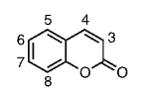

1.2. Historical background
The name coumarin comes from a French term for the Tonka bean, coumarou, seeds of Dipteryx odorata. The isolation of coumarin was first reported by Vogel in Munich in 1820. Vogel then concluded that the long colourless crystals which he discovered on slicing open tonk a beans and which crystallized as glistening needles from aqueous alcohol were identical with similar crystals he obtained, albeit in much lower yield, by extracting fresh clover blossoms.(Phytochemicals - Isolation, Characterisation and Role in Human Health, The introduction to coumarins)
1.3. Source and classification
Coumarins have been isolated from hundreds of plants species distributed in more than 40 different families. There were isolated more than different 1300 coumarins, well distributed in Angiospermae, Monocotyledoneae and Dicotyledoneae families. Orders with occurrence numbers > 100 are Araliales, Rutales, Asterales, Fabales, Oleales, Urticales, and Thymelaeales. Families with occurrence numbers > 100 are Apiaceae(Umbelliferae), Rutaceae, Asteraceae(Compositae), Fabaceae (Leguminosae), Oleaceae, Moraceae, and Thymelaeaceae[50]. The best known and researched coumarins in the field of phytochemistry, pharmacology, medicinal chemistry, and the food science can be found in these families.
Coumarins — An Important Class of Phytochemicals, Fungi as a source of natural coumarins
Coumarins are classified in four groups: simple coumarins, furanocoumarines, pyranocoumarins and pyrone-substituted coumarins [5].
Coumarins and Coumarin-Related Compounds in Pharmacotherapy of Cancer
Simple coumarins: these are composed of hydroxylated, alkoxylated and alkylated derivatives of coumarin and their glycosides (e.g., Umbelliferone, skimmin, limettin, herniarin, esculetin, esculin, daphnetin and daphnin (Figure 1)) [5].
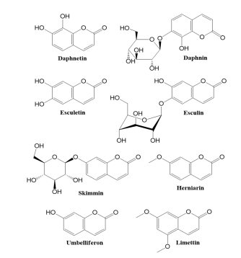
Furanocoumarins: This group of coumarins consists of a furan ring fused with a coumarin. They are divided into two groups as C6/C7 (linear) type, C7/C8 (angular) type according to the attachment place of the furan ring. (e.g., psoralen, xanthotoxin, bergapten, imperatorin, isopimpinellin, anjelisin, isobergapten and pimpinellin (Figure 2)) [3,5,39–42].
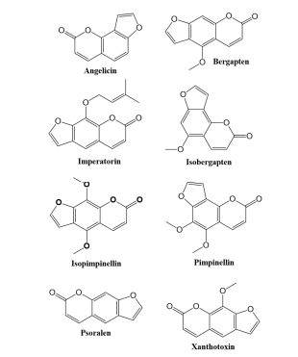

Pyranocoumarins: six-membered pyran ring is fused with the benzene ring via C6-7 (linear) or C7–8 (angular) (e.g., visnadin, xanthyletin and seselin) (Figure 3) [4,43].
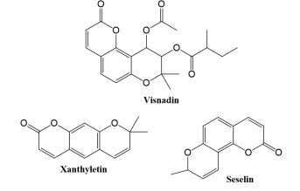

Pyrone-substituted coumarins: These are classified in three groups: 4-Hydroxycoumarin (Novobiocin and Dicumarol), 3-Phenylcoumarin (Coumestroln and Gravelliferone) and 3,4-Benzocoumarin (Aeternaryiol). 4-Hydroxycoumarins are not found in plants in free form. Warfarin, a synthetic compound, belongs to this group figure 4 [39,44]
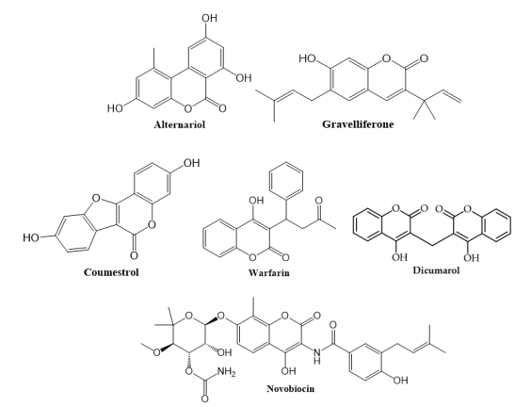

1.4. Toxicity of coumarin compounds
Higher doses of coumarins are found to be hepatotoxic however they exhibit beneficial effects by reducing the risk of cancer and other diseases of brain and cardiovascular system. Structural classification of coumarins and aflatoxin are found to be similar and considered as hepatotoxic, however, upon substitution they tend to lose their toxic effect, moreover, coumarins were found to be more hepatotoxic in rats as compared to humans. However, the toxicity of psoralen is beneficial in the treatment of psoriasis (Asif, 2015). In humans, coumarin is metabolised through 7-hydroxylation pathway, however 3, 4-epoxidation pathway is a major route for their detoxification leading to the formation of toxic metabolites (B.G. Lake, 1999). CYP2A enzyme of liver catalyzes the conversion of coumarins to 7-hydroxycoumarins (Vassallo et al., 2004). Linear furanocoumarins such as psoralen exhibit phototoxic activity but on the contrary, umbelliferone is proved to be non-toxic (Chaudhary et al., 1986) application and mechanism

2.Chemical and Physical Properties

Coumarins have the chemical formula (C₉H₆O₂ ) and molecular weight (146.1427g/mol). The conjugated double ring system and the reactivity of the benzene and pyrone rings are responsible for an electronic environment that plays a very important role in this family of compounds, that makes them interesting molecules for different fields of research. Coumarin typically appears as white crystals or a crystalline powder. It has a sweet, hay-like odor, often described as similar to vanilla or freshly cut grass. Coumarin has a melting point of around 68-70°C (154-158°F), density (0.937 mg/l). It is insoluble in water, but soluble in organic solvents such as methanol, ethanol, and benzene. Coumarins usually are in the free state in plants as they are polar structures, and many of them can sublimate. They might also be found in the form of glycosides, including psoralen corerelated structures [44]. They are characterized by UV light absorption, resulting in a very characteristic blue fluorescence; they are also very photosensitive as they can be altered by natural light [44].

These features are used in the isolation and analysis, as well as in unusual therapies such as photochemotherapy and the industry of chemical sensors [51, 52](Coumarin: Chemical and Pharmacological Profile) Coumarins — An Important Class of Phytochemicals Important Class of Phytochemicals
Coumarin and its derivatives are principal oral anticoagulants. Coumarin is water insoluble; however 4-hydroxy substitution confers weakly acidic properties to the molecule that makes it water soluble under slightly alkaline conditions
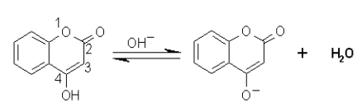

The structures of coumarin and its derivatives are as shown below. Warfarin is marketed as the sodium salt. It has one chiral center. The S (-) isomer is about 5 - 8 times more potent than the R (+) isomer; however, commercial warfarin is a racemic mixture. (Chen et al, 2001).

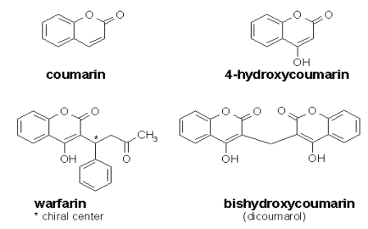

3.Synthesis

3.1. Biosynthesis of coumarins
Simple coumarins are biogenetically derived from shikimic acid, via cinnamic acid. The specificity of the process is the C-2 hydroxylation, producing a break (β-oxidation) of the side chain (i.e. Salix spp.), or chain isomerization and subsequent lactonization, generating the umbelliferone (Figure 4). [46, 53].
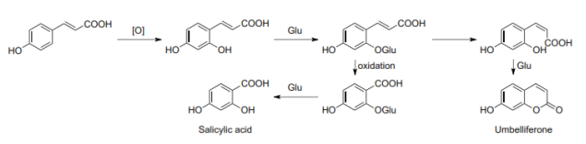

The biosynthetic pathways of such simple coumarins as umbelliferone, scopoletin, and esculetin were first discovered in different plants [20–22]. p-coumaric acid, caffeic acid, ferulic acid, and other precursors were used for the above synthesis by combining with 4-cinnamic acid Coenzyme A ligase (4CL) and feruloyl CoA 60 -hydroxylase (F60 H). Besides plants, microorganism hosts were also used to synthesize simple coumarins by biosynthetic pathway engineering and optimization. Simple coumarins have been synthesized from either hydroxycinnamic acid or glucose in Escherichia coli (E. coli) (Fig. 1) [18,23–25].

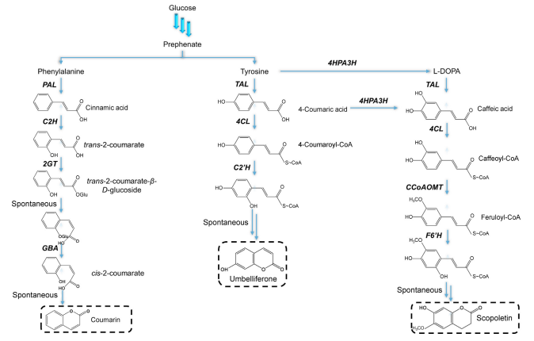

Biosynthetic pathway of simple coumarins in microbes. PAL, phenylalanine ammonia lyase; TAL, tyrosine ammonia lyase; C2H, cinnamate 2-hydroxylase; 2GT, 2-coumarate O-β-glucosyltransferse; GBA, β-glucosidase; 4CL, 4-coumarate CoA ligase; C20 H, coumaroyl-CoA 20 -hydroxylase; 4HPA3H, 4-hydroxyphenylacetate 3- hydroxylase; CCoAOMT, caffeoyl-CoA O-methyltransferase; F60 H, feruloyl-CoA 60 –hydroxylase.

Recent advances in the biosynthesis of coumarin and its derivatives

3.2. Synthesis of coumarins from phenols Friedel-Crafts condensation
f substituted malonic acid derivative (5) with phenol (4) to produce various 3-substituted 4-hydroxycoumarin compounds.19 In this study, a photoaffinity derivative of 4-hydroxycoumarin (8) was synthesized by the introduction of a p-azidobenzyl group at the 3-position through the condensation of p-nitrobenzylmalonic acid with phenol followed by reductive to give (7). The latter was converted to the azido compound (8) (Fig. 7)
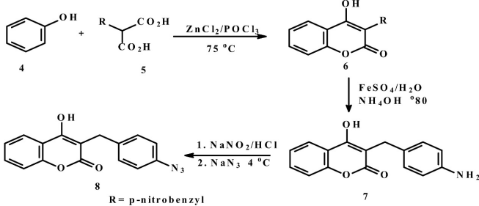

An overview on synthesis and reactions of coumarin based compounds

3.3. Synthesis of Simple Coumarins from Classic method
Coumarins can be classically synthesised by the Perkin, Pechmann or Knoevenagel reactions. Recently, the Wittig, the Kostanecki–Robinson and Reformatsky reaction were also conveniently applied to the synthesis of this type of heterocycles. eniently applied to the synthesis of this type of heterocycles. However, it is important to note that all the methods reported have some disadvantages, since they lack generality and efficiency, making the development of new reliable high-yielding methods for the synthesis of coumarins an important subject. The classical synthesis of coumarin, from salicylaldehyde and acetic anhydride, has been improved by the use of anhydrous sodium fluoride as catalyst or dibenzo-18-crown-6 [9]. Simple Coumarins and Analogues in Medicinal Chemistry
3.3.1. Perkin Reaction
The Perkin reaction consists in the formation of a coumarin by aldol condensation, of aromatic orthohydroxybenzaldehyde and acid anhydrides, in the presence of an alkali salt of the acid (figure 8). Several reports on the synthesis of coumarins through this method were published [9, 93, 94]

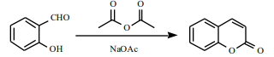

3.3.2. Pechmann Reaction

3.3.2.1. Pechmann-Duisberg
A very valuable method for the synthesis of coumarins is the Pechmann reaction. In general, the coumarins were obtained by condensation of phenols with b-ketoesters, in the presence of acid catalysts (Scheme 2). The reaction is often referred as Pechmann-Duisberg, when acetoacetic esters and derivatives are used. This synthetic route has been often used for obtaining natural coumarins and other benzopyrones with biological or industrial interest [9, 96-112].
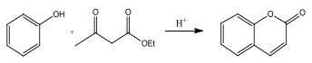

3.3.2.2. Using Gallium (III) triiodide as initiator
Sun and collaborators (46), have established an alternate Pechmann condensation method by using Gallium (III) triiodide as initiator. This deviation from the standard method offers many benefits, including gentle operating conditions, rapidly occurring reaction, ease of use and a high percentage of yield. They used Gallium (III) triiodide as an initiator in the reaction of naphthalen-1-ol and diacetic ether to produce 4-methyl-2H-benzo[H]chromen-2-ones, as shown in (Figure 10). Coumarin-Based Derivatives: A Review of Their Synthetic Routes, Reactivity, and Biomedical Attributes

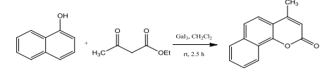

3.3.3. Knoevenagel Reaction

3.3.3.1. Doebner modification
Condensation of aldehydes with active methylene compounds, in the presence of ammonia or amines, is a reaction known as Knoevenagel. Usually, the reaction is catalysed by weak bases or by suitable combinations of amines and carboxylic or Lewis acids under homogeneous condition when malonic acid and pyridine, with or without traces of pipiridine, are used the reaction is often named by Doebner modification (figure 11).

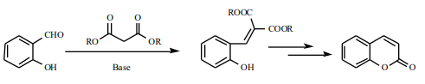

3.3.3.2. Using syringaldehyde derivative
Isofraxidin (7-hydroxy-6,8- dimethoxycoumarin), a well-known natural coumarin, was obtained through an expedite method using a syringaldehyde derivative and Meldrum´s acid, in the presence of ZnO, that promoted a Knoevenagel type reaction. The 3-carboxylic acid coumarin obtained was further decarboxylated with copper (figure 12) [133].

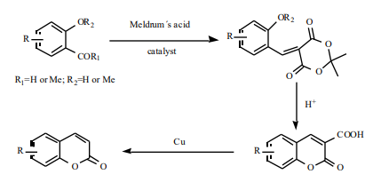
3.3.3.3. Using heterogeneous catalyst
The use of heterogeneous catalysts, such as zeolites and clays, for the synthesis of coumarin-3-carboxylic acids is a topic still under investigation [130]. New substituted coumarin-3-carboxylic acids were obtained by a solid phase synthesis, in which ethylmalonate, bound to the Wang resin and ortho-hydroxyarylaldehydes were used as starting materials (figure 13) [136]. Moreover, 3,3´-phenylenebiscoumarin derivatives, potential biscoumarin dyes, were obtained by a Knoevenagel reaction in a biphasic solid/liquid medium, using a strongly basic macroporous resin [137].
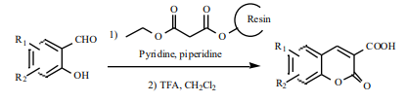
3.3.3.4. Using IL catalyst
A proposed mechanism for the synthesis of pyrano[2,3- h]coumarin derivatives 10 is shown in Scheme 15b. The authors explain that Knoevenagel products are formed from aryl aldehyde and malononitrile carboanion in a reaction catalyzed by IL. The addition of 4-substituted-5,7-dihydroxy-coumarin to Knoevenagel product then occurs, followed by further cyclization to the final product [25].

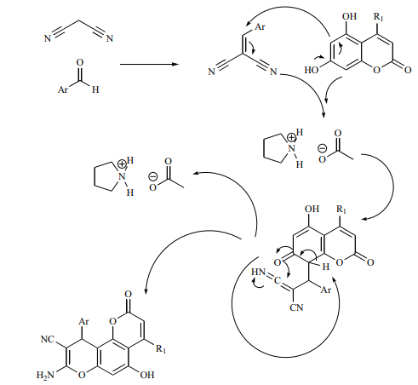
Green Chemistry Approaches to the Synthesis of Coumarin Derivatives
3.3.4. Wittig Reaction
In the Wittig reaction, the alkene formation occurs from carbonyl compounds and phosphonium ylides, proceeding primarily through betaine and/or oxaphosphetane intermediates (figure 14). When the ylide is replaced by a phosphine oxide carbanion or by a phosphonate carbanion, the reaction is referred to Horner or Horner-EmmonsWadsworth, respectively. This type of olefination of ortho-hydroxycarbonyl aromatic compounds, followed by further lactonisation, is a well-known method for the preparation of coumarin derivatives [9, 108, 122, 144-149].

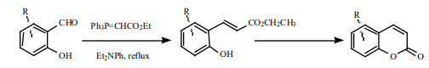

3.3.5. Kostanecki-Robinson Reaction
The formation of coumarins, usually 3- and 4- substituted coumarins, by this reaction occurred by acylation of ortho-hydroxyaryl ketones with aliphatic acid anhydrides, followed by cyclisation (figure 15). By this process, ortho-hydroxyketones were converted into phenylcoumarins, 3-cyano-4-methylcoumarins and in other type of coumarin derivatives (figure 16) [96, 158- 160]. These coumarins are suitable starting materials for obtaining another type of compounds such as styril and acetyl derivatives, hydrazones, etc.

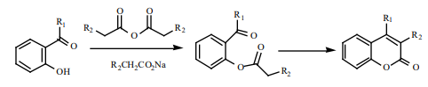

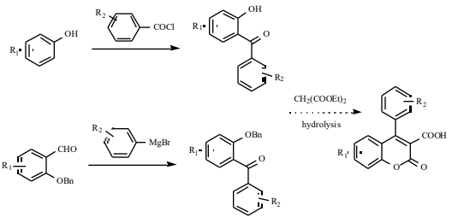
3.3.6. Reformatsky Reaction
Condensation of aldehydes or ketones with organozinc derivatives of a-halo esters to yield b-hydroxy esters is 3-Ureido derivatives of 4-phenylcoumarin. An original one-pot synthesis of 3-chlorocoumarins and styrenes, by cathodic reduction of trichloroacetyl esters of ortho-hydroxyketones and salicylaldehydes in aprotic media is presented by Batanero and Barba [162]. known as the Reformatsky reaction (Figure 17). In appropriate reaction conditions, lactonisation could occur with the formation of coumarins.

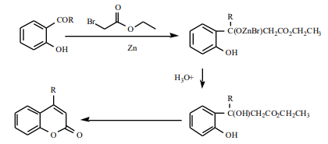

3.4. One-pot multistep reaction
Yavari and coworkers (52), described the one-pot multistep reaction procedure to produce Cou-Ds from dimethylacetylenedicarboxylate 4-fluorophenol. This coupling involves the formation of the complex by condensing phosphorus triphenyl and dimethylacetylenedica rboxylate with Ph-OH congeners in order to undergo an aromatic-electrophilic substitution reaction, cyclic ester creation to produces 4-methoxycarbonyl Cou-Ds, as shown in (Figure 18).
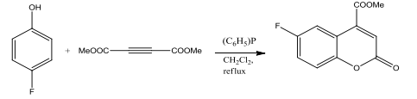
3.5. Heck coupling reaction
In the Heck condensation chemical reaction promoted by Pd, includes the palladium catalyzed aryl halides and alkenes are coupled to produce conjugated alkenes in a decided way. To produce Cou-Ds, the reaction is performed on cinnamic acid esters and 2-bromophenols (53), as shown in (Figure 19).
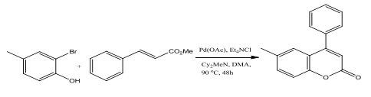

Coumarin-Based Derivatives: A Review of Their Synthetic Routes, Reactivity, and Biomedical Attributes

3.6. Using Grubbs initiator in ring-closing metathesis
Polito and collaborators (62), demonstrated a straightforward and easy way to create Cou-Ds, as shown in Figure 23. It includes the formation of acrylic ester by reacting 2-hydroxy styrene with prop-2-enoyl chloride. On the ester mediated from acrylic acid ester, the alkene metathesis reaction was carried out using an initiator in dichloromethane. The technique is an alternate for current Cou-D creation processes, which require nearly neutral conditions for ring formation (63)
Grubbs initiator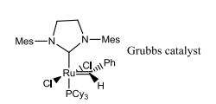
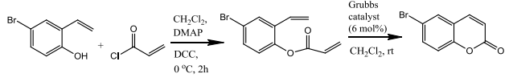
Coumarin-Based Derivatives: A Review of Their Synthetic Routes, Reactivity, and Biomedical Attributes

3.7. Coumarin, as a central core for the obtention of simple coumarins.
Simple Coumarins and Analogues in Medicinal Chemistry: Occurrence, Synthesis and Biological Activity
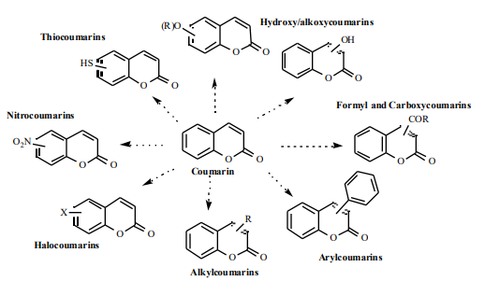
4. Reactions

4.1. Etherification
4,6-Dihydroxycoumarin (38) was methylated with dimethyl sulphate in potassium hydroxide solution to afford 4,6- dimethoxycoumarin (39) (Figure 17).35

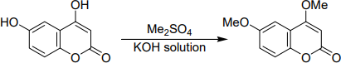
The reaction of 4-hydroxycoumarin (1) with primary amines and formaldehyde proceeded very rapidly, the 3- substituted aminomethyl-4-hydroxycoumarins were formed (40) (Figure. 21).36
R = H,alkyl; R1 = alkyl,aryl; NRR1 = heterocyclic

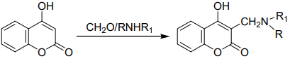
4.2. Acylation
Acylation of 4-hydroxycoumarin was accomplished using acetyl chloride in pyridine in the presence of catalytic amount of piperideine to afford 3-acetyl-4-hydroxycoumarin (3) (Figure. 22) 37

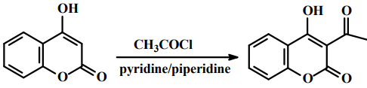

4-hydroxycoumarin (1) was reacted with phenylglyoxal (44) in the presence of 1,4- diazabicyclo [2.2.2] octane(dabco)[CH3COO]2 at room temperature to give (45) which upon irradiation by microwave in the presence of POCl3 the desired product (46) was obtained (Figure. 23).

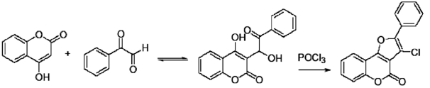

Condensation of 4-hydroxycoumarin (1) with aryl (alkyl) amines followed by treatment with sodium hydroxide solution afforded 4-aryl(alkyl) aminocoumarins Treatment of arylaminocoumarins (47) with phosphorusoxychloride in DMF affording benzopyrano[4,3-b]quinolines (48). In similar manner treatment of alkyl aminocoumarin with phosphorusoxychloride in DMF affording 4-alkylamin-3- formylcoumarins (49) (Figure. 24).

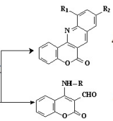
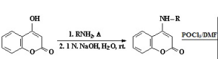

The 3-benzylidenecoumarins were prepared as shown in scheme. The Knovenagel condensation of 4- hydroxycoumarins (1a–b) with substituted benzaldehydes in pyridine gave compounds in only one diastereoisomeric form (Z) (Figure 25)

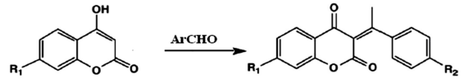

3,3΄-(4-dimethylaminobenzylidene)-bis-(4-hydroxycoumarin) was synthesized by the reaction of 4- hydroxycoumarin with 4-dimethylaminobenzaldehyde, and its chemical structure was determined by X-ray single-crystal diffraction (Figure. 26).
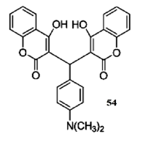
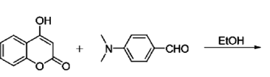
An overview on synthesis and reactions of coumarin based compounds
4.3. Metabolism of coumarin
Coumarin is metabolized by cytochrome P450-Jinked mono-oxygenase enzyme (CYP2A6) system in liver microsomes, which leads to hydroxylation; subsequently, the hydroxylated metabolite follows phase II conjugation reactions.7-hydroxycoumarin and 3-hydroxycoumarin are the main metabolites. The former one faces phase Il conjugation reaction resulting in the glucuronide derivative, whereas 3-hydroxycoumarin can be further metabolized by ring splitting to form two products, o-hydroxyphenyllactic acid and o-hydroxyphenylacetic acid (Figure 2) [4,211Since the expression of CYP2A6 varies between individuals, due to genetic and environmental factors, an inter-individual variation in the metabolism of coumarin drugs is possible (4).

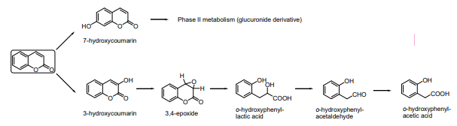

5. Application
5.1. Pharmacological Profile
Simple Coumarins and Analogues in Medicinal Chemistry: Occurrence, Synthesis and Biological Activity
Numerous biological activities have been attributed to simple coumarins and analogues. Among them, antimicrobial, antiviral, anticancer, enzyme inhibition, anti-inflammatory, antioxidant, anticoagulant, antidiabetes, photo-sensitizing agents and central nervous system activities. The pharmacological and biochemical properties and therapeutic applications of simple coumarins depend on the pattern of substitution in basic coumarin moiety

5.1.1. Antimicrobial and Molluscicidal
Novobiocin and clorobiocin (Fig. 3) are coumarin antibiotics of natural origin, which are inhibitors of DNA girase, and have a broad spectrum towards Gram-positive bacteria, including methicilin resistant strains of staphylococci species [228, 255]

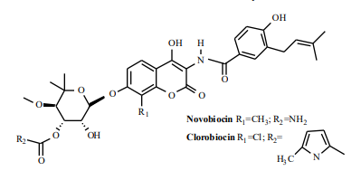
Due to some limitations of these compounds, particularly with regard to solubility, toxicity and development of resistance, a novel series of coumarin analogues has been synthesised. Over the past years, several efforts were directed towards the design of effective, orally bioavailable coumarin antibiotic inhibitors of bacterial DNA gyrase [256]. a series of coumarin congeners has appeared that bear the coumarin part of the molecule and isosteres, like carboxyl or basic amino groups, in order to improve the antibacterial activity [93, 108, 217, 256]. Some coumarins of natural and synthetic origin were screened for their antimicrobial activity Several coumarin derivatives were also tested for their antifungal activity. A free 6-OH on the coumarin nucleus was found to be important for its antifungal activity and, curiously, a free 7-OH on the same nucleus, was important for antibacterial activity [195]. novel antimicrobial agents, was carried out in order to determine the basic features of the structure, which are responsible for the biological activity. The substitutent ester or carboxylic acid on the coumarin ring was found to be important for inhibitory activity against Gram-positive and Gram-negative bacteria. The presence of phenolic hydroxyl groups and/or carboxylic acid was found necessary for enhanced activity against Helicobacter pylori [267].
5.1.2. Antiviral
The antiviral activity of simple coumarins focuses essentially on the inhibition of HIV-1 protease (HIV-PR) and HIV-1 integrase. inhibitory activity of various coumarins towards HIV-1 protease has been investigated, and classified as a class of drugs of interest as antiviral agents [173, 174, 279]. From this, phenprocoumon, warfarin and substituted 4-hydroxy-2-pyrone derivatives are, actually, referred to as first generation of HIV-PR inhibitors [280]. It was also found that certain coumarin dimers, particularly those containing hydrophobic moieties on the linker, display potent inhibitory activity against HIV-1 integrase [222, 224, 281]. In addition, some coumarin derivatives were tested for their activity against Herpes simplex virus (HSV). From these studies, 5,7,4´-trihydroxy-4-styrylcoumarin was found to exhibit a significant antiviral activity [67, 283]. It is worthwhile to note that the natural collinin, greveal, has significant anti-HBV DNA replication activity [32].
5.1.3. Anticancer
Among the coumarins screened for anticancer activity, geiparvarin (Fig. 4) was found to be the most representative. Geiparvarin is a natural coumarin based structure, isolated from the leaves of Geijera parviflora Lindl, which is known for its significant in vitro cytostatic activity [284]
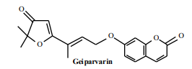
the compound is constituted of three units: a furan3(2H), an unsaturated alkenyloxysubstituent and a coumarin moiety.
Medicinal Research Progress of Natural Coumarin and its Derivatives
SAR studies of coumarin derivatives reveal their anti-cancer potency depending upon substituents on the coumarin nucleus. The coumarin derivatives bearing alkoxy, cyclopentene and hydroxyl groups are more likely to be potent anticancer agents. The substituents at the C3 position, including sulphonamide derivatives, hydrazide-hydrazone moiety, amine group and hydroxyl group, are more likely to be effective anticancer agents In the same manner, the presence of idophenol derivatives, hydrogen bond acceptor groups, alkoxy aromatic rings connected to triazole, tosyl groups and hydroxyl groups at position C4 enhances the anticancer potential of coumarin derivatives. Alkoxyl or hydroxyl groups at C5 also enhance their anticancer potency. The presence of chlorine atoms, methylenedioxy groups and hydroxyl groups at C6 also play a key role in anticancer efficacy of coumarin derivatives. Additionally, the presence of aromatic sulphonate derivatives, methoxy groups, amide derivatives, chlorine atoms and hydroxyl groups at the C7 position of coumarin derivatives showed the effective anticancer property. Finally, the presence of fused furan rings and benzosubernone rings at C3-C4 positions also contributes to anticancer activities of coumarins.

5.1.4. Anti-inflammation
an insight into the therapeutic applications of coumarin compounds and their mechanisms of action
Inflammation is caused by the release of chemicals from damaged tissues and migrating cells like prostaglandins, histamine, leukotrienes (Vane et al., 1987 and Morteau, 2000). Coumarins exhibit anti-inflammatory activity and have the potential to treat edema. They stimulate phagocytosis by stopping the release of edema fluid from the cell (Venugopala et al., 2013). In tissue space, the coumarins are transported by leaky micro-vessels, but if the permeability of capillary is less, coumarins are unable to act (Raymond et al., 1980). So, they can decrease the level of tissue swelling (Casley et al., 1983) and help in relaxing the smooth muscles, so are used in edema therapy (Fylaktakidou et al., 2004). The foundation of coumarins along with vasoactive drugs shows an immeasurable result towards this therapy. Esculetin, umbelliferone and umbelliferone-6-carboxylic acid (UMC) show antioxidant and anti-inflammatory activity (Sahu et al., 2017). Coumarins are also known to increase the phagocytic activity of murine peritoneal macrophages (Kostova, 2014). Coumarins bind with plasma proteins that result in the activation of macrophage and proteolysis (Rohini & Srikumar, 2014).
5.2. Coumarins Photoproperties
An Overview of Coumarin as a Versatile and Readily Accessible Scaffold with Broad-Ranging Biological Activities
The applications and properties of coumarin scaffold have remarkably wide boundaries. Coumarin-based compounds have been exploited in numerous research and industrial sectors, as active pharmaceutical ingredients, pesticides, fragrances, dyes for several purposes from laser technology to organic photoredox catalysis, cell imaging, photocleavable protecting groups and fluorescent biological probes [6,218–225]. In the following paragraphs, the most recent applications associated with the photophysical properties of coumarins is showen
5.2.1. Fluorescent derivatization
Simple Coumarins and Analogues in Medicinal Chemistry: Occurrence, Synthesis and Biological Activity
The fluorescence derivatisation is one of the most sensitive detection techniques for the trace analysis of environmental and biologically relevant molecules. The fluorescent properties, which are intrinsic to some coumarins, make them useful compounds for this type of application. different coumarins, such as amino or hydroxycoumarins have been used as fluorescent derivatising reagents [120, 122, 359-364]. The synthesis of fluoroionophores, consisting of coumarins fused to crown ethers was performed, allowing for the development of a new class of photoactive macrocycles. This type of compounds could be used as cation dependent fluorescent signalling systems or triplet sensitisers [119].

5.2.2. Coumarins as Fluorescent Probes
Coumarins possess a large electron-rich - conjugated system with charge transfer properties, reason why coumarin-based fluorophores are widely used for monitoring a variety of biologically important species and biochemical process in living cells, for example as diagnostic agent for detection of biothiols, enzymes, mitochondrial pH values, glucose and ions (3,222,235). In particular, several coumarin scaffolds have been proposed and evaluated for the detection of ions in different fields, from cellular imaging to environmental waters. Gong and co-workers based their work on an easily. synthesized coumarin-based fluorescent probe (179, Figure 59) that enzymes, mitochondrial pH values, glucose and ions (3,222,235). In particular, several coumarin scaffolds have been proposed and evaluated for the detection of ions in different fields, from cellular imaging to environmental waters. Gong and co-workers based their work on an easily. synthesized coumarin-based fluorescent probe (179, Figure 59) thatalready was effective in the detection of glutathione (GHS) in the presence of Cu* ions, expanding its potentiality to the detection of hypochlorite ions with high selectivity and sensitivity. The probe showed a remarkable fluorescent intensity change in response to hypochlorite ions; moreover, this probe could be applied to detect ClO in cells via intracellular fluorescent imaging (236,237).

Conclusion
The coumarin nucleus has been gaining increasing attention in the last years because of the variety of its applications both in medicinal chemistry and in agri-food sectors. In this research project we highlighted the wide range of pharmacological activities ascribable to coumarins (antioxidant, antibacterial, antifungal, antiviral, anti-proliferative, anti-inflammatory, antidiabetics, anticoagulant and anti-neurodegenerative) and coumarin photopropertie and the possibility to easily modify and decorate this natural scaffold to perform structure activity relationships studies, reactions of coumarins and metabolism. The coumarin nucleus possesses some fundamental properties that ensure it an advisable role in the design of new biologically active derivatives, mainly due to its stability, low molecular weight and to the easiness to decorate it for increasing pharmacodynamic and pharmacokinetic properties. This natural core is present in a number of currently available drugs used in the treatment of various diseases. For instance, the use of warfarin, acenocumarol and phenprocoumon in the treatment and prevention of thromboembolic diseases is now well established. Even though the coumarin nucleus presents an impressive number of biological activities, its presence among marketed drugs is not widespread yet. Further efforts are needed in order to achieve coumarin-based compounds with appreciable pharmacokinetic properties, along with high efficacy and a low toxicity profile.

Reference

