Department of Chemistry College of sciences University of Salahaddin
Subject: Heterocyclic Compounds

Course Book: Fourth Year
Lecturer's name: Dr. Karzan Khaleel Hameed

Academic Year: 2023/2024

Course Book

1. Course name | Heterocyclic Compounds
2. Lecturer in charge | Karzan Khaleel hameed
3. Department/ College | Chemistry / sciences
4. Contact | e-mail: karzan.hameed@su.edu.krd
5. Time (in hours) per week | Theoretical: 2 hours
6. Office hours | (2)hrs.
7. Course code
8. Teacher's academic profile | 1-(2008-2010) Msc. in Organic chemistry from Salahaddin University\ college of Science \ Chemistry department.  2-(2017-2020) PhD. In Heterocyclic Organic Chemistry \ Pavia University-Italy, Salahaddin University-College of Science.
9. Keywords | Beta-lactam , pyrrole, aziridine, oxazole
10. Course overview:
the course is for graduate students majoring in a field of science and engineering. This course introduces the broad field of heterocyclic organic chemistry by reviewing the major classes of heterocyclic compounds in terms of nomenclature, structure, properties, preparations and reactions. The syntheses of several physiologically important heterocyclic compounds are given.

11. Course objective:
The objective of this course is to give the student a broad understanding of the major classes of heterocyclic compounds. Specifically, the student will learn nomenclature, structure, properties, syntheses, and reactions of the simple three, four, five and six-membered ring heterocycles, the benzene ring fused ring heterocycles, the pyridine group, and the quinoline and isoquinoline groups.

12. Student's obligation
The students responded above average for most items. However, it was identified that students look difficulty to grasp the aim and understand the importance of the activities. Further it was found more satisfying and gave confidence if the lessons were well structured and student directed. On top of these most students wish organic chemistry laboratory to be a place where they could practice scientific
investigations.
13. Forms of teaching
Learning resources in this course include white board and PowerPoint presentations.
14. Assessment scheme

The students are required to do two exams along the semester. The exams have 40 mark,; classroom activities 5 marks, and attendance 5 marks (total 50 mark). Final examination: 50%
15. Student learning outcome
- At the successful completion of the course the student will have knowledge about the structures, syntheses, reactions, and properties of the major classes of heterocyclic compounds.
- Learn about nucleophilic substitution and elimination reactions. Students will be expected to be able to discuss concepts and answer questions on exams and problem sets as well as apply these concepts to a laboratory experiment and properly interpret the results on written lab reports. Students will be able to analyze reaction conditions that favor each reaction as well as understand the mechanistic principles of each of the reactions.
- Understand the reactions of B-lactam containing compounds (nucleophilic addition to carbonyls, nucleophilic acyl substitution, and carbonyl condensation reactions) that makes them important reactants in organic synthesis. Students will be expected be able to predict the outcomes of these reactions as well as show a full understanding of their reaction’s mechanisms.

16. Course Reading List and References:

- Heterocyclic chemistry, J.A. Joule and K. Mills, 4th ed., Blackwell Publishing 2000
- Joule, J.A., 2020. Heterocyclic chemistry. CRC Press. ISBN: 978-1-405-13300-5
- Katritzky, A.R., Ramsden, C.A., Joule, J.A. and Zhdankin, V.V., 2010. Handbook of heterocyclic chemistry. Elsevier.
The core materials of the course consist of the above book, articles from media and internet, and lecture’s notes, make sure you read all the materials and prepare well before going for the examinations.
Students are encouraged to search for any other materials that may help improve their English language ability in reading, writing, listening, and speaking organic chemistry texts.
17. The Topics: | Lecturer's name
This field not filled because I don’t have theoretical lecture. The next
field shows the practical topics.
18. Practical Topics (If there is any)
week1: Definition of Heterocyclic compounds, natural sources and importance, Criteria for aromaticity; aromatic and non-aromatic heterocycles. | Karzan KH. Hameed 2hr
Week 2 Nomenclature of Heterocyclic compounds (1)
Week 3 Nomenclature of Heterocyclic compounds (2)
Week 4 Nomenclature of Heterocyclic compounds (3)
Week 5 three-membered of Heterocyclic compounds (1)
Week 6 three-membered of Heterocyclic compounds (2)
Week 7 four-membered of Heterocyclic compounds (1)
Week 8 four-membered of Beta-lactam (2)
Week 9 five-membered of Heterocyclic compounds (1) pyrrole
Week 10 six-membered of Heterocyclic compounds (1)
Week 11 six-membered of Heterocyclic compounds (2): Pyridine
Week 12 : Biologically important heterocycles Uraciles (pyrimidines) and purines: structure, synthesis, DNA and RNA nucleotides (structure and nomenclature) (1)
Week 13 Biologically important heterocycles Uraciles (pyrimidines) and purines: structure, synthesis, DNA and RNA nucleotides (structure and nomenclature) (2)

19. Examinations:

Q1/ Write the structure of the following names.
Coumarin, Pyridazine, Monobactam, oxacyclohexane, 2,3-dihydroazete

Q2/ write the following reactions (all steps)
- Hassner Synthesis
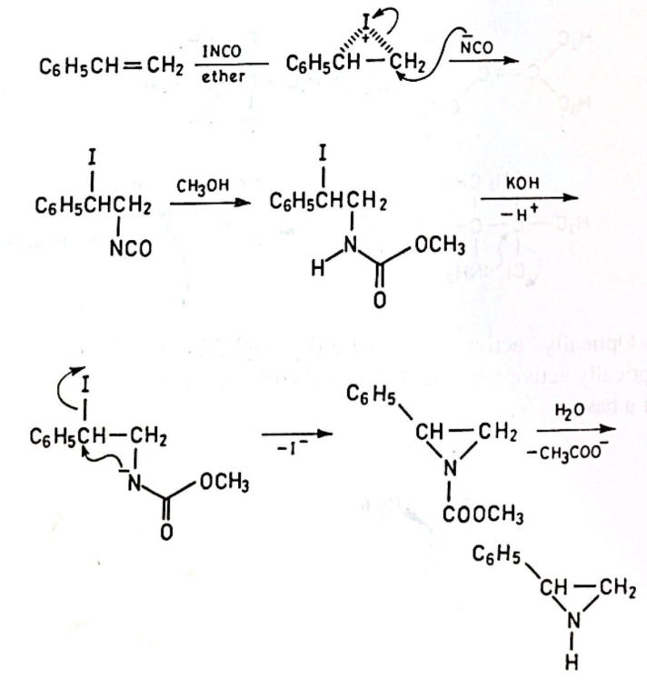
2- chichibabin reaction

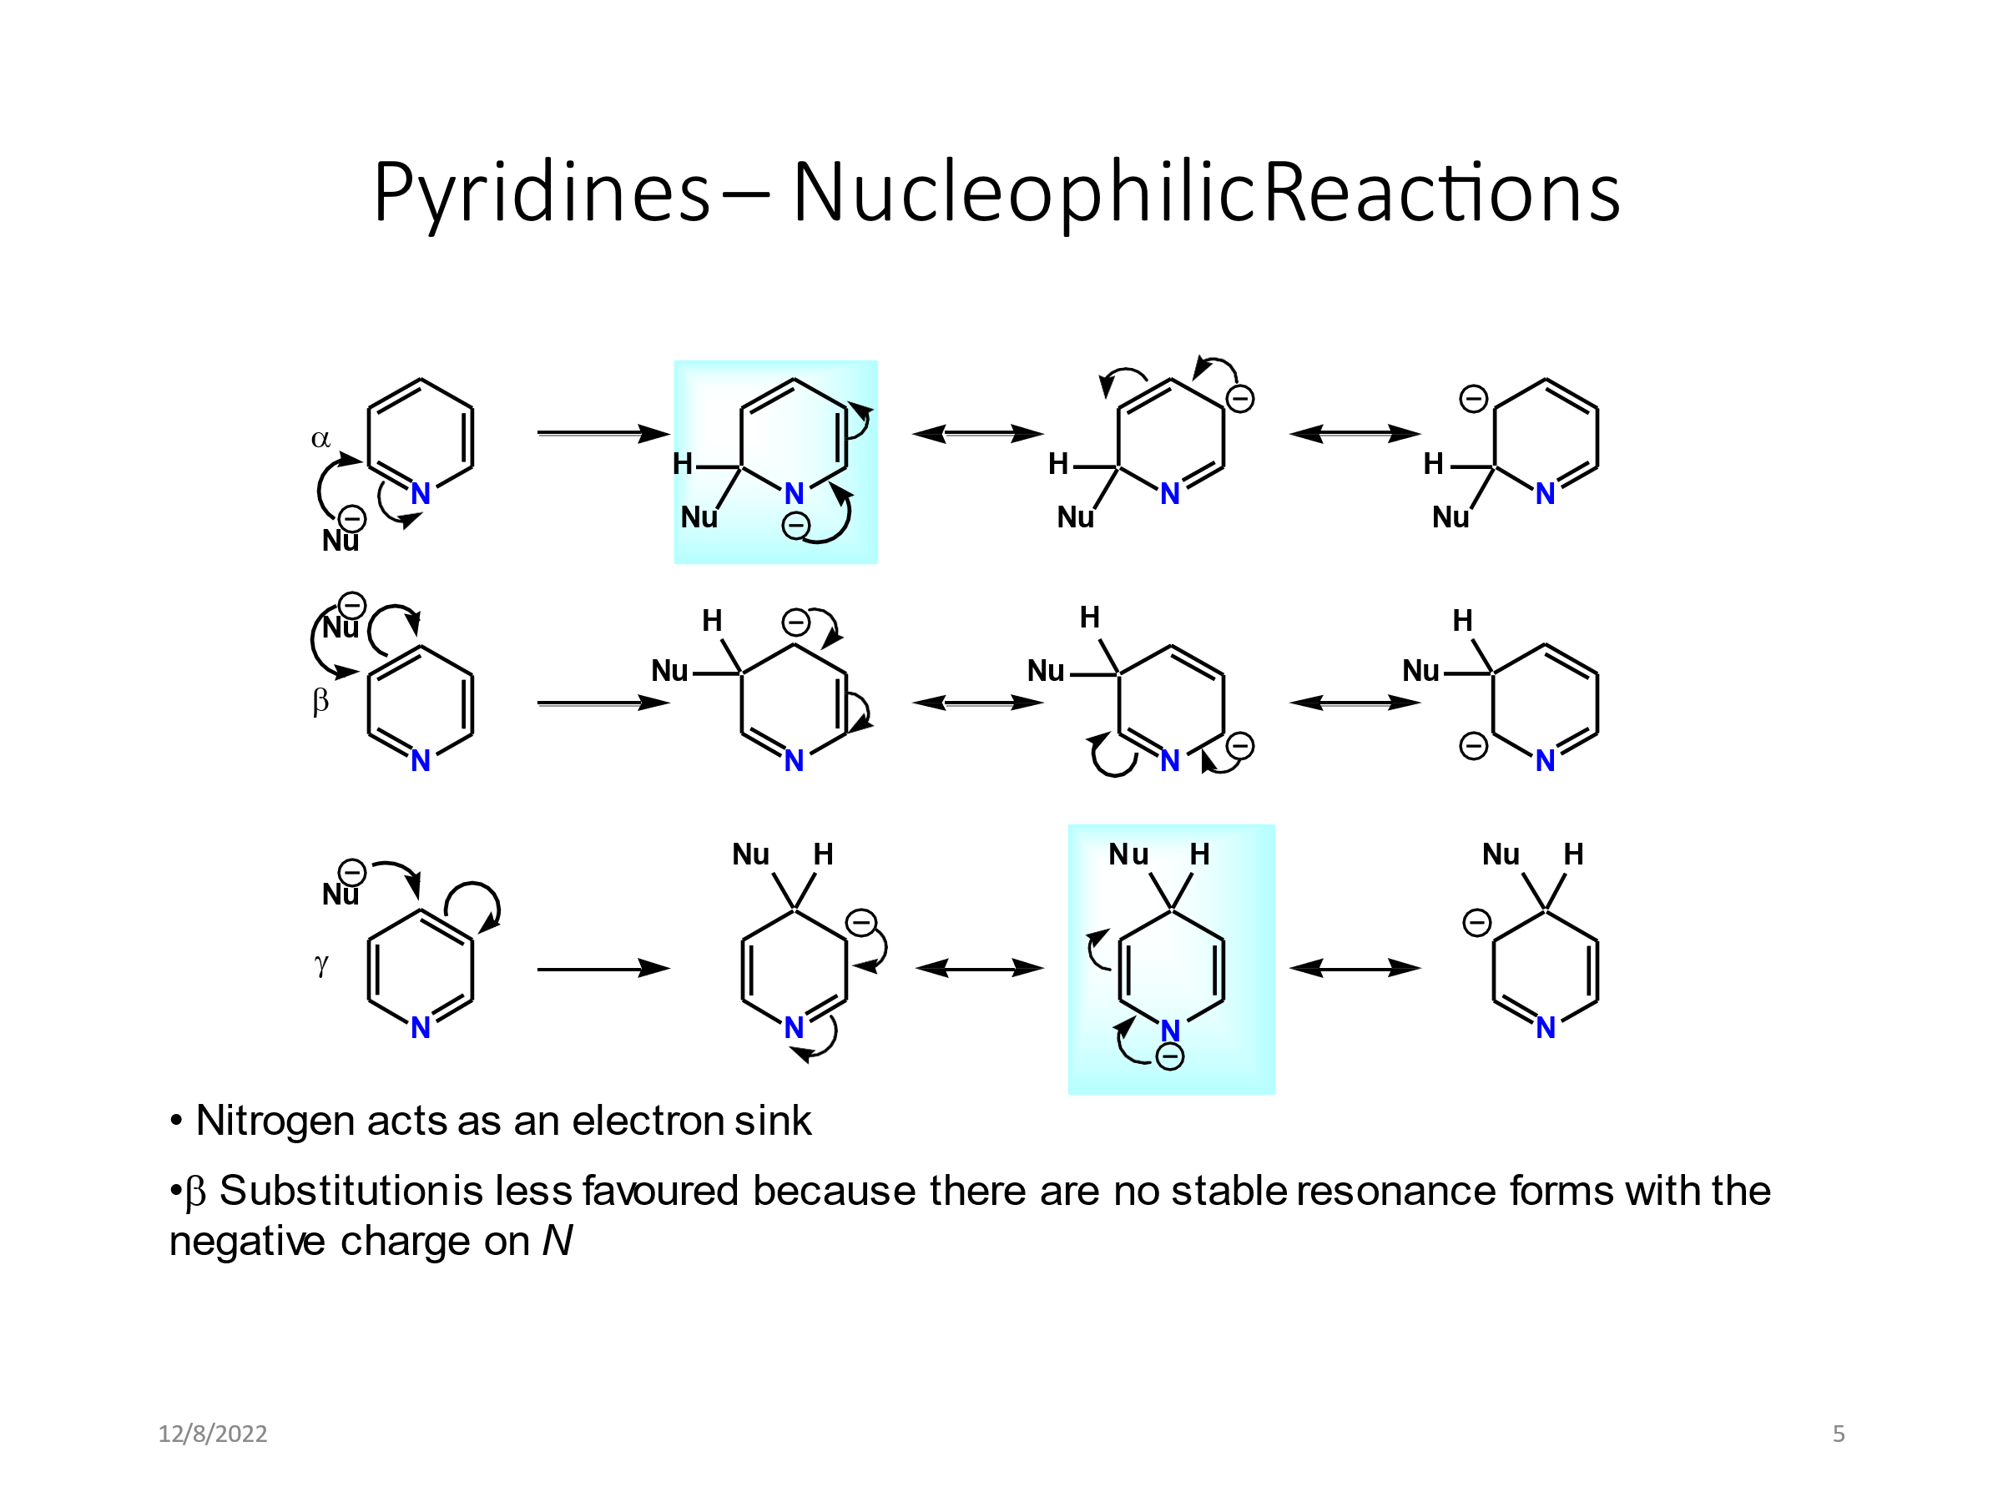

Q3/ rank the following compounds toward reactivity with substitution reaction
Ester, acid chloride, amide, thioester, acid anhydride

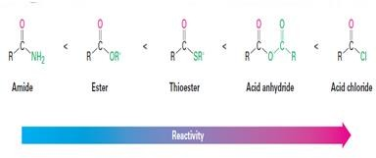

Draw and Complete the following chemical reactions:
- Acetic anhydride + H₂O / H⁺ →
- Acetyl chloride + BuMgBR → + BuMgBr → 3- Amide + Bromine/sodium hydroxide → →
- Nitrobenzene + H₂SO₄/HNO₃ →
- C₂H₃OCl(A) + C₂H₇N(B) → C₄H₇ON(C)

20. Extra notes:
Lecture and student must have good corporation to success learning process.
21. Peer review .

