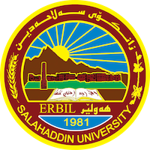
Academic Curriculum Vitae
Full Name: Karzan Abdullah Jezhny
Academic Title: Lecturer
Email: karzan.jezhny@su.edu.krd
Mobile: 07504957765
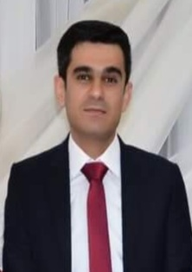

Education:
- BA degree at Salahadin University, College of Education (2007)
- MA degree in Britain at Sheffield Hallam University, in Applied Linguistics (2013)

Employment:
- 2007 Assistant researcher, Salahadin University, College of Education
- 2014 Assistant Lecturer, Salahadin University, College of Education
- 2021 Lecturer Salahadin University, College of Education

Qualifications
- IT qualifications: a wide range knowledge of computer systems and software
- Methods of teaching, University of Salahaddin, 2014

Teaching experience:
- General English at Salahaddin University, College of education, Undergraduate
- Linguistics and Literary terms at Salahaddin University, College of education, Undergraduate
- Pedagogical Grammar Salahaddin University, College of education, Undergraduate
Research and publications
- University Learners' Perspective towards Factors Affecting the Speaking Skill, Cihan University-Erbil, Journal of Humanities and Social Sciences, 2021.
- The Assessment of University Students Knowledge on Academic Writing, Zanco Journal of Humanity Sciences, 2021.

