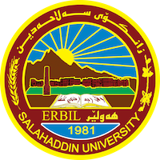
Academic Curriculum Vitae
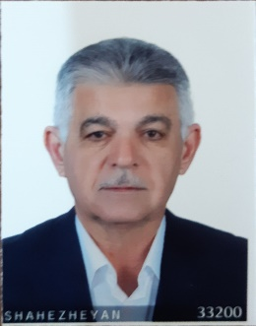
Personal Information:
Full Name: Dr. Kasim Saeed Hadi
Academic Title: Assistant Professor
Email: kasim.hadi@su.edu.krd
Mobile: +9647504789744

Education:
From- To | Degree | College-University | Country
1996 | PhD Degree in Polymer Chemistry | College of Science- University of Salahaddin | Iraq
1986 | Master’s Degree in Organic Chemistry, Department of Chemistry | College of Science- University of Baghdad | Iraq
1980 | B.Sc. Chemistry, Department of Chemistry, | College of Science- University of Baghdad | Iraq

Employment:
Assignments and Posts:
From- To | Post | Department -College | University
1987 to date | Lecturer of Polymer Petroleum Chemistry, Industrial Chemistry and Organic Chemistry | Chemistry Department-College of Science | Salahaddin University
1997 to date | Member of Scientific and high education committee | Chemistry Department-College of Science | Salahaddin University
2003 to 2015 | Member of the Scientific upgrading committee in the College of science | Chemistry Department-College of Science | Salahaddin University
2003-2009 | Member of central Scientific upgrading committee | Salahaddin University | Salahaddin University
5 years | Head or Member of supporting Scientific researches committee | Chemistry Department-College of Science | Salahaddin University
10 years | Head or member of preliminary examination committee | Chemistry Department-College of Science | Salahaddin University

Teaching experience:
- Teaching Activities
From- To | Subject | Stage-College | University
1997- to date | Polymer Chemsitry | 4th -year students / Chemistry Department-College of Science | Salahaddin University
1999-2008 | Petroleum Chemistry | 3rd-year students / Chemistry Department-College of Science | Salahaddin University
1999-2008 | Industrial Chemistry | 3rd-year students / Chemistry Department-College of Science | Salahaddin University

Research and publications
Published articles, papers and researches:

- Gulf Journal of Mathematics and Science, Synthesis of imide and isoimide, (1987).
- ZANCO, Synthesis of three member sulfide rings, (1989).
- Science and Nature, Determination of trace water and acetaldehyde, (1990).
- ZANCO, Synthesis of cyanide ion exchanger (1996).
- ZANCO, Synthesis of polyarylene sulfone (2003).
- JDU, Synthesis of Copolyethers, (2004).
- Synthesis and characterization of sulfonated aryl ether sulfones as proton fuel cell (2012)
- Production of biodiesel from vegetable oils International journal of applied chemistry (2014)
- Specification and characterization of biodiesel oils International journal of applied chemistry (2015)
- Specification and Evaluation of Diesel Fuel used in Electricity Generation in Erbil 2020, Zanco Journal of Pure and Applied Sciences 32 (5), 92-105
- Evaluation of Gasoline Samples from Several Erbil Petrol Stations 2023, Zanco Journal of Pure and Applied Sciences 35 (2), 189-196

Conferences and courses attended
2000 Higher education Conference in Kurdistan Region.
1997 3rd Scientific Conference of Salahaddin University, Erbil-Iraq
1987 13th Scientific Conference of Salahaddin University, Erbil-Iraq

Professional memberships
2000 to date a member of Chemical Society in Kurdistan Region
1986- 1991 Member of The Chemical Society of Iraq.

Professional Social Network Accounts:
ORCID ID: 0009-0003-2745-5152
Academic Profile: https://academics.su.edu.krd/kasim.hadi
LinkedIn: https://www.linkedin.com/in/kasim-saade-hadi-6a9669278/
Scholar Account: https://scholar.google.com/citations?view_op=list_works&hl=en&user=NzS8C3AAAAAJ
ResearchGate: https://www.researchgate.net/profile/Kasim-Barznji

