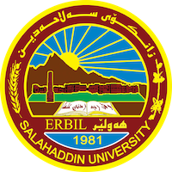
Academic Curriculum Vitae

Personal Information:
Full Name:kawa azeez braim
Academic Title:assistant professor 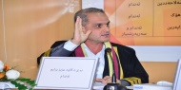
Email: (kawa.braim@su.edu.krd
Mobile:0750454988

I was born in the Salah al-Din resort town of Erbil, and I started studying there from elementary school to middle school, as I completed middle school in 1998, and then accepted into university studies for the year 1999-2000 in the History Department of the College of Arts, Salah al-Din University, and graduated from it in 2003 with honors. Very well, as I was the first in the department and the fourth at the college level, bearing in mind that the College of Arts at that time included the linguistic departments that later formed the faculties of languages, as I was the first at the college level without the linguistic departments, then I was appointed as a teaching assistant in the same college on October 30 the first of 2003

After serving two years, she was accepted into the master’s degree in 2005, and obtained a master’s degree in the year 2008, and the thesis was entitled (The Role of the Elite in the Emergence and Fall of Civilizations according to Arnold Toynbee). Four years later, in 2012, she accepted a doctorate from the University of Mosul and obtained a Doctorate degree in 2015, which was entitled (The Economic-Social Approach to Interpreting History by the Egyptian Historian Muhammad Anis) and continued to serve the university as it was specialized in the field of the philosophy of history, which is considered the main pillar in historical studies

And then I started writing scientific research related to the field of philosophy of history through scientific research, the geographical interpretation of history according to Montesquieu in the balance, and then the second research, which was titled What is the idea of ​​teleology in history with the Islamic thinker Muhammad Iqbal, and then I wrote the third research, which was titled Criticism of the historical materialism of the late Kurdish thinker Masoud Muhammad, and then the fourth research, which was titled “The Ethnic Interpretation of History by Gustave Le Bon, Between Scientific Reality and Philosophical Imagination” Contemporary Western) as a model, and in the field of knowledge of languages, I am fluent in the Arabic language, and then the English language very well

