C.V
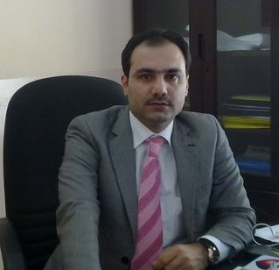

Name: Kawa Ali Khorsheed
Date of Birth: 05_04_ 1982
Religion: Kurdish
Martial statues: married
No. of children: three
Specialization: business administration
Position: lecturer
Scientific Degree: lecturer assistance
Work Address: SUH - college of economic and business
Work Phone: 00964 750 123 4567
Mobile: 00964 750 464 5063
E-mail: kawa_mba@yahoo.com

- First, Scientific Certification:

Date | College | University | Degree science
2007 | Business & economic college | SUH | B.Sc.
2011 | Business | UPJV-AMIENS | M.Sc.
 |  |  | Ph.D.
 |  |  | Any other
From -To | Workplace | Career | No.
2008-2008 | Retailers directorate of Erbil | Contract employee | 1
2009-2010 | SUH - Business & economic college - Evening studies Computer unit | Organize student | 2
2010-2011 | SUH - Business & economic college - Evening studies Planning unit | Letter of summer training | 3
2011 -2013 | SUH - Business & economic college – morning studies – banking department | Demonstrator | 4
2013-present | SUH - Business & economic college – morning studies – banking department | Lecturer | 5
 |  |  | 6
- Second, Career:

- Third, University Teaching.
From -To | The (Institute / College) | University | No.
2013- present | Economic& business | SUH | 1
2017-2019 | Business college | LFU | 2
 |  |  | 3

Year | Subject | Department | No.
2013-2017 | Principles of management | Banking & finance | 1
2014-present | Bank operation | Banking & finance | 2
2018-present | Bank management | Banking & finance | 3
2016-2017 | Commercial bank | Banking & finance | 4
2015-2016 | Organizational behaviors | Business | 5
2016-2017 | Risk and insurance | Business | 6
2014-2015 | Tourism management | Business | 7
 |  |  | 8

- Forth , Research Projects in The Felid of Specialization to The Environment and Society or the Development of Education:
No. | Research Title | Place of Publication | Year
1 | The impact of product prize and quality on choice supermarket | Polytechnic – Erbil | 2013
2 | العوامل المؤثرة على الرضا الوظيفي لأعضاء الهيئة التدريسية لأساتذة جامعة صلاح الدين | Kirkuk university – administrative & economic college | 2017
3 | الحوافز وانعكاسه على إنتاجية العاملين | Tikret university - administrative & economic college | 2019

- Fifth , Membership:
- Accounting syndicate
- Economic syndicate

- Fourth, Courses Which You Teach:
Principles of management
Bank operation
Bank management
Commercial bank
Organizational behaviors
Risk and insurance
Tourism management

- Twelfth, languages:
- Kurdish
- Arabic
- English
- Turkish

