Factors affecting the collection of financial revenue from land in Vietnam

Abstract
The study aims to determine the factors affecting the collection of financial revenues from land. The study carried out a 3 step survey through 400 householders to identify groups of influencing factors. Structural equation modeling (SEM) was used to assess the impact. Data checking was performed using SPSS20 and AMOS24 software. There are 5 groups of influencing factors. The group of human resources has the strongest impact; the group of people having financial obligations has the weakest impact on the realization of financial revenues from land. To better realize financial revenue from land, it is necessary to strengthen human resources; complete the land database; adjust the level of land financial revenue; complete administrative procedures; raise the sense of law observance of people having land financial obligations.

Keywords
Affecting factors, collection, financial revenue, land, Vietnam

Introduction
Financial revenues from land are essentially the content of land finance, which may have different names and quantities, but they are all intended to contribute to the state budget (Wang et al., 2020; Zhong et al. ., 2019). Financial revenues from land include proceeds from land sales, land leases (Chen and Wu, 2020; Qin et al., 2020; Zhang and Xu, 2017), or land sales tax (Gao, 2019; Qun et al., 2015; Tang et al., 2019) or land use tax (Chen and Wu, 2020; Hu and Qian, 2017; Huang and Chan, 2018) and related fees other land use (Liu et al., 2018; Tongwei et al., 2020). Financial revenues from land or land finance are a special source of finance for socio-economic development (Artioli, 2021; Liu et al., 2018; Pan et al., 2015). The rate of charge for each financial revenue from land in different countries. In some countries, the land use tax is the largest and most stable, but in some other countries, including Vietnam, the largest amount is from land use fees and land rent, but the land use tax rate is the lowest (Pham Phuong Nam). In developed countries, the main focus is on land tax collection, so this total revenue accounts for 50-90% of the total local budget revenue (Dang Hung Vo, 2019).
In Vietnam, the land is owned by the entire people, and the State represents the owner and uniformly manages the land. The State shall decide on financial revenues from land and the rate of collection for such revenues based on land area, land price, and other factors applicable to each financial revenue. Financial revenues from land include land use fees; land rent; land use tax; income tax from land use right transfer; fees; fines for administrative violations; compensation to the state when causing damage when causing damage in the management and use of land (National Assembly, 2013). The land use fee is the amount of money that a land user must pay when he/she is allocated land with a land-use fee by the State, when the land use right is recognized, or when the land use purpose is specified. Land rent is the amount of money a land user must pay when the land is leased by the State. Land tenants can choose to pay the land rent annually or once for the entire lease period. Income tax from land use right transfer is an amount of money that an individual or organization must pay when transferring land use by law.
Fees are also the amount of money that land users must pay when using land-related services such as when being granted a certificate of land use right, being provided with public information, and being entitled to register the right to use land. land use etc. The fine for administrative violations is the amount of money a land user must pay when there is a violation of the land law such as using land for wrong purposes, encroaching on land, failing to register land changes, etc. Compensation to the State when causing damage when causing damage in the management and use of land is also the amount that the subject of land-related water damage must pay to compensate for the cost of remedying the damage such as compensation to remedy pollution of the land environment (National Assembly, 2013).
Realization of financial revenues from land is the process of determining financial obligations for each land revenue in each specific case according to the prescribed order and procedures and by officials and individuals, the relevant organization implements. Persons with financial obligations must compile and send dossiers to competent state agencies to determine financial obligations. After determining the financial obligation, the state agency sends the financial obligation results to the financial obligor for them to pay the financial obligation. In case of a late payment meeting, they will be reminded and sanctioned according to regulations (Hoang Van Cuong, 2019; Pham Phuong Nam, 2019).
Up to now, there have been many studies on financial incomes from land (land finance) in different aspects, but there are few studies on the implementation aspect of financial income from land. Zhong et al., (2019) studied the link between land revenues and rural infrastructure inputs and its impact on the context of fiscal spending on rural infrastructure. Tang et al., (2019) studied the influence of land finance on incentives of local fiscal spending. As a result, land finance increased local government preference over local government spending on capital construction projects. Huang and Du, (2018) studied the effect of land finance on rural infrastructure inputs by regression analysis of panel data. Tongwei et al., (2020) studied the impact of land leasing and its marketization on labor input in the use of arable land. The results showed that renting land increased labor input in agriculture. Some studies focused on assessing the impact of policies, legislation, or urbanization on land finance (Feng et al., 2019; Chen and Wu, 2020) and concluded that policies, laws, or urbanization had a strong impact on financial revenues from land, and recommendations to ensure financial revenues from the land were stable and effective. Qin et al., (2020) studied the impact of the land registration and certification program on land rental and land rent in rural areas. Wang et al., (2019) studied to determine the interaction between institutions and land price mechanisms on financial revenues from land in China. Wang et al., (2020) again studied the impact of land finance on carbon emissions and showed that to balance economic development and environmental protection and enhance sustainable development; traditional land financing methods need to be changed as soon as possible. Yue and Lu, (2019) studied land finance's impact on economic growth.
Pan et al., (2015) studied the important issue related to the relationship between local government deficit, land finance, and the real estate market to estimate a smooth transition regression model. Yongle and Qun (2007) researched and presented the results of quantitative analysis to verify the impact of the financial system, including the land use tax, on the scale of arable land use. Xu, (2019) studied the impact of changes in government management on land financial revenues and showed that management changes did not change the total financial revenue from land. Liu et al., (2018) researched the literature extensively and proposed a conceptual framework to demonstrate the impact of land financial incentives on urban development in China. Guo and Shi, (2018) studied the high, even excessive investment in public infrastructure and showed that public infrastructure investment increases when local governments can reap the benefits from investment in land reclamation. Shu et al., (2018); Mittal, (2014) researched and analyzed the impact of urbanization and infrastructure investment on economic development and total state budget revenue from land. These studies showed that urban development is driven by economic development and the development of total financial revenue from land and provide evidence that when transport development is from land along the route markedly increased. Research by Ouma, (2014) focusing on assessing the impact of investments in arable land and agriculture on land finance in the context of land fever has shown a negligible increase in state budget revenue.
Fan et al., (2020) studied the impact of policy changes on land revenues on land transactions in the real estate market and showed the impact of small policy changes on transactions land. Wang and Hou, (2021) studied the relationship between government-imposed discrimination on land prices, land use fees, and house price fluctuations in China. Wu, (2019) studied looks at land mortgages, which have grown rapidly, and highlights the role of land in financing urban development. Kitay, (1986) researched and discussed the willingness of donors to finance land acquisition costs. The issue is broader than financing land to perform all its land acquisition functions more efficiently. Mo, (2018) researched and proposed a simple model in an institution owned and provided by the state and local government. Medda, (2012) studied the financial mechanisms of land value income. Hu and Qian, (2017b) researched and showed that the project of providing affordable housing in Chinese cities cannot be successfully implemented unless the local government's reliance on urban land-based interests is weakened. Quatrini and Crossman, (2018) researched and found that the synergistic features of multi-purpose land restoration activities can be exploited to improve investment efficiency and impact. Huang and Chan, (2018) researched and expanded the focal points of urban speculative through the analysis of land finance, a phenomenon of urban development financing arrangements. Gao, (2019) studied the construction of a growth model to investigate the correlation between land rental revenue, infrastructure development, and economic growth. Guo et al., 2015) studied the effects of land financing on business cycle volatility in China. Qun et al., (2015) studied the institutional reasons for the “land finance” strategy of city governments in China. The results showed fiscal decentralization and competition among city governments to promote economic growth. Lu et al., (2019) studied the influencing factors of peri-urbanization, but there are few studies in terms of land finance and public services. Zheng et al., (2014) studied rapid urbanization along with rapid urban development and the migration of rural people to cities.
In Vietnam, Ha Thuc Vien and Phan Thi Thanh Truong (2016) studied personal income tax factors when transferring land-use rights. Research by Nguyen Thi Dung (2012) showed that the factor that has the biggest impact on state budget revenue from land is the price of land for calculation of land use fees, and land rent because the land price is not suitable for the market price. much lower than the market price of land. According to research by Pham Phuong Nam (2014), one of the factors affecting the increase in state budget revenue from land is the determination of the starting price for auctioning land use rights. In addition, according to Pham Van Binh (2013), non-agricultural land use tax, specifically residential land use tax rate, has a great influence on state budget revenue from land. To exploit the financial revenue from land effectively according to Tran Duc Thang (2011), it is necessary to pay attention to the organization, implementation, and completion of regulations on income tax and taxable land price.
The above studies focused mainly on the impact of policy, legislation or urbanization, investment in infrastructure, some other factors on state budget revenue from land, and the impact of land finance on these factors. The above studies have not researched the implementation of financial revenues from land, so they have not shown the positive aspects, limitations, and causes when making financial revenues from land. Therefore, it is not clear what factors affect and how much affect the implementation of financial revenues from land to have a basis for proposing perfect policies and laws on the implementation of financial revenues from land. Therefore, the study aims to answer the following questions: By what factors is the realization of financial revenues from land affected? The level of impact of each factor on the realization of financial revenues from land? What method is needed to solve this problem? And how should policies and laws be perfected to implement financial revenues from land to ensure the correct, sufficient, and sustainable collection of these revenues?
The study selected Vinh city (Fig. 1) as a research point to test the research model because the total financial revenue from land in Vinh city accounts for a higher proportion (24.64% of the total budget revenue) and contributes significantly to economic and social development. However, the implementation of financial revenue from land still faces many difficulties and complications due to various factors (Vinh City People's Committee, 2021a) but there has not been a comprehensive evaluation study on this issue. Vinh city is Nghe An province's political, economic, cultural, and social center. In 2020, the city had 310,727 people with a natural land area of ​​10,499.95 ha; services and trade account had the highest proportion of the economic structure (72.34%); industry - construction accounted for 26.31%; agriculture accounted for 1.35% (Vinh City People's Committee, 2021b).

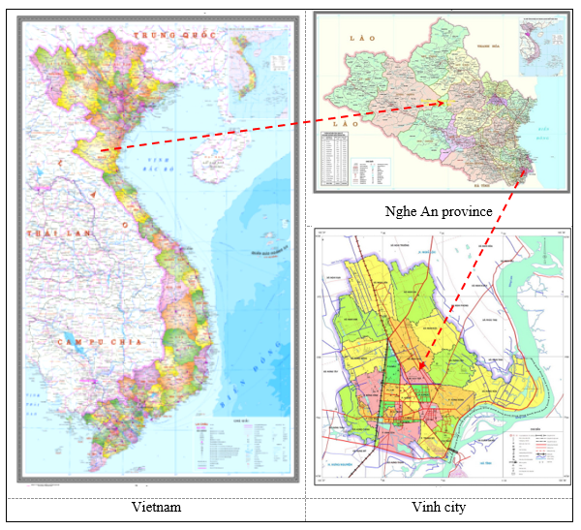
Fig. 1. Location sketch of Vinh city, Nghe An province

Material and methods
Data are collected randomly through 3 steps in March and April 2021 for households that had paid land financial obligations in Vinh city. The number of surveyed households in the first survey is determined by formula 1.

$n=\frac{t^{2}*p*q}{e^{2}}$ (Hair et al., 2009) (1)

Where: n – number of surveyed households; t - distribution value corresponding to the selected confidence; p - estimated percentage of the population; q =1 - p; e - allowable error (5÷15%).
Choosing the 95% confidence level, the corresponding distribution value is 1.96, the error allowed to choose 10%, and the largest possible assumption (pxq) is (0.5x0.5), so the number of survey households is 96. The study investigates 100 households. The content of the survey form includes basic information about the survey respondents and their opinions on the factors affecting the realization of financial revenues from the land (the respondents wrote the factors themselves). The results of the data processing of the first survey showed that 29 factors suggested influence and were included in the second survey.
The second survey was conducted with all those who responded to the first survey. The respondents selected factors that can affect the realization of financial revenues from land among the 29 proposed factors. The results of the data processing of the Step II survey show that there are 18 factors with an assessment rate of more than 50% of the total number of respondents and are selected to investigate and assess their impact on the implementation of the payments. The factors are divided according to the characteristics of the factors into 5 groups of factors (group of legal factors; a group of personnel factors; a group of land database factors; a group of factors for carrying out administrative procedures; a group of factors about people having financial obligations). These 5-factor groups are called 5 independent variables. Each independent variable has from 3 to 5 observed variables.
A dependent variable is a group of factors related to the realization of financial revenues from land with 3 observed variables including the correct collection of financial revenues from the land; fully collecting financial revenues from the land; a timely collection of financial revenues from land (Table 1). The observed variables of the dependent variable are the principles when performing financial obligations from the land according to the provisions of the land law of Vietnam.
Table 1. Independent variables and dependent variables
Variables | Variables
I. Independent variables | - Update level of data (DF2)
1. Group of legal factors (LF) | 4. Group of factors for carrying out administrative procedures (AF)
- Regulations on financial revenue rates (LF1) | - Process of submitting paperwork (AF1)
- Propagating and disseminating the law (LF2) | - Result return method (AF2)
- Handling complaints and appeals (LF5) | - Form of payment of financial obligations (AF3)
- Checking compliance with land finance law (LF3) | 5. Group of factors about people having financial obligations (FF)
- Reminding and sanctioning violations (LF4) | - People's knowledge of the law (FF1)
2. Group of personnel factors (PF) | - Financial capability (FF3)
- Personnel qualifications (PF2) | - Law observance (FF2)
- Communication skills (PF3) | II. Dependent variables
- Total personnel (PF1) | 1. Group of factors related to the implementation of land financial revenues (IF)
- Responsibility (PF4) | - Collecting timely payments (IF3)
3. Group of Land database factors (DF) | - Collecting all amounts (IF2)
- Degree of data connectivity (DF3) | - Collecting the correct amounts (IF1)
- Completeness of data (DF1)
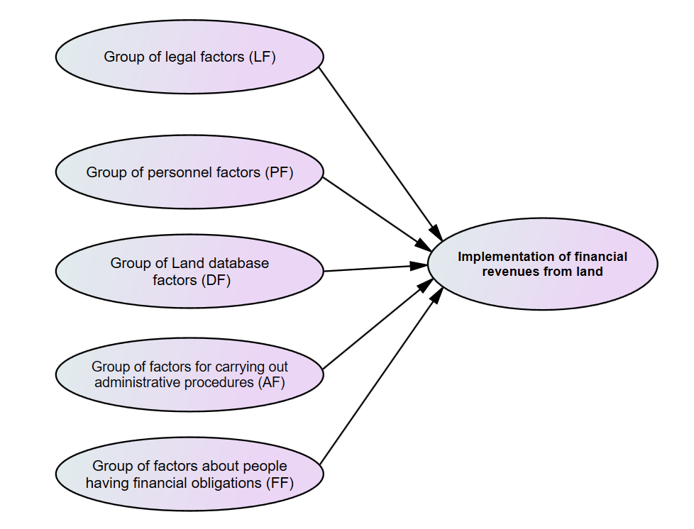
Figure 2. A research model for assessing the impact of factor groups

The content of the questionnaire in step III includes basic information about survey respondents, 18 presumptive impact factors with 5 levels of impact according to the Likert scale for each factor (Very impactful - 5 points; fairly impactful – 4 points; medium impactful – 3 points; little impactful – 2 points; very little impactful – 1 point) (Likert, 1932) for the evaluator to choose each impact level of each factor. In addition, in the survey form, there is also a section for people to write down their opinions on the advantages and disadvantages of making financial revenues from land, as well as suggestions for implementing better financial revenues from land in the future. The number of questionnaires in step III is the maximum number of sample sizes among the minimum samples required to perform the tests. The study has tested the reliability of the scale by Cronbach's Alpha coefficient; testing the degree of convergence and distinction of each variable in the factor group; testing the representativeness of observed variables for latent variables; Hypothesis testing and measuring the impact of each factor.
According to Hoang and Nguyen (2008); Slater and Narver (1995), testing the reliability of the scale is done by Cronbach's Alpha coefficient; testing the degree of convergence and discrimination of each variable in the factor group is done according to exploratory factor analysis (EFA) with minimum sample size. The number of samples was determined based on the requirements of exploratory factor analysis and multivariate regression with at least 5 observations for 1 measurement variable. Therefore, with 21 observed variables measuring the number of samples is 105. For multivariate regression analysis, the minimum sample size to achieve is 50 + 8 * p (p is the number of independent variables – p = 5) (Tabachnick and Fidell, 1996; Green, 1991). The minimum number of samples is to be 50 + 8 * 5 = 90. According to Green (1991), in case two, if the purpose wants to evaluate the factors of each independent variable set up as a t-test, regression coefficients…, the minimum sample size should be 104 + p (p is the number of independent variables – p =5). Therefore, with 5 independent variables, we have 104 + 5 = 109. To ensure both the minimum requirement of exploratory factor analysis and multivariate regression analysis, the survey evaluated 109 samples.
Test the representativeness of observed variables for latent variables by CFA. Myers, Ahn, and Jin (2011) suggest that the minimum sample size for the confirmatory factor analysis (CFA) is 200. In addition, this minimum sample size should be compared with the number of observed variables included in the CFA analysis. or the number of parameters of the CFA model. Specifically, this group of authors recommends a minimum sampling formula. The sample size should be ≥ 10*n; n is the number of observed variables included in the CFA analysis), so with n = 21, we have a minimum sample size of 10*21=210. Besides, the sample size must also be ≥ 5*q; q is a parameter of the model (independent and dependent variables), so with q = 6, there is a sample size of 5*6 = 30. To satisfy both conditions simultaneously, the minimum sample size is 210. According to Hair et al. (2009), hypothesis testing and measurement of the impact of each factor by structural Equation modeling (SEM) requires a minimum sample size of 100 when the number of factor groups ≤ 5 groups, each group with ≥ 3 observed variables with commonalities value when analyzing EFA is from 0.6 or more.
To simultaneously satisfy the above tests, investigation step III performed 210 votes.
The tests were performed using SPSS20 and AMOS24 software. Testing the reliability of the scale by Cronbach's Alpha coefficient was developed by Cronbach (1951) to measure the internal consistency of variables in the same group. The scale can be used when the Cronbach Alpha coefficient is greater than or equal to 0.6 and the variables have a total correlation coefficient greater than 0.3 (Hoang and Nguyen, 2008; Slater and Narver, 1995; Hair et al. al., 2009).
Exploratory factor analysis (EFA) is used to shorten many measurement variables into a set of variables (factors) to make them more meaningful but still contain most of the information of the original set of variables (Hair et al., 2009). EFA was assessed through KMO appropriate coefficient, Bartlett test, Eigenvalues ​​coefficient, total explanatory variance, and load factor. Variables are only accepted when KMO is in the range from 0.5 to 1.0 and its weight factors in other factors are less than 0.35 (Igbaria et al., 1995) or the distance between two load weights. According to Hair et al. (2009), with a sample size of about 200, weights of 0.55 should be chosen, so for sample size 210, in this study, a load weight must be greater than 0.55. Besides, the scale is only accepted when the total variance explained is greater than 50%; Barlett’s coefficient with Sig significance level less than 0.05 to ensure the factors are correlated with each other; Eigenvalue coefficients are valued from 1 to ensure the groups of factors are different.
- Confirmatory factor analysis (CFA) aims to test the representativeness of observed variables (measured variables) for latent variables (groups of influencing factors). According to Hu, L., T., and Bentler, P. M. (1999); Hair et al., (2009), Chi-square/df ≤ 2; GFI ≥ 0.9; CFI ≥ 0.9; TLI ≥ 0.9; RMSEA ≤ 0.06; PCLOSE ≥ 0.05. On reliability standardized loading estimates ≥ 0.5; composite reliability (CR) ≥ 0.7; about validity: convergence Average Variance Extracted (AVE) ≥ 0.5. Discriminant, maximum stop variance (MSV) < Average variance extracted (AVE); square root of AVE (SQRTAVE) > inter-construct correlations. Intopition, the CFA analysis s also tested through the combined confidence coefficient (ρ_{c}) and the mean extracted variance (ρ_{vc}).

$ρ_{c^{}}=\frac{{(\sum_{i=1}^{p}{λi})}^{2}}{{(\sum_{i=1}^{p}{λi})}^{2}+ {\sum_{i=1}^{p}{(1- λi})}^{2}}$ (Jöreskog, 1970)

$ρ_{{vc}^{}}=\frac{{\sum_{i=1}^{p}{λi}}^{2}}{{\sum_{i=1}^{p}{λi}}^{2}+ {\sum_{i=1}^{p}{(1- λi}}^{2})}$ (Fornell and Larcker, 1981)

Where: λi – the normalized weight of observed variable i; $1- {λi}^{2}$ is the variance of the measurement error of the i-th observation variable; p is the number of observed variables of the scale. The value of ρ_{c,} ρ_{vc} must be equal to or greater than 0.5.
- Hypothesis testing and measurement of the impact of each factor on the realization of financial revenues from land by the Structural Equation Modeling (SEM) is done through the following criteria: CMIN/df ≤ 2; P ≤ 0.05; GFI ≥ 0.9; CFI ≥ 0.9; TLI ≥ 0.9; RMSEA ≤ 0.06; PCCLOSE ≥ 0.005 (Chin et al, 1996).

Results
In the 2016-2020 period, the total financial revenue from land in Vinh city is 3125967 million VND, accounting for 24.64% of the city's total budget revenues. Meanwhile, the total revenue of Vietnam is 10% and the average total revenue of the provinces is 20% (Le Thi Loan, 2018; Nguyen Ho Phi Ha and Nguyen Thi Ha, 2019). Among the revenues, the revenue from land use fees is the largest, 2,596,237 million VND, accounting for 20.46% of the city's total budget revenue, while in developed countries, the total land tax accounts for the highest proportion. up to 90% of the total local budget revenue (Dang Hung Vo, 2019). In particular, land use fees are unstable and temporary when land users are allocated land, allowed to change land use purposes, or have land-use rights recognized; while the land tax is stable and always goes hand in hand with the land use process.
Table 2. Results of revenue collection from the land of Vinh city
Year | Total budget revenue  (Million VND) | Total revenue from land  (Million VND) | Percentage (%) | Land use fees  (Million VND) | Land rent  (Million VND) | Land use tax  Million VND) | Tax on income from land sales  (Million VND) | Land fees  (Million VND)
2016 | 2.350.562 | 90.065 | 3,83 | 7.141 | 101 | 16.396 | 36.544 | 29.883
2017 | 2.487.497 | 103.539 | 4,16 | 17.496 | 99 | 17.853 | 39.082 | 29.009
2018 | 2.484.214 | 954.910 | 38,43 | 849.419 | 60 | 18.866 | 51.267 | 35.298
2019 | 2.537.034 | 900.599 | 35,50 | 775.042 | 44 | 19.550 | 65.996 | 39.967
2020 | 2.829.140 | 1.076.854 | 38,06 | 947.139 | 93 | 19.958 | 67.121 | 42.543
Sum | 12.688.447 | 3.125.967 | 24,64 | 2.596.237 | 397 | 92.623 | 260.010 | 176.700
22,947 VND | ͌ |  | 1USD
(Source: People's Committee of Vinh City, 2021a)

Figure 3. Number of financial obligation records in Vinh city
The results of assessing the reliability of the scale through Cronbach's Alpha coefficients for 5 groups of factors show that Cronbach's Alpha coefficients range from 0.624 to 0.832, and the correlation coefficient of the total variable is greater than 0.30 (Table 3). Thus, the scale used to evaluate the factors affecting the implementation of financial revenues from land is reliable and suitable for subsequent analysis.

Table 3. Results of reliability analysis of the scale
Variables | Correlated total variables
I. Independent variables
1. Group of legal factors (LF - Alpha = 0.874)
Regulations on financial revenue rates (LF1) | 0.832
Propagating and disseminating the law (LF2) | 0.794
Handling complaints and appeals (LF5) | 0.775
Checking compliance with land finance law (LF3) | 0.628
Reminding and sanctioning violations (LF4) | 0.701
2. Group of personnel factors (PF - Alpha = 0.847)
Personnel qualifications (PF2) | 0.816
Communication skills (PF3) | 0.794
Total personnel (PF1) | 0.733
Responsibility (PF4) | 0.729
3. Group of Land database factors (DF- Alpha = 0.843)
Degree of data connectivity (DF3) | 0.775
Completeness of data (DF1) | 0.763
Update level of data (DF2) | 0.691
4. Group of factors for carrying out administrative procedures (AF - Alpha = 0.792)
Process of submitting paperwork (AF1) | 0.827
Result return method (AF2) | 0.811
Form of payment of financial obligations (AF3) | 0.684
5. Group of factors about people having financial obligations (FF- Alpha = 0.842)
People's knowledge of the law (FF1) | 0.816
Financial capability (FF3) | 0.782
Law observance (FF2) | 0.756
II. Dependent variable
1. Implementation of financial revenues from land (IF - Alpha = 0.795)
Collecting timely payments (IF3) | 0.890
Collecting all amounts (IF2) | 0.742
Collecting the correct amounts (IF1) | 0.721

Exploratory Factor Analysis (EFA) was performed to test the discriminant validity, convergence, and unidirectionality of the variable. Exploratory factor analysis with principal axis factoring method according to Promax perpendicular rotation. The analysis results in Table 4 show that, 0.5 < KMO = 0.962 < 1.0 and the value of Bartlett's test with Sig. = 0.000 < 0.005. This shows that the observed variables are correlated with each other.

Table 4. KMO and Bartlett’s Test results
Kaiser-Meyer-Olkin Measure of Sampling Adequacy |  | 0.962
Bartlett's Test of Sphericity | Approx. Chi-Square | 1915
 | df | 179
 | Sig. | 0.000

To analyze CFA, the study included the data of Table 5 (Weight of pattern matrix) when the CFA analysis results in Figure 4 show that the chi-square/df test value = 1.916 < 2; GFI = 0.945; TLI = 0.981; CFI = 0.973 > 0.9; RMSEA = 0.057 < 0.06; PCLOSE = 1,084 > 0.05, so the observed variables ensure convergence validity, discriminant validity and reliability. Also, ρ_{c,} ρ_{vc} > 0.5; Standardized Loading Estimates = 1.67 > 0.5; Composite Reliability (CR) = 2.32 > 0.7; Average Variance Extracted (AVE) = 1.68 > 0.5; Maximum Shared Variance (MSV) = 1.04 < Average Variance Extracted (AVE) = 1.68; Square Root of AVE (SQRTAVE) = 1.30 > Inter-Construct Correlations = 1.15 (Table 6), so the test condition is satisfied.
Table 5. Weight of pattern matrix
Measurement variables | Group of influencing factors
 | 1 | 2 | 3 | 4 | 5 | 6
LF1 | 0.876
LF4 | 0.841
LF2 | 0.793
LF3 | 0.764
PF3 |  | 0.847
PF2 |  | 0.799
PF1 |  | 0.753
PF4 |  | 0.721
DF1 |  |  | 0.857
DF3 |  |  | 0.826
DF2 |  |  | 0.748
AF3 |  |  |  | 0.845
AF2 |  |  |  | 0.811
AF1 |  |  |  | 0.792
FF1 |  |  |  |  | 0.764
FF2 |  |  |  |  | 0.710
FF3 |  |  |  |  | 0.694
IF3 |  |  |  |  |  | 0.846
IF1 |  |  |  |  |  | 0.822
IF2 |  |  |  |  |  | 0.794

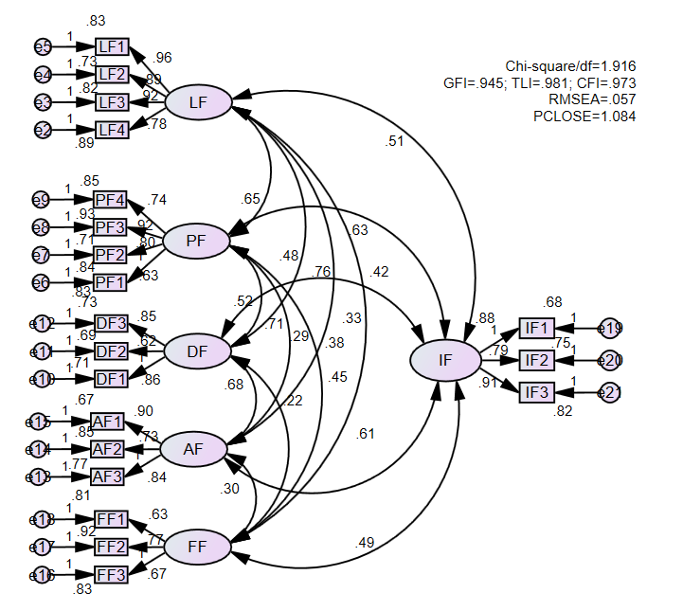
Figure 4. Confirmatory factor analysis model (CFA)

Table 6. CFA analysis results
Independent variables | Observed variables | Cronbach’s Alpha | ρ_{c} | ρ_{vc}
LF | 5 | 0.851 | 0.94 | 65.24
PF | 4 | 0.896 | 0.84 | 68.47
DF | 3 | 0.898 | 0.89 | 70.63
AF | 3 | 0.901 | 0.87 | 69.61
FF | 3 | 0.867 | 0.98 | 75.28
IF | 3 | 0.882 | 0.81 | 73.22
Standardized Loading Estimates = 1.67 > 0.5
Composite Reliability (CR) = 2.32 > 0.7
Average Variance Extracted (AVE) = 1.68 > 0.5
Maximum Shared Variance (MSV) = 1.04 < Average Variance Extracted (AVE) = 1.68
Square Root of AVE (SQRTAVE) = 1.30 > Inter-Construct Correlations = 1.15.
According to the data shown in Figure 5, the chi-square/df test value = 1.754 < 2; GFI = 0.973; TLI = 0.961; CFI = 0.984 > 0.9; RMSEA = 0.059 < 0.06; PCLOSE = 1.091 > 0.05, so the observed variables ensure convergence (convergent validity), discriminant validity and reliability. In addition, ρ_{c,} ρ_{vc} > 0.5 (Table 7) so the test conditions are satisfied.

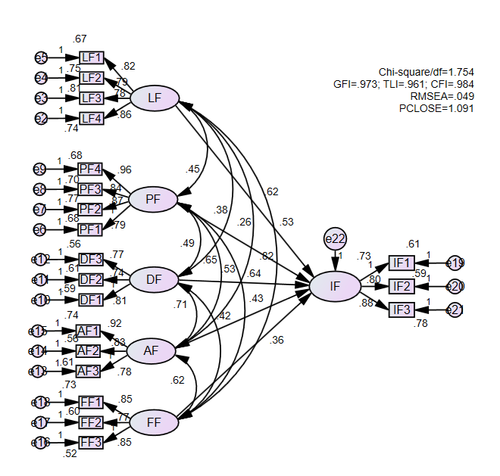
Figure 5. The SEM model evaluating the impact of factor groups

Table 7. SEM scale test results
Independent variable | Observable variable | Cronbach’s Alpha | ρ_{c} | ρ_{vc}
LF | 5 | 0.934 | 0.82 | 74.62
PF | 4 | 0.841 | 0.95 | 79.04
DF | 3 | 0.872 | 0.86 | 68.32
AF | 3 | 0.858 | 0.80 | 68.45
FF | 3 | 0.903 | 0.87 | 78.36
IF | 3 | 0.877 | 0.94 | 69.75

According to Table 8, the remaining variables all have sig (P) < 0.05, so all variables have an impact on the realization of financial revenues from land. Standardized regression weights have different values, which proves that the influencing factors have different degrees of impact on the realization of financial revenues from land.

Table 8. Research hypothesis test results (SEM)
Relationship between variables |  | Unstandardized regression weights | S.E. | C.R. | P | Standardized regression weights | Order of influence
Implementation of financial revenues from land | <---- Group of legal factors | 0.454 | 0.045 | 2.364 | 0.031 | 0.525 | 3
Implementation of financial revenues from land | <----Group of personnel factors | 0.714 | 0.043 | 3.145 | 0.007 | 0.821 | 1
Implementation of financial revenues from land | <----Group of Land database factors | 0.551 | 0.547 | 4.102 | 0.022 | 0.636 | 2
Implementation of financial revenues from land | <----Group of factors for carrying out administrative procedures | 0.417 | 0.646 | 2.951 | 0.005 | 0.434 | 4
Implementation of financial revenues from land | <----Group of factors about people having financial obligations | 0.349 | 0.041 | 4.073 | 0.006 | 0.363 | 5

The study performed a re-test of reliability by bootstrapping technique with a repeated sample of 2000 with an initial sample size of 210. The estimated results in Table 9 show that the original weights are significant with the average weights because all weights are within the 95% confidence interval. Thus, all estimates in the model are conclusive.

Table 9. Bootstrapping test results
Relationship between variables |  | Original weights | Average weights | Standard errors
Implementation of financial revenues from land | <---- Group of legal factors | 0.525 | 0.527 | 0.064
Implementation of financial revenues from land | <----Group of personnel factors | 0.821 | 0.835 | 0.071
Implementation of financial revenues from land | <----Group of Land database factors | 0.636 | 0.622 | 0.087
Implementation of financial revenues from land | <----Group of factors for carrying out administrative procedures | 0.434 | 0.439 | 0.079
Implementation of financial revenues from land | <----Group of factors about people having financial obligations | 0.363 | 0.356 | 0.068

Discussion
The test results of EFA, CFA, and SEM show that all 18 observed variables belonging to 5 hypothetical latent variables have satisfied the test criteria and have an impact on the realization of financial revenues from land. Standardized regression weights of the factors ranged from 0.363 to 0.821 (Table 9). This proves that different factors affect the realization of financial revenues from land. The percentage impact of the factors ranges from 13.06% to 29.54% (Figure 6).
The human factor has the strongest impact on the realization of financial revenues from land with an impact rate of 29.54%. The performance of human resources is reflected in the quality of human resources, the number of human resources, the ability to communicate, and the sense of responsibility when performing official duties. The quality of human resources is reflected in the professional qualifications and training related to land finance. To make good financial revenue from land, it is first necessary to pay attention to solving the human factor. Specifically, it is necessary to ensure that enough human resources with professional qualifications are trained by land finance to ensure that the application is handled following regulations, on time, and without errors. In addition, human resources must also improve their sense of responsibility in public affairs and have good communication skills with people performing financial affairs. Human resources must provide specific and detailed instructions for people to carry out administrative procedures and must not cause trouble or harassment to people.
The group of land database factors ranked second with an impact rate of 22.89%. Therefore, to determine the financial revenues from land accurately, quickly, to the right subjects and send the results to the financial obligors on time, the cadastral database must be completed and updated. It must also update information on land users and land plots. In addition, cadastral information must also be communicated between agencies, especially between the land management agency and the tax agency (the agency that determines financial obligations). Because the connection to the land database between agencies is still limited, determining the number of land plots of land users faces many difficulties, takes time, and is not accurate for all cases.

Figure 6 Percentage impact of factors on the realization of land financial revenues

The group of legal factors (LF) has third place with an impact rate of 18.89%. Specifically, income tax from land use right transfer (2% of land use right transfer value) is considered to be high compared to the ability of the person to perform financial obligations. In addition, these people also have to pay a registration fee at the rate of 0.5% of the land use right value for registration of ownership. In particular, land use fee accounts for the largest proportion but it is unstable, changing with land demand while land use tax is stable but accounts for a small and much smaller proportion than in developed countries (Dang Hung Vo, 2019). Therefore, to ensure a stable source of revenue for the state budget from land, it is necessary to reduce the income tax rate from the transfer of land use rights to less than 2% and remove the registration fee as part of the sales tax. At the same time, increase the progressive land use tax rate according to international practices to limit land speculation and use land more efficiently. At the same time, for people to understand and comply with the law related to land finance, it is necessary to strengthen the propaganda and dissemination of the law; inspect, examine, remind and strictly handle violations of the law. In addition, it is also necessary to handle complaints and denunciations about land finance well.
The group of factors that carry out administrative procedures has a fourth place with an impact rate of 15.62%. To facilitate people when performing financial obligations, it is necessary to complete the procedures for submitting and receiving financial obligation documents, as well as submitting financial obligations. Specifically, it is necessary to apply more forms of online application and receive results besides direct application so that people can submit documents anywhere and at any time to reduce the cost of implementation and administrative procedures. This also reduces work pressure for officials to carry out administrative procedures and reduces the possibility of negative incidents and bribery. In addition, it is necessary to apply information technology so that people can pay their financial obligations through the internet in addition to the current form of direct payment.
The group of people who perform financial obligations has the smallest impact on the realization of financial revenues from land with an impact rate of 13.06%. The research shows that the majority of people understand and obey the law on land finance well, but some people do not fully understand the legal provisions, so they do not comply with the provisions of the law. In addition, some people know the law but have not strictly complied with regulations such as the incomplete declaration of the number of land plots under their ownership, failure to declare changes in personal information, usage information, etc. land. To better realize financial revenues from land, it is necessary to continue to disseminate the law to those who have not yet understood the provisions of the law on land finance, and guide them to properly comply with the regulations. Those who understand the law but do not comply should be reminded that when they intentionally fail to do so, they need to apply administrative penalties following the provisions of the law.

Conclusion
The total budget revenue from land in the period 2016-2020 in Vinh city was 3125967 million VND, equal to 24.64% of the city's total budget revenue. There are 5 groups of factors and 18 factors affecting the realization of financial revenues from land. The level of impact of groups of factors is different. The group of human factors has the most impact; The group of factors people with financial obligations interact with the least. To make financial revenues from land properly and sufficiently according to regulations and on time, it is necessary to increase human resources and to complete the land database; to adjust levels of land financial revenues; to complete administrative procedures, and raise the sense of law observance of people with land financial obligations. The study only evaluates the factors affecting the realization of financial revenues from the land for individuals and households. Therefore, it is necessary to further study the factors affecting the implementation of financial revenues from the land for organizations.

References

Artioli, F., 2021. Sale of public land as a financing instrument. The unspoken political choices and distributional effects of land-based solutions. Land Use Policy 104, 105199. https://doi.org/10.1016/j.landusepol.2020.105199.
Chen, J., Wu, F., 2020. Housing and land financialization under the state ownership of land in China. Land Use Policy 104844. https://doi.org/10.1016/j.landusepol.2020.104844.
Chin L, Liégeois N, DePinho RA, Schreiber-Agus N (1996). Functional interactions among members of the Myc superfamily and potential relevance to cutaneous growth and development. J Investig Dermatol Symp Proc 1(2):128-35.
Chu Thi Thuy Chung, 2010. Improving land collection policy in Vietnam: Doctoral thesis, Academy of Finance, Hanoi.
Cronbach, L.J, 1951. Coefficient alpha and the internal structure of tests. Psychometrika 16, 297–334. https://doi.org/10.1007/BF02310555.
Dang Hung Vo, 2019. Land – a financial resource for development. National Scientific Conference "Recommendations for revision of economic issues in the 2013 Land Law", 17-30.
Fan, X., Qiu, S., Sun, Y., 2020. Land finance dependence and urban land marketization in China: The perspective of strategic choice of local governments on land transfer. Land Use Policy 99, 105023. https://doi.org/10.1016/j.landusepol.2020.105023.
Feng, W., Liu, Y., Qu, L., 2019. Effect of land-centered urbanization on rural development: A regional analysis in China. Land Use Policy 87, 104072. https://doi.org/10.1016/j.landusepol.2019.104072.
Fornell, C., Larcker, D. F., 1981. Evaluating structural equation models with unobservable variables and measurement error. Journal of Marketing Research, 18(1), 39–50. https://doi.org/10.2307/3151312
Green, S. B., 1991. How many subjects does it take to do a regression analysis? Multivariate Behavioral Research, 26, 499-510.
Gao, H., 2019. Public land leasing, public productive spending, and economic growth in Chinese cities. Land Use Policy 88, 104076. https://doi.org/10.1016/j.landusepol.2019.104076.
Guo, S., Liu, L., Zhao, Y., 2015. The business cycle implications of land financing in China. Econ. Model. 46, 225–237. https://doi.org/10.1016/j.econmod.2014.12.033.
Guo, S., Shi, Y., 2018. Infrastructure investment in China: A model of local government choice under land financing. J. Asian Econ. 56, 24–35. https://doi.org/10.1016/j.asieco.2018.04.001.
Hair, J. F., William C. Black, Barry J. Babin, Rolph E. Anderson (2009). Multivariate Data Analysis (7th ed.). New York: Macmillan Publishing Company.
Ha Thuc Vien, Phan Thi Thanh Truong, 2016. Evaluation of the performance of financial obligations of land users in Phan Thiet city, Binh Thuan province. Scientific Journal of Can Tho University, No. 42, 58-65.
Hoang Trong Chu, Nguyen Mong Ngoc, 2008. Analyzing research data with SPSS. Hong Duc Publishing House.
Hoang Van Cuong, 2019. Some recommendations to amend economic issues in the 2013 Land Law, National Scientific Conference “Recommendations for amending economic issues in the 2013 Land Law”, 3-16.
Hu, F.Z.Y., Qian, J., 2017. Land-based finance, fiscal autonomy, and land supply for affordable housing in urban China: A prefecture-level analysis. Land Use Policy 69, 454–460. https://doi.org/10.1016/j.landusepol.2017.09.050.
Hu, L., T., Bentler, P., M., 1999. Cutoff criteria for fit indexes in covariance structure analysis: Conventional criteria versus new alternatives. Structural Equation Modeling, 6(1), 1–55. https://doi.org/10.1080/10705519909540118.
Huang, D., Chan, R.C.K., 2018. On ‘Land Finance’ in urban China: Theory and practice. Habitat Int. 75, 96–104. https://doi.org/10.1016/j.habitatint.2018.03.002.
Igbaria, M., Iivari, J., and Maragahh, H. 1995. Why do individuals use computer technology? A Finnish case study. Information & Management, 29, 227-238.
Kitay, M.G., 1986. Land financing by international donor agencies: Problems and prospects. Habitat Int., Special Issue Report of the Ninth International Congress of Europe 10, 11–19. https://doi.org/10.1016/0197-3975(86)90006-8.
Jöreskog, K. G., 1970. A general method for analysis of covariance structures. Biometrika, 57, 239–251.
Le Thi Loan, 2018. Research and development of property tax policy in Vietnam, a ministerial-level scientific research project in 2017 code 2017-02, Ministry of Finance.
Likert R.A., 1932. A technique for measurements of attitudes, Archives of Psychology. 140(55), 1-53.
Liu, Y., Fan, P., Yue, W., Song, Y., 2018. Impacts of land finance on urban sprawl in China: The case of Chongqing. Land Use Policy 72, 420–432. https://doi.org/10.1016/j.landusepol.2018.01.004.
Lu, J., Li, B., Li, H., 2019. The influence of land finance and public service supply on peri-urbanization: Evidence from the counties in China. Habitat Int. 92, 102039. https://doi.org/10.1016/j.habitatint.2019.102039.
Medda, F., 2012. Land value capture finance for transport accessibility: a review. J. Transp. Geogr., Special Section on Accessibility and Socio-Economic Activities: Methodological and Empirical Aspects 25, 154–161. https://doi.org/10.1016/j.jtrangeo.2012.07.013.
Mittal, J., 2014. Self-financing land and urban development via land readjustment and value capture. Habitat Int. 44, 314–323. https://doi.org/10.1016/j.habitatint.2014.07.006
Mo, J., 2018. Land financing and economic growth: Evidence from Chinese counties. China Econ. Rev. 50, 218–239. https://doi.org/10.1016/j.chieco.2018.04.011.
National Assembly (2013). Land Law No. 45/2013/QH13 dated November 29, 2013.
Nicholas D. Myers, Soyeon Ahn, and Ying Jin (2011). Sample Size and Power Estimates for a Confirmatory Factor Analytic Model in Exercise and Sport. Research Quarterly for Exercise and Sport. Vol. 82, No. 3, pp. 412–423.
Nguyen Ho Phi Ha, Nguyen Thi Ha, 2019. The issue of exploiting financial resources from land in Vietnam today, a ministerial-level scientific research project in 2018 code 2018-02, Ministry of Finance.
Nguyen Thanh Hung, 2016. State management of land revenues in Vietnam, Doctoral Thesis, University of Commerce, Hanoi.
Ouma, S., 2014. Situating global finance in the Land Rush Debate: A critical review. Geoforum 57, 162–166. https://doi.org/10.1016/j.geoforum.2014.09.006.
Pan, J.-N., Huang, J.-T., Chiang, T.-F., 2015. An empirical study of the local government deficit, land finance, and real estate markets in China. China Econ. Rev. 32, 57–67. https://doi.org/10.1016/j.chieco.2014.11.003.
Qin, M., Lin, W., Li, J., Yu, Z., Wachenheim, C., 2020. Impact of land registration and certification on land rental by Chinese farmers. Land Use Policy 99, 104875. https://doi.org/10.1016/j.landusepol.2020.104875.
Quatrini, S., Crossman, N.D., 2018. Must finance to halt desertification also benefits multiple ecosystem services: A key to unlock investments in Land Degradation Neutrality? Ecosyst. Serv., Global Flows of Ecosystem Services 31, 265–277. https://doi.org/10.1016/j.ecoser.2018.04.003.
Qun, W., Yongle, L., Siqi, Y., 2015. The incentives of China’s urban land finance. Land Use Policy 42, 432–442. https://doi.org/10.1016/j.landusepol.2014.08.015.
Shu, C., Xie, H., Jiang, J., Chen, Q., 2018. Is Urban Land Development Driven by Economic Development or Fiscal Revenue Stimuli in China? Land Use Policy 77, 107–115. https://doi.org/10.1016/j.landusepol.2018.05.031.
Slater, S.F. and Narver, J.C., 1995. Market Orientation and the Learning Organization. Journal of Marketing, 59, 63-74. https://doi.org/10.2307/1252120.
Tabachnick, B. G., Fidell, L. S. (1996). Using Multivariate Statistics (3rd ed.). New York: Harper Collins.
Tang, P., Shi, X., Gao, J., Feng, S., Qu, F., 2019. Demystifying the key for intoxicating land finance in China: An empirical study through the lens of government expenditure. Land Use Policy 85, 302–309. https://doi.org/10.1016/j.landusepol.2019.04.012.
Tongwei, Q., Luo, B., Boris Choy, S.T., Li, Y., He, Q., 2020. Do land renting-in and its marketization increase labor input in agriculture? Evidence from rural China. Land Use Policy 99, 104820. https://doi.org/10.1016/j.landusepol.2020.104820.
Wang, J., Samsura, D.A.A., van der Krabben, E., 2019. Institutional barriers to financing transit-oriented development in China: Analyzing informal land value capture strategies. Transp. Policy 82, 1–10. https://doi.org/10.1016/j.tranpol.2019.07.010.
Wang, L.-O., Wu, H., Hao, Y., 2020. How does China’s land finance affect its carbon emissions? Struct. Change Econ. Dyn. 54, 267–281. https://doi.org/10.1016/j.strueco.2020.05.006.
Wu, F., 2019. Land financialization and the financing of urban development in China. Land Use Policy 104412. https://doi.org/10.1016/j.landusepol.2019.104412
Xu, N., 2019. What gave rise to China’s land finance? Land Use Policy 87, 104015. https://doi.org/10.1016/j.landusepol.2019.05.034.
Yongle, L., Qun, W., 2007. Quantitative Change of Cultivated Land Based on the Current System of Finance and Taxation. China Popul. Resour. Environ. 17, 119–123. https://doi.org/10.1016/S1872-583X(08)60012-1.
Yue, S., Lu, Y., 2019. How Does Land Finance Affect Economic Growth in China?, in He, D., Wang, C. (Eds.), A New Era: China’s Economy Globalizes. Springer, Singapore, pp. 155–173. https://doi.org/10.1007/978-981-10-8357-0_7.
Yamane, T., 1967. Statistics, An Introductory Analysis, 2nd Ed., New York: Harper and Row.
Vinh City People's Committee, 2021a. Report on the status of land management in Vinh city in 2020.
Vinh City People's Committee, 2021b. Report on the socio-economic situation in 2020 and plan for 2021.
Zhang, B., Li, J., Tian, W., Chen, H., Kong, X., Chen, W., Zhao, M., Xia, X., 2020. Spatio-temporal variances and risk evaluation of land finance in China at the provincial level from 1998 to 2017. Land Use Policy 99, 104804. https://doi.org/10.1016/j.landusepol.2020.104804.
Zhang, W., Xu, H., 2017. Effects of land urbanization and land finance on carbon emissions: A panel data analysis for Chinese provinces. Land Use Policy 63, 493–500. https://doi.org/10.1016/j.landusepol.2017.02.006
Zheng, H., Wang, X., Cao, S., 2014. The land finance model jeopardizes China’s sustainable development. Habitat Int. 44, 130–136. https://doi.org/10.1016/j.habitatint.2014.05.008.
Zhong, T., Zhang, X., Huang, X., Liu, F., 2019. Blessing or curse? Impact of land finance on rural public infrastructure development. Land Use Policy 85, 130–141. https://doi.org/10.1016/j.landusepol.2019.03.036.

