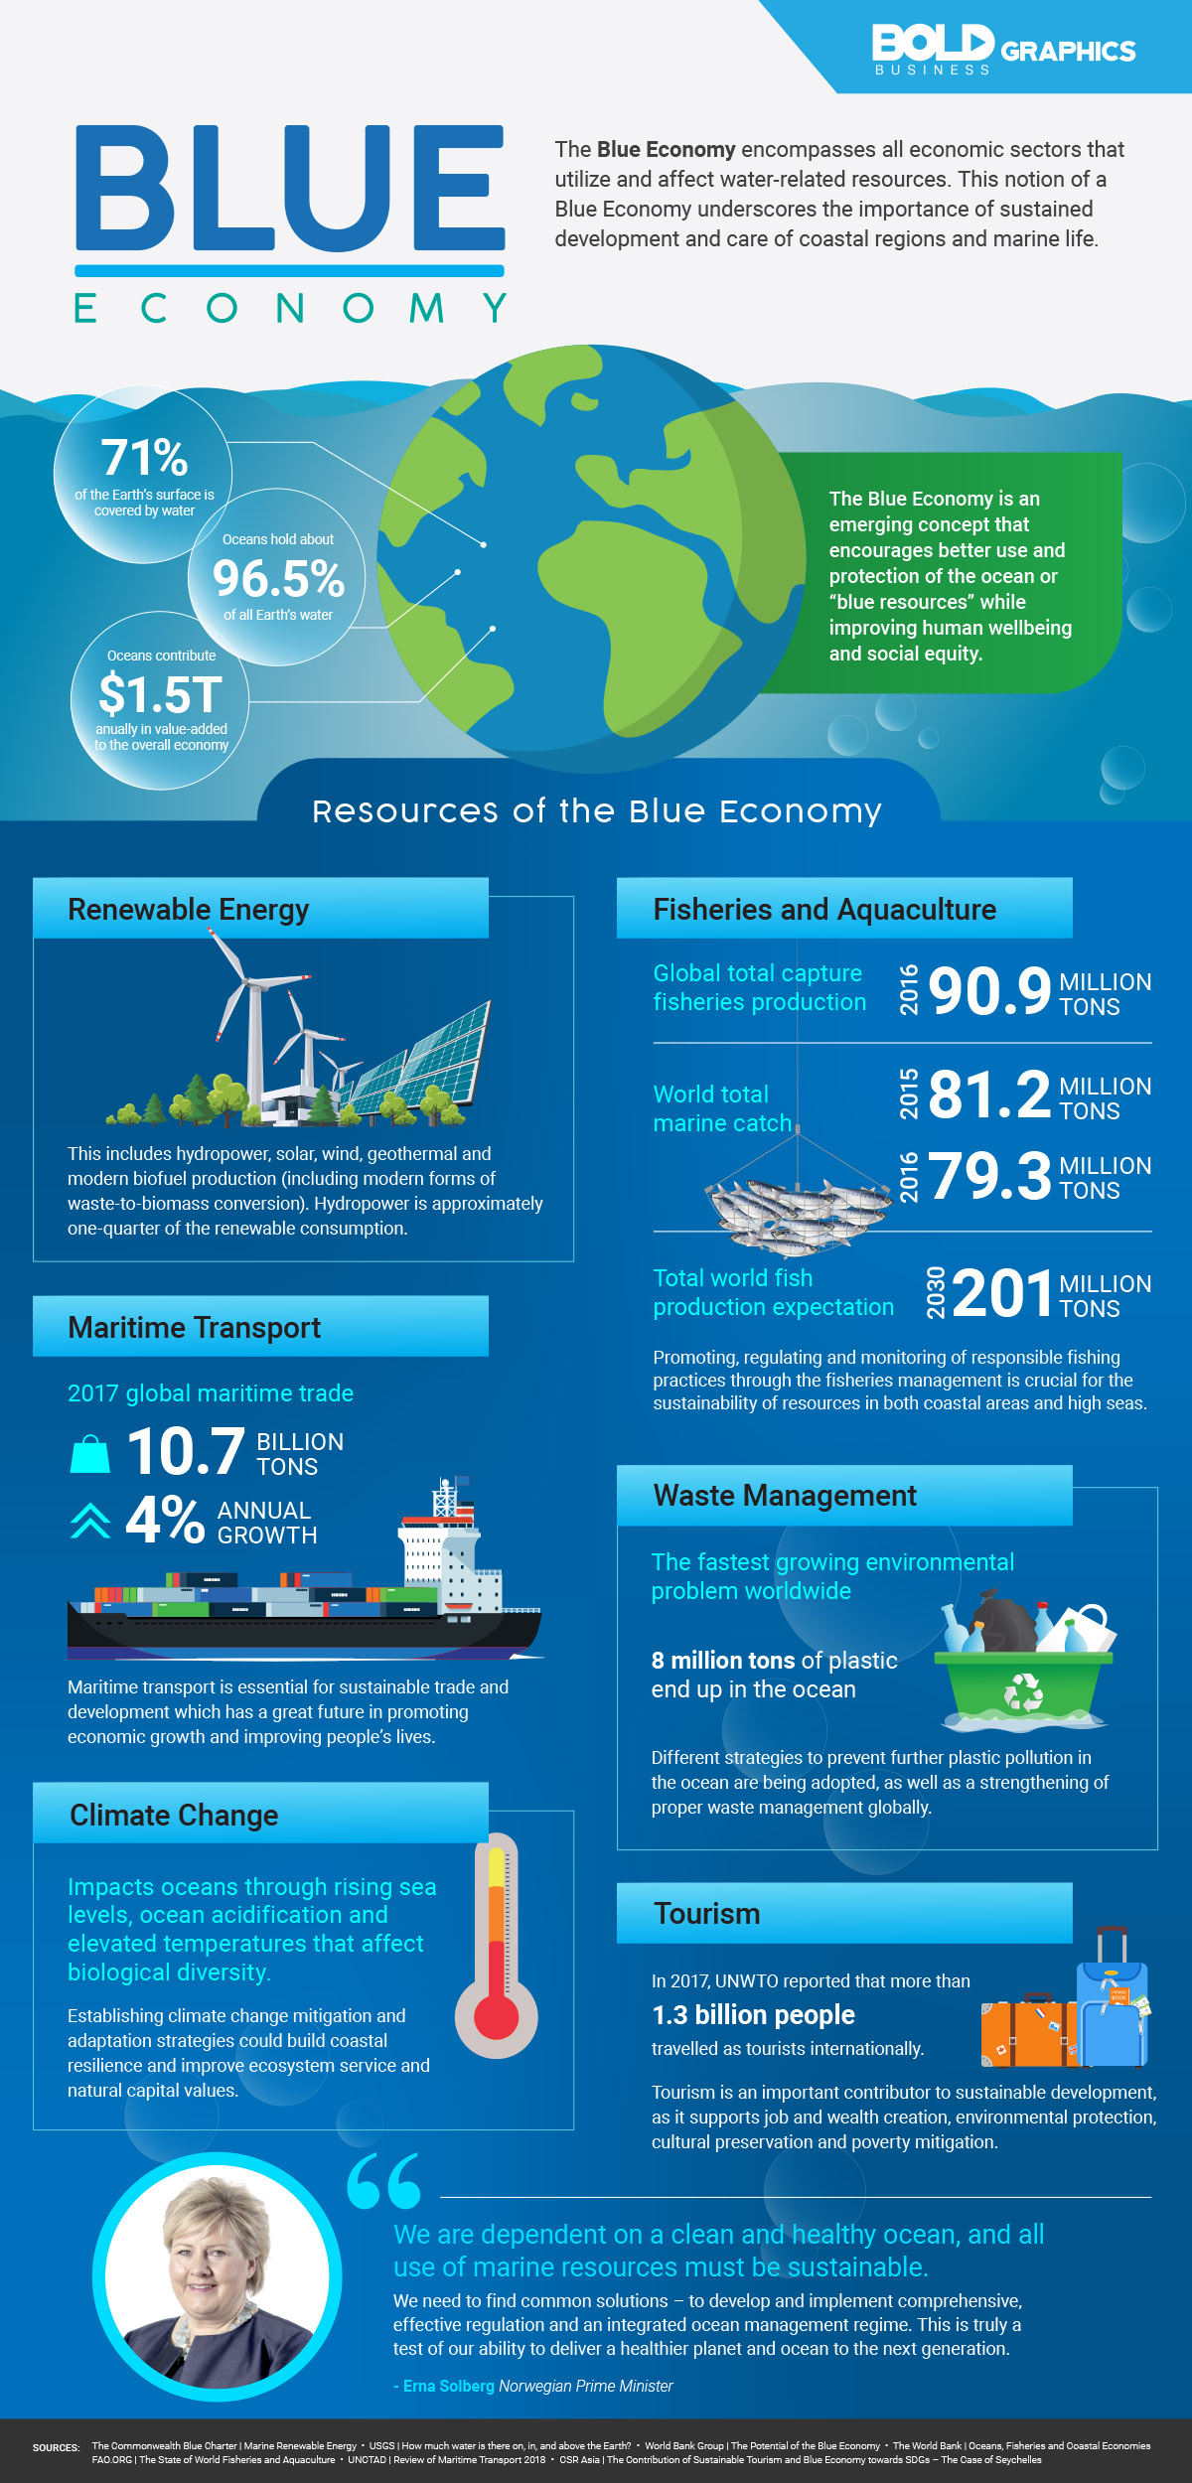
Presentation presented by Dr. Kawa Wali and Lecturer Banr Karim Darwish
23-01-2024

