AGA company manufactures and sells a product for $20 per Kg. The data for the year 2016 is given below:
- Sales in kgs: 75,000 kgs
- Finished goods inventory at the beginning of the period: 12,000 kgs
- Finished goods inventory at the closing of the period: 17,000 kgs
Manufacturing costs:
- Variable cost: $8 per Kg
- Fixed manufacturing overhead cost: $320,000 per year
Marketing and administrative expenses:
- Variable expenses: $2 per Kg of sale
- Fixed expenses: $300,000 per year
Required:
- Income statement using absorption and variable costing methods.
- Explanation of the cause of difference in net operating income under two concepts.

Solution

(1) Income statements:
(a) Absorption costing income statement:
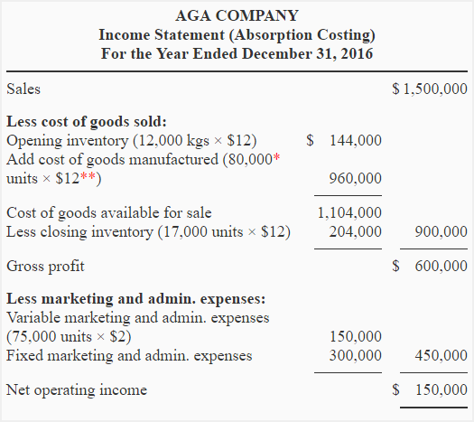
*Production for the year 2016:
Units manufactured during 2016 = Units sold + Units in closing inventory – Units in opening inventory
= 75,000 kgs + 17,000 kgs – 12,000 kgs
= 80,000 kgs
**Manufacturing expenses per unit:
Variable expenses + Fixed expenses
= $8 + ($320,000/80,000 kgs)
= $8 + $4
= $12
(b) Variable costing income statement:
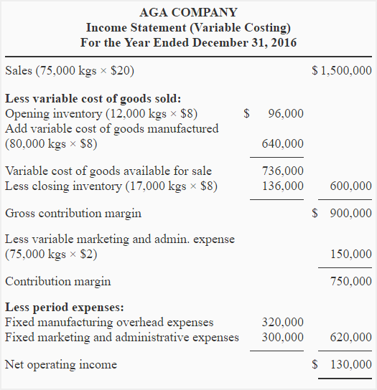

(2) Explanation of the difference in net operating income:
The net operating income under absorption costing is $20,000 more than the net operating income under variable costing. When production is more than sales (as in this exercise), the fixed manufacturing overhead is deferred in inventory that causes a higher net operating income under absorption costing than under variable costing. The reconciliation of net operating income is given below:
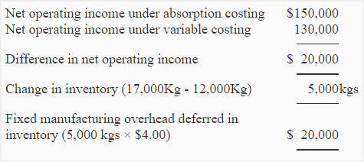
Or
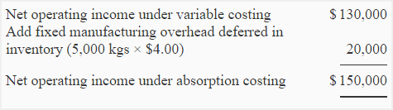

The following is the absorption costing income statement of Alpha Manufacturing Company for the year ended December 31, 2016:
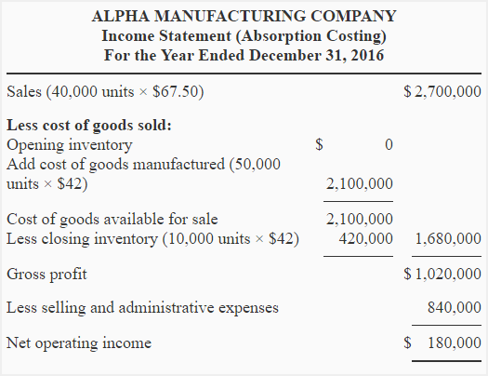
Fixed selling and administrative expenses are $600,000. Variable selling and administrative expenses are $6 per unit sold. The unit product cost under absorption costing is computed as follows:
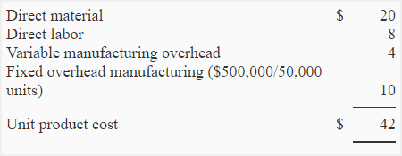
Required:
- Prepare an income statement of Alpha Manufacturing Company using variable costing system.
- Reconcile any difference in net operating income figure under variable costing system and under absorption costing system.

Solution

(1). Variable costing income statement:
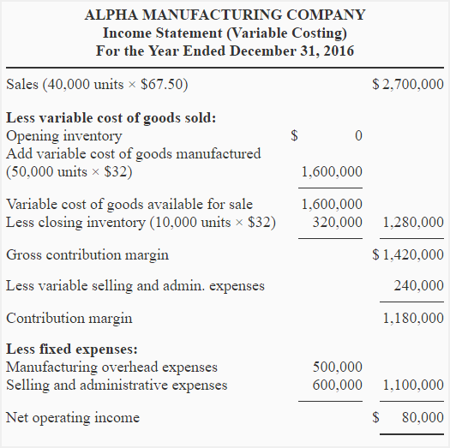

(2) Reconciliation of net operating income:
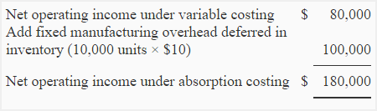

Super Bike Manufacturing Company presents the following data for year 2022:
- Opening inventory: 0 Units
- Sales: 8,000 Units
- Production: 10,000 Units
- Closing inventory: 2,000 Units
- Direct materials: $240
- Direct labor: $280
- Variable manufacturing overhead expenses: $100
- Variable selling and administrative expenses: $40
- Fixed manufacturing overhead expenses: $1200,000
- Fixed selling and administrative expenses: $800,000
Required: Using the data given above, compute the unit product cost of one bike under:
- absorption costing system.
- variable costing system.

Solution:

Computation of unit product cost:
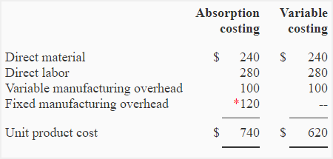
*1,200,000 / 10,000 = $120
The cost to manufacture one bike is $740 under absorption costing system and $620 under variable costing system.
Notice that the fixed manufacturing overhead cost has not been included while computing the cost of one bike under variable costing system.
Note for students: Selling and administrative expenses (both variable and fixed) are not relevant for the computation of unit product cost.

