**Relationship Between ARID3A and ERIC3A in Patients with Cancer Cell**

**ABSTRACT**

Thousands of distinct long non-coding RNAs are encoded in the human genome, and it is becoming clear that these transcripts play a crucial role in controlling gene expression and cell destiny. However, the transcriptional control of their expression is not well understood. The long noncoding RNA E2f1-regulated inhibitor of cell death (ERICD) is essential for inducing both cell death and proliferation and is a critical downstream target of the tumor suppressor. However, E2F-dependent transcription is triggered by ARID3A's binding to the E2F transcription factor. Osteosarcoma cells(U2OS) were performed for ERICD and ARID3A expression. Experiments including overexpression and knockdown of ARID3A and a knockdown of ERICD were conducted. Assays for colony development and migration were also carried out in U2OS. The siRNA was used for the inhibition of both ERICD and ARID3A in U2OS. Extraction of mRNA from U2OS then converting to cDNA by using random primer then qPCR was used for detection of bands. This investigation revealed that is the indirect pathway through which ARID3A and ERICD interact. In addition, ERICD and ARID3A exhibit carcinogenic properties in osteosarcoma. The discovery of a unique interaction between the ERICD and ARID3A marks a significant advancement in the understanding of lncRNAs that target DNA-binding proteins.The siRNA-mediated knockdown of ARID3A and ERICD significantly decreased colony formation and hindered cell migration in U2OS. Conversely, overexpression of ARID3A verified a noteworthy enhancement in wound closure and heightened capacity of U2OS cells to form colonies. ARID3A and ERICD have roles in transcription factors for the expression of cancer cells. During the transfection of siRNA, both genes inhibited cancer cells. ERICD when compared with non-transfected normal cells showed a significant decrease in the level.

**Keywords:** ERICD, ARID3A, Overexpression, Knockdown

1. **INTRODUCTION**

As a result of mistakes in the genes that regulate essential biological functions, including cell division and proliferation, cancer is a hereditary illness. Proto-oncogenes, tumor suppressor genes, and DNA repair genes are the three main gene groups that are impacted by genetic alterations that lead to cancer (Rinn and Guttman, 2014).Uncontrolled cell proliferation is one of the characteristics of the cancer class of disorders. This is a global public health concern of great importance (Bobbs et al., 2015). The World Health Organization projects that during the next 20 years, there will be a 70% increase in new cancer cases. Men most commonly get lung, prostate, colon, rectum, abdominal, and liver cancer, while women most commonly develop breast, colon, rectum, lung, cervix, and stomach cancer (Mariner et al., 2008). For instance, in the United States, the lifetime risk of cancer is around 44% for males and 38% for women (Gutschner et al., 2013). The term "cancer" refers to a broad category of illnesses, but one of their commonalities is the development of aberrant cells that proliferate beyond their normal limits. Since carcinogenesis is a multistage process, normal cells eventually become neoplastic and develop unique properties that make them tumorigenic during this time (Matouk et al., 2007).

ARID4A and ARID4B are the two members of the fourth mammalian ARID subfamily. The ARID region of these proteins exhibits 74% commonality, and the complete length of each protein displays 40-50% similarity. It has been determined that ARID4A is an E2F transcription repressor that is attracted to pRb (Brooks and Gu, 2011, Adams and Cory, 2007). ARID4A is expressed extensively. Only the testis expresses ARID4B abundantly; expression in normal tissue is severely restricted. However, in human carcinomas, it was initially found to be a frequently expressed tumor marker (Lowe et al., 2004).

ARID5A and ARID5B are the two members of the fifth ARID subfamily, ARID5. The capacity of both proteins to bind analogous AT-rich regions in the human cytomegalovirus transcriptional modulator was what defined them. These proteins do not resemble one another outside of the ARID region while having more than 70% similarity inside their ARID sequence. Because they resemble one another more than they do other members of the ARID family, ARID sequences are clustered together (Gupta et al., 2010).

Different regulatory paradigms for the duration of ncRNA function have been revealed by recent investigations. By inhibiting the recruitment of RNA Pol II to that region and chromatin remodeling, respectively, programming from the promoter region of the non-coding RNA upstream has a negative (Dorak and Karpuzoglu, 2012) or positive (Siegel et al., 2012) effect on the expression of the downstream gene (Gutschner and Diederichs, 2012). The spliceosome is unable to recognize fusion sites when an antisense transcript hybridizes with the overlapping sense transcript. Thus, reasons for alternative splicing (Hanahan and Weinberg, 2000).

Thirteen Alternatively, Dicer generates endogenous siRNA by the hybridization of sense and antisense transcripts. A noncoding transcript can change the activity of a protein (Paul, 2020), function as a structural element that facilitates the creation of a bigger RNA-protein complex (Liu et al., 2023), or change the location of a protein within a cell by binding to particular protein partners (Hollstein et al., 1991). It is possible to process long noncoding RNAs to create miRNAs, piRNAs, and other short RNAs with poor characterization.

The goal of this study was to determine whether the lncRNA ERICD and ARID3A could interact. It is known that both have putative binding sites for E2F, which are controlled by E2F and have been linked to several biological functions. However, the cell cycle controls the conflicting roles that ARID3A and ERICD play in apoptosis upon DNA damage. This leads me to believe that they have opposing roles in biological functions and look to identify potential relationships between them.

1. **MATERIALS AND METHODS** 
   1. **RNA isolation from cell line:**

Cell culture is used to cultivate cells from many cell types, including fetal liver, bone marrow, lung, colon, skeletal muscle, stomach, and prostate. Once the cells reach nearly 85% density, they are processed for RNA isolation from the cell culture under the right circumstances by using a high pure RNA isolation kit (Roche, Mannheim, Germany) (Tavares et al., 2011). Trypsin is used to eliminate the cells that have reached the proper density, and then Dulbecco’s Modified Eagle Media (DMEM) with FCS is added to counteract the enzyme's effects for five minutes then cells are centrifuged at 3500 rpm. The particle is not touched during the removal of the supernatant. 200 μl of PBS was used to resuspend the leftover pellet to this mixture and added 400 μl of Lysis Buffer, and vortex for 15 seconds (Marco et al., 2016).

After being moved to filter tubes, the entire mixture is centrifuged for 30 seconds at 9200 rpm. The bottom portion gets thrown away, filling the filtered tubes with 100 μl (10 μl DNAse and 90 μl DNAse incubation buffer), then let them sit at room temperature for forty-five minutes. After adding 500 μl of washing buffer I, centrifuge for 30 seconds at 9200 rpm. The bottom portion gets thrown away. After adding 500 μl to washing buffer II, the mixture was centrifuged for 30 seconds at 9200 rpm. A fresh tube is inserted instead of the bottom tube. After adding 200 μl of Wash Buffer II, centrifuge at 11800 rpm for two minutes. A fresh tube is introduced and the lower tube is discarded. After adding 50 μl of Elution Buffer, the mixture was allowed to sit at room temperature for a minute and then centrifuged at 9200 rpm. The filtered tube is disposed of, and the amount of RNA is measured using the NanoDrop 1000. Until the working time, RNAs are kept at -80 ºC (Peña-Llopis and Brugarolas, 2013).

**2.2 RNA Quantitation:**

With the use of a Nanodrop spectrophotometer, the amount and caliber of the acquired RNA samples were ascertained by measuring the A260/A280 ratio. RNA was diluted for PCR reactions based on its density (Desjardins and Conklin, 2010).

**2.3 cDNA components and their amounts**:

Single-stranded cDNA was obtained from RNA-isolated samples and tissue RNAs by using Maxima H Minus First Strand cDNA Synthesis Kit # K1652 (Thermo Scientific). RNA at a final concentration of 2 μg / μl RNA and tissue RNA at a final concentration of 1 μg / μl RNA were added to perform cDNA synthesis from the cell culture samples (Bachem et al., 1998).

**2.4 Real-Time PCR (qPCR):**

In this investigation, a Rotor-Gene Q (QIAGEN) Real-Time PCR device was employed. qPCR tests were conducted using the Maxima SYBR Green / ROX qPCR Master Mix (# K0251) under the guidance of the manufacturer's company. Using the NCBI/Primer Blast database, suitable synthetic primers were created for the exon regions of the ERICD and ARID3Agenes. Image J program was used for the detection of the concentration of the pure band.

**2.5 Statistical analysis**

All result data was statistically measured by GraphPad Prisma version 8.

1. **RESULTS**

The ARID3A expression level was analyzed in u2os different human tissues. -quantity PCR and Real-Time PCR methods performed gene expression analyses. ARID3A is most expressed in osteosarcoma among normal tissues and it has also been shown to be overexpressed in normal, bone marrow, lung, and prostate tissues. However, ARID3A was found to show low expression in the colon, skeletal muscle, stomach, and liver tissues (Figure 1).

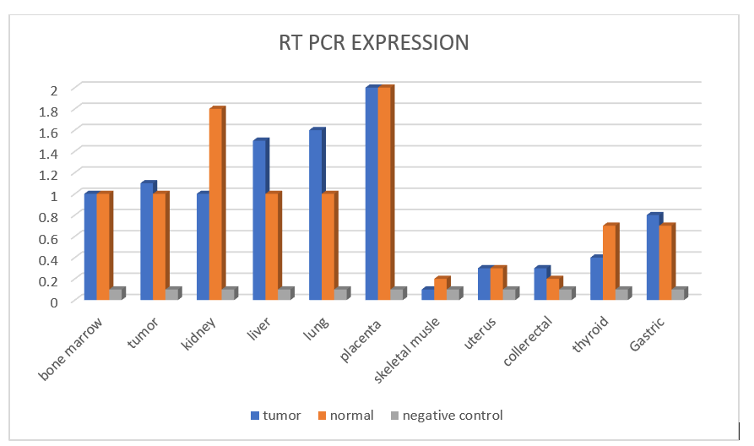

**Figure 1: The ARID3A expression level was analyzed in U2OS's different human tissues. Quantity PCR and Real-Time PCR methods performed gene expression analyses.**

Figure 2 demonstrates that the ARID3A gene makes silencing in the U2OS, and acts an effect as a superuser gene on the Osteosarcoma cells.

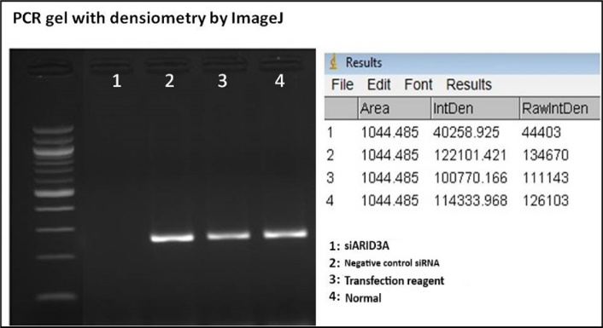

**Figure 2: Demonstration of ARID3A silencing in the U2OS cell line by RT-PCR. (24 hours after transfection). Gene expression analysis was performed by gel electrophoresis and the ImageJ program.**

After silencing ARID3A, its effects on ERICD expression were determined. Gene expression analysis of ERICD was performed using both RT-PCR and qPCR methods and compared with non-transfected normal cells showed a significant decrease in level (Figure 3).

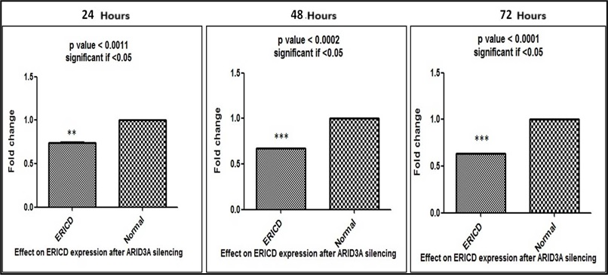

**Figure 3: Decreased expression of ERICD after silencing ARID3A. Fold change values ​​were significantly decreased in the level.**

Expression level of ERICD after silencing ARID3A detects fold change value by qPCR. After analysis by the Image J program to determine band concentration and compare with negative control and normal (Figure 4).

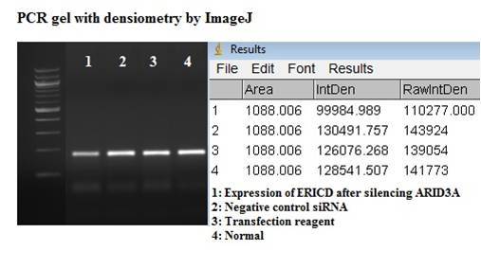

**Figure 4: RT-PCR showed a decrease in the expression of ERICD after silencing ARID3A.**

RT-PCR outputs showed changes in decreasing expression level of ERICD after silencing ARID3A. Results showed no significant levels seen between both ERICD and normal after transfection siRNA for decreasing ERICD (Figure 5).

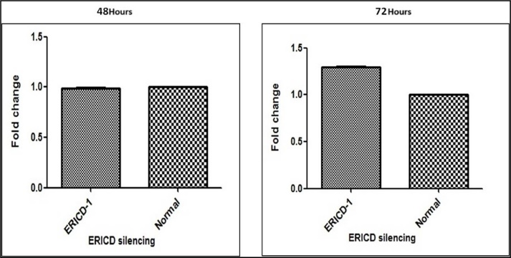

**Figure 5: Fold change analysis of ERICD expression level using siERICD-1 (ERICD-1) as siRNA. No significant decrease was observed.**

No significant decrease in level was seen of fold change of ERICD expression level using siERICD when comparing between negative control of siRNA, transfection regent, and normal (Figure 6).

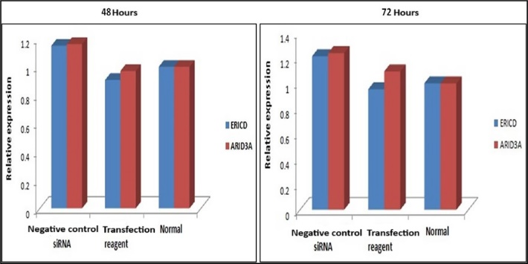

**Figure 6: ARICD expression level using siRNA between negative control and transfection. No significant decrease**

1. **DISCUSSION**

Genome regions that did not encode proteins were regarded as "garbage" by protein-centered orthodoxy. Many lncRNAs are produced from so-called "junk" areas of the genome, including pseudogenes, simple repetitions, and transposons that are biologically significant functional regulators (Levine and Kroemer, 2008, Mizushima, 2007). With more than 200 nucleotides, long non-coding RNAs (lncRNAs) are a broad and varied family of produced RNA molecules devoid of protein coding. The significance of lncRNAs as a cancer research subject is growing. Thus far, a large number of lncRNA molecules involved in malignancies have been found. While some lncRNAs function as oncogenes, others function as tumor suppressors. For instance, by inhibiting the production of p15 and consequently cell proliferation (senescence), the lncRNA ANRIL plays an oncogenic function in leukemia and prostate cancer (Galluzzi and Kroemer, 2008). A lncRNA called ERICD was found lately. It has two exons and is found on chromosome 8 (chr8:141646242-141648531). There are 1745 bps in the transcript. Transcription factor 1 (E2F) controls ERICD, which modifies the cell's reaction to DNA damage (Zong and Thompson, 2006).

Numerous lncRNAs, including MALAT1, H19, and HOTAIR, have been found to function as oncogenes in a variety of cancer types, including breast, colon, lung, and liver cancer (Xu *et al.,*2011; Grivennikov, 2013). Tumor suppressor long non-coding RNA PTCSC3 (Papillary Thyroid Carcinoma Susceptibility Candidate 3) is linked to thyroid cancer (Jendrzejewski et al., 2012).

Recently, ERICD was discovered to be a long noncoding RNA. It is located on chromosome 8 (chr8:141646242-141648531) and has two exons. The transcript has 1745 bps. The cell's response to DNA damage is altered by ERICD, which is regulated by transcription factor 1 (Feldstein et al., 2013).

A member of the AT-rich interaction domain (ARID) family of DNA-binding proteins, ARID3A is involved in the regulation of gene expression and chromatin remodeling. The ARID DNA binding domain is a characteristic that several proteins share. "AATTAA" is bound by a consensus sequence in ARID3A.44 E2F-dependent software (Cabili *et al.,*2011) and the E2F software agent are enabled by ARID3A and prevent Ras-induced premature senescence in primary murine fibroblasts (Blasco, 2005).

DNA damage and p53 both transcriptionally activate ARID3A, and it has been observed that ectopic production of ARID3A stimulates the development of Saos-2 cells lacking in p53 while inhibiting the growth of U2OS cells expressing normal p53 (Shay and Wright, 2000). Additionally, it was discovered that a favorable prognosis for colorectal cancer was correlated with high ARID3A gene expression (Schmidt et al., 2011). In the expression of the E2F target gene, ARID3A plays a crucial function. It has been demonstrated that the transcription of E2F target genes, including E2F1, p107, CDC2, and CDC6, is inhibited by siRNA-mediated suppression of ARID3A. It has also been discovered that ARID3A silencing inhibits the development of human tumor cell lines and weakens the S phase entrance of normal human dermal fibroblasts (NHDFs) (Bobbs et al., 2015). Consequently, it is believed that they play tumor-suppressive roles (Meyne et al., 1989). The question is still up for debate whether ARID3A is an oncogene or a tumor suppressor. It is known that a large number of lncRNAs target DNA-binding proteins in many biological processes (Benetatos et al., 2011). LncRNAs epigenetically control DNA transcription through their interaction with DNA-binding proteins.32 It is not yet known how ARID3A interacts with long non-coding RNAs (Counter et al., 1992).

1. **CONCLUSION**

ARID3A and ERICD are both transcription factors that play crucial roles in regulating gene expression in cancer cells. When siRNA was transfected into cancer cells, both ARID3A and ERICD were found to be effectively inhibited. Specifically, when ERICD expression in the transfected cancer cells was compared to non-transfected normal cells, a significant decrease in the level of ERICD was observed. This suggests that ERICD is involved in promoting the expression of cancer cells and its inhibition through siRNA transfection can effectively suppress cancer cell growth. Further studies are needed to fully understand the mechanisms by which ARID3A and ERICD contribute to cancer development and to explore the potential of targeting these transcription factors as therapeutic strategies for cancer treatment.

**Conflict of Interest**

The authors declare that they have no conflict of interest.

**REFERENCES**

ADAMS, J. M. & CORY, S. 2007. The Bcl-2 apoptotic switch in cancer development and therapy. *Oncogene,* 26**,** 1324-1337.

BACHEM, C. W., OOMEN, R. J. & VISSER, R. G. 1998. Transcript imaging with cDNA-AFLP: a step-by-step protocol. *Plant Molecular Biology Reporter,* 16**,** 157-157.

BENETATOS, L., VARTHOLOMATOS, G. & HATZIMICHAEL, E. 2011. MEG3 imprinted gene contribution in tumorigenesis. *International journal of cancer* 129**,** 773-779.

BLASCO, M. A. 2005. Telomeres and human disease: ageing, cancer and beyond. *Nature Reviews Genetics,* 6**,** 611-622.

BOBBS, A., GELLERMAN, K., HALLAS, W. M., JOSEPH, S., YANG, C., KURKEWICH, J. & COWDEN DAHL, K. D. 2015. ARID3B directly regulates ovarian cancer promoting genes. *PloS one,* 10**,** e0131961.

BROOKS, C. L. & GU, W. 2011. p53 regulation by ubiquitin. *FEBS Letters,* 585**,** 2803-2809.

COUNTER, C. M., AVILION, A. A., LEFEUVRE, C. E., STEWART, N. G., GREIDER, C. W., HARLEY, C. B. & BACCHETTI, S. 1992. Telomere shortening associated with chromosome instability is arrested in immortal cells which express telomerase activity. *The EMBO journal* 11**,** 1921-1929.

DESJARDINS, P. & CONKLIN, D. J. J. 2010. NanoDrop microvolume quantitation of nucleic acids. *Journal of Visualized Experiments* e2565.

DORAK, M. T. & KARPUZOGLU, E. 2012. Gender Differences in Cancer Susceptibility: An Inadequately Addressed Issue. *Frontiers in Genetics,* 3.

FELDSTEIN, O., NIZRI, T., DONIGER, T., JACOB, J., RECHAVI, G. & GINSBERG, D. 2013. The long non-coding RNA ERIC is regulated by E2F and modulates the cellular response to DNA damage. *Molecular Cancer,* 12**,** 131.

GALLUZZI, L. & KROEMER, G. 2008. Necroptosis: A Specialized Pathway of Programmed Necrosis. *Cell,* 135**,** 1161-1163.

GUPTA, R. A., SHAH, N., WANG, K. C., KIM, J., HORLINGS, H. M., WONG, D. J., TSAI, M.-C., HUNG, T., ARGANI, P., RINN, J. L., WANG, Y., BRZOSKA, P., KONG, B., LI, R., WEST, R. B., VAN DE VIJVER, M. J., SUKUMAR, S. & CHANG, H. Y. 2010. Long non-coding RNA HOTAIR reprograms chromatin state to promote cancer metastasis. *Nature,* 464**,** 1071-1076.

GUTSCHNER, T. & DIEDERICHS, S. 2012. The hallmarks of cancer. *RNA Biology,* 9**,** 703-719.

GUTSCHNER, T., HÄMMERLE, M. & DIEDERICHS, S. 2013. MALAT1—a paradigm for long noncoding RNA function in cancer. *Journal of molecular medicine,* 91**,** 791-801.

HANAHAN, D. & WEINBERG, R. A. 2000. The Hallmarks of Cancer. *Cell,* 100**,** 57-70.

HOLLSTEIN, M., SIDRANSKY, D., VOGELSTEIN, B. & HARRIS, C. C. 1991. p53 Mutations in Human Cancers. *Science,* 253**,** 49-53.

JENDRZEJEWSKI, J., HE, H., RADOMSKA, H. S., LI, W., TOMSIC, J., LIYANARACHCHI, S., DAVULURI, R. V., NAGY, R. & DE LA CHAPELLE, A. 2012. The polymorphism rs944289 predisposes to papillary thyroid carcinoma through a large intergenic noncoding RNA gene of tumor suppressor type. *Proceedings of the National Academy of Sciences,* 109**,** 8646-8651.

LEVINE, B. & KROEMER, G. 2008. Autophagy in the Pathogenesis of Disease. *Cell,* 132**,** 27-42.

LIU, X., DUAN, Y., HONG, X., XIE, J. & LIU, S. 2023. Challenges in structural modeling of RNA-protein interactions. *Current Opinion in Structural Biology*

81**,** 102623.

LOWE, S. W., CEPERO, E. & EVAN, G. 2004. Intrinsic tumour suppression. *Nature,* 432**,** 307-315.

MARCO, I., FEYERABEND, F., WILLUMEIT-RÖMER, R. & VAN DER BIEST, O. 2016. Degradation testing of Mg alloys in Dulbecco's modified eagle medium: Influence of medium sterilization. *Materials Science and Engineering: C,* 62**,** 68-78.

MARINER, P. D., WALTERS, R. D., ESPINOZA, C. A., DRULLINGER, L. F., WAGNER, S. D., KUGEL, J. F. & GOODRICH, J. A. 2008. Human Alu RNA Is a Modular Transacting Repressor of mRNA Transcription during Heat Shock. *Molecular Cell,* 29**,** 499-509.

MATOUK, I. J., DEGROOT, N., MEZAN, S., AYESH, S., ABU-LAIL, R., HOCHBERG, A. & GALUN, E. 2007. The H19 Non-Coding RNA Is Essential for Human Tumor Growth. *PLoS ONE,* 2**,** e845.

MEYNE, J., RATLIFF, R. L. & MOYZIS, R. K. 1989. Conservation of the human telomere sequence (TTAGGG)n among vertebrates. *Proceedings of the National Academy of Sciences,* 86**,** 7049-7053.

MIZUSHIMA, N. 2007. Autophagy: process and function. *Genes &amp; Development,* 21**,** 2861-2873.

PAUL, D. 2020. The systemic hallmarks of cancer. *Journal of Cancer Metastasis and Treatment,* 2020.

PEÑA-LLOPIS, S. & BRUGAROLAS, J. 2013. Simultaneous isolation of high-quality DNA, RNA, miRNA and proteins from tissues for genomic applications. *Nature Protocols,* 8**,** 2240-2255.

RINN, J. & GUTTMAN, M. 2014. RNA and dynamic nuclear organization. *Science,* 345**,** 1240-1241.

SCHMIDT, L. H., SPIEKER, T., KOSCHMIEDER, S., HUMBERG, J., JUNGEN, D., BULK, E., HASCHER, A., WITTMER, D., MARRA, A., HILLEJAN, L., WIEBE, K., BERDEL, W. E., WIEWRODT, R. & MULLER-TIDOW, C. 2011. The Long Noncoding MALAT-1 RNA Indicates a Poor Prognosis in Non-small Cell Lung Cancer and Induces Migration and Tumor Growth. *Journal of Thoracic Oncology,* 6**,** 1984-1992.

SHAY, J. W. & WRIGHT, W. E. 2000. Hayflick, his limit, and cellular ageing. *Nature Reviews Molecular Cell Biology,* 1**,** 72-76.

SIEGEL, R., NAISHADHAM, D. & JEMAL, A. 2012. Cancer statistics for Hispanics/Latinos, 2012. *CA: A Cancer Journal for Clinicians,* 62**,** 283-298.

TAVARES, L., ALVES, P. M., FERREIRA, R. B. & SANTOS, C. N. 2011. Comparison of different methods for DNA-free RNA isolation from SK-N-MC neuroblastoma. *BMC Research Notes,* 4**,** 3.

ZONG, W.-X. & THOMPSON, C. B. 2006. Necrotic death as a cell fate. *Genes &amp; Development,* 20**,** 1-15.