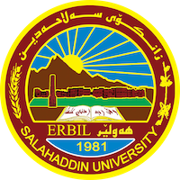
Academic Curriculum Vitae
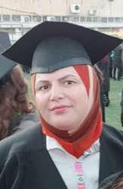
Personal Information:
Full Name: Khabat Anwar Ali
Academic Title: Professor Doctor
Email: khabat.ali@su.edu.krd
Mobile: 07504283866
Education:
- BSc: (27-6-1992), Univ. of Salahaddin/Hawler / College of Education / Dept. of Biology.
- MSc:(29-7-1999), Univ. of Salahaddin/Hawler / College of Science/Dept. of Biology/ Animal physiology.
- PhD :( 28-7-2009), Univ. of Mosul/ College of Science / Dept. of Biology/ Histology- Embryology.
Employment:
Assistant lecturer 6/9/1999
Lecturer 27/9/ 2009
Assistant. Prof. 20/8/2013
Professor 14/6/2020
Qualifications: Doctor of philosophy
Teaching experience:
I taught the following courses in Universities of Sallahaddin /College of Education /Department of Biology:
- undergraduate: Histology and Embryology
- post graduate MSc and PhD: Histology
- lab supervision: Histology and Embryology

Research and publications

Conferences and courses attended
- Give details of any conferences you have attended, and those at which you have presented delivered poster presentations.

Funding and academic awards
- List any bursaries, scholarships, travel grants or other sources of funding that you were awarded for research projects or to attend meetings or conferences.

Professional memberships
- List any membership you hold of any professional body or learned society relevant to your research or other life activities.

Professional Social Network Accounts:

- Research Gate link:
https://www.researchgate.net/profile/Khabat-Anwar/research

- LinkedIn link:
https://www.linkedin.com/in/khabat-anwar-1739b0121/

-Google Scholar link:
https://scholar.google.com/scholar?hl=en&as_sdt=0%2C5&q=khabat+anwar+ali&oq=kha

Face book;
https://www.facebook.com/dayky.dween/

ORCID:
https://orcid.org/0000-0002-5584-3668

It is also recommended to create an academic cover letter for your CV, for further information about the cover letter, please visit below link:
https://career-advice.jobs.ac.uk/cv-and-cover-letter-advice/academic-cover-letter/

