**[Ministry of Higher Education and Scientific Research](https://www.mhe-krg.org/)**

**Salahaddin University-Erbil**

**College of Education**

**Department of Physics**

**1st Stage**

**Laboratory of Mechanics**

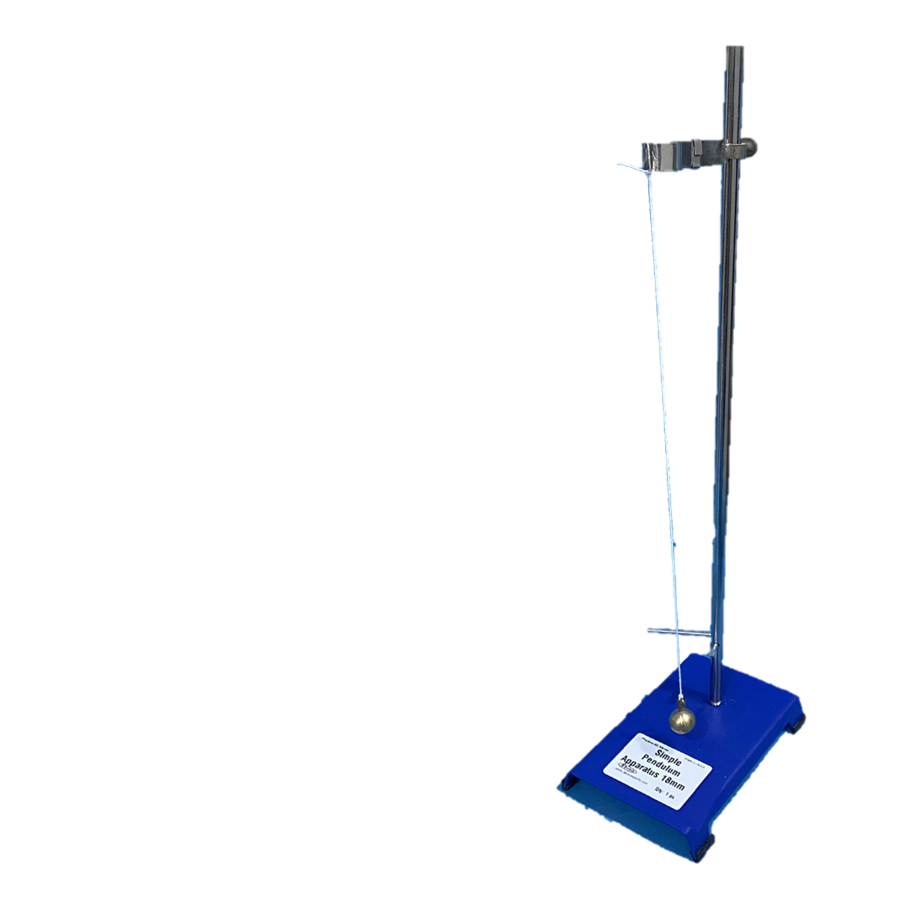

**Group ( )**

**Full Name:**

**Experiment Number: (1)**

**Name of Experiment:** **Simple Pendulum Experiment**

**Date:**

**Staff Group:**

* **Dr. Bestoon Taha Mustafa**
* **Dr. Ayoub Sabir Karim**
* **Dr. Kasim Fawzy Ahmed**
* **Mrs. Gullala Yaseen Baker**
* **Mrs. Khadija Najmdeen Abdulla**
* **Mrs. Lana Awni Pir Khudhur**

**Experiment No (1)**

**Simple Pendulum Experiment**

**Introduction:**

**Theory:**

**Items:**

**Methods:**

**Data collection:**

|  |  |  |  |  |  |  |
| --- | --- | --- | --- | --- | --- | --- |
| **L (cm)** | **(t) Time of 20 oscillations (sec)** | | | **One time period** | **(sec2)** | ***g* (cm/sec2)** |
| **t1 (sec)** | **t2 (sec)** | **(sec)** | $T=\frac{t_{ave}}{20}$**(sec)** |
| **30** |  |  |  |  |  |  |
| **40** |  |  |  |  |  |  |
| **50** |  |  |  |  |  |  |
| **60** |  |  |  |  |  |  |
| **70** |  |  |  |  |  |  |
| **80** |  |  |  |  |  |  |
| **90** |  |  |  |  |  |  |

**Plot and Calculate**:



**Result and Discussion**:

………………………………………………………………………………………………………………………………………………………………………………………………………………………………………………………………………………………………………………………………………………………………………………………………………………………………………………………………………………………………………………………………………………………………………………………………………………………………………………………………………………………………………………………………………………………………………………………………………………………………………………………………………………………………………………………………………………………………………………………………………………………………………………………………………………………………………………………………………………………………………………………………………………………………………………………………………………………………………………………………………………………………………………………………………………………………………………………………………………………………………………………………………………………………………………………………………………………………………………………………………………………………………………………………………………………………………………………………………………………………………………………………………………………………………………………………………………………………………………………………………………………………………………………………………………………………………………………………………………………………………………………………………………………………………………………………………………………………………………………………………………………………………………………………

**[Ministry of Higher Education and Scientific Research](https://www.mhe-krg.org/)**

**Salahaddin University-Erbil**

**College of Education**

**Department of Physics**

**1st Stage**

**Laboratory of Mechanics**

**Group ( )**

**Full Name:**

**Experiment Number: (2)**

**Name of Experiment: Determination of the Spring Constant of a**

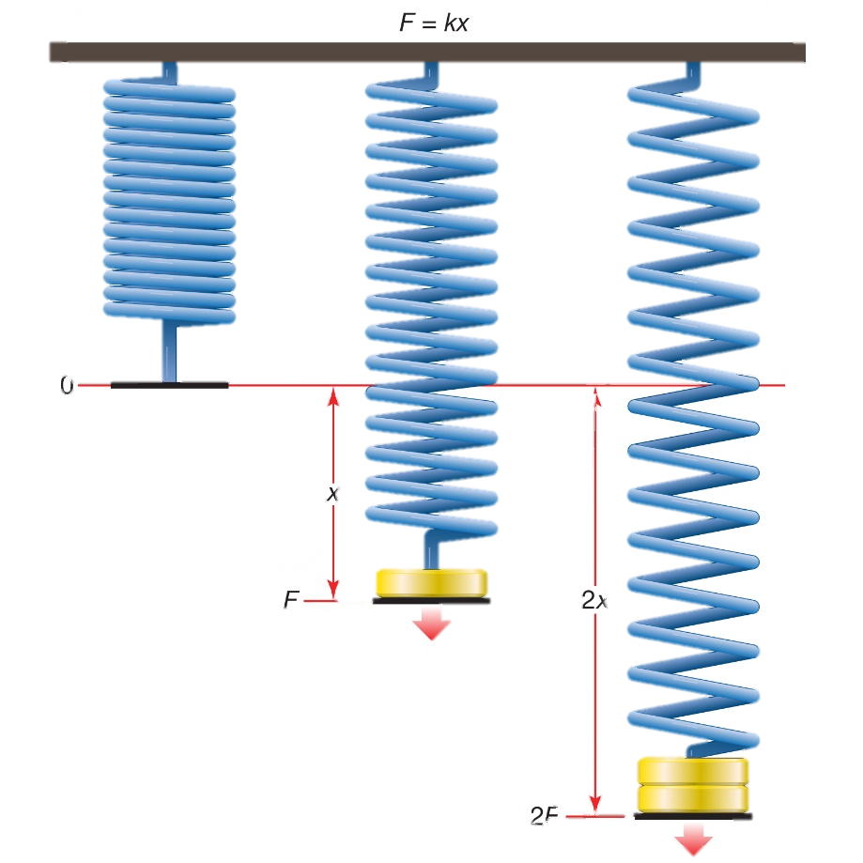 **Spiral Spring**

**Date:**

**Staff Group:**

* **Dr. Bestoon Taha Mustafa**
* **Dr. Ayoub Sabir Karim**
* **Dr. Kasim Fawzy Ahmed**
* **Mrs. Gullala Yaseen Baker**
* **Mrs. Khadija Najmdeen Abdulla**
* **Mrs. Lana Awni Pir Khudhur**

**Experiment No (2)**

**Determination of the Spring Constant of a Spiral Spring**

**Introduction:**

**Theory:**

**Items:**

**Methods:**

**Data collection: *xo*= m**

|  |  |  |  |  |
| --- | --- | --- | --- | --- |
| **Mass (m/gram)** | **F= mg (N)** | **x (m)** | **Δ𝒙 = 𝒙 − 𝒙𝟎 (m)** | $K=\frac{F}{∆x}$**(N)** |
| **50** |  |  |  |  |
| **100** |  |  |  |  |
| **150** |  |  |  |  |
| **200** |  |  |  |  |
| **250** |  |  |  |  |
| **300** |  |  |  |  |
| **350** |  |  |  |  |

**Plot and Calculate**:



**Result and Discussion**:

………………………………………………………………………………………………………………………………………………………………………………………………………………………………………………………………………………………………………………………………………………………………………………………………………………………………………………………………………………………………………………………………………………………………………………………………………………………………………………………………………………………………………………………………………………………………………………………………………………………………………………………………………………………………………………………………………………………………………………………………………………………………………………………………………………………………………………………………………………………………………………………………………………………………………………………………………………………………………………………………………………………………………………………………………………………………………………………………………………………………………………………………………………………………………………………………………………………………………………………………………………………………………………………………………………………………………………………………………………………………………………………………………………………………………………………………………………………………………………………………………………………………………………………………………………………………………………………………………………………………………………………………………………………………………………………………………………………………………………………………………………………………………………………………

**[Ministry of Higher Education and Scientific Research](https://www.mhe-krg.org/)**

**Salahaddin University-Erbil**

**College of Education**

**Department of Physics**

**1st Stage**

**Laboratory of Mechanics**

**Group ( )**

**Full Name:**

**Experiment Number: (3)**

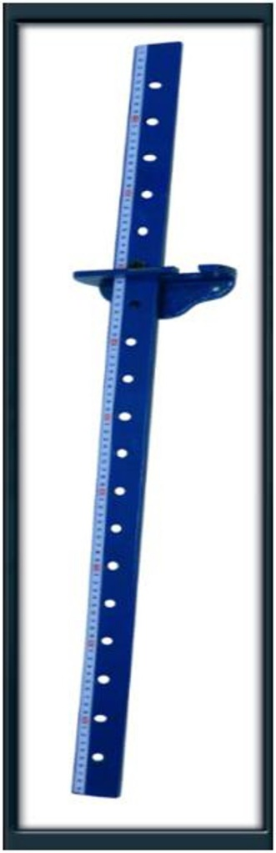**Name of Experiment: Determination the value of acceleration due to gravity (*g*) using compound pendulum**

**Date:**

**Staff Group:**

* **Dr. Bestoon Taha Mustafa**
* **Dr. Ayoub Sabir Karim**
* **Dr. Kasim Fawzy Ahmed**
* **Mrs. Gullala Yaseen Baker**
* **Mrs. Khadija Najmdeen Abdulla**
* **Mrs. Lana Awni Pir Khudhur**

**Experiment No (3)**

**Determination the value of acceleration due to gravity (g) using compound pendulum**

**Introduction:**

**Theory:**

**Items:**

**Methods:**

**Data collection:**

|  |  |  |  |  |
| --- | --- | --- | --- | --- |
| **d (m)** | **Time for (10) oscillations (sec)** | | | **(sec)** |
| **t1 (sec)** | **t2 (sec)** | **(sec)** |
|  |  |  |  |  |
|  |  |  |  |  |
|  |  |  |  |  |
|  |  |  |  |  |
|  |  |  |  |  |
|  |  |  |  |  |
|  |  |  |  |  |
|  |  |  |  |  |
|  |  |  |  |  |

**Plot and Calculate**:



**Result and Discussion**:

………………………………………………………………………………………………………………………………………………………………………………………………………………………………………………………………………………………………………………………………………………………………………………………………………………………………………………………………………………………………………………………………………………………………………………………………………………………………………………………………………………………………………………………………………………………………………………………………………………………………………………………………………………………………………………………………………………………………………………………………………………………………………………………………………………………………………………………………………………………………………………………………………………………………………………………………………………………………………………………………………………………………………………………………………………………………………………………………………………………………………………………………………………………………………………………………………………………………………………………………………………………………………………………………………………………………………………………………………………………………………………………………………………………………………………………………………………………………………………………………………………………………………………………………………………………………………………………………………………………………………………………………………………………………………………………………………………………………………………………………………………………………………………………………

**[Ministry of Higher Education and Scientific Research](https://www.mhe-krg.org/)**

**Salahaddin University-Erbil**

**College of Education**

**Department of Physics**

**1st Stage**

**Laboratory of Mechanics**

**Group ( )**

**Full Name:**

**Experiment Number: (4)**

**Name of Experiment: Determining the Speed of Sound in Air in a Resonance Tube open at one end**

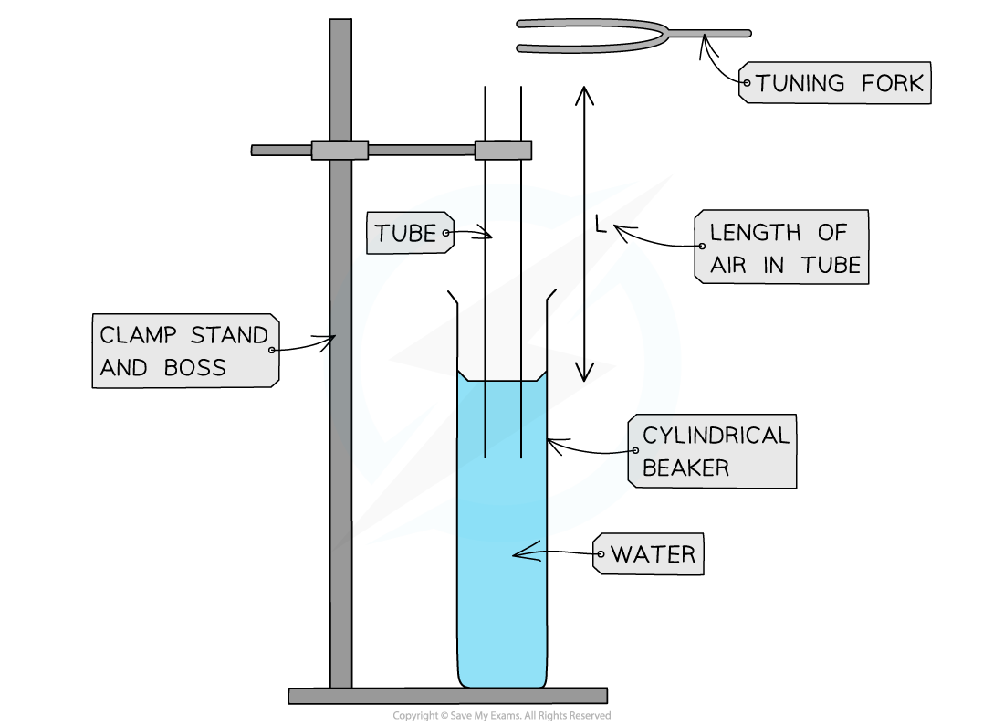

**Date:**

**Staff Group:**

* **Dr. Bestoon Taha Mustafa**
* **Dr. Ayoub Sabir Karim**
* **Dr. Kasim Fawzy Ahmed**
* **Mrs. Gullala Yaseen Baker**
* **Mrs. Khadija Najmdeen Abdulla**
* **Mrs. Lana Awni Pir Khudhur**

**Experiment No (4)**

**Determining the Speed of Sound in Air in a Resonance Tube open at one end**

**Introduction:**

**Theory:**

**Items:**

**Methods:**

**Data collection:**

|  |  |  |  |  |
| --- | --- | --- | --- | --- |
| **f (Hz)** | **Resonance cavity length (cm)** | | | **(m/sec)** |
| ***l1*(cm)** | ***l2* (cm)** | **(cm)** |
| **256** |  |  |  |  |
| **288** |  |  |  |  |
| **320** |  |  |  |  |
| **341** |  |  |  |  |
| **384** |  |  |  |  |
| **426.6** |  |  |  |  |
| **480** |  |  |  |  |
| **512** |  |  |  |  |

**Plot and Calculate**:



**Result and Discussion**:

………………………………………………………………………………………………………………………………………………………………………………………………………………………………………………………………………………………………………………………………………………………………………………………………………………………………………………………………………………………………………………………………………………………………………………………………………………………………………………………………………………………………………………………………………………………………………………………………………………………………………………………………………………………………………………………………………………………………………………………………………………………………………………………………………………………………………………………………………………………………………………………………………………………………………………………………………………………………………………………………………………………………………………………………………………………………………………………………………………………………………………………………………………………………………………………………………………………………………………………………………………………………………………………………………………………………………………………………………………………………………………………………………………………………………………………………………………………………………………………………………………………………………………………………………………………………………………………………………………………………………………………………………………………………………………………………………………………………………………………………………………………………………………………………