The structure of virus particles
Composition and Structure
Each plant virus consists of at least a nucleic acid and a protein. Some viruses consist of more than one size of nucleic acid and proteins, and some of them contain enzymes or membrane lipids. The nucleic acid makes up 5 to 40% of the virus, protein making up the remaining 60 to 95%. The lower nucleic acid percentages are found in the elongated viruses, whereas the spherical viruses contain higher percentages of nucleic acid

Morphology

Plant viruses come in different shapes and sizes. Nearly half of them are elongate (rigid rods or flexuous threads), and almost as many are spherical (isometric or polyhedral), with the remaining being cylindrical bacillus-like rods. Some elongated viruses are rigid rods about 15 by 300 nm, but most appear as long, thin, flexible threads that are usually 10 to 13 nm wide and range in length from 480 to 2,000 nm. Rhabdoviruses are short, bacillus like, cylindrical rods, approximately three to five times as long as they are wide (52–75 by 300– 380nm). Most spherical viruses are actually polyhedral, ranging in diameter from about 17 nm (tobacco necrosis satellite virus) to 60 nm (wound tumor virus). Tomato spotted wilt virus is surrounded by a membrane and has a flexible, spherical shape about 100 nm in diameter.
Many plant viruses have split genomes, they consist of two or more distinct nucleic acid strands.

1. Rigid rod: (E.g.) Tobacco Mosaic Virus (TMV) and Tobacco rattle Virus (TRV)
2. Flexuous rod: (E.g.) Potato Virus X (PVX), Bean Common Mosaic Virus (BCMV).
3. Filamentous rod: (E.g.) Tenuiviruses likes Rice Grassy Stunt (RGSV) and Rice Stripe Virus (RSV).
4. Isometric: (E.g.) Rice Tungro Spherical Virus (RTSV), Cucumber Mosaic Virus (CMV), Tomato Spotted Wilt Virus (TSWV).
5. Bacilliform: (E.g.) Rice Tungro Bacilliform Virus (RTBV), Banana streak virus (BSV) and Cocoa Swollen Shoot Virus (CCSV).

Composition and Structure of Viral Protein
Protein forms a protective coat (capsid) around the nucleic acid in a virus. Plant viruses have only one kind of protein. Individual protein subunits are called as capsomers. Protein subunits are spirally arranged in elongated viruses and packed on the side of polyhedral particles of spherical viruses. Proteins provide the basis for serological differentiation of viruses and other strains. Like all proteins, viral protein is made up of amino acids. Sequence of amino acids within a protein is detected by the sequence of nucleotides in the nucleic acid.

BIOLOGICAL FUNCTION OF VIRAL PROTEIN
1 - The protein coat of a virus protective sheathing for the nucleic acid of the virus.
2- Plays a role in determining vector transmissibility of a virus and the kinds of symptoms it causes.
3-Protein itself has no infectivity, but serves to protect the nucleic acid and its presence generally increases the infectivity of the nucleic acid.
4-Some viruses carry within them a transcriptase enzyme that they need in order to multiply and infect.
Composition and Structure of Viral Nucleic Acid
The nucleic acid of most plant viruses consists of RNA, but a large number of viruses have been shown to contain DNA. Both RNA and DNA are long, chain-like molecules consisting of hundreds or, more often, thousands of units called nucleotides. Each nucleotide consists of a ring compound called the base attached to a five-carbon sugar
[ribose (I) in RNA, deoxyribose (II) in DNA], which in turn is attached to phosphoric acid. The sugar of one nucleotide reacts with the phosphate of another nucleotide, which is repeated many times, thus forming the RNA or DNA strand.
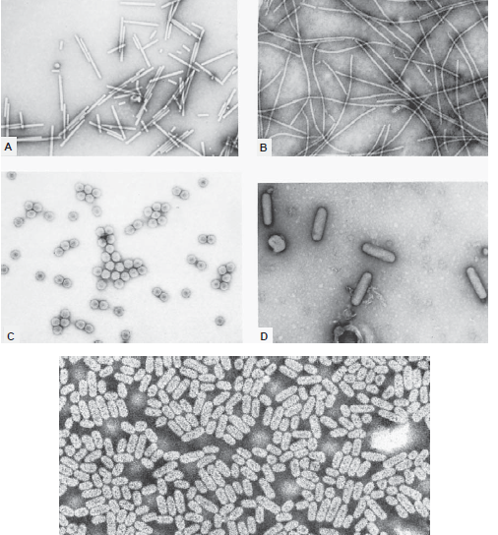
Electron micrographs of the various shapes of plant viruses. (A) Rod-shaped virus (tobacco mosaicvirus) . (B) Flexuous thread virus (sugarcane mosaic virus) . (C) Isometric virus (cowpea chloroticmottle virus) .(D) Bacilliform rhabdovirus (broccoli necrotic yellows virus) . (E) The variousshapes and sizes of alfalfa mosaic virus
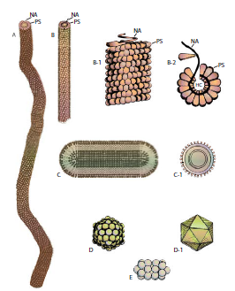
Relative shapes, sizes, and structures of some representative plant viruses. (A) Flexuous thread-like virus. (B) Rigid rod-shaped virus. (B-1) Side arrangement of protein subunits (PS) and nucleic acid (NA) in viruses A and B. (B-2) Cross-section view of the same viruses. HC, hollow core. (C) Short, bacillus-like virus. (C-1) Cross-section view of such a virus. (D) Isometric polyhedral virus. (D-1) Icosahedron representing the 20-sided symmetry of the protein subunits of the isometric virus. (E) Geminivirus consisting of twin particles.

