HISTOLOGICAL CHANGES
The macroscopic symptoms induced by viruses frequently reflect histological changes within the plant. These changes are of three main types—necrosis, hypoplasia, and hyperplasia—that may occur singly or together in any particular disease.
A. Necrosis
Necrosis, as a macroscopic symptom,. It may be general or may be limited to specific tissues, such as localized areas of the roots (e.g., Tobacco necrosis
Virus.
B. Hypoplasia
Leaves with mosaic symptoms frequently show hypoplasia (localised retarded growth frequently leading to thinner areas on leaves) in the yellow areas. The lamina is thinner than in the dark green areas, and the mesophyll cells are less differentiated with fewer chloroplasts and fewer or no intercellular spaces.
C. Hyperplasia
Hyperplasia is growth of abnormally large cells or excessive cell division.

1. Cell Size
Vein-clearing symptoms are due, with some viruses at least, to enlargement of cells near the veins. The intercellular spaces are obliterated, and since there is little chlorophyll present, the tissue may become abnormally translucent.
2. Cell Division in Differentiated Cells
Some viruses such as PVX may produce islands of necrotic cells in potato tubers. The tuber may respond with a typical wound reaction in a zone of cells around the necrotic area. Starch grains disappear, and an active cambial layer develops.

3. Abnormal Division of Cambial Cells
The vascular tissues appear to be particularly prone to virus-induced hyperplasia.
.
TRANSMISSION OF PLANT VIRUSES
There are two types of plant virus transmission
Horizontal transmission is by vectors, human pruning shears and tools, and other direct, external contamination.
Vertical transmission occurs when a plant gets it from its parent plant. Either through asexual propagation (cuttings) or in sexual reproduction via infected seeds.
Plant viruses are transmitted from plant to plant in a number of ways. Modes of transmission include vegetative propagation, mechanically through sap, through seed, pollen, and dodder and by specific insects, mites, nematodes, and fungi.

Transmission of Viruses by Vegetative Propagation
Whenever plants are propagated vegetatively by budding or grafting, by cuttings, or by the use of tubers, corms, bulbs, or rhizomes, any viruses present in the mother plant from which these organs are taken will almost always be transmitted to the progeny.
The transmission of viruses may also occur through natural root grafts of adjacent plants, particularly trees for several tree viruses, natural root grafts are the only known means of tree-to-tree spread of the virus within established orchards. , natural root grafts, and dodder.

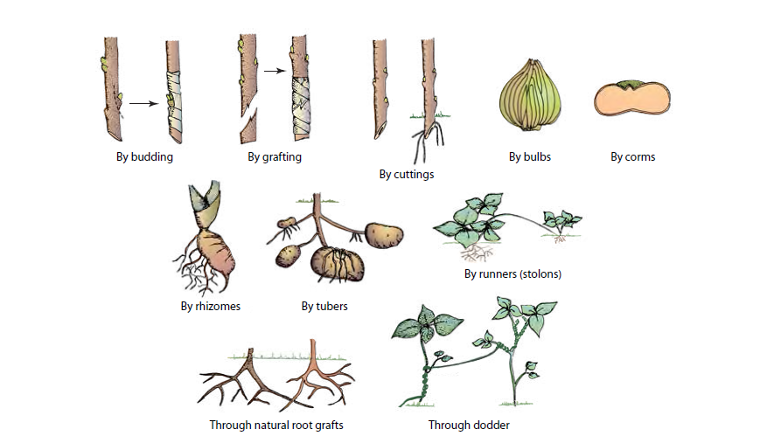

Mechanical Transmission of Viruses through Sap
The mechanical transmission of plant viruses in nature by the direct transfer of sap through contact of one plant with another is uncommon and relatively unimportant.
Such transmission may take place after a strong wind injures the leaves of adjacent diseased and healthy plants or when plants are wounded during cultural practices by tools, hands, or clothes, or by animals feeding on the plants and the sap carrying virus is transferred to wounded plants. Plant virus transmission through direct contact of plants, handling, seed, and pollen
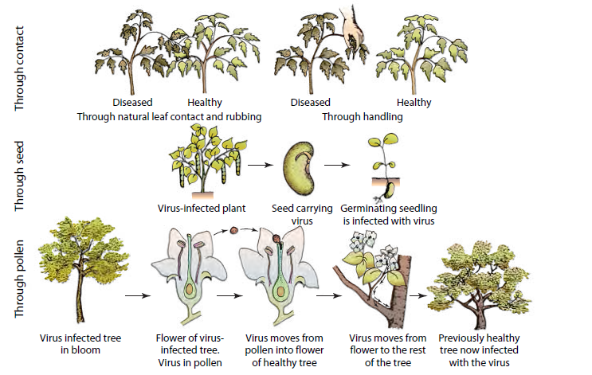

Seed Transmission
More than 100 viruses are transmitted by seed to a smaller or greater extent. As a rule, only a small portion (1–30%) of seeds derived from virus-infected plants of only some hosts of the virus transmit the virus.

Pollen Transmission
Virus transmitted by pollen may result in reduced fruit set, may infect the seed and the seedling that will grow from it, and, in some cases, can spread through the fertilized flower and down into the mother plant, which Such plant-to-plant transmission of virus through pollen is known to occur, for example, in sour cherry infected with prunus necrotic ring spot virus.
Insect Transmission
the most common and economically most important means of transmission of viruses in the field is by insect vectors. Members of relatively few insect
groups, however, can transmit plant viruses .The order:
- Homoptera, which includes aphids
- Hemiptera such as true bugs
- Thysanoptera thrips
- Coleoptera. Beetle
- (Orthoptera) Grasshoppers
The most important virus vectors are aphids, leafhoppers, whiteflies, and thrips. have piercing and sucking mouthparts. Insects with sucking mouthparts carry plant viruses on their stylets —stylet-borne viruses— have three relations with plant virus:
1-nonpersistent viruses
can acquire and inoculate the virus after short feeding periods of a few seconds to a few minutes. Stylet-borne viruses persist in the vector for only a few to several hours
2- semi persistent viruses
The insect vectors must feed on an infected plant from several minutes or hours to a few days before they accumulate enough virus for transmission. These insects can then transmit the virus after fairly long feeding periods of several minutes to several hours. Such viruses persist in the vector for a few (1 to 4) days.
3- circulative or persistent viruses.
the insect vectors accumulate the virus internally and, after passage of the virus through the insect tissues, introduce the virus into plants again through their mouthparts. Some circulative viruses may multiply in their respective vectors and are then called propagative viruses. Viruses transmitted by insects with chewing mouthparts (beetles) may also be circulative or may be carried on the mouthparts. aphid species can transmit several viruses. 0however, the vector–virus relationship is quite specific.
Mite Transmission
Primarily mites of the family Eriophyidae have been shown to transmit at least six viruses, including wheat streak mosaic and several other rymoviruses affecting cereals peach mosaic virus, is transmitted by mites of the family Tetranychidae.
Nematode Transmission
Approximately 20 plant viruses are transmitted by one or more species of three genera of soil-inhabiting, ectoparasitic nematodes . Nematodes of the genera Longidorus, Paralongidorus, and Xiphinema transmit several polyhedral-shaped viruses known as
nepoviruses, Nematode vectors transmit viruses by feeding on roots of infected plants and then moving on to roots of healthy plants.
Fungus Transmission
Root-infecting fungal-like organisms, the plasmodiophoromycetes Polymyxa and Spongospora, and the chytridiomycete Olpidium, transmit at least 30 plant viruses.
Dodder Transmission
Several plant viruses can be transmitted from one plant to another through the bridge formed between two plants by the twining stems of the parasitic plant dodder (Cuscuta sp.)
