Control of microorganisms ---Sterilization and Disinfection
Bactericidal:kills bacteria
Bacteriastatic:inhibits growth of bacteria
Sterilization:removal or killing of all living microorganisms including virus , bacteria,fungi and their spores by physical and chemical methods.
Disinfection:removal or killing of disease causing microorganisms

Methods of sterilization:
There are two methods of sterilization:
A- Physical methods:
1. Sterilization by Heat
2. Sterilization by Filtration
3. Sterilization by Irradiation
B- Chemical methods

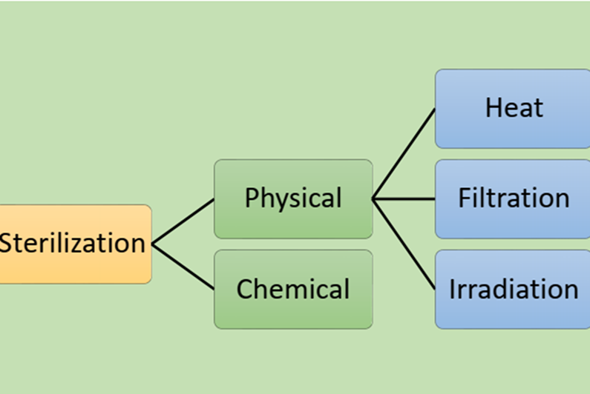
A- Physical methods:
1. Sterilization by heat
• Heat is the most practical, reliable, and inexpensive method of sterilization.
• It is used for sterilization of objects and materials that can withstand
high temperatures.
• It can be either:
• Dry heat
• Moist Heat
Dry heat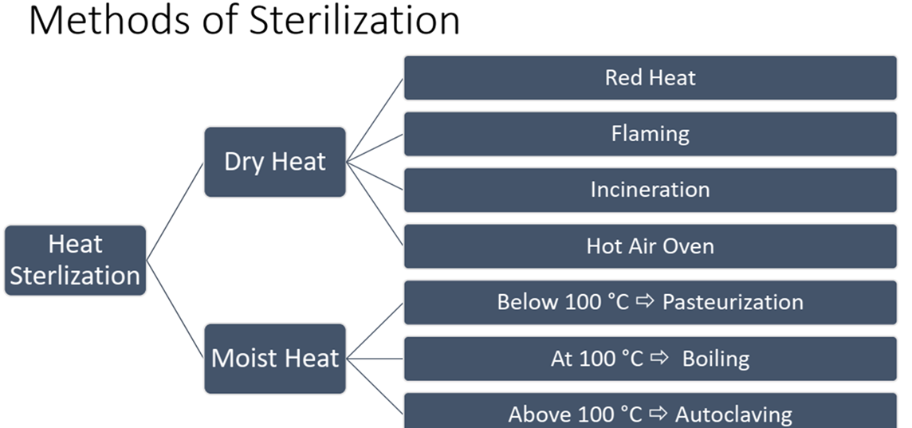
-Red Heat
Principle:
Holding object in Bunsen flame till they become red hot.
Used for:
Sterilization of:
• Bacteriological loops and needles.
• Tips of forceps

- Flaming
Principle:
Passing the object through the flame of Bunsen burner without heating to redness.
Used for:
Sterilization of:
• glass slides
• mouth of culture tubes.

-Incineration
Principle:
Infective materials is converted to sterile ash by burning in incinerator
Used for:
Destruction of contaminated disposable materials (waste)

-Hot air oven
Principle
• Articles to be sterilized are exposed to high temperature in an electrically heated oven.
• Even distribution of heat throughout the chamber is achieved by a fan.
Holding time:
• 160°C for two hour
• 180°C for one hour

Used for Sterilization of:
• All glasses: test tubes, Petri dishes, flasks, pipettes.
• Instruments: as forceps, scalpels, scissors
• Dry material in sealed containers as fat, oils, powder.

Moist Heat
Can be used at different temperatures:
• below 100 °C Pasteurization
• At 100 °C Boiling
• Above 100 °C Autoclave

-Pasteurization (Below 100 ⸰C)
Principle:
Pasteurization is a process of heating a liquid to a specific temperature for a definite length of time and then cooling it immediately.
-Classic pasteurization :milk was exposed to 65⸰C for 30 minute
-High temperature Short time Pasteurization HTST: milk is exposed to 72⸰C for 15 seconds
-Flash pasteurization
Used for:
Pasteurization is commonly used in milk and juice processing.
-Boiling (At 100 °C)
Principle:
Boiling in water for fifteen minutes will kill most vegetative bacteria and inactivate viruses.
However boiling is ineffective against many bacterial and fungal spores.

-Autoclaving
Principle:
• Chamber which filled with hot steam under pressure 15 psi
• Temperature of the steam reaches 121°C.
• Autoclaving is the most reliable method of sterilization that kills all kinds of bacteria and spores.
Temperature of sterilization:
- 121⸰C for 20 minutes.
Used for sterilization of:
• Culture media.
• Surgical supply e.g. dressing, and surgical instruments.
• Lab. Coat
• Decontamination of laboratory waste

2-Filtration
It is possible to remove bacteria from
Fluids by passing them through filters with pores so small that bacteria are arrested.
.A microfilter with pore size of usually 0.22 µm will usually effectively remove microorganisms
•Filtrations is used to sterilize liquids that would be damaged by heat as enzymes, antibiotic solutions, vaccines and culture media (contain heat sensitive materials)

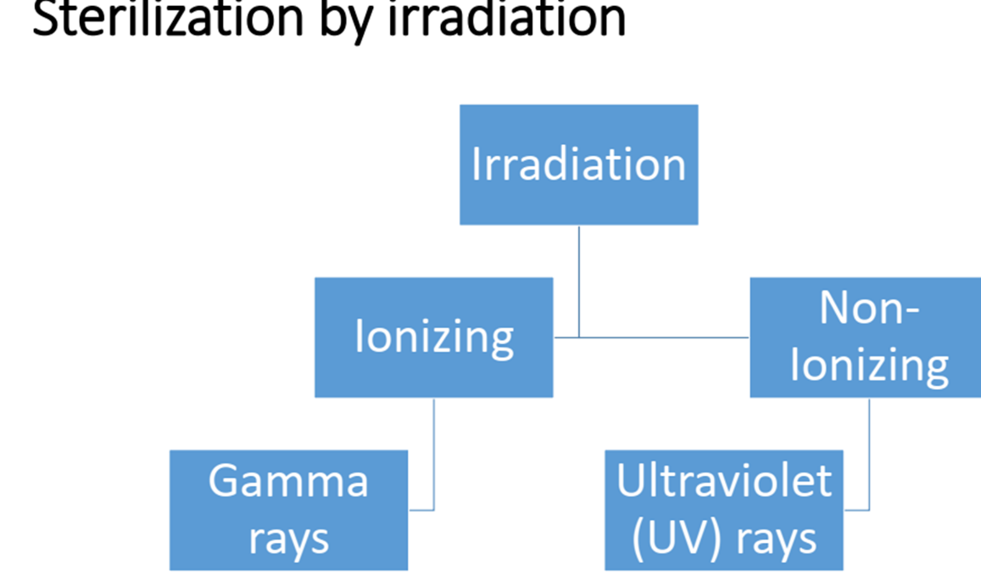

Ultraviolet radiation
Used for.
1. Sterilization of operating theatre
2. Sterilization of the interiors of biological safety cabinets

Ionizing irradiation (gamma rays)
• Used for sterilization of an article not stand heat as rubber catheters, gloves, plastic syringes.
Chemical methods of Sterilization

B-Chemical methods of Sterilization

• Disinfectant: are chemical materials used for sterilization but are toxic to the human tissues and cells.

• Antiseptics: are chemicals for sterilization but not toxic to the human body e.g. "mouth gargles".
1-Phenol and Phenolic
Phenol (carbolic acid): was first used as a disinfectant but rarely used today because it is a skin irritant and has strong odor.
Phenolic: are chemical derivatives of phenol
0.01% - 0.05% Chlorhexidine vaginal wash, OR hand-wash
3% - 5% carbonic acid or 2% Lysol floor or surface disinfection

2- Halogens (Effective alone or in compounds)
Iodine:
Iodine (alcohol solution) was one of first antiseptics used.
Iodophore used as skin antiseptics in surgery.
Chlorine:
When mixed in water forms hypochlorous acid:
Cl2 + H2O ------> H+ + Cl- + HOCl
Hypochlorous acid
Used to disinfect drinking water, pools, and sewage.

3- Alcohols
. Kill bacteria, fungi, but not endospores or naked viruses.
. Act by denaturing proteins and disrupting cell membranes.
. Used to mechanically wipe microbes off skin before injections or blood drawing.
. Not good for open wounds, because cause proteins to coagulate.

Ethanol (Optimum concentration is 70%)
4-Detergents: surface active agents surfactants that disrupt the cell membrane like soaps.
5- Heavy Metals
. Include copper, mercury, silver, and zinc.
. Very tiny amounts are effective.
Silver
1% silver nitrate used to protect infants against gonorrheal eye infections, now has been replaced by erythromycin.
Mercury
Organic mercury compounds are used to disinfect skin wounds.
Copper
Copper sulfate is used to kill algae in pools and fish tanks.
Zinc : zinc chloride is used in mouth washes ,
zinc oxide is used as anti fungal agent in paint.

6- Aldehydes
. Include some of the most effective antimicrobials.
. Inactivate proteins by forming covalent cross links with several functional groups.
Formaldehyde:
- Formalin was used extensively to preserve biological specimens and inactivate viruses and bacteria in vaccines.
Irritates mucous membranes, strong odor.
Glutaraldehyde:
- Less irritating and more effective than formaldehyde.
- Commonly used to disinfect hospital instruments.

7- Gaseous Sterilizers
Chemicals that sterilize in a chamber similar to an autoclave.
Ethylene Oxide
Kills all microbes and endospores, but requires exposure of 4 to 18 hours.
Most hospitals have Ethylene Oxide chamber to sterilized mattresses and large equipment.

8- Oxidizing Agents
. Oxidize cellular components of treated microbes.
. Disrupt membranes and proteins.
Ozone:
. Used along with chlorine to disinfect water.
. Helps neutralize unpleasant tastes and odors.
. More effective killing agent than chlorine, but less stable and more expensive.
. Made by exposing oxygen to electricity or UV light

9-Hydrogen Peroxide:
. Not good for open wounds because quickly broken down by catalase present in human cells.
Effective in disinfection of inanimate objects.

.Used by food industry and to disinfect contact lenses.

