Herbarium specimen
is as a pressed plant sample with collection data deposited for future reference. It supports research work and may be examined to verify the identity of the specific plant used in a study
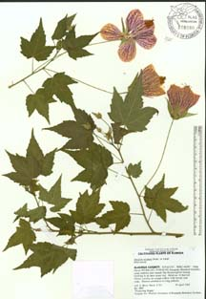

Initial Preparations
Preplanning for the preparation of voucher specimens is crucial.
- Target your collection locations and date periods to obtain useful specimens. Existing herbarium specimens and published research should be of help.
- Obtain collection permits from appropriate agencies (this can take months to a year). An understanding of export and import regulations should also be considered for international work.
- Establish official contact with government, herbarium, and research personnel in the area you will be working. This is required by law in most countries.
- Make arrangements with a herbarium to deposit your specimens.
- Assess and purchase collecting equipment and supplies: consider what you will need to prepare the specimens, e.g., plant press, plant drier, pruning shears, shovels, pressing papers, markers to write on the pressing papers
step 1: collecting - where to collect
When looking for specimens to add to your herbarium, the best places to look are along edges- here is where you will find the most diversity. Look along pathways, and field and woodland borders. Fence lines and railways also have a great variety, as the plants here are protected from the frequent trimming other areas are subjected to. Never collect from private property, and use caution along roadways!

step 1: collecting - what to collect
Plants are easiest to identify when flowering and press best when they have fresh blooms. Keep an eye out for plants that are close to blooming, and collect a sample as soon as the flowers open! Always collect healthy, pest-free, and dry specimens- all these things will ensure a better quality press. Be sure to collect all parts of the plant that can help in identification, including flowers, seed pods, and basal leaves if they differ from those on the stem.
Note
unique characteristics, such as smell, texture, height, and general growing conditions, all of which will aid in identification but are not necessarily noticeable in a dried specimen. Be sure to keep record of the date each specimen was collected!
step 2: preparation - protecting the specimens
After collecting, protect the specimens from damage during transport. Place them in sealable plastic bags within a sturdy leather satchel to help retain moisture and to protect them from both heat and breakage. For best results, press the plants immediately after returning from collecting. Recover slightly wilted plants by placing the stems in water for a short time prior to pressing, making sure to dry them again thoroughly before adding them to the press. If pressing must be delayed, some sturdier plants can tolerate being stored in the refrigerator in their plastic bags for up to a day’s time.
After collecting, protect the specimens from damage during transport. Place them in sealable plastic bags within a sturdy leather satchel to help retain moisture and to protect them from both heat and breakage. For best results, press the plants immediately after returning from collecting. Recover slightly wilted plants by placing the stems in water for a short time prior to pressing, making sure to dry them again thoroughly before adding them to the press. If pressing must be delayed, some sturdier plants can tolerate being stored in the refrigerator in their plastic bags for up to a day’s time.
step 2: preparation - arranging the specimens
I use sheets of thin plywood, with sheets of parchment paper above and below the plant for pressing. I personally have had the best results using parchment paper as opposed to newsprint, which can pull the color from the blossoms. Do note, that I work mostly with delicate wildflowers, for which this method works well. Plants with a higher moisture content, such as garden varieties with double blooms or those To ensure that the plants dry evenly, place only plants with similar thicknesses and moisture content together on a single layer. Arrange plants to minimize overlapping parts, taking extra care to isolate the blooms. The arrangement should highlight special parts of the plant that are critical for identification, such as leaf backs or cross-sections of flowers. To hold plants in the desired place, I use strips of the parchment paper and transparent tape, avoiding contact between the blossoms and the tape. When arranging the plant, be mindful of the natural structure of the plant to avoid unnatural-looking compositions.

step 3: pressing - pressing the specimens
After proper preparation, load the plants into the press, making sure there is a layer of parchment between the plants and the plywood dividers on both top and bottom. After the press is full, apply pressure to keep the plants flat while they dry. This ensures the plants remain flat enough to prevent bubbling, but also helps ensure they are not getting squashed beyond recognition. A stack of heavy books can work in place of a plant press, but lacks the ability to fine-tune the pressure
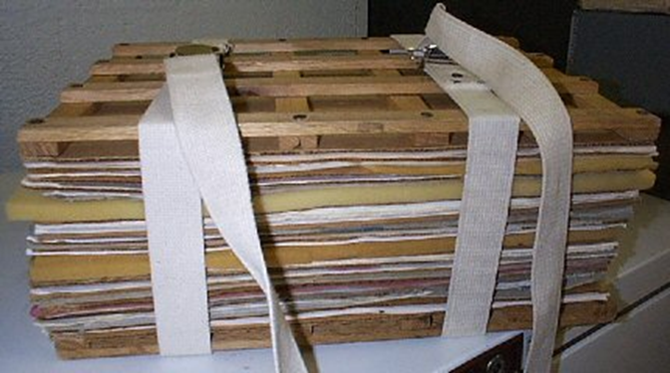
- step 3: pressing - pressing the specimens (continued)
- After 24 hours, open up the press and observe the plants. If the parchment on top of the plants is wrinkling with moisture, it can be replaced with a fresh sheet. The specimens are still pliable at this time and can be rearranged slightly into their final positions if needed. Resist the urge to rearrange or remove the paper from very thing or delicately petaled specimens at this stage, as they may fold up on themselves if the paper is removed. Close the press and reapply the pressure, a bit more tightly than was done the previous day. Leave the plants in the press for about 5 days before checking again- I have found that most plants need about a week until fully dry, while some fleshier plants can take up to two weeks. Remove plants from the press as they are dry and readjust the pressure for those that remai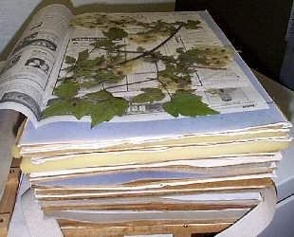n.
- step 4: mounting - mounting the specimens
- Once the plants are dry, they are ready to be mounted. It is important to use acid-free paper and adhesive to help ensure preservation of the specimens.
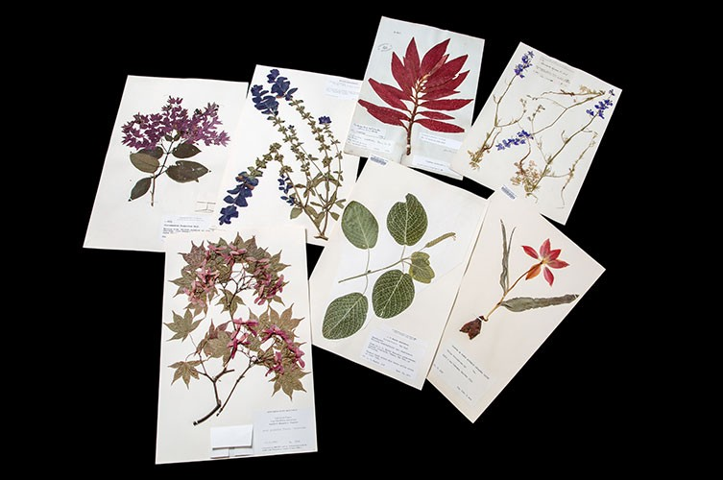
step 5: freezing - freezing the specimens
After mounting the specimens, I again lay each one between layers of parchment paper, separated by the plywood dividers as they were in the press. This stack of specimens is capped with thick boards on either side, wrapped in plastic foil, and strapped together tightly with adjustable belts. The entire stack is then placed in the freezer for 72 hours- an important step for eliminating any potentially harmful insects or fungus that might still be residing in the specimens. The plastic foil protects the specimens from condensation, and the pressure from the belts keeps the specimens flat and ensures good contact to the paper as the mounting glue dries.
step 6: identification - identifying the specimens
Identification should ideally be done as soon as the plants are collected and before they are pressed. But it is a time intensive step which I often do not complete before the plants begin to wilt. So I often find myself identifying the plants after they are already pressed and mounted. For this to be effective, be sure to record observations from the fresh plant that may not be retained in the pressed specimen, such as color, scent, and stem and hair structure. Invest in a good dichotomous key that identifies plants in your immediate area- I highly recommend “Flora Helvetica” in Switzerland and the surrounding countries. Also invest in a good hand lens, to magnify the small but important identifying characteristics.

step 6: identification - identifying the specimens (continued)
Once I have identified a plant, I compare the specimen to various photographs of that species for confirmation. But even more useful for confirmation are botanical illustrations, which illustrate each plants specific identifying characteristics better that photographs can.

step 7: cataloging and storage - preserving the specimens
Each plant is assigned a number, linking it to the digital database where the corresponding photographs and plant information is stored. To protect the herbarium specimens from damage, I insert each into a transparent, acid- free plastic or paper sleeve, and label it with the identification number, botanical and common name, and place and date of collection. The final specimens are stored in wooden cases to protect them from light damage. Cedar shavings in the cases help deter insect pests. The specimens should be inspected frequently for signs of insect damage, and refrozen (Step 5) if extermination is needed.

