WEED INDICES
“weed indices are use to study the effect or weed density growth and suppression effect of weed on crop plant. The common indices uses for weed flora study are Weed Infestation, weed index and Weed control efficiency”
Weed indices provide a logistic support in impact assessment, interpretations and drawing appropriate conclusions in weed management research.
The under listed terms provide a logistic support in impact assessment, interpretations and drawing appropriate conclusions in weed management research.
OBJECTIVE OF WEED INDICES
- To study the weed and crop response to weed control treatment
- To study the efficiency of herbicide
- To determine the efficiency of intercropping system in suppression of weed
Different weed indices
• Weed infestation
• Weed index
• Weed persistence index (WPI)
• Herbicide efficiency index (HEI):
• Weed Control Efficiency (WCE):

WEED INFESTATION
- It refers to the percentage of weeds in the composite population of weed and crop plants.

$$WI=\frac{Total number of weeds in an unit area }{Total number of weed and crop plants in the same area}×100$$

Weed Index
Weed Index = It refer to the reduction in crop yield due to the presence of weed in comparison to weed-free plots.

Where X and Y are the yield of weed free and herbicide-treated plots, respectively.
This is used to assess the efficacy of a herbicide.
Lesser the weed index, better is the efficiency of a herbicide.
WEED INDEX COUNTI..
Example: Calculate the weed index for atrazine applied in the maize from the following data:
- Yield of maize from weed free plot = 20 q/ha
- Yield of maize from atrazine treated plot = 1 8 q/ha
Weed $index for atrazine=\frac{20-18}{20}×100$ =10%
Weed persistence index (WPI)
- This index indicates the resistance in weeds against the tested treatments and confirms the effectiveness of the selected herbicides, and the same was computed using the given formula

Where DWT and DWC were dry weight of weeds of treated and control plots respectively, while WNT and WNC are number of weeds in the treatment and control, respectively
Data on weed dynamics (density, dry weight) were recorded at 45 DAS from two randomly selected quadrants (50×50 cm) from each experimental unit. Weeds were counted individually and clipped at ground level to record their biomass. Weed dry weight was recorded after drying in an oven at 70 ºC for 48h this data were further used to compute different indices
Herbicide efficiency index (HEI):
Herbicide efficiency indices express the tolerance of weeds to different herbicide treatments as well as their efficiency to eradicate the weeds.
This was calculated according to the following equation as implemented by Khaliq et al.,(2014).
$$HEI=\frac{YT-YC}{YC}×100 / \frac{DWT}{DWC}×100$$
Where YT and YC were yields of treated and control plots respectively, while DWT and DWC are weed dry weight in treatment and control, respectively.
Weed Control Efficiency (WCE):
It indicates the percentage reduction in weed population or dry weight of weeds under treated plot (herbicide) in comparison to untreated plot (weedy).
This index is used to compare the different weed control treatments. It is also known as Weed Control Index (WCI).
Higher the WCE, better is herbicidal / weed control treatment.

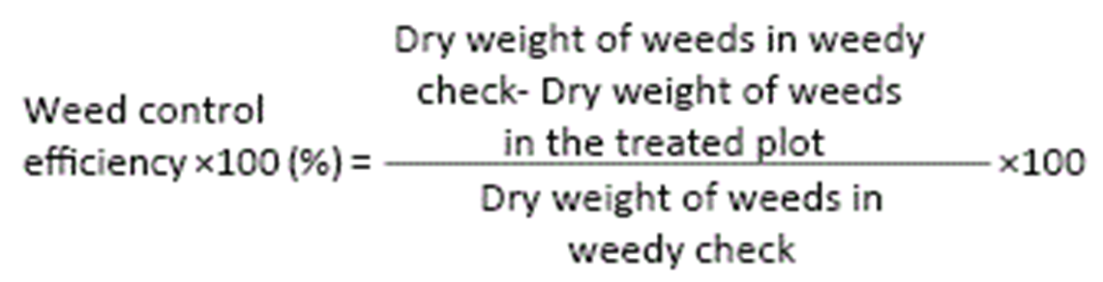

Example : In a weed control experiment in wheat crop, dry-weight d weeds in un weeded plots was 500 kg/ha, whereas in isoproturon and metsulfuron treated plots, it was 250 and 150 kg/ha, respectively. Find out the WCE and report which one herbicide in better Solution
1.) WCE for isoproturon = $\frac{500-250}{500}$×500 = 50%
WCE for metsulfuron $=\frac{500-150}{500}$ ×500= 70%
Result Since the WCE of metsulfuron is higher (70%) than that of isoproturon (50%), so metsulfuro is better than isoporoturon in controlling weeds in wheat crop.

