Seed
“ A mature plant ovule containing an embryo”
A seed, which develops from an ovule, consists of a partially developed embryo and none or various amount of food storage tissue (endosperm) covered by a protective seed coat (testa), which derived from sexual function (fertilization).
The typical seed consists of three main parts are:
a- Embryo (zygote).
b- Storage food (endosperm).
c- Seed coats (testa).

- Embryo (zygote):
The fertilized egg cell or zygote is develops into an embryo which consists at first exclusively of cells that are embryonic tissue capable of division.
- Food storage (endosperm):
Food storage tissue (endosperm) sustains that germinating embryo until root and leaves are functionally developed. Endosperm cells contain mostly starch with lesser amounts of proteins, oils and / or fats.
- The seed coat (testa):
Is the outer protective covering of seed, which made up of the ovules, usually the seed coat is very thick and may be colored.

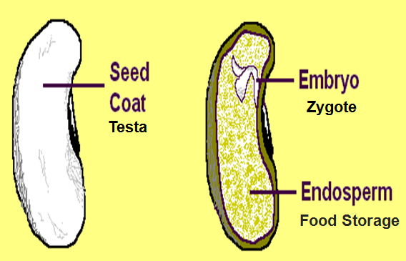

Monocot seed:
Monocots or grain fruits (caryopsis) have only one seed leaf (cotyledon) which enclose young leaves over the shoot apical meristem and a protective cap over the root apex. It is often only a thin leaf, because the endosperm to feed the new plant is not inside the seed leaf.
Characteristics of monocotyledons
- One seed-leaf
- Leaves have parallel viens
- E.g. grass & maize
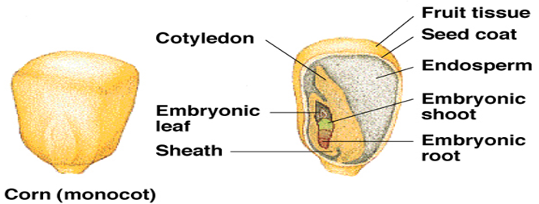

Dicot seed:
Dicots have two seed leaves (cotyledons) inside the seed coat, As the bean seed splits in half, only one cotyledon is shown . They are usually rounded and fat, because they contain the endosperm to feed the embryo plant. Between the cotyledons is the hypocotyl axis with the epicotyls (shoot meristem) at one end, and radicle (root meristem) at the other end.
Characteristics of Dicotyledons
- Two seed-leaves
- Leaves have veins in network
- e.g. trees, sunflower, rose
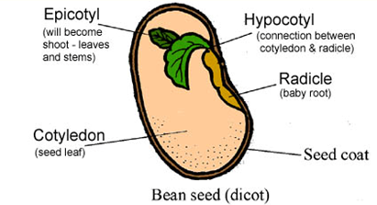

Methods to seed determination and distinction:

- Morphological description:

- Seed form and shapes:

There are different kinds of seed shape, globular e.g. chick pea, green gram and field pea, lens-shaped e.g. lentil, kidney-shaped e.g. broad bean and kidney bean, irregular e.g. sugar beet seed.

b. Seed size:
- Very small e.g. tobacco, Egyptian clover.
- Small e.g. barley, wheat.
- Medium e.g. green gram.
- Big e.g. bean, cow pea.
- Very big e.g. broad bean, ground nut.

c. Seed surface:
- Glossy: e.g. kidney bean.
- Roughish: e.g. chick pea.
d. Seed colors:
- White e.g. safflower.
- Green: e.g. green gram.
- Brown: e.g. broad bean.
- Black: e.g. black seed.
- Speckled: e.g. cow pea.
2- Feeling method (by feel): smelling or tasting or rubbing.

3- Laboratory methods:
a. Chemical testing (analyzing treatment):
This method uses to distinguishing between the many varieties in one species for example differentiation the varieties of wheat by phenol 1%.
b. Pathology:
Able to distinct varieties by its immunity.

c. Anatomy:
By the transverse or longitudinal sections of seed, can distinguish the embryo or cotyledons position in seed to determination.

Advantage of seed identification:
1- The seed sizes using to limiting seed amount for lot of land (area) requirement for example, the broad beans need 20-30kg/donum, while on the other hand to cultivation tobacco in green house needs only one table spoon of seed.

2- The relationship between seed size and soil preparation, the small seed cultivation needs good smothering, pulverization and a little depth for seeding to obtain better grow, and sequent plentiful yield.

3- Seed weight and size also has an important role to determination irrigation type and number with time of irrigation.

4- Seed form (shape) and its surface structure limit the germination period and a requirement of water and available water of soils. In other hand some crop seeds, e.g. most legume seeds needed maceration process before cultivation.

5- Seed types have different farming and seed bed.

