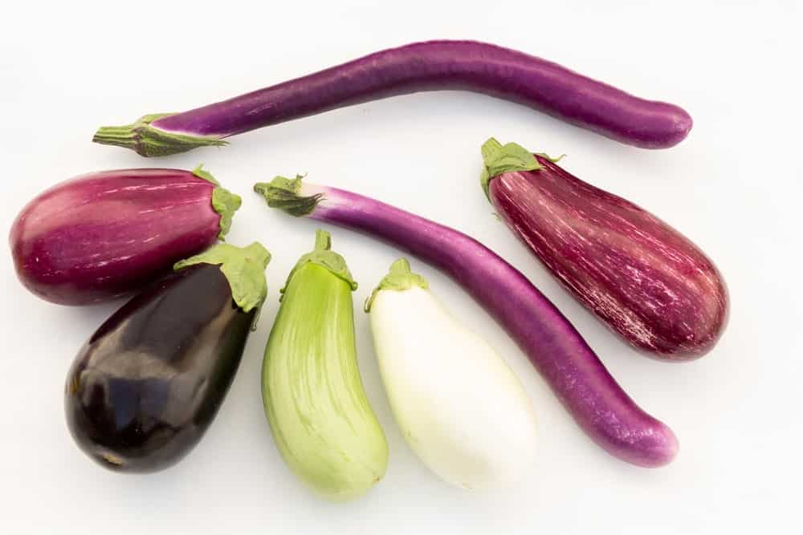
Eggplant
(Solanum melongena L)
Family: Solanaceae
Introduction:
Eggplant is a delicate perennial often cultivated as an annual crop belong to solanaceae family. The eggplant, also known as aubergine, garden egg, guinea squash, melon gene, and brinjal, usually has an egg-like shape and a vibrant purple color. It is rich in fiber, low in calories, it provides a range of nutrients. Eggplants also contain flavonoids, such as anthocyanins. Anthocyanins are water-soluble pigments that have many health benefits. They also help give the eggplant its well-known, dark purple color. The skin of the eggplant is rich in antioxidants, fiber, potassium, and magnesium. Although the dark purple version of eggplants is best known, the shape, size, and color can vary from small and oblong to long and thin, and from shades of purple to white and green.

Origin: Eggplant is native to India.
Health Benefits of Eggplants:
1-Aid in Digestion: Eggplants, like many other vegetables, are great sources of dietary fiber, a necessary element in any balanced diet.
2-Weight Loss: Since eggplants contain a minimal amount of fat or cholesterol, they are a very healthy food in lose weight.
3-Prevent Cancer: Eggplants are also great sources of antioxidants, one of the body’s best lines of defense against a wide variety of diseases and conditions. Eggplants contain vitamin C, which is a key part of the immune system since it stimulates the production and activity of white blood cells. Also, eggplants contain manganese, which is a natural antioxidant and an essential mineral.
4-Improve Bone Health: Phenolic compounds are what give eggplants and many other fruits their unique coloration. Eggplants also have significant amounts of iron and calcium, which are integral to bone health and overall strength.
6-Improve Brain Function: Eggplants are wonderful sources of phytonutrients, which increase blood flow to the brain by delivering more oxygen-rich blood to the brain.
7-Improve Heart Health: Eggplant have been known to reduce the presence of “bad” LDL cholesterol in the body, and stimulate the uptake of “good” HDL cholesterol. Reducing LDL cholesterol can prevent heart diseases.
Environmental conditions:-
Temperature: Eggplant is a summer-growing vegetable that requires warm to hot conditions during the 5–6 month growing period to produce high yields and quality fruit. Cool weather will retard plant growth and reduce yields, however can survive certain amounts of cold units, but are intolerant to very low temperatures. Affected plants seldom recover, even if favorable growing conditions return. The optimal growing temperature range is 21– 30 °C, with a maximum of 35 °C and a minimum of 18 °C. The optimal soil temperature for seed germination is 24–32 °C. Young seedlings are sensitive to frost.
They do best on light-textured soils such as sandy loams or alluvial soils that are deep and free draining.
Soil requirements: Eggplants are moderately deep rooting and can be grown on a wide range of soils, a deep, fertile and well drained sandy loam soils. These soils warm up quickly in spring and are suitable for early plantings. Avoid soils with high clay content. A soil pH between 6.0–7.0 is desirable.
Irrigation: Irrigation is essential during the long growing period. Excessive dry periods can cause shedding of flowers and developing fruit. The amount of irrigation water needed depends on soil type, weather condition, the development stage, depth of root, and crop growing methods. Sandy soil must be watered more frequently than clay soil. The method of applying irrigation water depends on soil texture, topography, and water supply. Generally furrow and drip irrigation are used in eggplant production. Mulching with black polyethylene will maintain more uniform soil moisture between irrigations.
Fertilization: The nutrient requirement of eggplants is similar to that of tomatoes. Organic manure, such as poultry manure, applied at 12–15 t/ha 4–6 weeks before transplanting, will supply organic matter, add nutrients, improve soil structure and help to retain moisture in the soil. If using only artificial fertilizers, apply a low-analysis N: P: K mixture, such as 5:7:4 at 1200–1500 kg/ha, before transplanting. Regular applications of nitrogen at 25–30 kg/ha are needed during the growing season. Apply the first when plants are 30 cm high and the second after the first set of fruit then at 1–2 week intervals, depending on the growing conditions. On lighter soils, which are readily leached, extra nitrogen and potassium should be applied. Several applications of potassium nitrate at up to 200 kg/ha can be used.
Ripening and harvesting:
Fruit size is determined by variety and market requirements. Traditional teardrop shape fruit varieties are ready for harvest 50–70 days after transplanting or one month after fruit set. These varieties can crop for up to five months. Market trends have been towards smaller size fruit of 7–10 cm diameter and 12–15 cm long. Long, slim, cylindrical varieties can be picked when 1–2 cm in diameter and 5–10 cm long. The fruit is harvested when it reaches a glossy deep purple but before seeds begins to harden and turn brown. Over-mature fruit have a dull colour, crinkled skin, spongy feel and wrinkled stem.
Quantity of yield: 30-40 tons/ha of marketable fruit.
Storage: Eggplant does not have a long storage life and should be marketed immediately after harvest. It can be stored safely for 7 to 10 days at 10-12 °C and 90-95% relative humidity.

