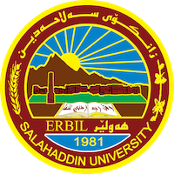

**Academic Curriculum Vitae**

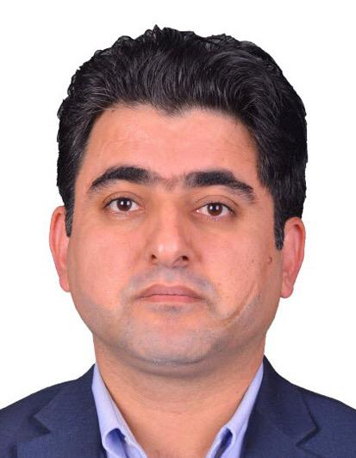**Personal Information:**

Full Name: Khattab Azeez Sulaiman

Academic Title: Assistant Lecturer

Email: khattab.sulaiman@su.edu.krd

Mobile: 009647504825899

**Education:**

* Bachelor Degree in Sociology in College of Arts-salahaddin University Erbil -Iraq2006
* Master degree in sociology in college of Arts -Alexandria University – Egypt 2015

**Employment:**

* 2007 – 2011 Assistant Researcher of Sociology, University of Salahaddin, Erbil, Kurdistan. Salahaddin University -Erbil.
* 2011-2015 Researcher of Sociology , University of Salahaddin, Erbil, Kurdistan. Salahaddin University -Erbil.
* 2015-2018 lecturer in philosophy Department .
* 2019-present Assistant Lecture

**Qualifications**

-Teaching methods, Salahaddin University-Continuing Education, Erbil, Kurdistan, juh-jul2015

-IELTS Academic Test Report, Overall Band Score (4.5) Date: 13-12-2018

-English Language Course, Alexandria University, Alexandria, Egypt.1December 2013-24febriwary 2014.

-Arabic Language Course, Languages and Translation Unit, College of Arts, Alexandria University, Egypt.Oct-Dec2014

-English Language Course (160 hours, Listening, Speaking, Reading, Comprehension, Vocabulary, Grammar and essay Writing Course 24 January -20april -2009

**Teaching experience:**

Faculty Member and Lecturer, the Salahaddin University, College of Arts, Dep. of sociology. Erbil, Kurdistan Iraq.

2015 Trainer from Peace and Freedom Organization Kurdistan (PFOK). PFOK is a local NGO in the Kurdistan region that works on education, unemployment and freedom of expression.

2015 – 2016 Lecturer, the Educational and Psychological Dep , Education College, Salahaddin University/Erbil, Kurdistan.

**Research and publications**

* 2018 Private schooling and national identity in the Iraqi Kurdistan region (Forthcoming)
* 2016 Islamic educational curriculum analysis study for education programs in the basic stage.
* 2017 Survey of the Peshmerga , for PHD Candidate in the Political Science Department- Massachusetts (MIT)
* 2017 Data Collector, evaluator, infinitas international LTD AN Evaluation project of HIP project was funded by EU 1.7 Million pounds
* 2017 Gender violence Iraqi Kurdistan region (Not yet published)
* 2017 Social Cohesion Contextual Analysis, for Oxfam, Erbil Office ( questioner with Interview)
* 2017 An Examination of Muslims Responsibilities form Religious Minorities Perspectives – The 3rd Lalish Conference for peace and Coexistence: the civic Guarantees Sustainable Peace 25-26/4/2017 American University in Dihouk Conference.
* 2017 Social Integration in the Privet Schools, Analytical study for the integration reality in the Privet school
* 2016 Demonstrate Law between Theory and Practice, Analytical study for The Kurdistan Demonstrate Right Law .
* 2018 The situation of new marriages In Erbil. A survey for Kurdistan Union Women’s

**Conferences and courses attended**

Dignity of the family from the perspective of religion in 28 February2023 and published research (family disputes in Kurdish society)

**Funding and academic awards**

Attended the Training about Disabilities and Sustainable Development , University of Rouen Normandy,19-24-6-2022 France

**Professional memberships**

* 2008 - Present Kurdistan Institute for Human Rights.
* 2006 - Present Kurdistan Sociological Association.
* 2015-Present Peace and Freedom Organization
* 2013-present stop Organization for Anti-corruption
* 2005-2008 American Society for Kurd ASK
* 2016-present Aram House for Old care and Social Consulate
* 2019-present Zhin Association for Disability

**Professional Social Network Accounts:**

* Facebook <https://www.facebook.com/khattab.azeez?mibextid=LQQJ4d>
* Linkden [linkedin.com/in/sulaiman-sulaiman-35bb6215b](https://www.linkedin.com/in/sulaiman-sulaiman-35bb6215b?lipi=urn%3Ali%3Apage%3Ad_flagship3_profile_view_base_contact_details%3BYn%2FsXyIYSqC69Upy%2BkNjRA%3D%3D)

**More Activities**

2008 5 january- 15march Trainer of Human Rights Basics for 20 High and Secondary schools in Erbil, Submitted by Kurdistan Institute for Human Rights.

2009 1April-20june Trainer of Social Relationship and Good use for IT, for 30 high Schools, Institutions, Colleges, in Erbil submitted by Women Empowerment Organization (WEO).

2010 20July-1August Trainer of Keep Environment and develop it for 100 yang’s, in Soran Town –Erbil, Submitted by Together to Protect human and Environment Association.

It is also recommended to create an academic cover letter for your CV, for further information about the cover letter, please visit below link:

<https://career-advice.jobs.ac.uk/cv-and-cover-letter-advice/academic-cover-letter/>