Group I, the alkali metals.
The alkali metals – lithium, sodium, potassium, rubidium, cesium and francium – are members of group 1 of the periodic table, and each has a ground state valence electronic configuration ns¹.
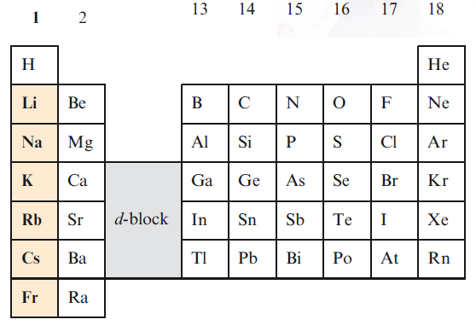
Occurrence, extraction and uses
Sodium and potassium are abundant in the Earth’s biosphere (2.6% and 2.4% respectively) but do not occur naturally in the elemental state.
The main sources of Na and K are rock salt (almost pure NaCl), natural brines and seawater, sylvite (KCl), sylvinite (KCl/NaCl) and carnallite (KCl.MgCl₂.6H₂O).
Other Na- and K-containing minerals such as borax Na₂[B₄O₅(OH)₄].8H₂O
Extraction
Sodium is economically the most important of the alkali metals, and is manufactured by the Downs process in which molten NaCl is electrolyzed:
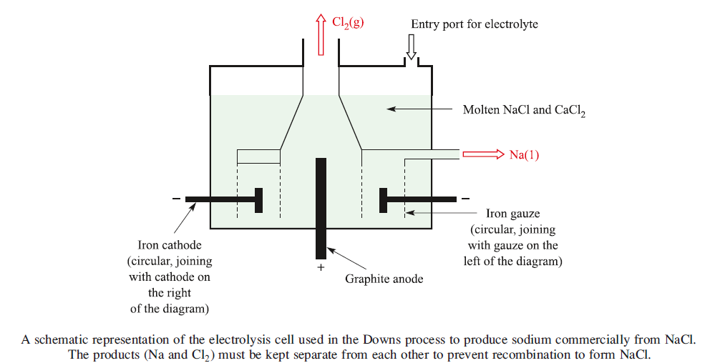
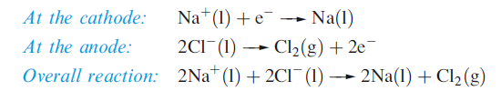
Lithium is extracted from LiCl in a similar electrolytic process. LiCl is first obtained from the silicate mineral spodumene (LiAlSi₂O₆) by heating it with CaO to give LiOH, which is then converted to the chloride. Potassium can be obtained electrolytically from KCl, but a more efficient method of extraction is the action of Na vapour on molten KCl in a counter-current fractionating tower. This yields an Na–K alloy which can be separated into its components by distillation. Similarly, Rb and Cs can be obtained from RbCl and CsCl, small quantities of which are produced as by-products from the extraction of Li from spodumene.
Small amounts of Na, K, Rb and Cs can be obtained by thermal decomposition of their azides.
An application of NaN₃ is in car airbags.
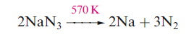
Lithium cannot be obtained from an analogous reaction because the products recombine, yielding the nitride, Li₃N

Major uses of the alkali metals and their compounds
Lithium has the lowest density (0.53 g cm⁻³) of all known metals. It is used in the manufacture of alloys, and in certain glasses and ceramics. Lithium carbonate is used in the treatment of bipolar (manic-depressive) disorders, although large amounts of lithium salts damage the central nervous system.
Sodium, potassium and their compounds have many uses of which selected examples are given here. Sodium–potassium alloy is used as a heat-exchange coolant in nuclear reactors. A major use of Na–Pb alloy was in the production of the anti-knock agent PbEt₄, but the current demand for unleaded fuels now renders this of minimal importance. The varied applications of compounds of Na include those in the paper, glass, detergent, chemical and metal industries.

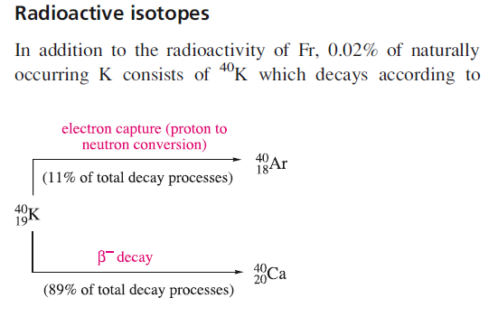
The overall half-life for both the b-decay and electron capture is
$1.25×{10}^{9}yr$.

The metals
Appearance
The metals Li, Na, K and Rb are silvery-white, but Cs has a golden-yellow cast. All are soft, Li the least so, and the trend is consistent with their melting points.
The particularly low melting point of Cs (301.5 K) means that it may be a liquid at ambient temperatures in some hot climates.

Reactivity
Although Li, Na and K are stored under a hydrocarbon solvent to prevent reaction with atmospheric O₂ and water vapour, they can be handled in air, provided undue exposure is avoided; Rb and Cs should be handled in an inert atmosphere.
Lithium reacts quickly with water, Na reacts vigorously, and K, Rb and Cs react violently with the ignition of H₂ produced.
Sodium is commonly used as a drying agent for hydrocarbon and ether solvents.
All the group 1 metals react with the halogens and H₂ when heated
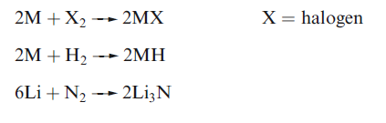
The alkali metals dissolve in Hg to give amalgams. Sodium amalgam is a liquid only when the percentage of Na is low. It is a useful reducing agent in inorganic and organic chemistry.

Alkaline Earth Metals
Members of group 2 of the periodic table (second vertical column) are called earth alkaline metals. In this group are included the following elements: beryllium (Be), magnesium (Mg), calcium (Ca), strontium (Sr), barium (Ba) and radium (Ra). Radium is a radioactive element.
Earth alkaline metals together with the alkali metals form the so-called s-block metals. Earth alkaline metals have two electrons in their outer shell which is an s-orbital type. The chemistry of the metals is characterized by the loss of both electrons, which is a result of the relatively low ionisation energy (IE) of both electrons and the subsequent formation of the stable cation M²⁺, which has a noble gas configuration.
Group 2 elements are all silvery-white metals with high reactivity, similar to alkali metals, but less soft and not as reactive. Earth alkaline metals can be mostly found in the earth’s crust in the form of their cations displayed in minerals and not as the elemental metal, as these are very reactive. For example, beryllium principally occurs as beryl (Be₃Al₂[Si₆O₁₈]), which is also known as aquamarine.
The alkaline earth metals are silvery and of fairly low density.
As with the alkali metals, density generally increases with increasing atomic number.
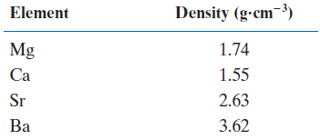
Magnesium can be found in rock structures such as magnesite (MgCO₃) and dolomite (MgCO₃⋅CaCO₃), and is the eighth most abundant element in the earth’s crust. Calcium is the fifth most abundant element and can be found in minerals such as limestone (CaCO₃) and its metamorphs such as chalk and marble.
Earth alkaline metals are harder and have a higher density than sodium and potassium and higher melting points. This is mostly due to the presence of two valence electrons and the resulting stronger metallic bond.
Atomic and ionic radii increase within the group, and the ionic radii are significantly smaller than the atomic radii. Again, this is due to the existence of two valence electrons, which are located in the s orbital furthest from the nucleus.
Extraction
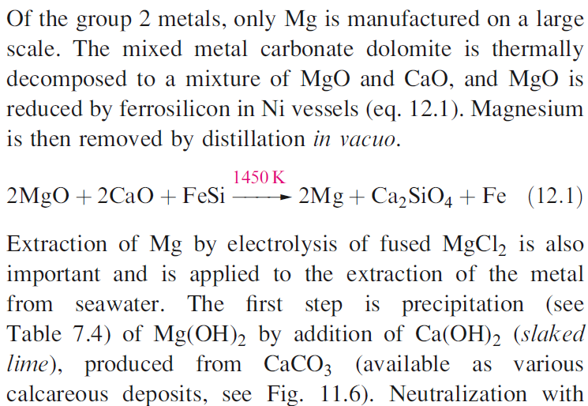
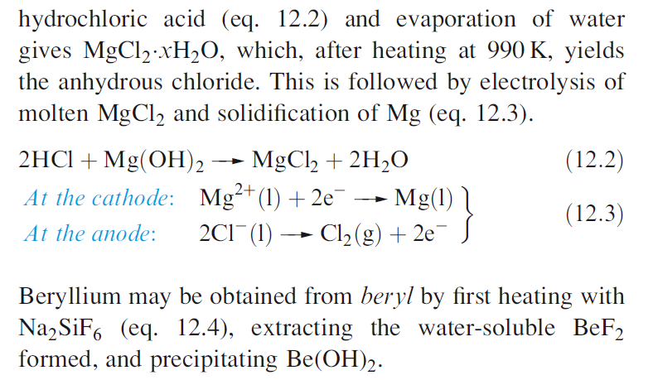
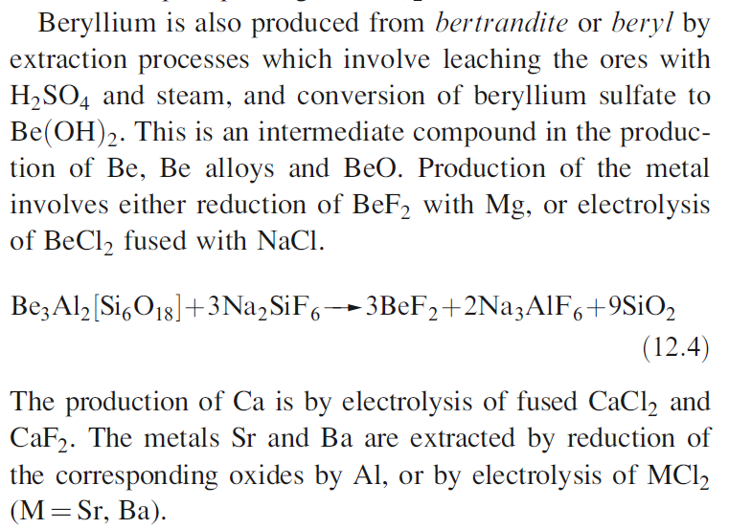

Major uses of the group 2 metals and their compounds
Caution! Beryllium and soluble barium compounds are extremely toxic.
Beryllium is one of the lightest metals known, is nonmagnetic, and has a high thermal conductivity and a very high melting point (1560K).
It is used in the manufacture of body parts in high-speed aircraft and missiles, and in communication satellites. Because of its low electron density, Be is a poor absorber of electromagnetic radiation and, as a result, is used in X-ray tube windows. Its high melting point and low cross-section for neutron capture make Be useful in the nuclear energy industry.
The presence of Mg in Mg/Al alloys imparts greater mechanical strength and resistance to corrosion, and improves fabrication properties. Mg/Al alloys are used in aircraft and automobile body parts and lightweight tools.
Miscellaneous uses include flares, fireworks and photographic flashlights, and medical applications such as indigestion powders (milk of magnesia, Mg(OH)₂) and a purgative (Epsom salts, MgSO₄.7H₂O). Both Mg²⁺ and Ca²⁺ ions are catalysts for diphosphate–triphosphate transformations in biological systems; Mg²⁺ is an essential constituent of chlorophylls in green plants.

Reactivity
Beryllium and magnesium are passivated and are kinetically inert to O₂ and H₂O at ambient temperatures.
However, Mg amalgam liberates H₂ from water, since no coating of oxide forms on its surface. Mg metal reacts with steam or hot water
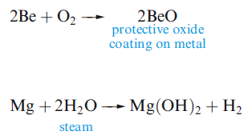
Beryllium and magnesium dissolve readily in non-oxidizing acids. Magnesium is attacked by nitric acid, whereas beryllium reacts with dilute HNO₃ but is passivated by concentrated nitric acid. Magnesium does not react with aqueous alkali, whereas Be forms an amphoteric hydroxide.
The metals Ca, Sr and Ba exhibit similar chemical behaviours, generally resembling, but being slightly less reactive than, Na. They react with water and acids liberating H₂, and the similarity with Na extends to dissolution in liquid NH₃ to give blue solutions containing solvated electrons.
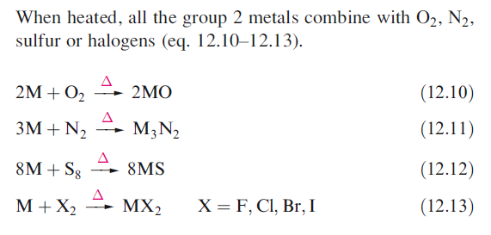
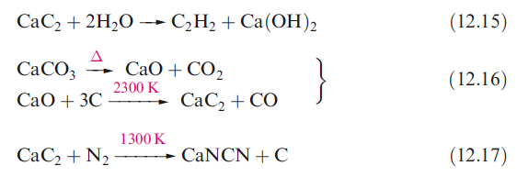

Calcium Carbonate
Calcium is the fifth most abundant element on Earth. It is found largely as calcium carbonate in the massive deposits of chalk, limestone, and marble that occurs worldwide. Chalk was formed in the seas, mainly during the Cretaceous period, about 135 million years ago, from the calcium carbonate skeletons of countless marine organisms. Limestone was formed in the same seas, but as a simple precipitate, because the solubility of calcium carbonate was exceeded in those waters:
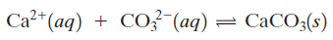
Some deposits of limestone became buried deep in the Earth’s crust, where the combination of heat and pressure caused the limestone to melt. The molten calcium carbonate cooled again as it was pushed back up to the surface, eventually solidifying into the dense solid form that we call marble.
Both marble and limestone have been used as building materials and for sculptures. Unfortunately, the material is readily attacked by acid rain; thus World Heritage buildings such as the Parthenon in Greece and the Taj Mahal in India are in danger of corroding away:
There are three naturally occurring crystalline forms of calcium carbonate: calcite, aragonite, and vaterite.

Calcium Carbide
This compound was first prepared by accident. Thomas “Carbide” Willson was endeavoring to prepare calcium metal by heating calcium oxide with carbon in an electric furnace. A product was formed, and it reacted with water to produce a gas as expected. However, the gas was not the expected hydrogen but acetylene. This synthesis had a major effect on late nineteenth century life. The solid calcium carbide could be easily stored and transported and addition of readily available water released a flammable gas.
Even though CaC₂ is commonly called calcium carbide, the compound does not contain the carbide ion, C⁴⁻. Instead, it contains the dicarbide(2-) ion, $C_{2}^{2-}$, which is commonly called the acetylide ion. The compound adopts the sodium chloride crystal structure, with each anion site being occupied by a dicarbide(2-) unit.
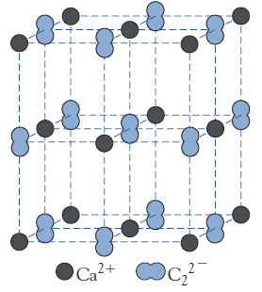
Calcium dicarbide(2–) is prepared by heating carbon (coke) and calcium oxide at about 2000°C in an electric furnace:
Worldwide production has dropped from about 10 million tons in the 1960s to about 5 million tons in the 1990s—China is now the main producer—as the chemical industry has shifted to the use of oil and natural gas as the starting point for synthesizing organic compounds.
The major use of the carbide process is to produce ethyne (acetylene) for oxyacetylene welding:
The very exothermic reaction with dioxygen gives carbon dioxide and water vapor:
Another important reaction of calcium dicarbide(2-) is that with atmospheric nitrogen, one of the few simple chemical methods of breaking the strong nitrogen-nitrogen triple bond. In the process, calcium dicarbide(2-) is heated in an electric furnace with nitrogen gas at about 1100°C:
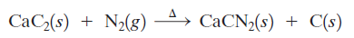
The cyanamide ion, ${\left[N=C=N\right]}^{2-}$, is isoelectronic with carbon dioxide, and it also has the same linear structure. Calcium cyanamide is a starting material for the manufacture of several organic compounds, including melamine plastics. It is also used as a slow-release nitrogen-containing fertilizer:
Biological Aspects
The most important aspect of the biochemistry of magnesium is its role in photosynthesis. Magnesium-containing chlorophyll, using energy from the Sun, converts carbon dioxide and water into sugars and oxygen:
Without the oxygen from the chlorophyll reaction, this planet would still be blanketed in a dense layer of carbon dioxide, and without the sugar energy source, it would have been difficult for life to progress from plants to herbivorous animals. Interestingly, the magnesium ion seems to be used for its particular ion size and for its low reactivity. It sits in the middle of the chlorophyll molecule, holding the molecule in a specific configuration. Magnesium has only one possible oxidation number, +2. Thus, the electron transfer reactions involved in photosynthesis can proceed without interference from the metal ion.
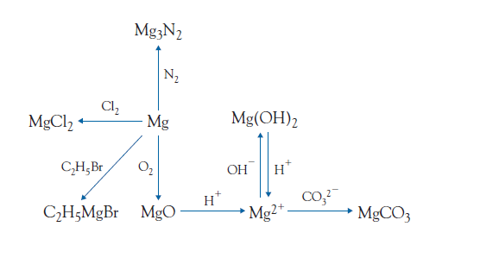

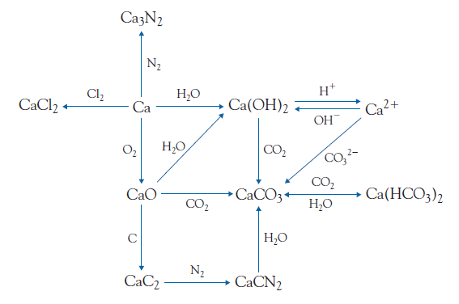

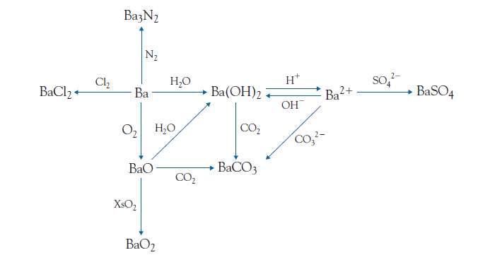
Xs = excess
The Group 13 Elements
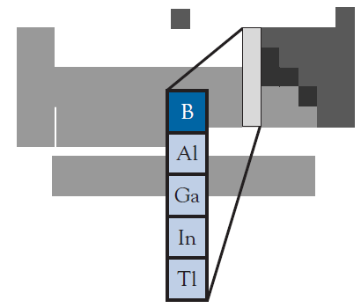
The German chemist Friedrich Wöhler was among the first to prepare pure aluminum metal. He did so by heating potassium metal with aluminum chloride in a redox reaction:

Group Trends
Boron exhibits mostly nonmetallic behavior and is classified as a semimetal, whereas the other members of Group 13 are metals. But even the metals have no simple pattern in melting points, although their boiling points do show a decreasing trend as the mass of the elements increases.
The reason for this lack of order is that each element in the group is organized a different way in the solid phase. For example, in one of its four allotropes, boron forms clusters of 12 atoms. Each cluster has a geometric arrangement called an icosahedron
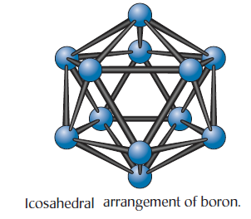
Aluminum adopts a face-centered cubic structure, but gallium forms a unique structure containing pairs of atoms. Indium and thallium each form other, different structures. It is only when the elements are melted and the crystal arrangements destroyed that we see, from the decreasing boiling points as the group is descended, that the metallic bond becomes weaker.
As we would expect, boron, classified as a semimetal, favors covalent bond formation. However, covalency is common among the metallic members of the group as well. The reason for the covalent behavior can be attributed to the high charge and small radius of each metal ion. The resulting high charge density of Group 13 ions is sufficient to polarize almost any approaching anion enough to produce a covalent bond.
It is in Group 13 that we first encounter elements possessing more than one oxidation state. Aluminum has the +3 oxidation state, whether the bonding is ionic or covalent. However, gallium, indium, and thallium have a second oxidation state of +1. For gallium and indium, the +3 state predominates, whereas the +1 state is most common for thallium. At this point, it is appropriate to note that formulas can sometimes be deceiving. Gallium forms a chloride, GaCl₂, a compound implying that a +2 oxidation state exists. However, the actual structure of this compound is now established as [Ga]⁺[GaCl₄]⁻, thus, the compound actually contains gallium in both +1 and +3 oxidation states.
Boron is the only element in Group 13 that is not classified as a metal we classified it as a semimetal. However, on the basis of its extensive oxanion and hydride chemistry, it is equally valid to consider it as a nonmetal. The element can be obtained from its oxide by heating with a reactive metal such as magnesium:
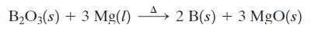
The magnesium oxide can be removed by reaction with acid.
Boron is a vital component of nuclear power plants because it is a strong absorber of neutrons. Boron-containing control rods are lowered into reactors to maintain the nuclear reaction at a steady rate.
Borides
Boron forms a large number of binary compounds. These compounds are all very hard, high melting, and chemically resistant, and they have become of increasing importance as materials that can be used for such purposes as rocket nose cones.
However, the stoichiometry of these compounds is far from simple.
The most important of the compounds is boron carbide, which has the empirical formula B₄C.
One preparative method is the reduction of diboron trioxide with carbon:
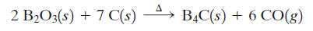
Boron carbide is one of the hardest substances known. Its fibers have enormous tensile strength and are used in bulletproof (المضادة للرصاص.) clothing.
Boranes
Boron is second only to carbon in the number of hydrides that it forms. Over 50 neutral boranes, BnHm, and an even larger number of borane anions, $B_{n}H_{m}^{2-}$, are known.
There are three reasons why the chemistry of boranes is important.
- The shapes of borane molecules are different from those of other hydrides.
- The bonding in boranes has required the expansion of molecular orbital theory.
- The reaction chemistry of the boranes has interesting parallels to, and differences from, organic chemistry.
Structures of Boranes
The simplest borane is B₂H₆ .As can be seen from the figure, one of the most unique aspects of borane chemistry is that hydrogen atoms often act as bridges between neighboring boron atoms.
Also, the boron atoms often form triangular units. Any polyhedron containing triangular faces (such as an octahedron) is generically known as a deltahedron. There are three common classes of boranes and borane anions:
- The closo-cluster, where the boron atoms form a closed deltahedral cage. The generic formula is ${\left[B_{n}H_{n}^{ }\right]}^{2-}$, for example, ${\left[B_{6}H_{6}^{ }\right]}^{2-}$
- The nido-cluster, an open cage cluster derived from a closed deltahedron with one boron atom missing. The common generic formulas are $B_{n}H_{(n+4)}$ or ${\left[B_{n}H_{(n+3)}^{ }\right]}^{-}$, for example, B₂H₆, B₅H₉ and ${\left[B_{5}H_{8}^{ }\right]}^{-}$.
- The arachno-cluster, an open cage cluster derived from a closed deltahedron with two boron atoms missing. The common generic formulas are $B_{n}H_{(n+6)}$ or ${\left[B_{n}H_{(n+5)}^{ }\right]}^{-}$, for example, B₄H₁₀ and ${\left[B_{4}H_{9}^{ }\right]}^{-}$.
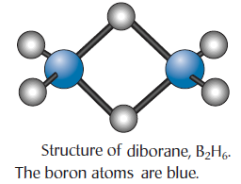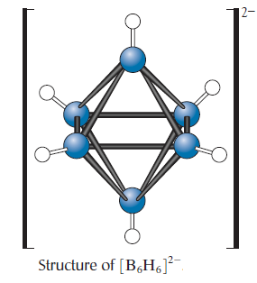
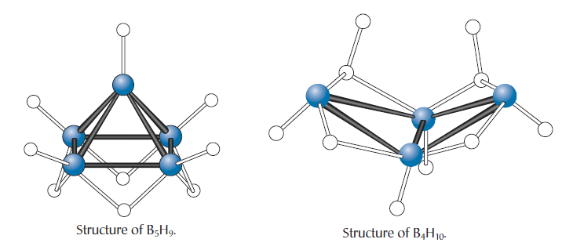
Synthesis and Reactions of Boranes
About 200 tonnes of diborane are produced each year. The industrial synthesis is accomplished by the reaction of boron tri fluoride with sodium hydride to produce toxic, colorless diborane:
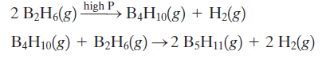
Aluminum
Because aluminum is a metal with a high negative standard reduction potential, it might be expected to be very reactive. This is indeed the case. Why, then can aluminum be used as an everyday metal rather than consigned to the chemistry laboratory like sodium? The answer is found in its reaction with oxygen gas. Any exposed surface of aluminum metal rapidly reacts with dioxygen to form aluminum oxide, Al₂O₃. An impermeable oxide layer, between 10⁻⁴ and 10⁻⁶ mm thick, then protects the layers of aluminum atoms underneath. This can happen because the oxide ion has an ionic radius (124 pm) similar to the metallic radius of the aluminum atom (143 pm). As a result, the surface packing is almost unchanged because the small aluminum ions (68 pm) fit into interstices in the oxide surface structure.
To increase their corrosion resistance, aluminum products are anodized.
In other words, the aluminum product is used as the anode in an electrochemical cell, and additional aluminum oxide is deposited as an electrolytic product over the naturally formed layers. This anodized aluminum possesses an oxide layer about 0.01 mm thick, and this very thick oxide coating has the useful property of absorbing dyes and pigments so that a colored surface can be produced.
The particular attraction of aluminum as a construction metal is its low density (2.7 g/cm³).
Aluminum is a good conductor of heat, a property accounting for its role in cookware. It is not as good as copper, however.
Chemical Properties of Aluminum
Like other powdered metals, aluminum powder will burn in a flame to give a dust cloud of aluminum oxide:
$${4Al}_{(s)}+{3O}_{2(g)}→{2Al}_{2}O_{3(s)}$$
and aluminum will burn very exothermically with halogens, such as dichlorine:
$${2Al}_{(s)}+{3Cl}_{2(g)}→{2Al}_{ }{Cl}_{3(s)}$$
Aluminum, like beryllium, is an amphoteric metal, reacting with both acid and base:
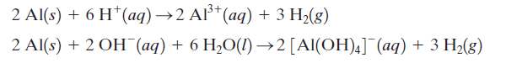
As a result, aluminum 3+ is soluble at low and high pH’s but insoluble under neutral conditions.
Aluminum hydroxide is used in a number of antacid formulations. Like other antacids, the compound is an insoluble base that will neutralize excess stomach acid:
$${Al(OH)}_{3(s)}+{3H}_{(aq)}^{+}→{Al}_{(aq)}^{3+}+3H_{2}O_{(l)}$$
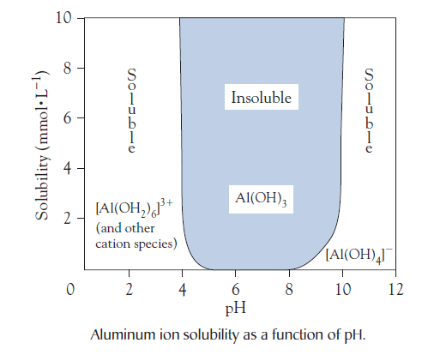

The Industrial Extraction of Aluminum
The discovery of an electrolytic reduction method by the French chemist Henri Sainte-Claire Deville and the decreasing cost of electricity caused the price of metallic aluminum to drop dramatically in the late nineteenth century. However, the production of the metal on a large scale required a method that would use an inexpensive, readily available ore. This route was found independently in 1886 by two young chemists: one in France, Paul Héroult, and one in the United States, Charles Hall. Hence, the process is known as the Hall-Héroult process. Charles was assisted by his sister, Julia, who kept detailed notes of the experiments, though it is now known that she played a quite minor role in the discovery.
The first step in the extraction process is the purification of bauxite. This step is accomplished by digesting (heating and dissolving) the crushed ore with hot sodium hydroxide solution to give the soluble aluminate ion:
The insoluble materials, particularly iron (III) oxide, are filtered off as “red mud.”
On cooling, the equilibrium in the solution shifts to the left and white aluminum oxide trihydrate precipitates, leaving soluble impurities in solution:
The hydrate is heated strongly to give anhydrous aluminum oxide:
With its high ion charges, aluminum oxide has a very large lattice energy and hence a high melting point (2040ºC). However, to electrolyze the aluminum oxide, it was necessary to find an aluminum compound with a much lower melting point. Hall and Héroult simultaneously announced the discovery of this lower-melting-point aluminum compound, the mineral cryolite, whose chemical name is sodium hexafluoroaluminate, Na₃AlF₆.
Silicon tetrafluoride gas reacts with water to give insoluble silicon dioxide and a solution of hexafluorosilicic acid, H₂SiF₆, a relatively safe fluorine-containing compound:
The acid is then treated with ammonia to give ammonium fluoride:
Finally, the ammonium fluoride solution is mixed with a solution of sodium aluminate to give the cryolite and ammonia, which can be recycled:
The aluminum oxide is dissolved in molten cryolite at about 950°C. Molten aluminum is produced at the cathode, and the oxygen that is produced at the anode oxidizes the carbon to carbon monoxide (and some carbon dioxide):
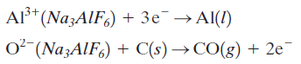
About 25 percent of the output of aluminum metal is used in the construction industry, and lesser proportions are used to manufacture aircraft, buses, and railroad passenger cars (18 percent), containers and packaging (17 percent), and electric power lines (14 percent). Aluminum is becoming increasingly favored for automobile construction.
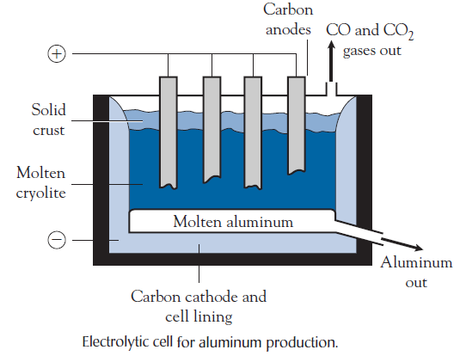
Environmental Issues of Aluminum Production
Aluminum production yields four by-products that create major pollution problems:
- Red mud, which is produced from the bauxite purification and is highly basic.
- Hydrogen fluoride gas, which is produced when cryolite reacts with traces of moisture in the aluminum oxide.
- Oxides of carbon, which are produced at the anode.
- Fluorocarbons, which are produced by reaction of fluorine with the carbon anode.
Aluminum Halides
The aluminum halides constitute an interesting series of compounds: aluminum fluoride melts at 1290ºC, aluminum chloride sublimes at 180ºC, and aluminum bromide and iodide melt at 97.5ºC and 190ºC, respectively.
The bromide and iodide both exist as covalently bonded dimers, Al₂Br₆ and Al₂I₆, analogous to diborane, with two bridging halogen atoms.
Anhydrous aluminum chloride is an important reagent in organic chemistry.
In particular, it is used as a catalyst for the substitution of aromatic rings in the Friedel-Crafts reaction.
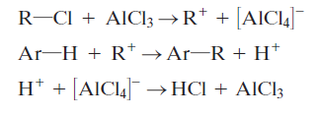
Aluminum Potassium Sulfate
Alum, KAl(SO₄)₂.12H₂O, is the only common water-soluble mineral of aluminum.
As such, it has played an important role in the dyeing industry. To adsorb a dye permanently onto cloth.

Biological Aspects
Boron is an essential micronutrient in plants. The element is believed to play a major role in the synthesis of one of the bases for RNA formation and in cellular activities, such as carbohydrate synthesis. After zinc, boron is the most common soil deficiency worldwide.
The Toxicity of Aluminum
Aluminum is the third most abundant element in the lithosphere. Despite its ubiquitousness in the environment, it is a highly toxic metal. Fortunately, under near-neutral conditions aluminum ion forms insoluble compounds, minimizing its bioavailability. Fishes are particularly at risk from aluminum toxicity. Research has shown that the damage to fish stocks in acidified lakes is not due to the lower pH but to the higher concentrations of aluminum ion in the water that result from the lower pH. In fact, an aluminum ion concentration of $5×10^{-6} mol/L$ is sufficient to kill fish.
Human tolerance of aluminum is greater, but we should still be particularly cautious of aluminum intake. Part of our dietary intake comes from aluminum containing antacids. Tea is high in aluminum ion, but the aluminum ions form inert compounds when milk or lemon is added. It is advisable not to inhale the spray from aluminum-containing antiperspirants because the metal ion is believed to be absorbed easily from the nasal passages directly into the bloodstream.
The aluminum ion enters the plant root cells, inhibiting cell metabolism.

The Hazard of Thallium
Thallium is widely distributed in the lithosphere, and it enters the environment primarily from coal burning and cements manufacture. In the smelting of lead from its ores, thallium is a dangerous by-product. For example, in the summer of 2001 at the giant lead and zinc smelter in Trail, British Columbia, Canada, dozens of maintenance workers became ill following exposure to thallium dust during the cleaning of the inside of the smelter ducts. The company owning the plant also admitted to allowing thallium waste to run into the Columbia River.

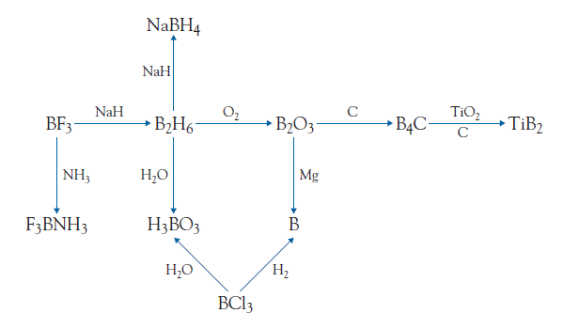

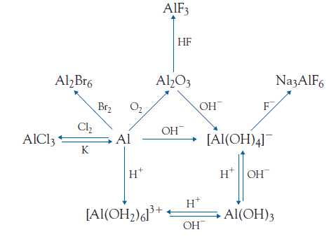

The Group 14 Elements
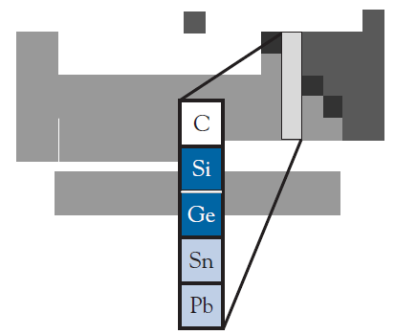
This group contains a nonmetal (carbon), two semimetals (silicon and
germanium), and two weakly electropositive metals (tin and lead). Carbon has the most important chemistry of the group. It is the variety of oxyanions, many of which are found in minerals, that makes silicon chemistry interesting.
Group Trends
The first three elements of Group 14 have very high melting points, a characteristic of network covalent bonding for nonmetals and semimetals, whereas the two metals in the group have low melting points and, common to all metals, long liquid ranges.
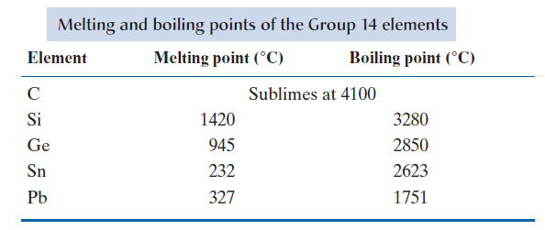
Now that we have reached the middle of the main groups, the nonmetallic properties are starting to predominate. In particular, multiple oxidation states become common. All members of Group 14 form compounds in which they have an oxidation number of +4. This oxidation state involves covalent bonding, even for the two metals of the group. In addition, an oxidation state of -4 exists for the three nonmetals/semimetals when they are bonded to more electropositive elements. Tin and lead also have an oxidation state of +2, which is the only oxidation state in which they form ionic compounds. For silicon, there is no common compound in which silicon exists in a +2 oxidation state; in contrast, the +2 oxidation state of lead is the most stable and in the +4 state lead is strongly oxidizing. One of the few common examples of carbon in the +2 oxidation state is the reducing compound carbon monoxide.

Contrasts in the Chemistry of Carbon and Silicon
The Dioxides of Carbon and Silicon
Carbon dioxide and silicon dioxide share the same type of formula, yet their properties are very different. Carbon dioxide is a colorless gas at room temperature, whereas solid silicon dioxide melts at 1600°C and boils at 2230°C. The difference in boiling points is due to bonding factors. Carbon dioxide consists of small, triatomic, nonpolar molecular units whose attraction to one another is due to dispersion forces. By contrast, silicon dioxide contains a network of silicon-oxygen covalent bonds in a giant molecular lattice. Each silicon atom is bonded to four oxygen atoms, and each oxygen atom is bonded to two silicon atoms, an arrangement consistent with the SiO₂ stoichiometry of the compound.
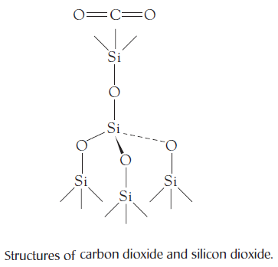
Carbon
Diamond and graphite have been known throughout much of recorded history.
In the diamond form of carbon, there is a network of single, tetrahedrally arranged covalent bonds. Diamond is an electrical insulator but an excellent thermal conductor, being about five times better than copper.
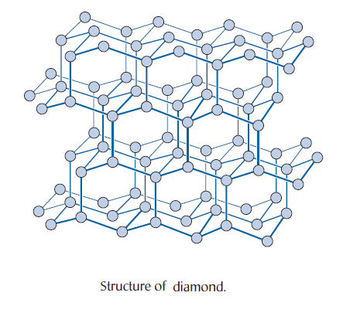
Diamond is a solid to over 4000°C because an enormous amount of energy is needed to break these strong covalent bonds.
The density of diamond (3.5 g/cm³) is much greater than that of graphite (2.2 g/cm³).
Until the nineteenth century, it was thought that graphite and diamond were two different substances. It was Humphry Davy—by “borrowing” one of his spouse’s diamonds and setting fire to it—who showed that carbon dioxide is the only product when diamond burns:
$C_{(s)}+O_{2(g)}→{CO}_{2(g)}$
Fortunately, Davy’s wife was rich enough not to be too upset about the loss of one of her gems to the cause of science. This is one of the more expensive chemical methods of testing whether you really have a diamond.
Graphite
The structure of graphite is quite different from that of diamond. Graphite consists of layers of carbon atoms.
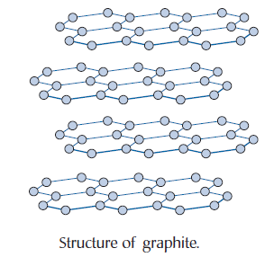
The distance between the carbon layers is very large (335 pm). Hence, the attraction between layers is very weak. In the common hexagonal form of graphite alternating layers are aligned to give an abab arrangement. When you look at the sequential layers, one-half of the carbon atoms are located in line with carbon atoms in the planes above and below, and the other half are located above and below the centers of the rings.
The layered structure of graphite accounts for one of its most interesting properties: a high electrical conductivity.
Graphite is also an excellent lubricant by virtue of the ability of sheets of carbon atoms to slide over one another. However, this is not quite the whole story. Graphite also adsorbs gas molecules between its layers.
Graphite is used in lubricants, as electrodes, and as graphite-clay mixtures in lead pencils.
There is no lead in a lead pencil. The term originated from the similarity between the streak left on a surface from a soft lead object and that from graphite.
Fullerenes
Chemistry is full of surprises, and the discovery of a new series of allotropes of carbon must rank as one of the most unexpected findings of all.
Fullerenes constitute a family of structures in which the carbon atoms are arranged in a spherical or ellipsoidal structure. To make such a structure, the carbon atoms form five- and six-membered rings, similar to the pattern of lines on a soccer ball.
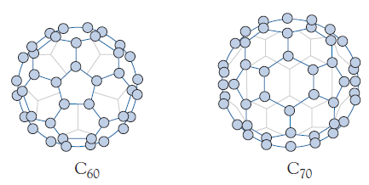
Isotopes of Carbon
Natural carbon contains three isotopes: carbon-12 (98.89 percent), the most prevalent isotope; a small proportion of carbon-13 (1.11 percent); and a trace of carbon-14. Carbon-14 is a radioactive isotope with a half-life of $5.7×{10}^{3}$ years.
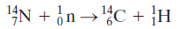
Carbides
Binary compounds of carbon with less electronegative elements (except hydrogen) are called carbides. Carbides are hard solids with high melting points. Despite this commonality of properties, there are, in fact, three types of bonding in carbides: ionic, covalent, and metallic.
Ionic Carbides
Ionic carbides are formed by the most electropositive elements: the alkali and alkaline earth metals and aluminum.
Covalent Carbides
Because most nonmetals are more electronegative than carbon, there are few covalent carbides. Silicon carbide, SiC, and boron carbide, B₄C, are the common examples; both are very hard and have high melting points.
Metallic Carbides
Metallic carbides are compounds in which the carbon atoms fit within the crystal structure of the metal itself, and they are usually formed by the transition metals.
The most important of these compounds is tungsten carbide (WC), of which about 20000 tones are produced annually worldwide. Most of the material is used in cutting tools.
Chlorofluorocarbons
Thomas Midgley, Jr., a General Motors chemist, in 1928 first synthesized dichlorodifluoromethane, CCl₂F₂. This discovery was made as part of a search to find a good, safe refrigerant material. A refrigerant is a compound that, at room temperature, is a gas at low pressures but a liquid at high pressures. Reducing the pressure on the liquid causes it to boil and absorb heat from the surroundings (such as the inside of a refrigerator). The gas is then conveyed outside the cooled container, where it is compressed.
At the time they were discovered, the chlorofluorocarbon family (CFCs), also known as freons.
Silicon
About 27 percent by mass of the Earth’s crust is silicon. However, silicon itself is never found in nature as the free element but only in compounds containing oxygen-silicon bonds.
Although it looks metallic, it is not classified as a metal because it has a low electrical conductivity.
About half a million tons per year of silicon are used in the preparation of metal alloys. Although alloy manufacture is the major use, silicon plays a crucial role in our lives as the semiconductor that enables computers to function.
The element is prepared by heating silicon dioxide (quartz) with coke at over 2000°C in an electrical furnace similar to that used for the Acheson process of calcium carbide synthesis. Liquid silicon (melting point 1400°C) is drained from the furnace:
To obtain ultrapure silicon, the crude silicon is heated at 300°C in a current of hydrogen chloride gas. The trichlorosilane product, SiHCl₃, can be distilled and redistilled until the impurity levels are below the parts per billion levels:
The reverse reaction is spontaneous at 1000°C, depositing ultrapure silicon. The hydrogen chloride can be reused in the first part of the process:
Silicon forms a variety of hydrides analogous to the saturated hydrocarbons, such as SiH₄, Si₂H₆, Si₃H₈, and Si₄H₁₀ (two isomers), and even analogs of the cyclic saturated hydrocarbons, such as cyclo-Si₅H₁₀ and cyclo-Si₆H₁₂.
However, they are very different from the carbon compounds in their reactivity. The silanes are explosively flammable in air.
Silicon tetrachloride reacts violently with water to give silicic acid and hydrogen chloride gas in an analogous manner to the reaction of boron trichloride with water.
Silicon Dioxide
The most common crystalline form of silicon dioxide, SiO₂, commonly called silica, is the mineral quartz. Most sands consist of particles of silica that usually contain impurities such as iron oxides. Silicon dioxide is very unreactive; it reacts only with hydrofluoric acid (or wet fluorine) and molten sodium hydroxide. The reaction with hydrofluoric acid is used to etch designs on glass:
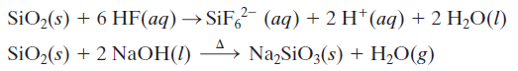
Silicon dioxide is mainly used as an optical material. It is hard, strong, and transparent to visible and ultraviolet light, and it has a very low coefficient of expansion. Thus, lenses constructed from it do not warp as the temperature changes.
Silica gel
Silica gel is a hydrated form of silicon dioxide, SiO₂.xH₂O. It is used as a desiccant (drying agent) in the laboratory and also for keeping electronics and even prescription drugs dry. You may have noticed the packets of a grainy material enclosed with electronic equipment or the little cylinders placed in some drug vials by pharmacists. These enclosures keep the product dry even in humid climates. Commercial silica gel contains about 4 percent water by mass, but it will absorb very high numbers of water molecules over the crystal surface. And it has the particular advantage that it can be reused after heating for several hours; the high temperature drives off the water molecules, enabling the gel to function effectively once more.
Aerogels
In the 1930s, an American chemist, Samuel Kistler, devised a way of drying wet silica gel without causing it to shrink and crack like mud on a dried riverbank. At the time, there was little interest in the product. Furthermore, the procedure required extremely high pressures, and one laboratory was destroyed by an explosion during the preparation of this material. Now, more than 70 years later, chemists have discovered new and safer synthetic routes to this rediscovered family of materials, called aerogels. The basic aerogel is silicon dioxide in which a large number of pores exist-so many, in fact, that 99 percent of an aerogel block consists of air. As a result, the material has an extremely low density, yet is quite strong.
The translucent solid is also an excellent thermal insulator, and it promises to be a useful fire proof insulating material. Aerogels also have some unique properties. For example, sound travels through aerogels more slowly than through any other medium. Chemists have now prepared aerogels that incorporate other elements, a technique that enables the chemists to vary the characteristics of the aerogels.

Glasses
Glasses are noncrystalline materials. The cooling of molten glass results in an increasingly viscous liquid until it finally becomes infinitely viscous at its solidification point without change into an ordered crystalline structure. Glass has been used as a material for at least 5000 years. It is difficult to obtain a precise figure of current annual production, but it must be about 100 million tones.
Almost all glass is silicate glass; it is based on the three-dimensional network of silicon dioxide. Quartz glass is made simply by heating pure silicon dioxide above 2000°C and then pouring the viscous liquid into molds. The product has great strength and low thermal expansion, and it is highly transparent in the ultraviolet region. However, the high melting point precludes the use of quartz glass for most everyday glassware.
The properties of the glass can be altered by mixing in other oxides.
The compositions of three common glasses are shown in Table below. About 90 percent of glass used today is soda-lime glass. It has a low melting point, so it is very easy to form soda-lime glass into containers, such as soft-drink bottles.
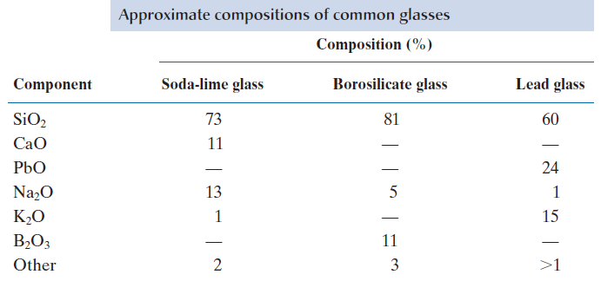
Silicates
About 95 percent of the rocks of the Earth’s crust are silicates, and there is a tremendous variety of silicate minerals. The simplest silicate ion has the formula${SiO}_{4}^{4-}$; zirconium silicate, ZrSiO₄, the gemstone zircon, being one of the few minerals to contain this ion. Silicates are generally very insoluble, as one might expect of rocks that have resisted rain for millions of years. The one common exception is sodium silicate, which can be prepared by reacting solid silicon dioxide with molten sodium carbonate:
A concentrated solution of sodium (ortho) silicate is called water glass, and it is extremely basic as a result of hydrolysis reactions of the silicate anion. Before modern refrigeration became available, the water glass solution was used to preserve eggs, the soft porous shell of calcium carbonate being replaced by a tough, impervious layer of calcium silicate that seals in the egg contents:
Now the sodium silicate solution is used in the “crystal garden” toy. Addition of crystals of colored transition metal salts results in the formation of the appropriate insoluble silicate. For example, adding a crystal of nickel(II) chloride gives a large green “plume” of nickel(II) silicate:

Zeolites
One three-dimensional aluminosilicate structure has open channels throughout the network. Compounds with this structure are known as zeolites, and their industrial importance is skyrocketing. A number of zeolites exist in nature, but chemists have mounted a massive search for zeolites with novel cavities throughout their structures.
There are four major uses for zeolites:
- Zeolites are used as ion exchangers.
- Zeolites can act as adsorption agents.
- Zeolites can be used for gas separation.
- Zeolites are vital as industrial catalysts.
One of the most important catalysts is Na₃[(AlO₂)₃(SiO₂)].xH₂O, commonly called ZSM-5. This compound does not occur in nature; it was first synthesized by research chemists at Mobil Oil. It is higher in aluminum than most naturally occurring zeolites, and its ability to function depends on the high acidity of water molecules bound to the high-charge-density aluminum ions. In fact, the hydrogen in ZSM-5 is as strong a Brønsted-Lowry acid as that in sulfuric acid.
The zeolite ZSM-5 catalyzes reactions by admitting molecules of the appropriate size and shape into its pores and then acting as a strong Brønsted-Lowry acid. This process can be illustrated by the synthesis of ethylbenzene, an important organic reagent, from ethene, C₂H₄, and benzene, C₆H₆. It is believed that the ethene is protonated within the zeolite:
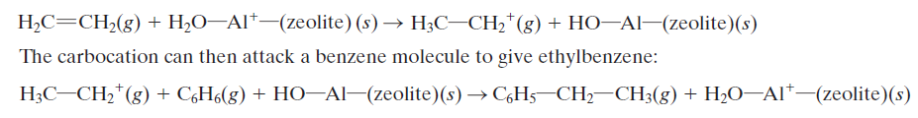
Ceramics
The term ceramics describes nonmetallic, inorganic compounds that are prepared by high-temperature treatment. The properties of ceramic materials are a function not only of their chemical composition but also of the conditions of their synthesis. Typically, the components are finely ground and mixed to a paste with water. The paste is then formed into the desired shape and heated to about 900°C. At these temperatures, all the water molecules are lost, and numerous high-temperature chemical reactions occur. In particular, long needle crystals of mullite, Al₆Si₂O₁₃, are formed. These make a major contribution to the strength of the ceramic material.
Tin and Lead
Tin and lead exist in two oxidation states, +4 and +2.
Tin
Tin forms two common allotropes: the shiny metallic allotrope, which is thermodynamically stable above 13°C, and the gray, nonmetallic diamond-structure allotrope, which is stable below that temperature.
Tin is also amphoteric, another of its weak metallic properties. Thus, tin(II) oxide reacts with acid to give (covalent) tin(II) salts and with bases to form the stannite ion, [Sn(OH)₃]⁻
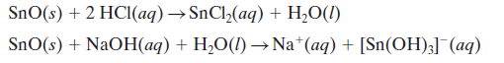
Lead
Lead, the more economically important of the two metals, is a soft, gray-black, dense solid found almost exclusively as lead(II) sulfide, the mineral galena. To obtain metallic lead, lead(II) sulfide is heated with air to oxidize the sulfide ions to sulfur dioxide. The lead(II) oxide can then be reduced with coke to lead metal:
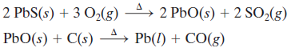
Two major environmental concerns arise in connection with this lead extraction process. First, the sulfur dioxide produced contributes to atmospheric pollution unless it is utilized in another process; second, lead dust must not be permitted to escape during the smelting.

Tin and Lead Oxides
The oxides of the heavier members of Group 14 can be regarded as ionic solids. Tin(IV) oxide, SnO₂, is the stable oxide of tin, whereas lead(II) oxide, PbO, is the stable oxide of lead. Lead(II) oxide exists in two crystalline forms, one yellow (massicot) and the other red (litharge). There is also a mixed oxide oflead, Pb₃O₄ (red lead), which behaves chemically as PbO₂.2PbO; hence, its systematic name is lead(II) lead(IV) oxide. The chocolate brown lead(IV) oxide, PbO₂, is quite stable, and it is a good oxidizing agent. Tin(IV) oxide is incorporated in glazes used in the ceramics industry. About 3500 tonnes are used annually for this purpose. The consumption of lead(II) oxide is much higher, of the order of 250 000 tonnes annually, because it is used to make lead glass and for the production of the electrode surfaces in lead-acid batteries. In these batteries, both electrodes are formed by pressing lead(II) oxide into a frame of lead metal. The cathode is formed by oxidizing lead(II) oxide to lead(IV) oxide, and the anode is produced by reducing lead(II) oxide to lead metal. The electric current arises when lead(IV) oxide is reduced to insoluble lead(II) sulfate in the sulfuric acid electrolyte while the lead metal is oxidized to lead(II) sulfate on the other electrode:
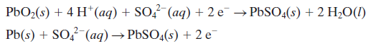
These two half-reactions are reversible. Hence, the battery can be recharged by applying an electric current in the reverse direction.
Tetraethyllead
The less electropositive (more weakly metallic) metals form an extensive range of compounds containing metal-carbon bonds. The metal-carbon compound that has been produced on the largest scale is tetraethyllead, Pb(C₂H₅)₄, known as TEL. Tetraethyllead is a stable compound that has a low boiling point and at one time was produced on a vast scale as a gasoline additive. One method of synthesis involves the reaction of a sodium-lead alloy with chloroethane (ethyl chloride):

