Half-lives

The half-life is the time taken for a given concentration to decrease to half of its value, for example
if [M] = 12 × 10⁻³ mole dm⁻³ at the start of the reaction, then the first half-life is the time taken for [M] to drop to 6×10⁻³ mole dm⁻³.
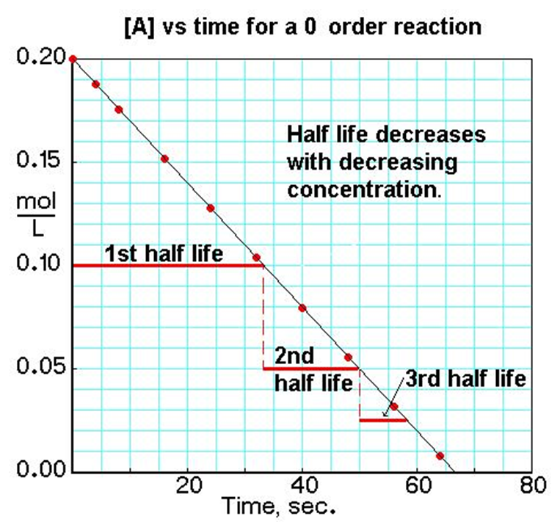

Sometime the reaction is monitored by measuring the concentration of product from time to time. If C_{t} is the concentration of product at any time t and $C_{∞}$ the final concentration of product when the reaction is completed , the $C_{∞}$ is a measure of the initial concentration of reactant and $C_{∞}$ - $C_{t}$ is a measure of reactant remaining at time t .
Q:- From the following data for the decomposition of N₂O₅ in CCl₄ solution at 48⁰C, show that the reaction is first order
( N₂O₅ 2NO₂ + $\frac{1}{2}$O₂)
t/min | 10 | 15 | 20 | $$∞$$
Vol. of O₂ evolved / ml | 6.3 | 8.95 | 11.4 | 34.75

Solution: - For the first order reaction the integrated rate equation is
$kt=\ln{\frac{V∞}{V∞-Vt}}$
Y=2.06×10⁻³ + 0.01976X
R=0.99998
THEN THE REACTION IS FIRST ORDER
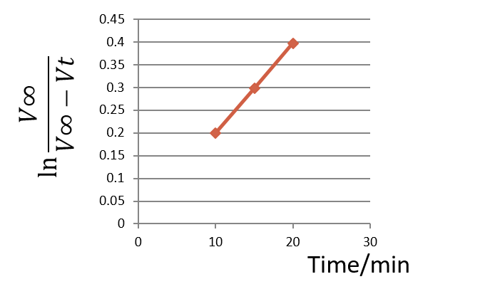
Q:- Trichloroethanoic acid is readily decarboxylated in aqueous solution
CCl₃COOH_{(aq.)} CHCl_{3(aq.)} + CO_{2(g)}
Vol.CO₂/ml | 2.25 | 8.3 | 14.89 | 31.14 | 40.04
t/min | 330 | 1200 | 2400 | 7760 | $$∞$$

Show the reaction to be first order, and calculate the time taken for the initial concentration of CCl₃COOH to fall by 25 per cent.
For first order reaction $\ln{\frac{V_{∞}}{V_{∞}-V_{t}}}$=kt
or $\ln\left(V_{∞}-V_{t}\right)=\ln{V_{∞}-kt}$
The least square equation is
y=3.694+(-1.94×10⁻⁴)x
r=-0.9998
Then the reaction is first order
k=1.94×10⁻⁴ min⁻¹
When 25 per cent of the CCl₃COOH has reacted, 25 per cent of the final amount of
CO₂ will have been formed, i.e. 10.01 ml
ln(40.04-10.01)=ln(40.04)- 1.94×10⁻⁴t
t = 1485 min

t/min
$$\ln\left(V_{∞}-V_{t}\right)$$

Inversion of sucrose:-
Q: - The optical rotation of sucrose in 0.9N HCl at various time intervals is given in the table below
t/min | 0 | 7.18 | 18 | 27.1 | $$∞$$
Rotation/degree | +24.09 | +21.4 | +17.7 | +15 | -10.74

Show that inversion of sucrose is a first order reaction.
The integral rate equation for first order reaction can be written as follows
kt = $\ln{\frac{r_{o}-r_{∞}}{r_{t}-r_{∞}}}$
$$\ln{\frac{r_{o}-r_{∞}}{r_{t}-r_{∞}}}$$
Time/min
Y=A+BX
$\ln{\frac{r_{o}-r_{∞}}{r_{t}-r_{∞}}}$=kt

Y = A + BX
Y=8.45×10⁻⁴+0.011X
R=0.999996
Then the reaction is first order

Second order reactions with different initial concentrations
A + B Product
When [A]_{o} ≠ [B]_{o} then
Kt = $\frac{1}{a-b}\ln{\frac{b(a-x)}{a(b-x)}}$
a=[A]_{o} b=[B]_{o}
or $\ln{\frac{b(a-x)}{a(b-x)}}$ = $(a-b) kt$
then $\ln{\frac{\left(a-x\right)}{\left(b-x\right)}}$ = $\ln{\frac{a}{b}}$ + $\left(a-b\right)kt$ ……….1
if $a>b$ the $\ln{\frac{(a-x)}{(b-x)}}$ (in y axis) plotted against (t) in x axis
or $\ln{\frac{\left(b-x\right)}{\left(a-x\right)}}$ =$\ln{\frac{b}{a}}$ + $(b-a)kt$ ………2 if $b>a$
Q: - The table below shows the data for the second order reaction
R₁COOR + OH⁻ R₁COO⁻ + ROH
t/min | 0 | 5 | 17 | 36 | 65
(a-x)/mM | 19.75 | 14.75 | 9.4 | 5.93 | 3.57
(b-x)/mM | 20.85 | 15.85 | 10.5 | 7.03 | 4.67
Calculate k.
$b>a$ then we use eq. 2
Time/min
$$\ln{\frac{\left(b-x\right)}{\left(a-x\right)}}$$
$$\ln{\frac{b}{a}}$$
Y = 0.0547 + 3.273×10⁻³ X
Intercept = 0.0547 = $\ln{\frac{b}{a}}$
Slope = (b-a)k = 3.273×10⁻³
k = 3.273×10⁻³ / (20.85-19.75)
k = 0.00297 mM⁻¹.min⁻¹.

*Using integrated rate law for a gaseous reaction
Q: - A gas reaction (2A B) is second order in A and goes to completion in a reaction vessel of constant volume and temperature with a half-life of 1h. If the initial pressure of A is 1atm, what are the partial pressure of A and B, and what is the total pressure at 1h, 2h, and at equilibrium?
2A B
P_{o} zero before reaction
P_{o}-2x x
P_{T} = P_{A}+P_{B} = P_{o}-2x + x = P_{o} – x ===> x= P_{o} - P_{T}
Then P_{A}= P_{o}-2x = P_{o} – 2(P_{o}- P_{T}) = 2P_{T} – P_{o} -----------1
P_{B} = x = P_{o} - P_{T} ------------2
For second order reaction
kt = $\frac{1}{P_{A}}-\frac{1}{P_{o}}$ and $t_{\frac{1}{2}}$ = $\frac{1}{{kP}_{o}}$
k = $\frac{1}{1h ×1atm}$ = 1 atm⁻¹.h⁻¹.
- At 1h
1 atm⁻¹.h⁻¹ × 1h = $\frac{1}{P_{A}}-$ $\frac{1}{1atm}$
P_{A} = 0.5 atm.
In eq.1 P_{T} =$\frac{P_{A}+P_{o}}{2}$ = $\frac{0.5+1}{2}$ = 0.75 atm.
P_{B} = 1-0.75 = 0.25 atm.
- At 2h
P_{A} = 0.3333 atm.
P_{T} = 0.6666 atm.
P_{B} = 0.3333 atm.
- At $∞$ (equil.) P_{A} = zero
Then P_{T} = 0.5 atm. P_{B} = 0.5 atm.
Q: - The gaseous reaction (A₂ 2A) is first order in A₂ , after 751 sec. 64.7% of A₂ remains undecomposed. Calculate
- The half-life
- The length of time required to decompose 90% of A₂.
For first order reaction
$\ln{\frac{P_{o}}{{2P}_{o}-P_{T}}}$ = kt
or $\ln{\frac{P_{o}}{P_{A_{2}}}}$ = kt
k = $\frac{\ln{\frac{100}{64.7}}}{751}$ = 5.798 × 10⁻⁴ sec⁻¹.
- $t_{\frac{1}{2}}$ = $\frac{\ln{2}}{{5.798 × 10}^{-4}}$ = 1196 sec.

- t = $\frac{\ln{\frac{100}{10}}}{{5.798 × 10}^{-4}}$ = 3971 sec.

Q: - The first order rate constant for the gas phase decomposition of dimethyl ether,
(CH₃)₂O CH₄ + H₂ + CO
ln0.35PO-x=0.15360.35Po-x=1.166Po-x=0.3ln0.35PO-x=0.15360.35Po-x=1.166Po-x=0.3Is 3.2 × 10⁻⁴ S⁻¹ at 450ºC. The reaction is carried out in a constant volume container , initially only dimethyl ether is present , and the pressure is 0.350 atm. . what is the pressure of the system after 8 min ? assume ideal gas behavior.
P_{T}= P_{o}-x+3x = P_{O} + 2x
$\ln{\frac{0.35}{P_{O}-x}}$ = 3.2 × 10⁻⁴ × 8 × 60
P_{O}-x = 0.3 == x = 0.05 atm.
P_{T} = P_{O} + 2x = 0.35 + 2 * 0.05 = 0.45 atm.

Complex reactions: -
- Reversible reactions
K₁
A B
k₋₁

$\frac{d[A]}{dt}$ = -k₁[A] + k₋₁[B] ……………(1)
At equilibrium, there is no net change in the concentration of A with time
Then $\frac{d[A]}{dt}$ = 0 ……………..(2)
Eq.1 became
k₁[A] = k₋₁[B] ====> $\frac{[B]}{[A]}=\frac{k_{1}}{k_{-1}}=K$ ………(3)
Where K is the equilibrium constant
We have
Δ[B] = -Δ[A]
So [B]-[B]_{o} = -([A]-[A]_{o})
Or [B] = [B]_{o}+[A]_{o}-[A] …………..(4)
By substituting eq.4 into eq1
$\frac{d[A]}{dt}=$ -k₁[A] + k₋₁[B]_{o}+ k₋₁[A]_{o}- k₋₁[A] …………(5)
At ( t $∞$ ) the system reaches equilibrium , the rates of the forward and reverse reactions having become equal.
At equilibrium (eq.2) $\frac{d[A]}{dt}$ = 0 and [A]=[A]_{eq}

Then k₋₁[B]_{o}+ k₋₁[A]_{o} = (k₁+k₋₁)[A]_{eq} …………….(6)
By sub. eq 6 into eq 5
$\frac{d[A]}{dt}=$ -k₁[A] - k₋₁[A] + (k₁+k₋₁)[A]_{eq}
= (k₁+k₋₁)[A]_{eq} – (k₁+k₋₁)[A] = (k₁+k₋₁)( [A]_{eq}-[A]) ….(7)

Or $\frac{d[A]}{{[A]}_{eq}-[A] }$ = (k₁+k₋₁)dt ………..(8)
By integration eq 8 then

$\ln{\frac{{[A]}_{o}-{[A]}_{eq}}{[A]-{[A]}_{eq}}}$ = (k₁+k₋₁) t ……………….(9)

Or ${[A]}_{o}-{[A]}_{eq}= \left({\left[A\right]-[A]}_{eq}\right)e^{\left(k_{1}+k_{-1}\right)t}$ ……..(10)
Or $\ln{\frac{{[B]}_{eq}}{{[B]}_{eq}-[B]}}$ = (k₁+k₋₁) t or $\ln{\frac{x_{e}}{x_{e}-x}}$ = (k₁+k₋₁) t
Note
$$\int{{(x+s)}^{-1}dx=\ln{(x+s)}}$$

$$\frac{[A]}{{[A]}_{o}}$$

time
concentration
$$\frac{[B]}{{[A]}_{o}}$$

- Consecutive Reactions: -
A consecutive reaction is one in which the product from the first step becomes the reactant for the second step, and so on.
Ex.
- CH₃COCH₃ CH₂=CO + CH₄
CH₂=CO CO + ½ C₂H₄
- ${}_{92}^{239}U$ ${}_{93}^{239}{Np}$ + ${}_{-1}^{0}β$

${}_{93}^{239}{Np}$ ${}_{94}^{239}{Pu}$ + ${}_{-1}^{0}β$

For a two-step consecutive reaction, we have
K₂
K₁
A B C

R₁= k₁ [A] R₂ = k₂ [B]

$\frac{ d[A]}{dt}$ = - k₁ [A] ---------(1) $\frac{ d[C]}{dt}$ = k₂ [B] ----------(3)

$\frac{d[B]}{dt}= k_{1}[A]- k_{2}[B] ------(2)$

Because the decrease in A is first order, we write
$\left[A\right]= {\left[A\right]}_{o} e^{{-k}_{1}t}$ -----------------(4)
By applying the steady state approximation for the intermediate B, that is
$\frac{d[B]}{dt}=0= k_{1}[A]- k_{2}[B] -----(5)$

$\left[B\right]= \frac{k_{1}}{k_{2}} \left[A\right]= \frac{k_{1}}{k_{2}}{\left[A\right]}_{o} e^{{-k}_{1}t}$

Or $\left[B\right]= \frac{k_{1}}{k_{2}}{\left[A\right]}_{o} e^{{-k}_{1}t}-----(6)$

In eq. 3 $\frac{d[C]}{dt }= k_{2}[B]$ == $\frac{d[C]}{[B] }= k_{2} dt-----(7)$
By substituting equation 6 in equation 7

$$\frac{d[C]}{{[A]}_{o}}= \frac{k_{1}}{k_{2}} k_{2} e^{{-k}_{1}t} dt$$

$$\frac{1}{{[A]}_{o}} \int_{0}^{C}{d[C]}= k_{1} \int_{0}^{t}{e^{{-k}_{1 }t}} dt-----(8)$$
$$\int{e^{kx} } dx= \frac{e^{kx}}{k}+C$$
Note

$$\frac{[C]}{{[A]}_{o}}= k_{1} \frac{e^{{-k}_{1 }t}}{{-k}_{1}}- k_{1} \frac{e^{{-k}_{1} ×0}}{{-k}_{1}}-----(9)$$

$\frac{[C]}{{[A]}_{o}}= \left({-e}^{{-k}_{1}t}+1\right)$ = $\left(1- e^{-k_{1} t}\right)$
$\left[C\right]= {\left[A\right]}_{o} \left(1- e^{{-k}_{1 }t}\right) -----(10)$

- Parallel Reactions (Competing Reactions)
Frequently a species can react in different ways to give a variety of products. For example, in the nitration of bromobenzene, ortho, meta, and para nitrobromobenene are obtained.
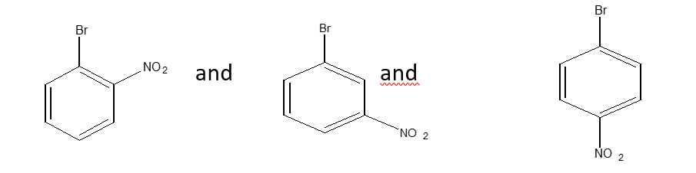
we shall consider the simplest case, that of two parallel irreversible first order reaction
K₂
K₁
A B A C
K₁
B
or A
K₂
C
$$\frac{d[A]}{dt}=-k_{1}\left[A\right]-k_{2}\left[A\right]=-\left(k_{1}+k_{2}\right)\left[A\right]-----(1)$$

$\left[A\right]= {\left[A\right]}_{o} e^{{-(k}_{1}+k_{2})t}-----(2)$

$$\frac{d[B]}{dt}= k_{1}\left[A\right]= k_{1} {\left[A\right]}_{o} e^{-\left(k_{1}+ k_{2}\right)t}----(3)$$

$\left[B\right]= \frac{k_{1}{\left[A\right]}_{o}}{k_{1}+ k_{2}} \left(1- e^{-\left(k_{1}+k_{2}\right) t}\right)----?$ HOW?

and $\left[C\right]= \frac{k_{2}{\left[A\right]}_{o}}{k_{1}+ k_{2}} \left(1- e^{-\left(k_{1}+k_{2}\right) t}\right) ----?$ HOW?

- Chain Reaction
For example
CH₃CHO_{(g)} CH_{4 (g)} + CO_{(g)}

Prove that the rate law is R = k [CH₃CHO$]^{\frac{3}{2}}$
CH₃CHO .CH₃ + .CHO R=k_{i}[CH₃CHO] initiation
CH₃CHO + .CH₃ CH₃CO. + CH₄ R=k_{p}[CH₃CHO][.CH₃]
Propagation
CH₃CO. .CH₃ + CO R=k’_{p}[CH₃CO.]
.CH₃ + .CH₃ C₂H₆ R= k_{t}[.CH₃]² termination
Sol.: -
$\frac{d\left[{CH}_{4}\right]}{dt}=$ k_{p}[CH₃CHO][.CH₃] ---------(1)

$\frac{{d[CH}_{3}^{.}]}{dt}$ = k_{i}[CH₃CHO] + k’_{p}[CH₃CO.] - k_{p}[CH₃CHO][.CH₃] -2 k_{t}[.CH₃]²-------(2)

$\frac{d\left[{CH}_{3}{CO}^{.}\right]}{dt}$ = k_{p}[CH₃CHO][.CH₃] - k’_{p}[CH₃CO.] -------(3)

By steady state approximation

$\frac{{d[CH}_{3}^{.}]}{dt}$ = $\frac{d\left[{CH}_{3}{CO}^{.}\right]}{dt}$ = 0
Eq 2 + eq 3 = 0
k_{i}[CH₃CHO] + k’_{p}[CH₃CO.] - k_{p}[CH₃CHO][.CH₃] -2 k_{t}[.CH₃]² + k_{p}[CH₃CHO][.CH₃] - k’_{p}[CH₃CO.]=0

Then k_{i}[CH₃CHO] = 2 k_{t}[.CH₃]² ---------(4)

and [.CH₃] = $\sqrt{\frac{k_{i}}{{2k}_{t}}}$ [CH₃CHO]^{1/2} ----------(5)

by substitution equation 5 in eq 1

$\frac{{d[CH}_{4}]}{dt}$ = R = k_{p}[CH₃CHO] × $\sqrt{\frac{k_{i}}{{2k}_{t}}}$ [CH₃CHO]^{1/2}
If k_{p} × $\sqrt{\frac{k_{i}}{{2k}_{t}}}$ = K

Then R = K [CH₃CHO]^{3/2}

Reaction Mechanisms
Many reactions that follow simple rate laws occur through a series of steps, these steps are called elementary reactions because they cannot be broken down further into simpler chemical reactions.
The sequence of elementary reactions that add up to give the overall reaction is called the mechanism of the reaction.
The mechanism of a reaction leads directly to a set of differential equations that completely describe the kinetic behavior of that mechanism.
There are two approximation methods that yield expression for the rate of the overall reaction in terms of concentration of the various reactants and products and the rate constants.
- Steady state method.
The net change of the concentration of intermediate with the time is zero.
- Rapid equilibrium method.
The slow step in the mechanism is the rate determining step.

Example
For this reaction ( A + B D )
Consider the following mechanism
K₁
A + B C
K₂
K₃
C D
Derive the rate law using the steady state approximation to eliminate the concentration of C.
R = $\frac{d[D]}{dt}$ = $k_{3}\left[C\right]$ ---------- (1)
$\frac{d\left[C\right]}{dt}= k_{1}\left[A\right]\left[B\right]- k_{2}\left[C\right]- k_{3}\left[C\right]$ ---------- (2)
By steady state approximation
$\frac{d\left[C\right]}{dt}=0$
Then $k_{1}\left[A\right]\left[B\right]$ = $\left(k_{2}+ k_{3}\right)\left[C\right]$ --------- (3)
$\left[C\right]= \frac{k_{1}\left[A\right]\left[B\right]}{k_{2}+k_{3}}$
Then the rate of reaction = R = $\frac{d[D]}{dt}$ = $\frac{k_{1}k_{3}\left[A\right]\left[B\right]}{k_{2}+k_{3}}$
Reaction Mechanism
Q:- For this reaction
Br⁻
H⁺ + HNO₂ + C₆H₅NH₂ C₆H₅N₂⁺ + 2H₂O
The rate law is observed to
R = $K\left[H^{+}\right]\left[{HNO}_{2}\right]\left[{Br}^{-}\right]$ -------- (1)
Prove that the rate law is suitable when the proposed mechanism is:-
K₁
H⁺ + HNO₂ H₂NO₂⁺ rapid equilibrium
K₋₁
K₂
H₂NO₂⁺ + Br⁻ ONBr + H₂O slow

ONBr + C₆H₅NH₂ C₆H₅N₂⁺ + H₂O + Br⁻ fast
We can say that the rate of the reaction is
R = $k_{2}\left[H_{2}{NO}_{2}^{+}\right]\left[{Br}^{-}\right]$ ------- (2)
But the species $H_{2}{NO}_{2}^{+}$ is an intermediate so
$\frac{d\left[H_{2}{NO}_{2}^{+}\right]}{dt}=0$ ( steady state approximation )

Then $\frac{d\left[H_{2}{NO}_{2}^{+}\right]}{dt}$ =$k_{1}\left[H^{+}\right]\left[{HNO}_{2}\right]-k_{-1}\left[H_{2}{NO}_{2}^{+}\right]-{ k}_{2}\left[H_{2}{NO}_{2}^{+}\right]\left[{Br}^{-}\right]=0$ ------------ (3)

$\left[H_{2}{NO}_{2}^{+}\right]=\frac{k_{1}\left[H^{+}\right]\left[{HNO}_{2}\right]}{k_{-1}+k_{2}\left[{Br}^{-}\right]}$ ---------------- (4)

By applying the rate determining step approximation
k₋₁ >> k₂[Br⁻]
Then eq.4 becomes

$\left[H_{2}{NO}_{2}^{+}\right]=\frac{k_{1}\left[H^{+}\right]\left[{HNO}_{2}\right]}{k_{-1}}$ ------------(5)
By substituting eq.5 in eq.2

R = k₂ [Br⁻] $\frac{k_{1}\left[H^{+}\right]\left[{HNO}_{2}\right]}{k_{-1}}$ =$k_{2}\frac{k_{1}}{k_{-1}} \left[H^{+}\right]\left[{HNO}_{2}\right]\left[{Br}^{-}\right]$
If $k_{2}\frac{k_{1}}{k_{-1}}$ = K
Then R = K $\left[H^{+}\right]\left[{HNO}_{2}\right]\left[{Br}^{-}\right]$

Q: - For this reaction
H₂O₂ + 2H⁺ + 2I⁻ I₂ + 2H₂O
Find the rate law, suppose one mechanism
K₁
H⁺ + I⁻ HI rapid equilibrium
K₋₁
HI + H₂O₂ H₂O + HOI slow
K₂
K₃
HOI + I⁻ I₂ + OH⁻ fast
K₄
OH⁻ + H⁺ H₂O fast
Solution:-
R = k₂ [HI] [H₂O₂] ---------(1)
$\frac{d\left[HI\right]}{dt}= k_{1}\left[H^{+}\right]\left[I^{-}\right]- k_{-1}\left[HI\right]-k_{2}\left[HI\right]\left[H_{2}O_{2}\right]$ ---------(2)
By steady state approximation $\frac{d\left[HI\right]}{dt}=0$
Then [HI] = $\frac{k_{1}\left[H^{+}\right]\left[I^{-}\right]}{k_{-1}+k_{2}\left[H_{2}O_{2}\right]}$ --------(3)
By substituting eq. 3 in eq. 1
R = $\frac{k_{2}k_{1}\left[H^{+}\right]\left[I^{-}\right]\left[H_{2}O_{2}\right]}{k_{-1}+ k_{2}\left[H_{2}O_{2}\right]}$ ------------(4)
By applying Rate-Determining step approximation
k₋₁ >> k₂ [H₂O₂]
R = k [H⁺][I⁻][H₂O₂] -------------(5)
Q: - Apply the steady-state approximation and R.D.S.A to the mechanism
K₁
A + B C + D Rapid equilibrium
K₂
K₋₁
D + E F + B Slow
to obtained the rate law .
R = $k_{2}\left[D\right]\left[E\right]$ -----------(1)
$\frac{d[D]}{dt} = k_{1}\left[A\right]\left[B\right]-k_{-1}\left[C\right]\left[D\right]-k_{2}\left[D\right]\left[E\right]$ --------(2)
By applying S.S.A
$\frac{d\left[D\right]}{dt}=0$
Then [D] = $\frac{k_{1}\left[A\right]\left[B\right]}{k_{-1}\left[C\right]+ k_{2}\left[E\right]}$ -----------(3)
By sub eq 3 into eq 1
R = $\frac{k_{2}k_{1}\left[A\right]\left[B\right]\left[E\right]}{k_{-1}\left[C\right]+ k_{2}\left[E\right]}$ ------------(4)
By R.D.S.A
k₋₁[C] >> k₂[E]
Then R = $\frac{k\left[A\right]\left[B\right]\left[E\right]}{\left[C\right]}$ ---------------(5)

Q: - For a reversible first order reaction
K₁
A B
K₂
k₁= 10⁻² s⁻¹ , k₋₁= 0.0025 s⁻¹ , [A]_{o} = 1 M , and [A]_{equ.}= 0.1 M .
Calculate the concentration of [A] after 30 sec.
$\ln{\frac{{[A]}_{o}-{[A]}_{eq}}{[A]-{[A]}_{eq}}}$ = (k₁+k₋₁) t
$\ln{\frac{1-0.1}{\left[A\right]-0.1}}$ = (0.01+0.0025) 30
[A] = 0.718 mol/L.

Q : For the first order consecutive reaction type
K₁
K₂
A B C
After 30 min of the initiation of reaction we found that the concentration of C = 0.259 mol/L.
If k₁ = 0.01 min⁻¹ , and k₂ = 1min⁻¹ .
Calculate [A]_{o} and concentration of A and B after 30 min.

0.259 = [A]_{o} ( 1- $e^{-0.01×30}$ )
[A]_{o} = 1 mol/L
[B] = $\frac{0.01}{1} ×1 × e^{-0.01 ×30}$ $\left[B\right]= \frac{k_{1}}{k_{2}}{\left[A\right]}_{o} e^{{-k}_{1}t}$
[B] = 7.408 × 10⁻³ mol/L
$\left[B\right]= \frac{k_{1}}{k_{2}} \left[A\right]$ then $\left[A\right]= \frac{k_{2}}{k_{1}} \left[B\right]$ = 0.7408 mol/L

Q: - Consider the parallel reaction
K₁
B

A
C
K₂

In an experiment it was observed that 60% decomposition of A takes place in 20 min. and analysis of product showed that 75% of B and 25 % of C are present . calculate k₁ and k₂ .
$\frac{\left[B\right]}{\left[C\right]} =$ $\frac{\frac{k_{1}{\left[A\right]}_{o}}{k_{1}+ k_{2}} \left(1- e^{-\left(k_{1}+k_{2}\right) t}\right)}{\frac{k_{2}{\left[A\right]}_{o}}{k_{1}+ k_{2}} \left(1- e^{-\left(k_{1}+k_{2}\right) t}\right)}$ = $\frac{k_{1}}{k_{2}}= \frac{\frac{75}{100} ×60}{\frac{25}{100} ×60}$ = 3
K₁ = 3k₂
$$\left[B\right]= \frac{k_{1}{\left[A\right]}_{o}}{k_{1}+ k_{2}} \left(1- e^{-\left(k_{1}+k_{2}\right) t}\right)$$
$$45= \frac{3k_{2}100}{3k_{2}+ k_{2}} \left(1- e^{-\left({3k}_{2}+k_{2}\right)20}\right)$$

K₂ = 0.01145 min⁻¹.
K₁= 0.0344 min⁻¹.

Rate influencing factors
The effect of Temperature on Reaction Rate
Reaction rate
Reaction rate
T/Kº
T/Kº
(b)
(a)

Reaction rate
Reaction rate
T/Kº
T/Kº
(c)
(d)

These figures shows four types of temperature dependence for reaction rate constants.
- Represent normal reactions whose rates increase with increasing temperature.
- Enzyme catalyzed reaction.
- Complex mechanism (some exothermic reaction).
- Chain reaction. Explosive .
The Arrhenius Equation
In 1889 , Arrhenius discovered that the temperature dependence of many reactions could be described by the following equation: -

$$k=A e^{{-E_{a}}/{RT}}$$
k = rate constant
A = frequency factor or pre-exponential factor
E_{a} = Activation energy J/mol or cal/mol
R = gas constant
T = absolute temperature.
The activaton energy is the minimum amount of energy required to initiate the chemical reaction.
(A) represents the frequency of collisions between reactant molecules ( A have the same units of the rate constant ).
Exp ( -Ea/RT ) resembles the Boltzman distribution law , it represents the fraction of molecular collisions that have energy equal to or greator than the activation energy (Ea)
A high activation energy signifies that the rate onstant depends strongly on temperature.

Energy
Activated state
Ea for forward reaction
Ea for reverse reaction

Reactants

Products

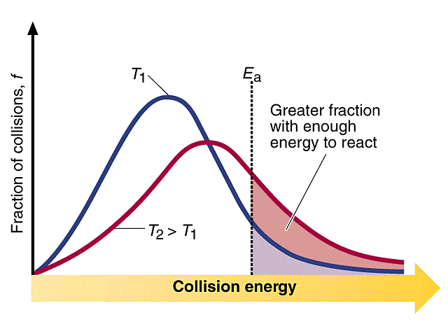
$$k=A e^{{-E_{a}}/{RT}}$$
$$\ln{k}=\ln{A}-\frac{E_{a}}{RT} \ln{\frac{k_{2}}{k_{1}}=-\frac{E_{a} }{R}}\left(\frac{1}{T_{2}}-\frac{1}{T_{1}}\right)$$
Arrhenius Equation

$$k=A e^{{-E_{a}}/{RT}}$$
Q: - Determine A and E_{a} from the following data

T / ºK | 300 | 350 | 400 | 450 | 500
K / l.mol⁻¹.s⁻¹ | 7.9×10⁶ | 3×10⁷ | 7.9×10⁷ | 1.7×10⁸ | 3.2×10⁸

1/T | Ln k
3.33×10⁻³ | 15.88
2.86×10⁻³ | 17.22
2.50×10⁻³ | 18.18
2.22×10⁻³ | 18.95
2.00×10⁻³ | 19.58
By plotting a curve between 1/T and (ln k) we can calculate A and E_{a}
y=25.11 + (-2767.34x)
r=0.9999

$$\ln{A}=25.11 ≫≫ A=8×{10}^{10} {dm}^{3}.{mol}^{-1}.s^{-1}$$

Slope = -2767.34 = $\frac{{-E}_{a}}{R} ≫≫ E_{a}=23kJ/mol$

Q: - Determine A and E_{a} from the following data: -
T/ºk | 700 | 730 | 760 | 790 | 810 | 840 | 910 | 1000
k/dm³.mol⁻¹.s⁻¹ | 0.011 | 0.035 | 0.105 | 0.343 | 0.789 | 2.17 | 20 | 145

Ans.
A = 1.1×10¹² l.mol⁻¹.s⁻¹ E_{a}= 188.32 kJ/mol

Q: - the rate constant of a first order reaction is 4.6×10⁻⁴ s⁻¹ at 350ºC . If the activation energy is 104 kJ/mol . Calculate the temperature at which its rate constant is 8.8×10⁻⁴ s⁻¹.
Sol. 1- ln A = 12.38 ( k₁ and E_{a} and T₁ are known )
T₂ = 644.08 ºK = 371 ºC

Or 2- $\ln{\frac{k_{2}}{k_{1}}=-\frac{E_{a} }{R}}\left(\frac{1}{T_{2}}-\frac{1}{T_{1}}\right)$
$Ln\frac{{8.8×10}^{-4}}{{4.6×10}^{-4}}= -\frac{104000}{8.314} \left(\frac{1}{T_{2}}-\frac{1}{623}\right)$

T₂ = 644.08 ºK = 371 ºC

Q1: - 20% for a particular reaction completed in 12.5min at 300ºK, and the same percent completed in 3.2min at 340ºK, calculate activation energy if the reaction is first order .

Q2: - The gas-phase reaction between methane (CH₄) and diatomic sulpher (S₂) is given by the equation
At 550ºC the rate constant for this reaction is 1.1 l.mol⁻¹.s⁻¹ and at 625ºC the rate constant is 6.4 l.mol⁻¹.s⁻¹ .
Calculate E_{a} for this reaction.

Q3: - Many reactions double their rates with every 10º rise in temperature .Assume that such a reaction takes place at 305ºK and 315ºK. What must its activation energy be for this statement to hold?

Q4: - Consider the following parallel reactions
B
k₁
A
k₂
C

The activation energies are 45.3 kJ/mol for k₁ and 69.8 kJ/mol for k₂ . If the rate constants are equal at 320 ºK , at what temperature will k₁/k₂ = 2 ?

