CURRICULUM VITAE
August 2019.
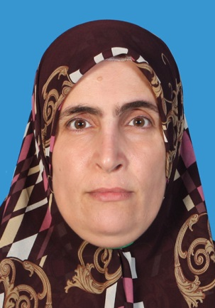
Personal Data:
Name: Khunaw Abdullah Rahman
Nationality: Iraqis
Date of birth: February, 24 1979
Place of birth: Erbil City, Iraq
Marital Status: Married and having three children
Phone: +964 750 4635810
Sex: Female
Address: 94 Badaw, Salahaddin University, Erbil City, Iraq
Present job: Lecturer, Department of Soil and Water,
College of Agriculture, Salahaddin University, Erbil City, Iraq

E-mail: khunaw.rahman@su.edu.krd, khunaw9882@yahoo.com,
khunaw.upm@gmail.com
Passport Number: A2331700, Iraq

Hobby/Interest: Researching, Teaching, Writing

Education:

- Ph. D. Soil Microbiology, Faculty of Agriculture, Universiti Putra Malaysia (Sep. 2017). Thesis title "Influence of Soil pH on Microbial Community and Incidence of Basal Stem Rot (BSR) Disease Development in Oil Palm Seedlings Planted on BSR Affected and Forest Soils".
- M. Sc. Soil Microbiology, College of Agriculture, Salahaddin University, Erbil, Iraq (April 2007). Thesis title “Effect of Potassium Level on Soybean Plant in Erbil City".
- B. Sc. Plant Science, College of Agriculture, Salahaddin University, Erbil, Iraq (Jan. 2002).

Working Experience:
2002 - Date  2013 – 2016  2019- | Lecturer, Department of Soil and Water, College of Agriculture,  Salahaddin University, Erbil City, Iraq.  United Melaka, MPOB, Oil Palm Company  Reviewer ,Libyan Journal of Ecological and Environmental Sciences and Technology(LJEEST)

Research Projects:
- Soil microbiology and soil fertilizer.
- Undergraduate supervision

Publications:

- Khunawa, A.R., Radziah, O., Nusaibah S.A., Mohamed HanafI, M., Rabar F.S. (2017). Role of Microbial Community in Suppressing Development of Ganoderma in Oil Palm Seedlings. International Journal of Plant & Soil Science. 19(1): 1-14.

- Khunawa, A.R., Radziah, O., Nusaibah S.A., Mohamed HanafI, M., Rabar F.S. (under review). Effect of pH on growth of oil palm seedlings and basal stem rot disease incidence in Ganoderma inoculated plants. The Indian Journal of Agricultural Science, Manuscript ID: 71037.

Conference/ Workshop

- Training Course on Statistics and Statistical Data Analysis with SPSS, GraphPad Prism, March 10-14, 2019, Salahaddin University, Erbil, Iraq.

- 10th International Symposium on Plant Soil Interaction at Low pH, Poster Presentation, June, 25-29 2018.

- 3rd International Scientific Conference for Agricultural Science, Oral Presentation, November, 10 2018.

- 2nd International Conference on Crop Improvement (ICCI), December 2015.

References:

- Dr. Akram Othman Esmail (Professor of Soil Chemistry),
College of Agriculture, University of Salahaddin,
Erbil, Iraq.
Email: arez96y@yahoo.com

- Dr. Adel Kamal Khider (Professor of Microbiology),
College of Education, University of Salahaddin,
Erbil, Iraq.
(Masters Supervisor)
Email: adelbio@yahoo.com

- Dr. Tariq Hamakarim Kakahama (Professor of Soil and Water),
College of Education, University of Salahaddin,
Erbil, Iraq.
Email: tariq.kakahama@su.edu.krd

Applicants Signature

Khunaw Abdullah Rahman

