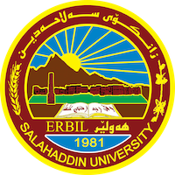
Academic Curriculum Vitae
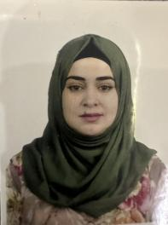
Personal Information:
Full Name: Kurdistan Saman Mahmood
Academic Title: Assistant lecturer
Email: (university email): Kurdistan.saman@su.edu.krd
Mobile: 07507553978

Education:
Bachlors degree in a geology in 2011-2012
Master degree in Sedimentology and Stratigraphy 2015

Employment:
Working as assistant lecturer in labrotaries of earth Science and petroleum department. Teaching Sedimentology ( Sedimentation and petrography) .
Good experience in field technics in geology.

Qualifications
- Successfully completed a course of Academic Capacity Development (Teaching method and Research Methodology)17-7-2016-26-3-2017.
- Successfully completed an English language Proficiency course / Intermediate level , 14/2/2019
- I have attend a course of Academic writing 2023.

Teaching experience:
Teaching Sedimentology ( Sedimentation and petrography) and stratigraphy in a department laboratories.
Good experience in field technics in geology.

Research and publications
I have an article published in Arabian journal of Geo science , March 2012 the title is : Facies association and sequence stratigraphy (Middle-late Eocene) Pila Spi formation , in the High Folded Zone , Kurdistan Region , northeastern Iraq. With prfissor Dr. Sardar balaki
: https://www.researchgate.net/publication/349868125

Professional Social Network Accounts:

- ReserchGate: https://www.researchgate.net/profile/Kurdistan-Saman-2

- Google schooler : https://scholar.google.com/citations?user=1y_QslEAAAAJ&hl=ar

