Salahaddin University
Collage of Science
Earth Science and Petroleum Department

Petrography and Diagenesis of Gercus Formation (Lower - Middle Eocene) Shaqlawa Area , Iraqi Kurdistan Region

Prepared by : Miran salim
Payam Khwrshid
Supervised by : Mrs. Krdistan Saman Mahmud

Acknowledgment

we would like to express our special thanks of gratitude to our teacher
Mrs. Kurdistan Saman, who gave us opportunity to do this wonderful project of Gercus Formation.
Who also helped us in completing our project. we came to know about so many new things we are really thankful to them.
Secondly, we would also like to thank our parents and friends who helped as a lot in finalizing this project within the limited time frame.

Abstract
Gercus Formation (Lower –MiddleEocene) has been studied for its Petrography and Diagenesis from one outcrop section in Shaqlawa area within the High Folded Zone- Iraqi Kurdistan Region. Lithology of the formation consist red and purple mudstone sandstone, Pebbly sanstone, Shales , marls, conglomerates and some limestone beds.
petrographic study based on 27 thin sections, showed that, The main component of sandstones of Gercus Formation is quartz and rock fragment, iron oxides are present in a substantial quantity, cherts are also present in a miner amount. The cements are mostly non silicate (carbonate) cements and Ferruginous cements.Avana formation cropped out as a tong within the Gercus Formation .Avana formation consist of creamy and light brown color limestone and fossiliferous limestone.The some of 2 thin sections was prapared from Avana formation. Pertographic study of limestone of Avana Formation showed that it contain fossiles and bioclasts.
Petrographic study of Gercus Formation showed that many diagenetic processes affected the formation like : cementation , dissolution, dolomitization and micritization.

List of Contents

Aknoldgment ……………………………………………………. i
Abstract…………………………………………………………... ii
List of contents…………………………………………………... iii
List of figures …………………………………………………… iii
Introduction……………………………………………………… 4
Aim of Study…………………………………………………….. 4
Location of studied area…………………………………………. 4
Methodology…………………………………………………….. 6
Field work and sampling ……………………………………...… 6
Lab work ………………………………………………………… 6
Geologic setting of studied area …………………………………. 7
Petrography of Gercus Formation………………………………… 9
Depositional invironment
Summury and conclusion

List of figurs
Fig1………………………………………………………………... 5
Fig2………………………………………………………………... 8

1-Introduction
Many individual sedimentary cycles and formations including Gercus Formation was distinguished during the Tertiary period. The Gercus Formation was deposited during AP10 (Early Paleocene-Late Eocene; 65.5-34 Ma) of tectonostratigraphic mega sequence of Arabian plate (Sharland et al., 2001) and delta environment, river environment.The Gercus Formation is equivalent to the Avanah, the lower part of Pila Spi, Jaddala, Ratga, the Upper part of Dammam formations, Red bed ,Walash and Naopurdan Groups, which are representing (lower to middle Eocene) sequence (Numan, 1997). Lithology: Generally red and purplemudstone sandstone, Pebbly sanstone, Shales , marls, conglomerates and some limestone beds

- Aimes of Studdy

A-Studying detailed petrography of Gercus formation
B-Interpretation of depostional environment

3-Location of studied Area
In this study, one cropping out selected section was chosen within the High Folded Zone ' . Gercus Formation is well cropping out at the north east limp of Safeen Anticline. The located Area is near Shaqlawa town, 47km away from Erbil City, Iraqi Kurdistan Rigion. It located at latitude (44 30. 83’00’’ ) and longitude ( 36. 42.11’ 21’’ ) Fig (1 ). At this area the thickness of Gercus Formation is about 250 m, shale beds in the lower part, alternation of course grained sand and mudstone , gray and reddish brown in color.bedded sandstone and mudstone redish brown , massive sandstone , about 25 cm dolomitic limestone and thick bed of medium grained sandstone with clast supported conglomerate in upper part of the Formation. Avana Formation cropping out as a tong within Gercus Formation.

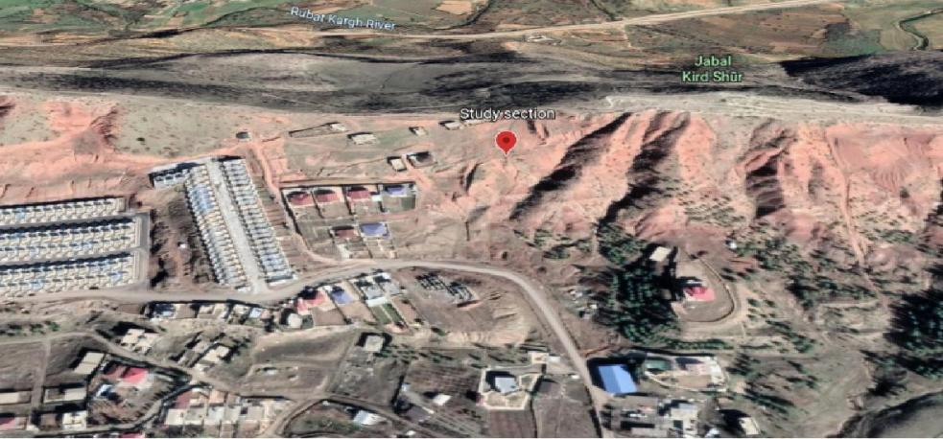

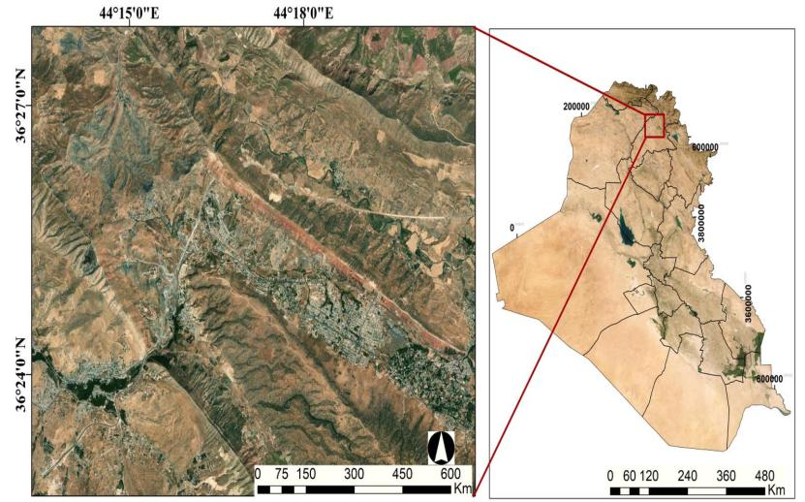

Fig.(1) : Satelite image shows Location of studied area.

Methodology
3-1 Field work and sampling

Extensive fieldwork was carried out in the area around the High Folded Zone in order to choosing the appropriate section for this study. One locality was chosen and one outcrop section was detected. The outcrop was described and measured in detail including lithology and sedimentary structures. The thickness of the studied section was about 300 m and total of 27 samples was prepared. The samples were collected non systematically (random sampling) according to changing lithology.

3-2 Lab work
We took 27 sample to laboratory, 1st we cut them slabs and then we rubbed the rock by the silicon carbide & water to make its surface smooth and the sample slide should be rough we make it by using Carborundum, after that we used Canada balsam on the slab leaving it for 48 hours finally, we thinned the slide to (0.3mm)

and Naopurdan Groups are interpreted to have been formed as a calc-alkaline volcanic arc and in a fore-arc basin. Their mutual position suggests that they formed above a NE dipping subduction zone in the closing Neo-Tethys Ocean. (Fig 2 )

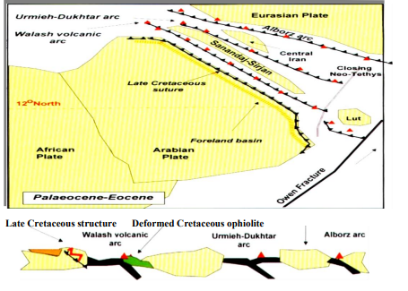

Fig. (2) : Eocene development of Arabian plate

