Q1/ Multiple choices (circle the correct answer). (45 M.)

- Amino acids are the building blocks of

- DNA and RNA
- Lipids
- Proteins

- In a DNA double-helix, nucleotides on complementary strands are held together by
- hydrogen bonds
- phosphodiester bonds
- none of the above

- Which of the following statements true?

- Each DNA molecule is a single gene
- DNA molecules are in the shape of a double helix
- mRNA molecules are in the shape of a double helix
4- A promoter is a
a- binding site for DNA polymerase.
b- binding site for RNA polymerase.
- start signal for replication.

- Which of the following statements is true about the protein synthesis process?

- When a section of a DNA molecule unwinds and unzips along its bases, a transfer RNA forms by copying one side of the DNA.
- The transfer RNA leaves the nucleus and goes out to the ribosomes in the cytoplasm where proteins are assembled with the help of messenger RNA.
- Both statements are false

- Each tRNA anticodon has three bases. The three base combinations are codes for attracting specific kinds of:

- Endoplasmic reticula
- Ribosomes
- Amino acids.

- A DNA codon consists of:

- One nucleotide
- Three nucleotides
- Hundreds or even thousands of nucleotides

- Which of these catalyzes the synthesis of RNA from a DNA template
- DNA ligase
- DNA polymerase
- RNA polymerase

- The RNA components of ribosomes are synthesized in the ________.
  - cytoplasm
  - nucleus
  - nucleolus

- A mRNA molecule is produced by
- Transcription
- Duplication
- Translation

- Which of the following is the correct sequence of event with reference to the central dogma?
- Transcription, Replication, Translation
- Duplication, Translation, Transcription
- Replication, Transcription, Translation

- Which of the following processes does not occur in prokaryotes?
a-Transcription
b-Splicing
c-Translation

- Which of the following base-pairing rule is correct?
a- Adenine with guanine and thymine with cytosine
b- DNA base pairing is non-specific
c- Adenine with cytosine and guanine with thymine

- What is produced during transcription?
- RNA polymerase
b- DNA molecules
d- Proteins

15- During translation, the type of amino acid that is added to the growing polypeptide depends on the
b- Anticodon on the mRNA and the anticodon on the tRNA.
c- Anticodon on the rRNA and the codon on the mRNA.
d- Codon on the mRNA and the anticodon on the Trna

Q2/ Multiple choices (circle the correct answer). (45 M.)
1- Short strands of ——- primers are used in DNA replication.
- DNA
- RNA
- Histone
- Protein
2- During DNA replication the synthesis of the leading strand of DNA results in fragments known as
- Okazaki fragments
- Satellite segments
- Kornberg segment
- Double -helix segment
3- Which of the following base-pairing rule is correct?
- Adenine with guanine and thymine with cytosine
- DNA base pairing is non-specific
- Adenine with cytosine and guanine with thymine
- Adenine with thymine and guanine with cytosine

4- True replication of DNA is due to
- Phosphate backbone
- Hydrogen bonding
- Complementary base pairing rule
- None
5- During translation, a transfer RNA (tRNA) molecule is associated with:
- An amino acid molecule, a DNA molecule, and a ribosome.
- An amino acid, a messenger RNA molecule and a ribosome.
- RRNA molecule, DNA molecule, and a phosphate
- An amino acid, rRNA and DNA
6-A promoter is ________.
- a specific sequence of DNA nucleotides
- a specific sequence of RNA nucleotides
- a protein that binds to DNA
- an enzyme that synthesizes RNA
7-The function of β subunit of polymerase is
- Template binding
- Catalytic binding
- Promoter binding
- Cation binding
8- Which of the following processes does not occur in prokaryotes?
- Transcription
- Splicing
- Translation
- Replication
9- How many RNA polymerases are present in a bacterial system?
- 4
- 2
- 1
- 3
10-Translation is terminated when a stop codon is presented at the ________ site.
A.A
B.P
C.E
E. either A or C
11- Which of the following proteins first binds to TATA box during transcription?
- TF II A
- TF II D
- TF II B
- RNA polymerase
12-The location of core promoter in eukaryotes is a short DNA sequence known as a TATA
box,is
- at the transcription start site
- approximately 90 bases upstream of the transcription start site
- approximately 10 bases upstream of the transcription start site
- approximately 25 bases upstream of the transcription start site

13- The sigma factor……………………
- is responsible for recognizing the termination sequence
- provides the catalytic function of cleaving off pyrophosphates during mRNA synthesis
- recognizes the promoter
- accomplishes DNA restriction
14- Proofreading and repair occur
- at anytime during and after synthesis of DNA
- only before DNA synthesis
- Only in the presence of DNA polymerase
- Only in the presence of an excision repair mechanism.
15-During DNA replication what is the first process to occur?
- Sealing of the nicks between short DNA sections
- Synthesis of the lagging strand
- Unwinding of parental DNA
- Synthesis of the leading strand

Q3/ Outline the three steps involved in processing pre- mRNA in eukaryotes before translation.
(25 M.)

Q4/ a- What is the PCR? (20 M.)
- Comparative between DNA Replication and PCR.

Q5/ Transcribe this DNA strand into an mRNA strand (10 M.)

5- ATGCCTAGGTACCTATGA-3
3- TACGGATCCATGGATACT-5

Q6/ Mention the major types of RNA and their functions (20 M.)
Q7/ What are the roles of TATA-binding protein (TBP), α factor, RNA polymerase III, and Transcription factors of DNA in transcription? (20 M.)
Q8 / Answer these questions briefly. (8 M.)
- What is the role of topoisomerase in DNA replication?
- What happens if DNA polymerase 1 is absent?
- Which type of DNA is more stable?
- Which side of DNA has continuous replication? Why?

Q9 /What are the stages of translation? Briefly describe what occurs in each stage. (7 M.)

Q10 / If you have a polypeptide sequenced as (start amino acid, Glutamic, Alanine, Glycine)

What is the sequence of the mRNA and DNA for this polypeptide, and then if a secondC deletedin the DNA sequence write down the new DNA, mRNA and polypeptide chain sequences. Use this table for your answer. (10 M.)
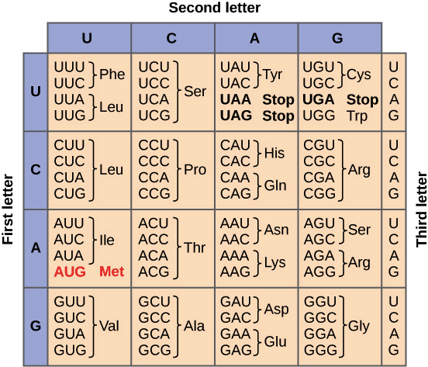

Q11 / Numerate types of markers, and describe molecular markers in detail. (10 M.)
Q12/ What is protein and describe structure of proteins in short? (10 M.)
Q13: Define the Polymerase Chain Reaction, and write all stages for this machine with graph. (10 Marks)
Q14: Write what you know about transcription and translation in animal cell. (10 Marks)
- Q15: Account the functions for all component helps to make the DNA replications. (10 Marks)
Q16: Write what you know about DNA extraction from blood samples. (10 Marks
Q17/ Another type of examinations:
Q: Account for the following phrases: (7 Marks)
- Using the 1% and 3% of agarose gel to test the genome DNA and part of DNA, respectively.
- You must add the Ethidium bromide to the gel or to become covered on it, when you need to take DNA photo.
- DNA sample must mixed with 6X Loading Buffer when load it in the gel electrophoresis.
- Adding the DNA Ladder Standard to the right side of the gel.
- Using the electric field in the DNA running on the agarose gel.
- Using isopropanol in DNA extraction.
- The sticky end in DNA fragment is best than Blunt end in cloning process.

