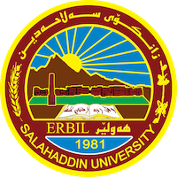

**Academic Curriculum Vitae**

**Personal Information:** 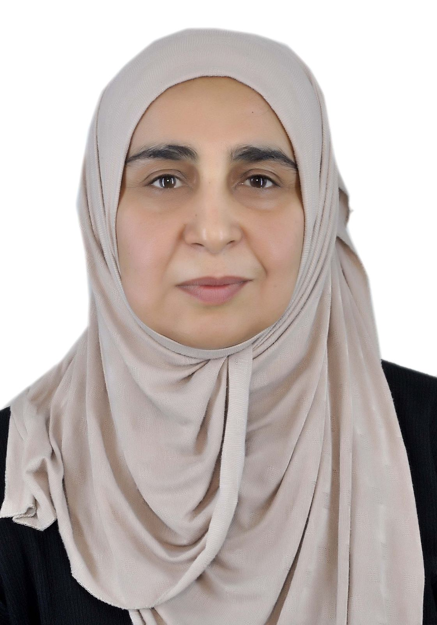

Full Name: Lana Sardar Saleh

Academic Title: Assistant prof.

Email: lana.alalem@su.edu.krd

Mobile: 07504603222

**Education:**

1. Phd degree in Histology and embryology/Mosul University 2008.
2. Master in animal physiology/Salahaddin university 2004

**Employment:**

|  |  |  |  |
| --- | --- | --- | --- |
| 1997 | 2002 | كؤلێژی زانست/ زانكۆی سه‌لاحه‌ددین-هه‌ولێر | معید |

|  |  |  |  |
| --- | --- | --- | --- |
| 2002 | تا ئێستا | كؤلێژی زانست/‌ زانكۆی سه‌لاحه‌ددین-هه‌ولێر | مامۆستا / ستافی ئه‌كادیمی |

**Qualifications**

* Teaching qualifications
* IT qualifications
* Language qualifications such as TOEFL, IELTS or any equivalent
* Any professional qualification
* You could put any professional courses you have attended

**Teaching experience:**

* General biology, zoology, cell biology, micro technique, invertebrate, animal and human histology and embryology
* Supervising deploma, master, and phd student.

**Research and publications**

|  |  |  |  |
| --- | --- | --- | --- |
| Clarivate, Web of Science Scopus,  CS=2.5 | 1.6 | Cellular and Molecular Biology 2023, 69(14): 237-242 | Next-generation sequencing and immunohistochemistry approaches for microsatellite instability detection in endometrial cancer |
|  |  | Diyala Journal of Medicine | Effect of Isotretinion on Rat’s Liver and Aptness of Cumin Oil in Protection |
| Scopus  CS=1.5 |  | Iraqi Journal of Science, 2024, Vol. 65, No. 2, pp: 675- 683 | The association of age and gender with histopathological features among thyroid cancer pateints in Erbil city, Iraq: clinical analysis of 153 cases |
| Science-Direct  ElSEVIER | 2.7 | Tissue and Cell 88 (2024) 102379 | Enhancing sciatic nerve regeneration with osteopontin-loaded acellular nerve allografts in rats: Effects on macrophage polarization |
| Clarivate, Web of Science Scopus,  CS=2.5 | 1.6 | Cellular and Molecular Biology 2023, 69(4): 75-80 | The histological and immunopathological landscape of lung autopsy sample of COVID 19 |
| Scops |  | Azerbaijan Medical Journal 2022, vol 62 | Prosopis fracta extract mitigating effect on testicular toxicity of gentamicin |

**Conferences and courses attended**

* Give details of any conferences you have attended, and those at which you have presented delivered poster presentations.

**Funding and academic awards**

* List any bursaries, scholarships, travel grants or other sources of funding that you were awarded for research projects or to attend meetings or conferences.

**Professional memberships**

* List any membership you hold of any professional body or learned society relevant to your research or other life activities.

**Professional Social Network Accounts:**

<https://www.researchgate.net/profile/Lana_Alalem>

<https://scholar.google.com/citations?user=jkgcxEIAAAAJ&hl=en>

<https://www.linkedin.com/in/lana-alalem-a808126b/>

<https://orcid.org/0000-0001-8698-8598>