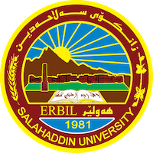

**Academic Curriculum Vitae**



**Personal Information:**

Full Name:Lana Mohammed Hasan

Academic Title: Assistant lecturer

Email: (university email) lana.hasan@su.edu.krd

Mobile: 07509050606

**Education:**

* State all educations accomplished

**Employment:**

Bsc 2010 – University of Salahaddin Msc

2016 – University of Salahaddin

**Qualifications**

* Windows xp – Microsoft Word – Excel- Microsoft powerpoint- Autocad program- 3d Max
* IELTS = 5.5

**Teaching experience:**

Architecture Design and Supervising 2010-2015 UB holding  
2018-2021 High build C.

• Teaching from 2011

Teaching different materials for different grades till today as a Assistant Lecturer in the Department such as (Architecture Design, Building material, Building construction, Urban design ....... etc.)

**Professional memberships**

* Member of KURDISTAN ENGINEERS UNION in ERBIL ID. Card No. (8505)

**Professional Social Network Accounts:**

<https://orcid.org/my-orcid?orcid=0000-0002-0503-2517>

<https://www.researchgate.net>