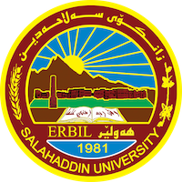
Academic Curriculum Vitae

Personal Information:
Full Name: Dr. Lanja Abdulrazzaq Dabbagh
Academic Title: Assistant Professor
Email: lanja.dabbagh@su.edu.krd
Mobile: +964 750 445 3971

Education:
- PHD in English Language and Linguistics
- MA in English Language and Linguistics
- BA in English Language and Literature

Employment:
- Translator – College of Medicine – Salahaddin University – 1993
- Assistant Lecturer – College of Arts – Salahaddin University – 2001
- Head of the German Department – College of Languages – Salahaddin University – 2018

Qualifications
- Teaching all branches of language and linguistics
- Microsoft software: word, excel, PowerPoint.
- TOEFL, IELTS, PTE
- Professional qualifications: Department management, communication relations.
- Professional courses: Teacher’s training, ToT, Management Training

Teaching experience:
- Teaching all branches of language and linguistics for undergraduate students, and postgraduate students.
- Supervising postgraduate and undergraduate students.

Research and publications
- Over 65 published research in international and national journals.

Conferences and courses attended
- Attended over 30 national and international conferences and participated in over 20 national and international conferences.

Funding and academic awards
- Workshops and conferences funded by DAAD.

Professional memberships
- Member of research gate, google scholar, LinkedIn, and Orcid.

