Q1: 1. How can you identify these samples? Compare it. (20 marks)
2. What is the name of this test?
3. Define this test.
4. Write the measurment equation of it .

Q2: A/ The following procedure is used for determination of …………………….
B/ This procedure have a name, Write the name of this method.
C/What is the component of buffer solution used in this procedure?
D/ What is the reaction (principle) that happened in this procedure? (20 marks)
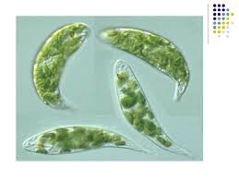
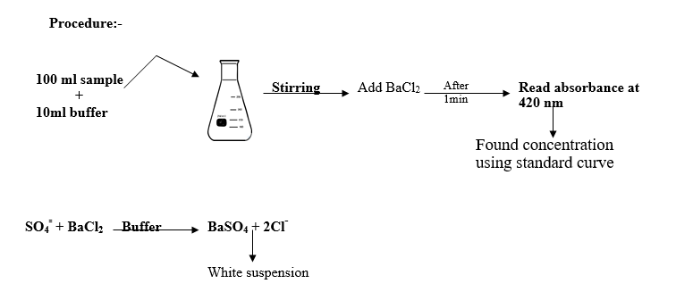

Q3: A/ Identify this figure, how can you recognize it in the lab?
B/ What is the relationship between this organism and water pollution?
C/ Write about some other similar species that are related to water pollution.
(15 marks)

Q4: A/Write the (name) and the (use) of the following instrument. (15 marks)
B/ What are the advantages of this test?
C/ What are the differences between this test and the classical test?
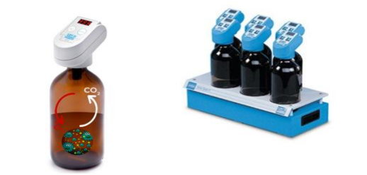
Q5: Choose suitable phrases for the following criteria: (10 marks)
1. The permissible limit for nitrate NO₃ in drinking water is:
a) 10 mg/l b) 30 mg/l c) 100 mg/l

2. The wave length of spectrophotometer that used for determination of Ammonia NH₃ in water is:
- 640 nm b) 275 nm c) 885 nm

3. The preferable method for determination of PO₄ water is:
a) Dichromate reflux method b) Ascorbic acid c) Winkler method

4. The phenomenon that caused by high levels of N and P compounds in water called:
a) Self-purification b) Eutrophication c) Ammonification

5. Water quality is considered “very good” water when the BOD concentration ranged between:
a) 1-2 mg/l b) 3--5 mg/l c) 6-9 mg/l

Q6: A/ Answer (4) of the following questions: (20 marks)

- What are the major sources of NO₂ in water?
- What are the differences between BOD and COD?
- What are the factors that affect the TSS of water?
- What are the effects of ammonia (NH₃) in water?
- Write the steps of determination the PO₄ concentration in water?
- What are the effect of SO₄ in water?

