Name:

Q1: Fill the blanks with suitable sentences:

- The most two groups of pesticide identified as being extremely toxic to earth worms and most other soil organisms are………..……………...and ……………..…………
- Natural food preservatives are chemical that added to food to help …………………; …………………………and ........................................
- The tissue digestion of plants tissue can be made by two methods, they are ……………..............................and…………………..…………..
- …………………………is a general term used to describe any chemical interacting with an organism that does not occur in the normal metabolic pathways of that organism.
- Germination% =...........................................................................................
- BFC =……………………………………………………………………….

Q2: Choose suitable phrases of the following criteria:-
- …………is the concentration that has an effect on 50% of the test groups of an organisms
- LD₅₀ b. LC₅₀ c. EC₅₀

- ………….. is considered as a natural toxin:-
- Mycotoxin b. Therapeutic drug c.Insecticide

- The advantages of invertebrate animal testing due to:-
- Short life cycle b. Housing and studying large no. are easy c. Both of them

- ……………..is one of the natural food additives:-
- NaCl b. CuSO₄ c. H₂SO₄

- The acid used for digestion of water is
- H₂SO₄ b. HCl c. HNO₃

Q3: A/ Identify this experiment.
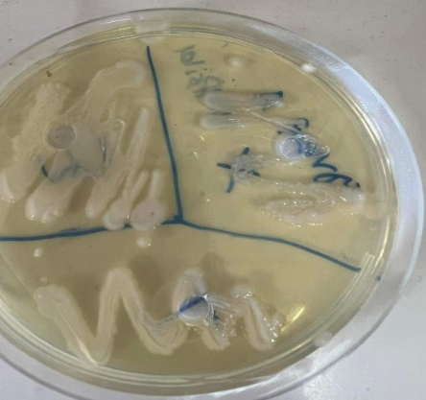
B/ What are the toxic substances used in this procedure?

Q4: A/ Identify and write the name of this experiment (name of lab).
B/ We have three (3) test to make this procedure.
- What are they?
- Which test applied in this procedure?
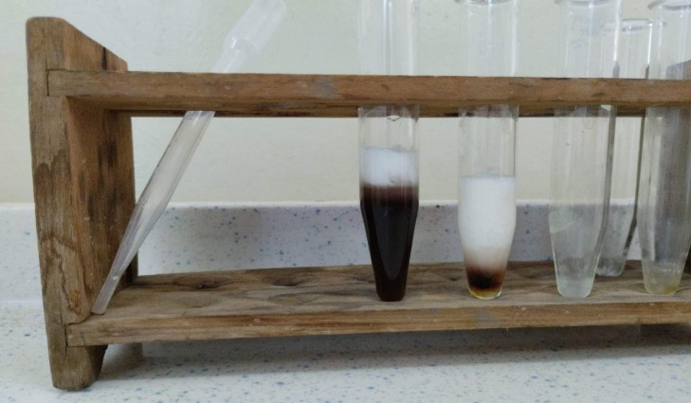

Q5: Identify these hazardous signs:
1 2 3

4 5
Q6: How can you explain your experiment and the results that you obtained from the toxicity tests of pesticides on earthworms lab?

Q7: A/ 1. Identify these two slides.
2. Write the name of this experiment.
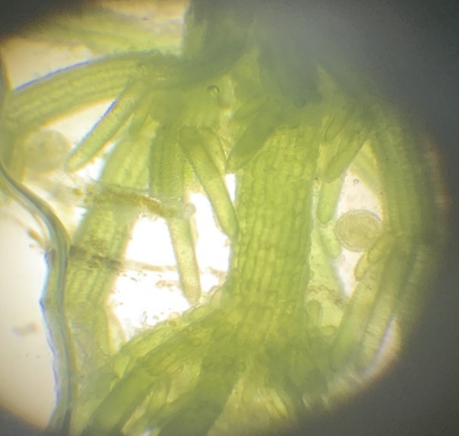
B/ What are the differences between these two slides?

Q8: Answer (2) of the following questions:
- What are mechanisms of the action of preservation of food?
- What are the factors of the toxicity of hydrocarbons that depended on?
- Write the steps of plant digestion in a diagram.

Q9: Determine the LD₅₀ by Karber’s methods on an acute toxicity testing of the effects of toxicant (Arsenic) on albino rats by administering single dose via oral for 14 days by using the following tables.

