**Solved Problems on Transistor**

**Q1. A common base transistor amplifier has an input resistance of 20 Ω and output resistance of 100 kΩ. The collector load is 1 kΩ. If a signal of 500 mV is applied  between emitter and base, find the voltage amplification. Assume αac to be nearly one.**

**Solution :**

Fig.1 shows the conditions of the problem. Here the output resistance is very high as compared to input resistance, since the input junction (base to emitter) of the transistor is forward biased while the output junction (base to collector) is reverse biased.

[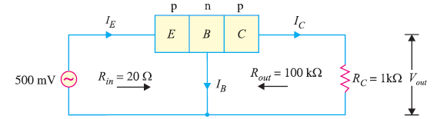](https://electronicspost.com/wp-content/uploads/2019/07/103.png)

Fig. 1

[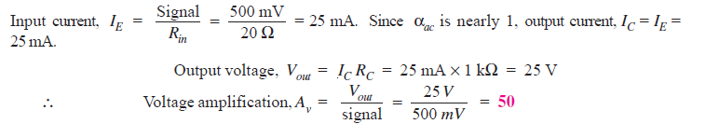](https://electronicspost.com/wp-content/uploads/2019/07/104.png)

**Q2. In a common base connection, IE = 1mA, IC = 0.95mA. Calculate the value of IB.**

**Solution :[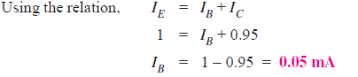](https://electronicspost.com/wp-content/uploads/2019/07/105.png)**

**Q3. In a common base connection, current amplification factor is 0.9. If the emitter current is 1mA, determine the value of base current.**

**Solution :**

[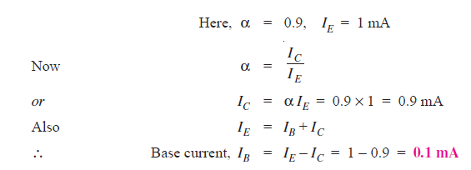](https://electronicspost.com/wp-content/uploads/2019/07/106.png)

**Q4. In a common base connection, IC = 0.95 mA and IB = 0.05 mA. Find the value of α.**

**Solution :**

[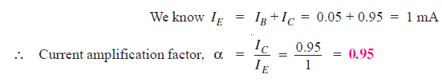](https://electronicspost.com/wp-content/uploads/2019/07/107.png)

**Q5. In a common base connection, the emitter current is 1mA. If the emitter circuit is open, the collector current is 50 μA. Find the total collector current. Given that α =  0.92.**

**Solution :**

[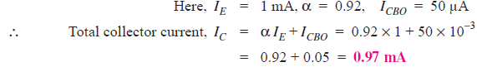](https://electronicspost.com/wp-content/uploads/2019/07/108-1.png)

**Q6. In a common base connection, α = 0.95. The voltage drop across 2 kΩ resistance  
which is connected in the collector is 2V. Find the base current.**

**Solution :**

[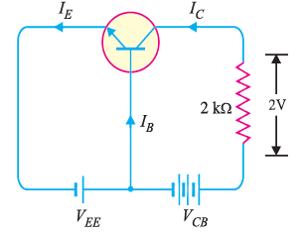](https://electronicspost.com/wp-content/uploads/2019/07/109.png)Fig. 2

Fig. 2 shows the required common base connection.

The voltage drop across RC (= 2 kΩ) is 2V.

[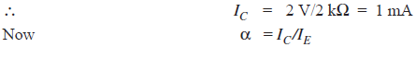](https://electronicspost.com/wp-content/uploads/2019/07/110.png)

[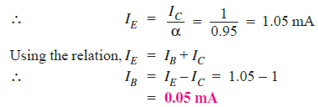](https://electronicspost.com/wp-content/uploads/2019/07/111.png)

**Q7. For the common base circuit shown in Fig. 3, determine IC and VCB. Assume the  transistor to be of silicon.**

[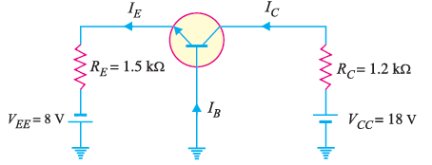](https://electronicspost.com/wp-content/uploads/2019/07/112.png)Fig. 3

**Solution :**

Since the transistor is of silicon, VBE = 0.7V.

Applying Kirchhoff’s voltage law to the emitter-side loop,we get,

[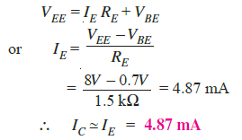](https://electronicspost.com/wp-content/uploads/2019/07/113.png)

Applying Kirchhoff’s voltage law to the collector-side loop, we have,

[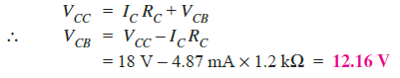](https://electronicspost.com/wp-content/uploads/2019/07/114.png)

**Q8. Find the value of β if (i) α = 0.9 (ii) α = 0.98 (iii) α = 0.99.**

**Solution :**

**(i) α = 0.9**

[https://electronicspost.com/wp-content/uploads/2019/07/115.png](https://electronicspost.com/wp-content/uploads/2019/07/115.png)

**(ii) α = 0.98**

[https://electronicspost.com/wp-content/uploads/2019/07/116.png](https://electronicspost.com/wp-content/uploads/2019/07/116.png)

**(iii) α = 0.99**

[https://electronicspost.com/wp-content/uploads/2019/07/117.png](https://electronicspost.com/wp-content/uploads/2019/07/117.png)

**Q9. Calculate IE in a transistor for which β = 50 and IB= 20 μA.**

**Solution :**

**[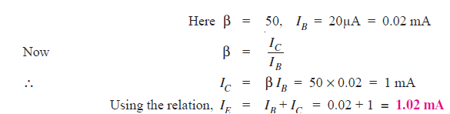](https://electronicspost.com/wp-content/uploads/2019/07/118.png)**

**Q10. Find the α rating of the transistor shown in Fig. 4. Hence determine the value of IC using both α and β rating of the transistor.**

[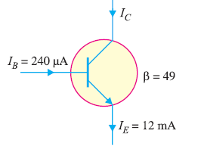](https://electronicspost.com/wp-content/uploads/2019/07/119.png)

Fig. 4

**Solution :**

Fig. 8.20 shows the conditions of the problem.

[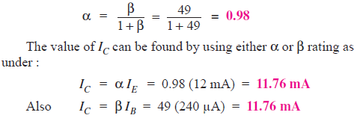](https://electronicspost.com/wp-content/uploads/2019/07/120.png)

**Q11. For a transistor, β = 45 and voltage drop across 1kΩ which is connected in the  collector circuit is 1 volt. Find the base current for common emitter connection.**

**Solution :**

[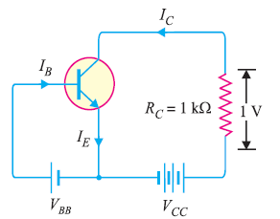](https://electronicspost.com/wp-content/uploads/2019/07/121.png)

Fig. 5

Fig. 5 shows the required common emitter connection. The voltage drop across RC (= 1 kΩ) is 1 volt.

[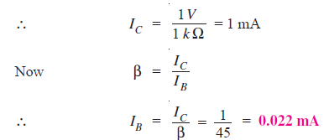](https://electronicspost.com/wp-content/uploads/2019/07/122.png)

**Q12. A transistor is connected in common emitter (CE) configuration in which collector supply is 8 V and the voltage drop across resistance RC connected in the collector circuit is 0.5 V. The value of RC= 800 Ω. If α = 0.96, determine : (i) collector-emitter voltage (ii) base current.**

**Solution :**

[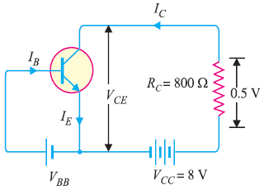](https://electronicspost.com/wp-content/uploads/2019/07/123.png)

Fig.6

Fig. 6 shows the required common emitter connection with various values.

**(i)**[https://electronicspost.com/wp-content/uploads/2019/07/124.png](https://electronicspost.com/wp-content/uploads/2019/07/124.png)

**(ii)**

[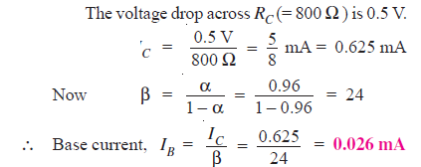](https://electronicspost.com/wp-content/uploads/2019/07/125.png)

**Q13. An n-p-n transistor at room temperature has its emitter disconnected. A voltage of 5 V is applied between collector and base. With collector positive, a current of 0.2 μA flows. When the base is disconnected and the same voltage is applied between collector and emitter, the current is found to be 20 μA. Find α, IEand IB when collector current is 1 mA.**

**Solution :**

[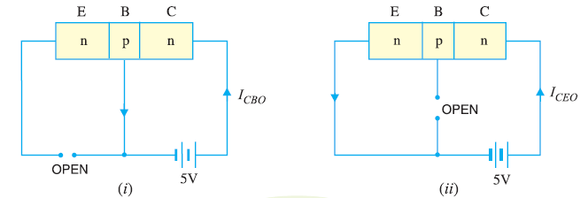](https://electronicspost.com/wp-content/uploads/2019/07/126.png)

Fig. 7

When the emitter circuit is open as shown in Fig.7 (i) , the collector-base junction is reverse biased. A small leakage current ICBOflows due to minority carriers.

[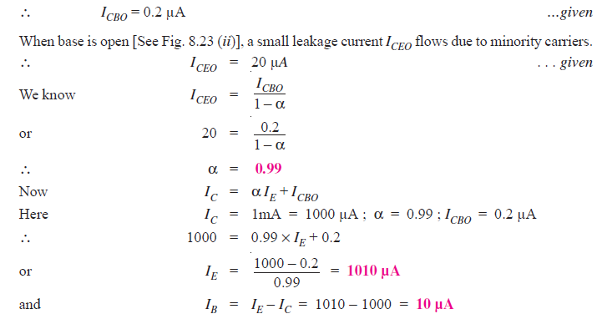](https://electronicspost.com/wp-content/uploads/2019/07/127.png)

**Q14. The collector leakage current in a transistor is 300 μA in CE arrangement. If now  
the transistor is connected in CB arrangement, what will be the leakage current? Given that β = 120.**

**Solution :**

[https://electronicspost.com/wp-content/uploads/2019/07/129-2.png](https://electronicspost.com/wp-content/uploads/2019/07/129-2.png)

[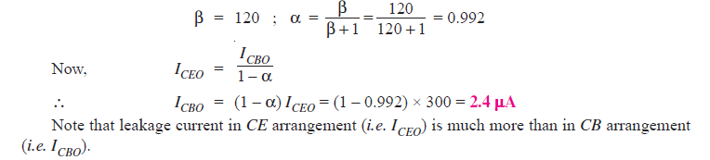](https://electronicspost.com/wp-content/uploads/2019/07/130.png)

**Q15. For a certain transistor, IB = 20 μA; IC= 2 mA and β = 80. Calculate ICBO.**

**Solution :**

[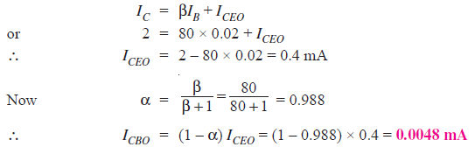](https://electronicspost.com/wp-content/uploads/2019/07/131.png)

**Q16. Using diagrams, explain the correctness of the relation ICEO = (β + 1)ICBO.**

**Solution :**

The leakage current ICBO is the current that flows through the base-collector junction when emitter is open as shown is Fig. 8.

[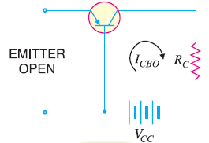](https://electronicspost.com/wp-content/uploads/2019/07/132.png)

Fig. 8

When the transistor is in CE arrangement, the base current (i.e. ICBO) is multiplied by β in the collector as shown in Fig. 9.

[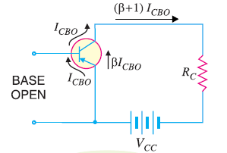](https://electronicspost.com/wp-content/uploads/2019/07/133.png)

Fig.9

[https://electronicspost.com/wp-content/uploads/2019/07/134.png](https://electronicspost.com/wp-content/uploads/2019/07/134.png)

**Q17. Determine VCBin the transistor circuit shown in Fig. 10 (i). The transistor is of silicon and has β = 150.**

**Solution :**

[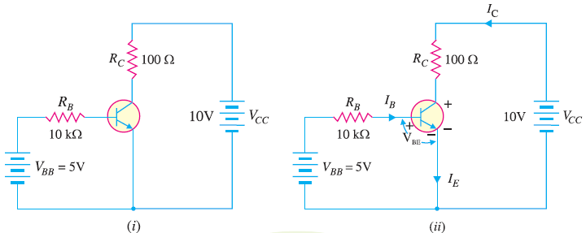](https://electronicspost.com/wp-content/uploads/2019/07/135.png)

Fig.10

Fig. 10 (i) shows the transistor circuit while Fig. 10 (ii) shows the various currents and voltages along with polarities.

[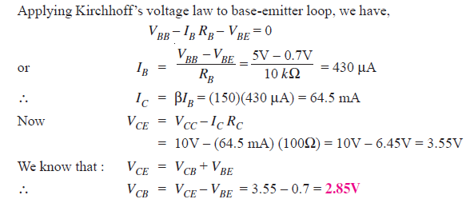](https://electronicspost.com/wp-content/uploads/2019/07/136.png)

**Q18. In a transistor, IB = 68 μA, IE = 30 mA and β = 440. Determine the α rating of the transistor. Then determine the value of IC using both the α rating and β rating of the transistor.**

**Solution :**

[https://electronicspost.com/wp-content/uploads/2019/07/138.png](https://electronicspost.com/wp-content/uploads/2019/07/138.png)

[https://electronicspost.com/wp-content/uploads/2019/07/139-1.png](https://electronicspost.com/wp-content/uploads/2019/07/139-1.png)

**Q19. A transistor has the following ratings : IC (max) = 500 mA and βmax = 300.  
Determine the maximum allowable value of IB for the device.**

**Solution :**

[https://electronicspost.com/wp-content/uploads/2019/07/140.png](https://electronicspost.com/wp-content/uploads/2019/07/140.png)

For this transistor, if the base current is allowed to exceed 1.67 mA, the collector current will exceed its maximum rating of 500 mA and the transistor will probably be destroyed.

**Q20. Fig. 11 shows the open circuit failures in a transistor. What will be the circuit behaviour in each case ?**

**Solution :**

[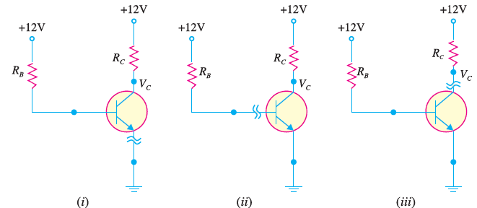](https://electronicspost.com/wp-content/uploads/2019/07/141.png)

Fig. 11

Fig 11 shows the open circuit failures in a transistor. We shall discuss the circuit behaviour in each case.

**(i) Open emitter :**

Fig. 11 (i) shows an open emitter failure in a transistor. Since the collector diode is not forward biased, it is OFF and there can be neither collector current nor base current.  
Therefore, there will be no voltage drops across either resistor and the voltage at the base and at the  
collector leads of the transistor will be 12V.

**(ii) Open-base :**

Fig. 11 (ii) shows an open base failure in a transistor. Since the base is open, there can be no base current so that the transistor is in cut-off. Therefore, all the transistor currents are 0A. In this case, the base and collector voltages will both be at 12V.

**(iii) Open collector :**

Fig. 11 (iii) shows an open collector failure in a transistor. In this case, the emitter diode is still ON, so we expect to see 0.7V at the base. However, we will see 12V at the collector because there is no collector current.

**Q21. For the circuit shown in Fig. 12 , draw the d.c. load line.**

[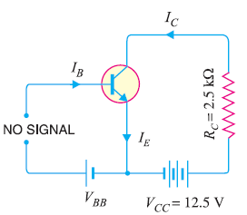](https://electronicspost.com/wp-content/uploads/2019/07/143.png)

Fig.12

**Solution :**

The collector-emitter voltage VCE  is given by ;

[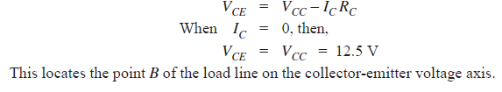](https://electronicspost.com/wp-content/uploads/2019/07/144.png)

[https://electronicspost.com/wp-content/uploads/2019/07/145.png](https://electronicspost.com/wp-content/uploads/2019/07/145.png)

This locates the point A of the load line on the collector current axis. By joining these two points, we get the d.c. load line AB as shown in Fig. 13.

[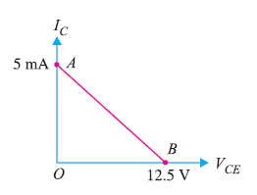](https://electronicspost.com/wp-content/uploads/2019/07/146.png)

Fig.13

**Q22. In the circuit diagram shown in Fig. 14, if VCC = 12V and RC = 6 kΩ,  draw the d.c. load line. What will be the Q point if zero signal base current is 20μA and β = 50 ?**

[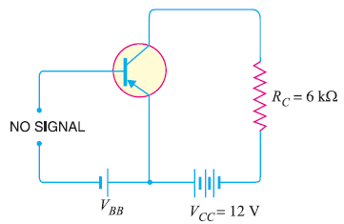](https://electronicspost.com/wp-content/uploads/2019/07/147.png)

Fig.14

**Solution :**

The collector-emitter voltage VCE  is given by :

[https://electronicspost.com/wp-content/uploads/2019/07/148.png](https://electronicspost.com/wp-content/uploads/2019/07/148.png)

When IC = 0, VCE = VCC = 12 V. This locates the point B of the load line.

When VCE = 0, IC = VCC  / RC  = 12 V/6 kΩ = 2 mA.

This locates the point A of the load line. By joining these two points, load line AB is constructed as shown in 15.

[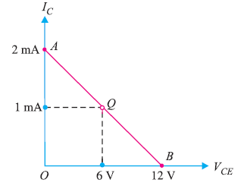](https://electronicspost.com/wp-content/uploads/2019/07/149.png)

Fig. 15

[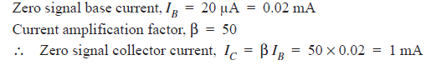](https://electronicspost.com/wp-content/uploads/2019/07/150.png)

[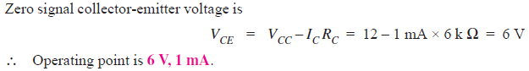](https://electronicspost.com/wp-content/uploads/2019/07/151-1.png)

Fig. 15 shows the Q point. Its co-ordinates are IC  = 1 mA and VCE= 6 V.

**Q23. In a transistor circuit, collector load is 4 kΩ whereas quiescent current (zero signal collector current) is 1 mA. (i) What is the operating point if  VCC = 10 V ? (ii) What will be the operating point if RC = 5 kΩ ?**

**Solution :[https://electronicspost.com/wp-content/uploads/2019/07/152.png](https://electronicspost.com/wp-content/uploads/2019/07/152.png)**

(i) When collector load RC= 4 k Ω , then,

[https://electronicspost.com/wp-content/uploads/2019/07/153.png](https://electronicspost.com/wp-content/uploads/2019/07/153.png)

(ii) When collector load RC= 5 k Ω , then,

[https://electronicspost.com/wp-content/uploads/2019/07/154.png](https://electronicspost.com/wp-content/uploads/2019/07/154.png)

**Q24. Determine the Q point of the transistor circuit shown in Fig. 16. Also draw the d.c. load line. Given β = 200 and VBE = 0.7V.**

[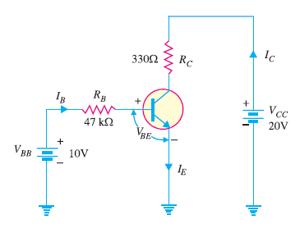](https://electronicspost.com/wp-content/uploads/2019/07/155.png)

Fig. 16

**Solution :**

The presence of resistor RB in the base circuit should not disturb you because we can apply Kirchhoff’s voltage law to find the value of IB and hence IC (= βIB). Referring to Fig. 16 and applying Kirchhoff’s voltage law to base-emitter loop, we have,

[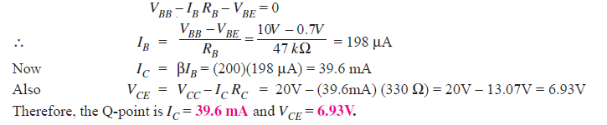](https://electronicspost.com/wp-content/uploads/2019/07/156.png)

**D.C. load line:**

In order to draw the d.c. load line, we need two end points.

[https://electronicspost.com/wp-content/uploads/2019/07/148.png](https://electronicspost.com/wp-content/uploads/2019/07/148.png)

When IC = 0, VCE = VCC  = 20V. This locates the point B of the load line on the collector-emitter voltage axis as shown in Fig. 17.

When VCE = 0, IC = VCC/ RC = 20V/330Ω = 60.6 mA. This locates the point A of the load line on the collector current axis.

By joining these two points, d.c. load line AB is constructed as shown in Fig. 17.

[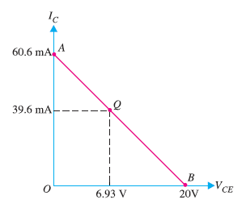](https://electronicspost.com/wp-content/uploads/2019/07/157.png)

Fig. 17

**Q25. Determine the Q point of the transistor circuit shown in Fig. 18. Also draw the d.c. load line. Given β = 100 and VBE = 0.7V.**

[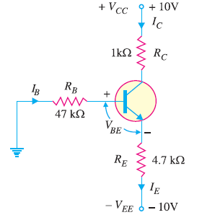](https://electronicspost.com/wp-content/uploads/2019/07/158.png)

Fig.18

**Solution :**

The transistor circuit shown in Fig. 18 may look complex but we can easily apply Kirchhoff’s voltage law to find the various voltages and currents in the circuit.

[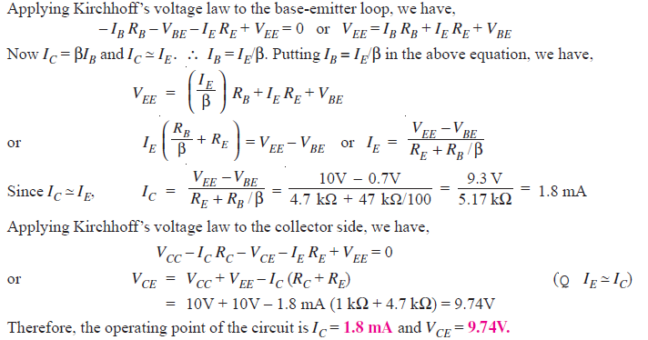](https://electronicspost.com/wp-content/uploads/2019/07/159.png)

**D.C. load line :**

The d.c. load line can be constructed as under :

[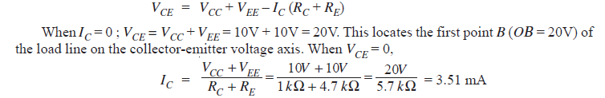](https://electronicspost.com/wp-content/uploads/2019/07/160.png)

This locates the second point A (OA = 3.51 mA) of the load line on the collector current axis. By joining points A and B, d.c. load line AB is constructed as shown in Fig. 19.

[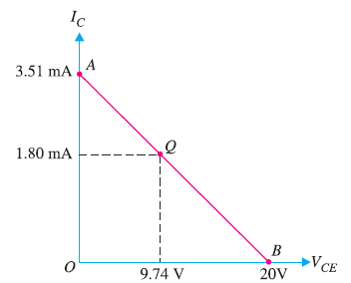](https://electronicspost.com/wp-content/uploads/2019/07/161.png)

Fig.19

**Q26. In the above example, find (i) emitter voltage w.r.t. ground (ii) base voltage w.r.t. ground (iii) collector voltage w.r.t. ground.**

**Solution :**

[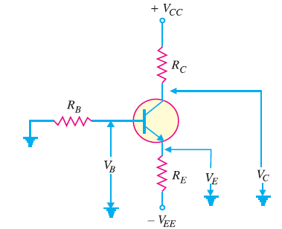](https://electronicspost.com/wp-content/uploads/2019/07/162.png)

Fig.20

Referring  to Fig. 20:

(i) The emitter voltage w.r.t. ground is

[https://electronicspost.com/wp-content/uploads/2019/07/163.png](https://electronicspost.com/wp-content/uploads/2019/07/163.png)

(ii) The base voltage w.r.t. ground is

[https://electronicspost.com/wp-content/uploads/2019/07/164.png](https://electronicspost.com/wp-content/uploads/2019/07/164.png)

(iii) The collector voltage w.r.t. ground is

[https://electronicspost.com/wp-content/uploads/2019/07/165.png](https://electronicspost.com/wp-content/uploads/2019/07/165.png)

**Q27. If the collector current changes from 2 mA to 3mA in a transistor when collector-  
emitter voltage is increased from 2V to 10V, what is the output resistance ?**

**Solution :**

Change in collector-emitter voltage is :

[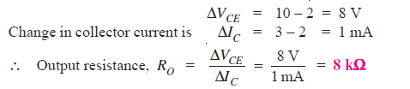](https://electronicspost.com/wp-content/uploads/2019/07/166.png)

**Q28. A change of 200 mV in base-emitter voltage causes a change of 100 μA in the  
base current. Find the input resistance of the transistor.**

**Solution :**

Change in base-emitter voltage is :

[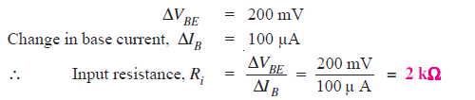](https://electronicspost.com/wp-content/uploads/2019/07/167.png)

**Q29. For a single stage transistor amplifier, the collector load is RC= 2kΩ and the input resistance Ri = 1kΩ. If the current gain is 50, calculate the voltage gain of the amplifier.**

**Solution :**

**[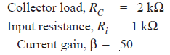](https://electronicspost.com/wp-content/uploads/2019/07/168.png)**

[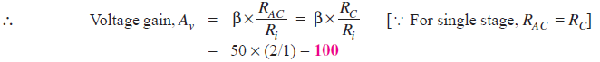](https://electronicspost.com/wp-content/uploads/2019/07/169.png)

**Q30. Find IC(sat) and VCE(cutoff)  for the circuit shown in Fig. 21.**

[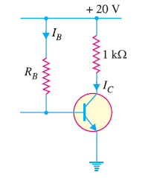](https://electronicspost.com/wp-content/uploads/2019/07/170.png)

Fig.21

**Solution :**

As we decrease RB, base current and hence collector current increases. The increased collector current causes a greater voltage drop across RC ; this decreases the collector-emitter voltage.

Eventually at some value of RB, VCE  decreases to Vknee . At this point, collector-base junction is no longer reverse biased and transistor action is lost.

Consequently, further increase in collector current is not possible. The transistor conducts maximum collector current or we can say the transistor is saturated.

[https://electronicspost.com/wp-content/uploads/2019/07/171.png](https://electronicspost.com/wp-content/uploads/2019/07/171.png)

As we increase RB, base current and hence collector current decreases. This decreases the voltage drop across RC. This increases the collector-emitter voltage. Eventually, when IB = 0, the emitter-base junction is no longer forward biased and transistor action is lost.

Consequently, further increase in VCE is not possible. In fact, VCE now equals to VCC.

[https://electronicspost.com/wp-content/uploads/2019/07/172.png](https://electronicspost.com/wp-content/uploads/2019/07/172.png)

Fig. 22 shows the saturation and cut off points. Incidentally, they are end points of the d.c. load line.

[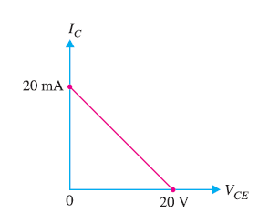](https://electronicspost.com/wp-content/uploads/2019/07/173.png)

Fig. 22

**Q31. Determine the values of VCE(off) and IC(sat)for the circuit shown in Fig. 23.**

[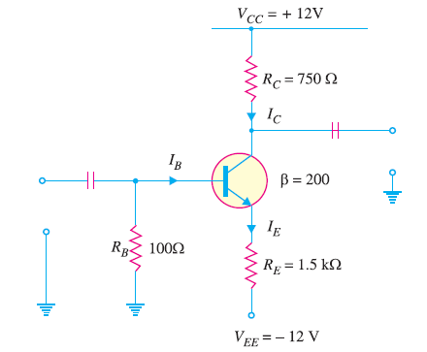](https://electronicspost.com/wp-content/uploads/2019/07/174.png)

Fig. 23

**Solution :**

Applying Kirchhoff’s voltage law to the collector side of the circuit in Fig. 23, we have ,

[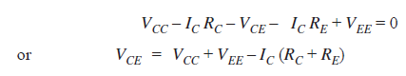](https://electronicspost.com/wp-content/uploads/2019/07/175.png)

[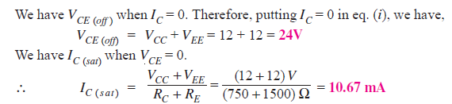](https://electronicspost.com/wp-content/uploads/2019/07/176.png)

**Q32. Determine whether or not the transistor in Fig. 24 is in stauration. Assume Vknee= 0.2V.**

[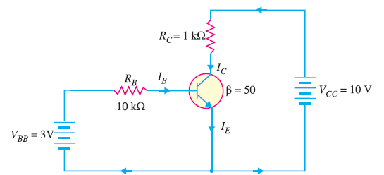](https://electronicspost.com/wp-content/uploads/2019/07/177.png)

Fig.24

**Solution :**

[https://electronicspost.com/wp-content/uploads/2019/07/178.png](https://electronicspost.com/wp-content/uploads/2019/07/178.png)

Now we shall see if IB is large enough to produce IC(sat).

[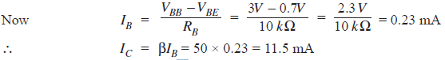](https://electronicspost.com/wp-content/uploads/2019/07/179-1.png)

This shows that with specified β, this base current (= 0.23 mA) is capable of producing IC greater than IC(sat). Therefore, the transistor is**saturated**. In fact, the collector current value of 11. 5 mA is never reached. If the base current value corresponding to IC(sat) is increased, the collector current remains at the saturated value (= 9.8 mA).

**Q33. Is the transistor in Fig. 25 operating in saturated state ?**

[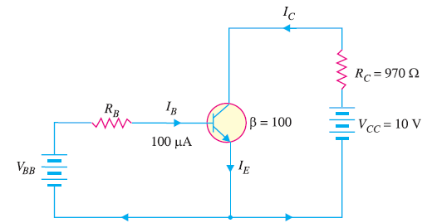](https://electronicspost.com/wp-content/uploads/2019/07/180.png)

Fig.25

**Solution :**

[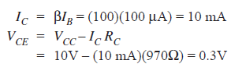](https://electronicspost.com/wp-content/uploads/2019/07/181.png)

Let us relate the values found to the transistor shown in Fig. 26.

[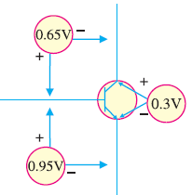](https://electronicspost.com/wp-content/uploads/2019/07/182.png)

Fig.26

As we can see, the value of VBE is 0.95V and the value of VCE = 0.3V.

This leaves VCB of 0.65V (Note that VCE = VCB + VBE).

In this case, collector–base junction (i.e., collector diode) is forward biased as is the emitter-base junction (i.e., emitter diode). Therefore, the transistor is operating in the **saturation region**.

**Q34. For the circuit in Fig. 27, find the base supply voltage ( VBB) that just puts the transistor into saturation. Assume β = 200.**

[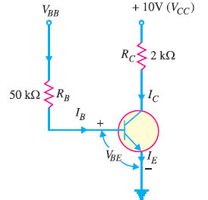](https://electronicspost.com/wp-content/uploads/2019/07/183.png)

Fig.27

**Solution :**

When transistor first goes into saturation, we can assume that the collector shorts to the emitter (i.e. VCE= 0) but the collector current is still β times the base current.

[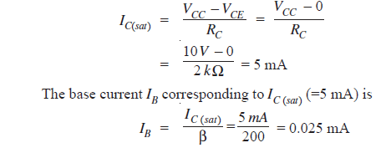](https://electronicspost.com/wp-content/uploads/2019/07/184.png)

Applying Kirchhoff’s voltage law to the base circuit, we have,

[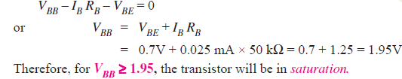](https://electronicspost.com/wp-content/uploads/2019/07/185.png)

**Q35. Determine the state of the transistor in Fig. 28 for the following values of collector resistor : (i) RC = 2 kΩ (ii) RC= 4 kΩ (iii) RC= 8 kΩ.**

[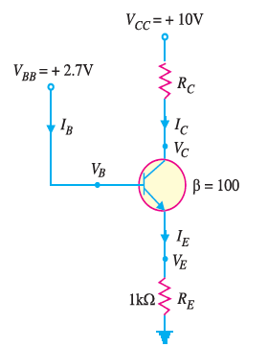](https://electronicspost.com/wp-content/uploads/2019/07/186.png)

Fig. 28

**Solution :**

Since IE does not depend on the value of the collector resistor RC, the emitter current ( IE) is the same for all three parts.

[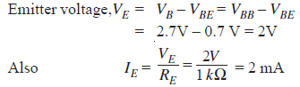](https://electronicspost.com/wp-content/uploads/2019/07/187.png)

**(i) When RC = 2 kΩ**

Suppose the transistor is active.

[https://electronicspost.com/wp-content/uploads/2019/07/188.png](https://electronicspost.com/wp-content/uploads/2019/07/188.png)

[https://electronicspost.com/wp-content/uploads/2019/07/189.png](https://electronicspost.com/wp-content/uploads/2019/07/189.png)

Since VC (= 6V) is greater than VE (= 2V), the transistor is active. Therefore, our assumption that transistor is active is correct.

**(ii) When RC = 4 kΩ**

Suppose the transistor is active.

[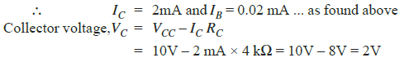](https://electronicspost.com/wp-content/uploads/2019/07/190.png)

Since VC = VE, the transistor is just at the edge of saturation.  
We know that at the edge of saturation, the relation between the transistor currents is the same as in the active state. Both answers are correct.

**(iii) When RC = 8 kΩ**

Suppose the transistor is active.

[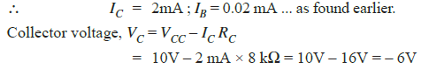](https://electronicspost.com/wp-content/uploads/2019/07/191.png)

Since VC < VE, the transistor is saturated and our assumption is not correct

**Q36. In the circuit shown in Fig. 29, VBB is set equal to the following values:  
(i) VBB= 0.5V (ii) VBB= 1.5V (iii) VBB= 3V. Determine the state of the transistor for each value of the base supply voltage VBB.**

[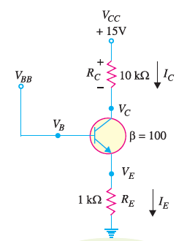](https://electronicspost.com/wp-content/uploads/2019/07/192.png)

Fig.29

**Solution :**

The state of the transistor also depends on the base supply voltage VBB

**(i) For VBB= 0.5V**

Because the base voltage VB (= VBB = 0.5V) is less than 0.7V, the transistor is**cut-off.**

**(ii) For VBB= 1.5V**

The base voltage VB controls the emitter voltage VE which controls the emitter current IE.

[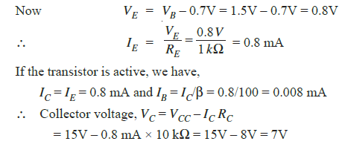](https://electronicspost.com/wp-content/uploads/2019/07/193.png)

Since VC > VE, the transistor is **active** and our assumption is correct.

**(iii) For VBB = 3V**

[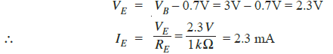](https://electronicspost.com/wp-content/uploads/2019/07/194-1.png)

Assuming the transistor is active, we have,

[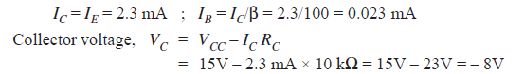](https://electronicspost.com/wp-content/uploads/2019/07/195.png)

Since VC< VE, the transistor is saturated and our assumption is not correct.

**Q37. The maximum power dissipation of a transistor is 100mW. If  VCE = 20V, what is the maximum collector current that can be allowed without destruction of the transistor?**

**Solution :**

**[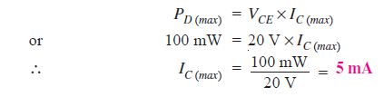](https://electronicspost.com/wp-content/uploads/2019/07/196.png)**

**Q38. For the circuit shown in Fig. 30, find the transistor power dissipation. Assume that β = 200.**

[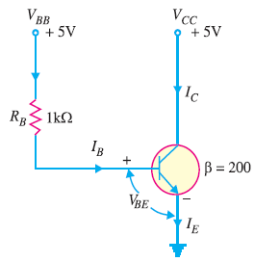](https://electronicspost.com/wp-content/uploads/2019/07/199.png)

Fig.30

**Solution :**

**[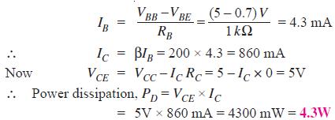](https://electronicspost.com/wp-content/uploads/2019/07/197.png)**

**Q39. For the circuit shown in Fig. 31, find the power dissipated in the transistor. Assume β = 100.**

[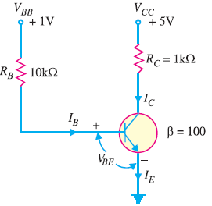](https://electronicspost.com/wp-content/uploads/2019/07/198.png)Fig. 31

**Solution :**

The transistor is usually used with a resistor RC connected between the collector and its power supply VCC as  
shown is Fig.31.

The collector resistor RC serves two purposes. Firstly, it allows us to control the voltage VC at the collector.  
Secondly, it protects the transistor from excessive collector current IC and, therefore, from excessive power dissipation.

Referring to Fig. 31 and applying Kirchhoff’s voltage law to the base side, we have,

[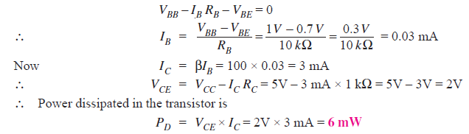](https://electronicspost.com/wp-content/uploads/2019/07/200.png)

**Q40. The transistor in Fig.32 has the following maximum ratings : PD (max) = 800 mW ; VCE(max) = 15V ; IC(max) = 100 mA. Determine the maximum value to which VCC can be adjusted without exceeding any rating. Which rating would be exceeded first ?**

[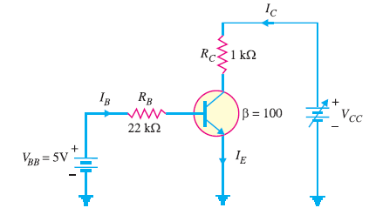](https://electronicspost.com/wp-content/uploads/2019/07/201.png)

Fig.32

**Solution :**

[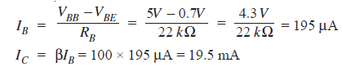](https://electronicspost.com/wp-content/uploads/2019/07/202.png)

Note that ICis much less than IC(max) and will not change with VCC. It is determined only by IB and β. Therefore, current rating is not exceeded.

[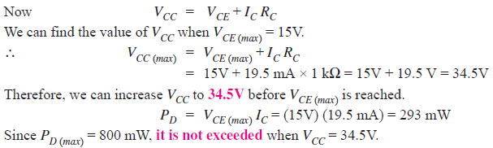](https://electronicspost.com/wp-content/uploads/2019/07/203.png)

If base current is removed causing the transistor to turn off, VCE(max) will be exceeded because the entire supply voltage VCC will be dropped across the transistor.

**Solved Problems on Field Effect Transistors**

**Q1. Fig. 1 shows the transfer characteristic curve of a JFET. Write the equation for drain current.**

[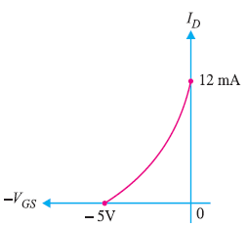](https://electronicspost.com/wp-content/uploads/2021/09/1-3.png)

Fig.1

**Solution.** Referring to the transfer characteristic curve in Fig. 1, we have,

[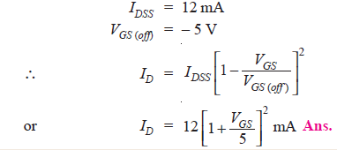](https://electronicspost.com/wp-content/uploads/2021/09/2-3.png)

**Q2. A JFET has the following parameters: IDSS = 32 mA ; VGS (off) = – 8V ; VGS = – 4.5 V. Find the value of drain current.**

**Solution :**

[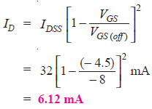](https://electronicspost.com/wp-content/uploads/2021/09/3-4.png)

**Q3. A JFET has a drain current of 5 mA. If IDSS = 10 mA and VGS (off) = – 6 V, find the value of (i) VGS and (ii) VP.**

[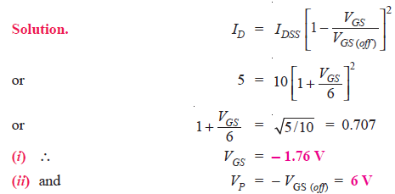](https://electronicspost.com/wp-content/uploads/2021/09/4-3.png)

**Q4. For the JFET in Fig. 2, VGS (off) = – 4V and IDSS = 12 mA. Determine the minimum value of VDD required to put the device in the constant-current region of operation.**

[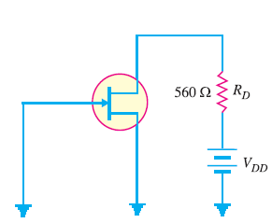](https://electronicspost.com/wp-content/uploads/2021/09/5-2.png)

Fig.2

[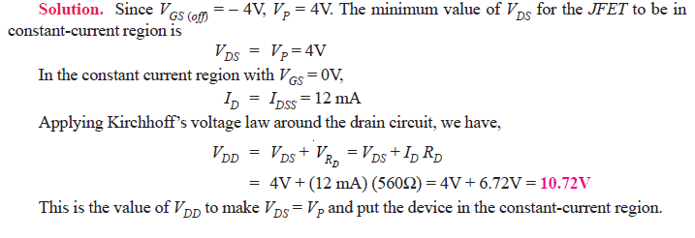](https://electronicspost.com/wp-content/uploads/2021/09/6-2.png)

**Q5. Determine the value of drain current for the circuit shown in Fig. 3.**

[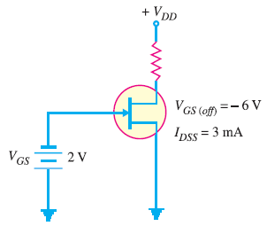](https://electronicspost.com/wp-content/uploads/2021/09/7-2.png)

Fig.3

**Solution.**It is clear from Fig. 3 that VGS = – 2V. The drain current for the circuit is given by;

[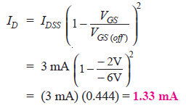](https://electronicspost.com/wp-content/uploads/2021/09/8-1.png)

**Q6. When a reverse gate voltage of 15 V is applied to a JFET, the gate current is 10−3 μA. Find the resistance between gate and source.**

**Solution.**

[https://electronicspost.com/wp-content/uploads/2021/09/9-1.png](https://electronicspost.com/wp-content/uploads/2021/09/9-1.png)

[https://electronicspost.com/wp-content/uploads/2021/09/10-2.png](https://electronicspost.com/wp-content/uploads/2021/09/10-2.png)

**Q7. When VGS of JFET changes from –3.1 V to –3 V, the drain current changes from 1 mA to 1.3 mA. What is the value of transconductance?**

[](https://electronicspost.com/wp-content/uploads/2021/09/11-3.png)

**Q8. A JFET has a value of gmo = 4000 μS. Determine the value of gm at VGS = – 3V. Given that VGS (off) = – 8V.**

[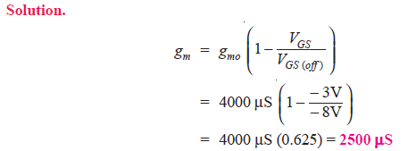](https://electronicspost.com/wp-content/uploads/2021/09/12-3.png)

**Q9. The datasheet of a JFET gives the following information: IDSS = 3 mA, VGS (off) = – 6V and gm (max) = 5000 μS. Determine the transconductance for VGS = – 4V and find drain current ID at this point.**

[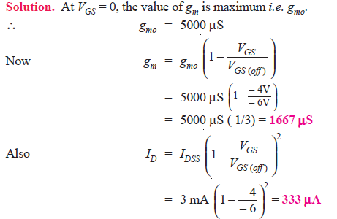](https://electronicspost.com/wp-content/uploads/2021/09/13-3.png)

**Q10. A JFET in Fig. 4 has values of VGS (off) = – 8V and IDSS = 16 mA. Determine the values of VGS, ID and VDS for the circuit.**

[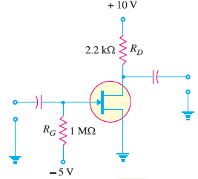](https://electronicspost.com/wp-content/uploads/2021/09/14-4.png)

Fig. 4

**Solution.**

Since there is no gate current, there will be no voltage drop across RG.

[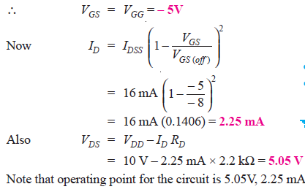](https://electronicspost.com/wp-content/uploads/2021/09/15-3.png)

**Q11. Find VDS and VGS in Fig. 5, given that ID = 5 mA.**

[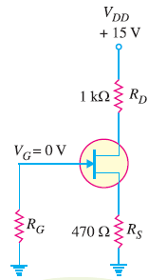](https://electronicspost.com/wp-content/uploads/2021/09/16-6.png)

Fig. 5

[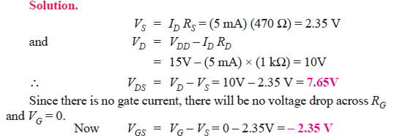](https://electronicspost.com/wp-content/uploads/2021/09/17-4.png)

**Q12. The transfer characteristic of a JFET reveals that when VGS = – 5V, ID = 6.25 mA. Determine the value of RS required.**

**Solution.**

[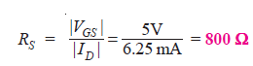](https://electronicspost.com/wp-content/uploads/2021/09/18-5.png)

**Q13. Determine the value of RS required to self-bias a p-channel JFET with IDSS = 25 mA, VGS (off) = 15 V and VGS = 5V.**

**Solution.**

[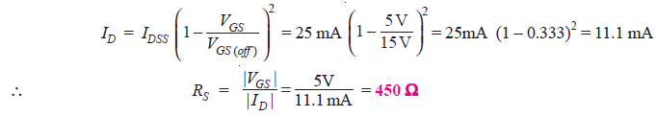](https://electronicspost.com/wp-content/uploads/2021/09/19-4.png)

**Q14. Select resistor values in Fig. 6 to set up an approximate midpoint bias. The JFET parameters are : IDSS = 15 mA and VGS (off) = – 8V. The voltage VD should be 6V (one-half of VDD).**

[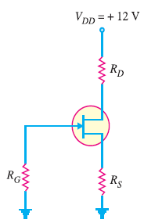](https://electronicspost.com/wp-content/uploads/2021/09/20-4.png)Fig.6

[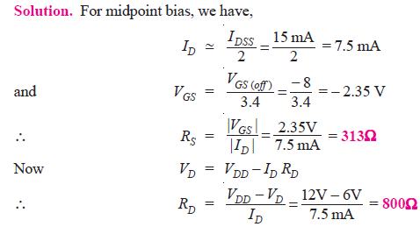](https://electronicspost.com/wp-content/uploads/2021/09/21-4.png)

**Q15. In a self-bias n-channel JFET, the operating point is to be set at ID = 1.5 mA and VDS =10 V. The JFET parameters are IDSS = 5 mA and VGS (off) = − 2 V. Find the values of RS and RD. Given that VDD = 20 V.**

**Solution.**Fig. 7 shows the circuit arrangement.

[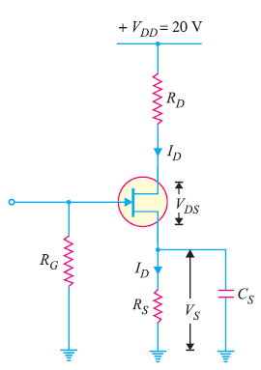](https://electronicspost.com/wp-content/uploads/2021/09/22-4.png)Fig.7

[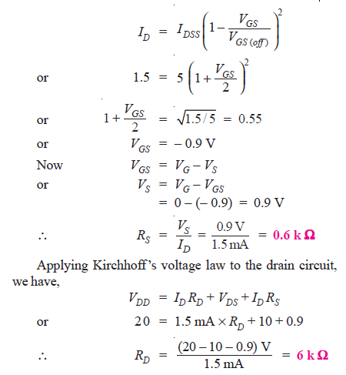](https://electronicspost.com/wp-content/uploads/2021/09/23-4.png)

**Q16. In the JFET circuit shown in Fig. 8, find (i) VDS and (ii) VGS.**

[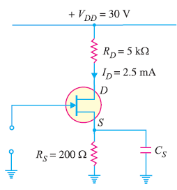](https://electronicspost.com/wp-content/uploads/2021/09/24-3.png)

Fig.8

[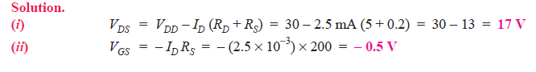](https://electronicspost.com/wp-content/uploads/2021/09/25-3.png)

**Q17. Determine ID and VGS for the JFET with voltage-divider bias in Fig. 9, given that VD = 7V.**

[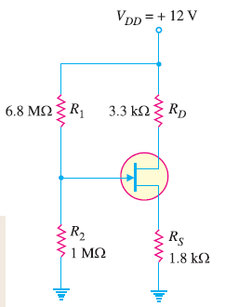](https://electronicspost.com/wp-content/uploads/2021/09/26-2.png)

Fig.9

**Solution.**

[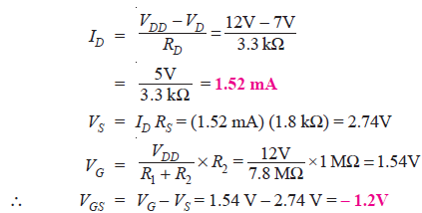](https://electronicspost.com/wp-content/uploads/2021/09/27.png)

**Q18. In an n-channel JFET biased by potential divider method, it is desired to set the operating point at ID = 2.5 mA and VDS = 8V. If VDD = 30 V, R1 = 1 MΩ and R2 = 500 kΩ, find the value of RS. The parameters of JFET are IDSS = 10 mA and VGS (off) = – 5 V.**

**Solution.** Fig. 10 shows the conditions of the problem.

[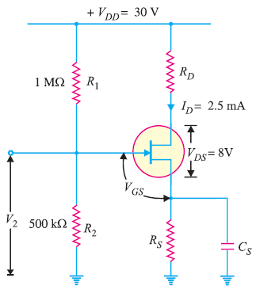](https://electronicspost.com/wp-content/uploads/2021/09/28-1.png)

Fig.10

[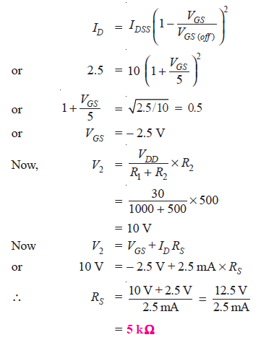](https://electronicspost.com/wp-content/uploads/2021/09/29-1.png)

**Q19. Draw the d.c. load line for the JFET amplifier shown in Fig. 11.**

[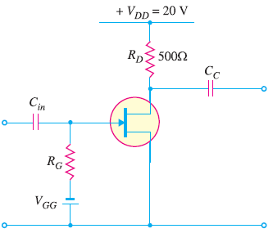](https://electronicspost.com/wp-content/uploads/2021/09/30-2.png)

Fig.11

**Solution.**

[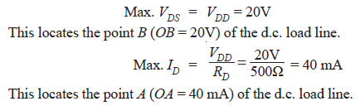](https://electronicspost.com/wp-content/uploads/2021/09/31-2.png)

Fig. 12 shows the d.c. load line AB.

[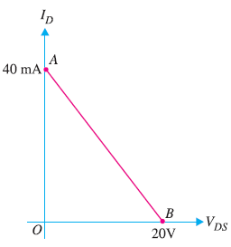](https://electronicspost.com/wp-content/uploads/2021/09/32-2.png)

Fig.12

**Q20. The JFET in the amplifier of Fig. 13 has a transconductance gm = 1 mA/V. If the source resistance RS is very small as compared to RG, find the voltage gain of the amplifier.**

[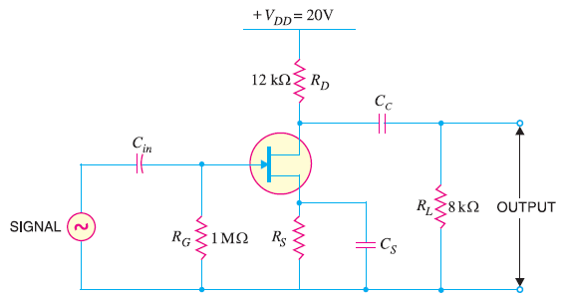](https://electronicspost.com/wp-content/uploads/2021/09/33-1.png)

Fig.13

**Solution.**

Transconductance of JFET, gm= 1 mA/V

[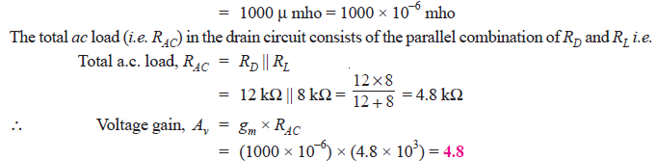](https://electronicspost.com/wp-content/uploads/2021/09/34-1.png)

**Q21. The transconductance of a JFET used as a voltage amplifier is 3000 μmho and drain resistance is 10 kΩ. Calculate the voltage gain of the amplifier.**

**Solution.**

[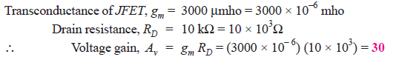](https://electronicspost.com/wp-content/uploads/2021/09/35-1.png)

**Q22. What is the r.m.s. output voltage of the unloaded amplifier in Fig. 14? The IDSS = 8 mA, VGS (off) = – 10V and ID = 1.9 mA.**

[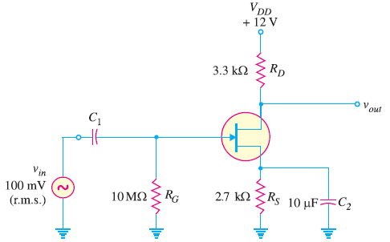](https://electronicspost.com/wp-content/uploads/2021/09/36-1.png)

Fig.14

**Solution.**

[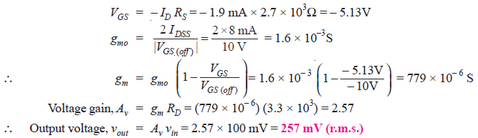](https://electronicspost.com/wp-content/uploads/2021/09/37-1.png)

**Q23. If a 4.7 kΩ load resistor is a.c. coupled to the output of the amplifier in Fig. 15 , what is the resulting r.m.s. output voltage?**

[](https://electronicspost.com/wp-content/uploads/2021/09/36-1.png)

Fig.15

**Solution.**

The value of gm remains the same. However, the value of total a.c. drain resistance RAC changes due to the connection of load RL (= 4.7 kΩ).

Total a.c. drain resistance, RAC = RD || RL

[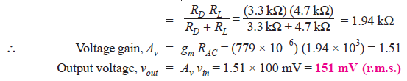](https://electronicspost.com/wp-content/uploads/2021/09/38-1.png)

**Q24. In a JFET amplifier, the source resistance RS is unbypassed. Find the voltage gain of the amplifier. Given gm = 4 mS; RD = 1.5 kΩ and RS = 560Ω.**

[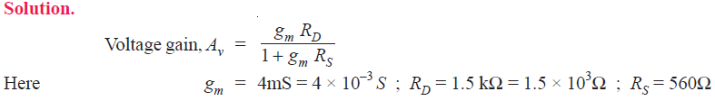](https://electronicspost.com/wp-content/uploads/2021/09/40-1.png)

[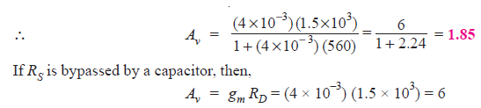](https://electronicspost.com/wp-content/uploads/2021/09/41-3.png)

Thus with unbypassed RS, the gain = 1.85 whereas with RS bypassed by a capacitor, the gain is 6. Therefore, voltage gain is reduced when RS is unbypassed.

**Q25. For the JFET amplifier circuit shown in Fig. 16, calculate the voltage gain with (i) RS bypassed by a capacitor (ii) RS unbypassed.**

[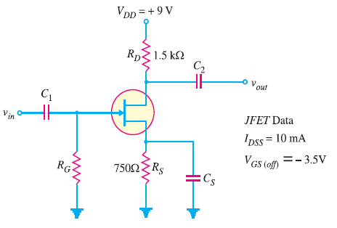](https://electronicspost.com/wp-content/uploads/2021/09/42-1.png)

Fig.16

[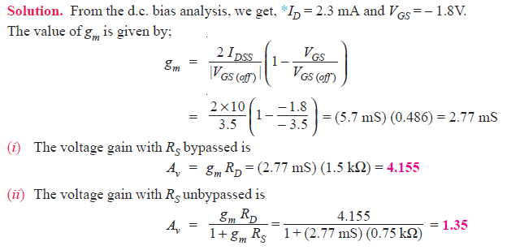](https://electronicspost.com/wp-content/uploads/2021/09/43-2.png)

**Q26. For a certain D-MOSFET, IDSS = 10 mA and VGS (off) = – 8V.**  
**(i) Is this an n-channel or a p-channel ?**  
**(ii) Calculate ID at VGS = – 3V.**  
**(iii) Calculate ID at VGS = + 3V.**

**Solution.**

[](https://electronicspost.com/wp-content/uploads/2021/09/44-2.png)

[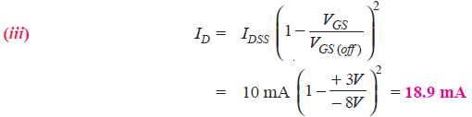](https://electronicspost.com/wp-content/uploads/2021/09/45-1.png)

**Q27. A D-MOSFET has parameters of VGS (off) = – 6V and IDSS = 1 mA. How will you plot the transconductance curve for the device?**

**Solution.**

When VGS = 0 V, ID = IDSS = 1 mA and when VGS = VGS (off), ID = 0A. This locates two points viz IDSS and VGS (off) on the transconductance curve. We can locate more points of the curve by changing VGS values.

[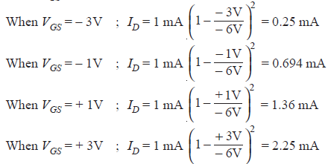](https://electronicspost.com/wp-content/uploads/2021/09/46-1.png)

Thus we have a number of VGS – ID readings so that transconductance curve for the device can be readily plotted.

**Q28. Determine the drain-to-source voltage (VDS) in the circuit shown in Fig. 17  if VDD = +18V and RD = 620Ω. The MOSFET data sheet gives VGS (off) = – 8V and IDSS = 12 mA.**

[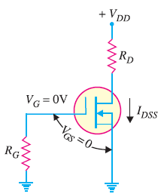](https://electronicspost.com/wp-content/uploads/2021/09/47-1.png)

Fig.17

[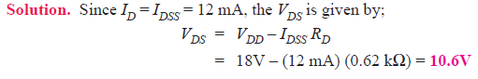](https://electronicspost.com/wp-content/uploads/2021/09/48-1.png)

**Q29. The D-MOSFET used in the amplifier of Fig. 18 has an IDSS = 12 mA and gm = 3.2 mS. Determine (i) d.c. drain-to-source voltage VDS and (ii) a.c. output voltage. Given vin = 500 mV.**

[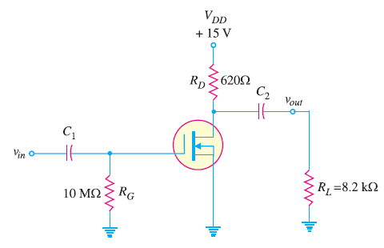](https://electronicspost.com/wp-content/uploads/2021/09/49-1.png)

Fig.18

**Solution.**

[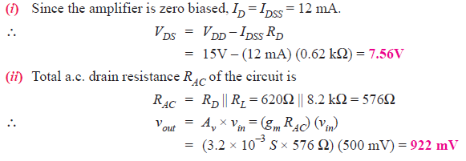](https://electronicspost.com/wp-content/uploads/2021/09/50-1.png)

**Q30. The data sheet for an E-MOSFET gives ID(on) = 500 mA at VGS = 10V and VGS (th) = 1V. Determine the drain current for VGS = 5V.**

[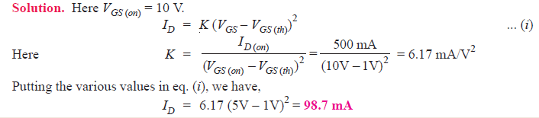](https://electronicspost.com/wp-content/uploads/2021/09/51-2.png)

**Q31. The data sheet for an E-MOSFET gives ID (on) = 3 mA at VGS = 10V and VGS (th)= 3V. Determine the resulting value of K for the device. How will you plot the transconductance curve for this MOSFET ?**

[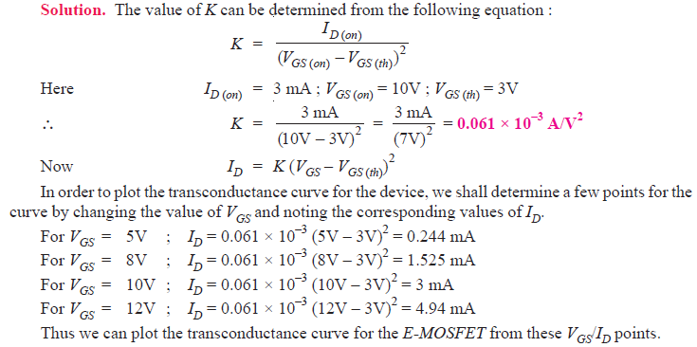](https://electronicspost.com/wp-content/uploads/2021/09/52-2.png)

**Q31. Determine VGS and VDS for the EMOSFET circuit in Fig. 19. The data sheet for this particular MOSFET gives ID (on) = 500 mA at VGS = 10V and VGS (th) = 1V.**

[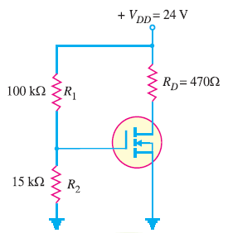](https://electronicspost.com/wp-content/uploads/2021/09/53-1.png)

Fig.19

**Solution.** Referring to the circuit shown in Fig. 19, we have,

[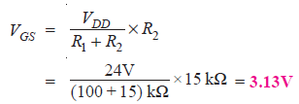](https://electronicspost.com/wp-content/uploads/2021/09/54-1.png)

The value of K can be determined from the following equation :

[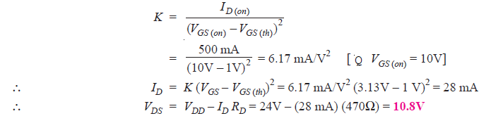](https://electronicspost.com/wp-content/uploads/2021/09/55-1.png)

**Q32. Determine the values of ID and VDS for the circuit shown in Fig. 20. The data sheet for this particular MOSFET gives ID (on) = 10 mA when VGS = VDS.**

[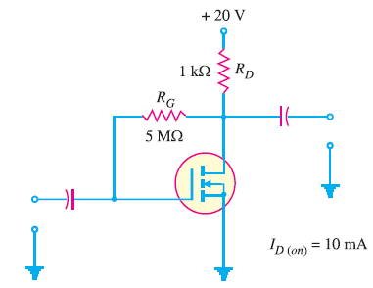](https://electronicspost.com/wp-content/uploads/2021/09/56-1.png)

Fig.20

[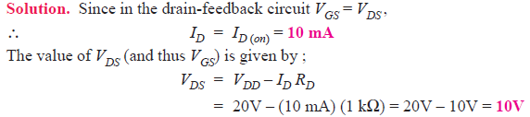](https://electronicspost.com/wp-content/uploads/2021/09/57-1.png)