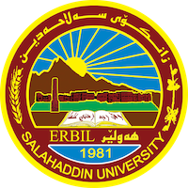
Academic Curriculum Vitae

Personal Information 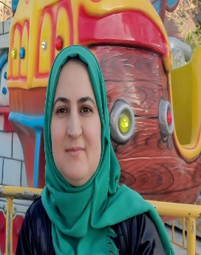
Full Name: Lawen Abdulstar Esmail
Academic Title: Assistant lecture
Email: lawen.esmail@su.edu.krd
Mobile: +9647504556581

Education:
From- To | Degree | College-University | Country
2020 to date | PhD student in Analytical Chemistry, Department of Chemistry | College of Science- University of Salahaddin | Iraq
2007-2009 | M. Sc. in physical Chemistry, Department of Chemistry | College of Science- University of Salahaddin | Iraq
2000-2004 | B.Sc. Chemistry, Department of Chemistry, | College of Science- University of Salahaddin | Iraq

Employment:
Assignments and Posts:
From- To | Post | Department -College | University
2010-to date | Assistant Lecture | Chemistry Department-College of Science | Salahaddin University
2004-2007 | Reporter in Chemistry  Department | Chemistry Department-College of Science | Salahaddin University

Teaching experience:
- Teaching Activities
From- To | Subject | Stage-College | University
2015-2022 | Physical chemistry | 3ed- year students / Chemistry Department-College of Science | Salahaddin University
2010-2015 | physical Chemistry | 2nd- year students/Chemistry Department | salahaddin University

Research and publications
Published articles, papers and researches:

      - ADSORPTION- DESORPTION FOR SOME HEAVY METALS IN THE PRESENCE OF SURFACTANT ON SIX AGRICULTURAL SOILS.( international Journal of Recent Research and Applied Studies (IJRRAS) Vol.(12) No. (3) 2012).
      - Kinetic studies of bioethanol production from wheat straw. (ZANCO Journal of Pure and Applied Sciences. (ZJPAS) Vol.( 28) No.(3) 2016).
      - Effect of storage temperature and sunlight exposure on the physicochemical properties of bottled water in Kurdistan region-Iraq.( J. Appl. Sci. Environ. Manage. Vol. 15 No.(1) 2011).
      - Violuric acid carbon dots as a highly fluorescence probe for ultrasensitive determination of Zn (II) in tomato paste.( Food Chemistry. Vol(413).2023).

Conferences and courses attended
1-Training workshop on bologna process Organized by college of engineering, salahadin university- erbil on 3th-4th, November ,2019.
2-Organized committee of 6th International Conference and Workshop on Basic and Applied Sciences (6thICOWOBAS, 18th – 19th March 2017.
3-International Workshop Advanced Analytical instruments in chemistry and physics, august 24th-26th august ,2019.

Professional memberships
- From 2004 to date member in Kurdistan chemistry syndicate

Professional Social Network Accounts:
ORCID ID: https: https://orcid.org/0000-0002-7190-7131
Academic Profile: https://academics.su.edu.krd/lawen.esmail/
LinkedIn: https://www.linkedin.com/in/lawen-abdulsatar-781339122/
Scholar Account: https://scholar.google.com/citations?hl=en&user=d4yS41wAAAAJ&view_op=list_works&gmla=AJsN F5BqMwKNZRZH0tYHrUwcz3yQTXDSRzTZrGbJgKHt8F3IJLjmCFcEPlCRxS7UJmm_c4I0MDIAhgupguv7ykhgPrlTdZ6Odnuj9pLMwvHNQ_tSBefUNg
Research gate: https://www.researchgate.net/profile/Lawen-Esmail

