University of Salahaddin ‐ Hawler
College of Engineering
Department of Mechanical Engineering

Problems on
Heat Transfer

Academic Year 2021 – 2022

Senior Students (3rd Year)

Lecturer: Mahde A. Molan

Chapter One

Pr.1 | 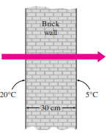  The inner and outer surfaces of a 5-m x 6-m brick wall of thickness 30 cm and thermal conductivity 0.69 W/m·°C are maintained at temperatures of 20°C and 5°C, respectively. Determine the rate of heat transfer through the wall, in W.
Pr.2 | The concrete slab of a basement is 11 m long, 8 m wide and 0.20 m thick. During the winter, temperatures are nominally 17 C and 10 C at the top and bottom surfaces, respectively. If the concrete has a thermal conductivity of 1.4 W/m.K, what is the rate of heat loss through the slab? If the basement is heated by a gas furnace operating with natural gas is priced at Cg = $0.02/MJ, what is the daily cost of the heat loss?
Pr.3 | 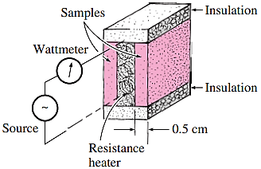  One way of measuring the thermal conductivity of a material is to sandwich an electric thermofoil heater between two identical rectangular samples of the material and to heavily insulate the four outer edges, as shown in the figure. Thermocouples attached to the inner and outer surfaces of the samples record the temperatures. During an experiment, two 0.5-cm-thick samples 10 cmx10 cm in size are used. When steady operation is reached, the heater is observed to draw 35 W of electric power, and the temperature of each sample is observed to drop from 82°C at the inner surface to 74°C at the outer surface. Determine the thermal conductivity of the material at the average temperature
Pr.4 | Hot air at 80°C is blown over a 2-m 4-m flat surface at 30°C. If the average convection heat transfer coefficient is 55 W/m2 · °C, determine the rate of heat transfer from the air to the plate, in kW.
Pr.5 | A 5cm-external-diameter 10m long hot water pipe at 80°C is losing heat to the surrounding air at 5°C by natural convection with a heat transfer coefficient of 25 W/m²·°C. Find the rate of heat loss from the pipe by natural convection.
Pr.6 | A Consider a sealed 20-cm-high electronic box whose base dimensions are 40 cm x 40 cm placed in a vacuum chamber. The emissivity of the outer surface of the box is 0.95. If the electronic components in the box dissipate a total of 100 W of power and the outer surface temperature of the box is not to exceed 55°C, determine the temperature at which the surrounding surfaces must be kept if this box is to be cooled by radiation alone. Assume the heat transfer from the bottom surface of the box to the stand to be negligible.
Pr.7 | 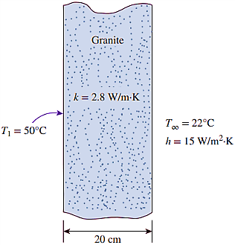  Consider a 20-cm-thick granite wall with a thermal conductivity of 2.79 W/m·K. The temperature of the left surface is held constant at 50°C, whereas the right face is exposed to a flow of 22°C air with a convection heat transfer coefficient of 15 W/m²·K. Neglecting heat transfer by radiation, find the right wall surface temperature and the heat flux through the wall.
Pr.8 | 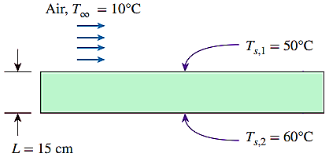  A solid plate with thickness of 15cm and a thermal conductivity of 80 W/m·K is being cooled at the upper surface by air. The air temperature is 10°C, while the temperatures at the upper and lower surfaces of the plate are 50°C and 60°C, respectively. Determine the convection heat transfer coefficient of air at the upper surface, and discuss whether the value is reasonable or not for forced convection of air.
Pr.9 | 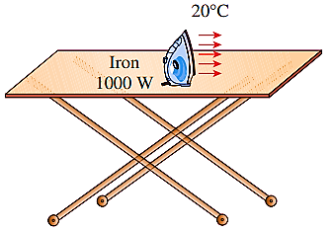  A 1000-W iron is left on an ironing board with its base exposed to the air at 20°C. The convection heat transfer coefficient between the base surface and the surrounding air is 35 W/m²⋅K. If the base has an emissivity of 0.6 and a surface area of 0.02 m², determine the temperature of the base of the iron.
Pr.10 | 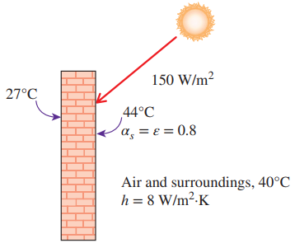  The inner and outer surfaces of a 25-cm-thick wall in summer are at 27°C and 44°C, respectively. The outer surface of the wall exchanges heat by radiation with surrounding surfaces at 40°C and by convection with ambient air also at 40°C with a convection heat transfer coefficient of 8 W/m²⋅K. Solar radiation incident on the surface at a rate of 150 W/m². If both the emissivity and the solar absorptivity of the outer surface are 0.8, determine the effective thermal conductivity of the wall.
Pr.11 | 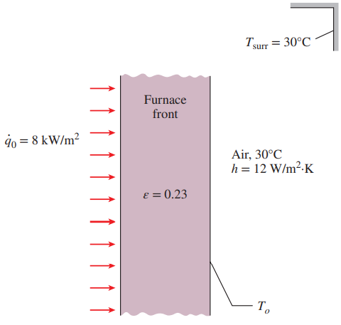  In the metal processing industry, heat treatment of metals is commonly done using electrically heated draw batch furnaces. Consider a furnace that is situated in a room with surrounding air temperature of 30°C and an average convection heat transfer coefficient of 12 W/m²⋅K. The furnace front is made of a steel plate with thickness of 20 mm and a thermal conductivity of 25 W/m⋅K. The outer furnace front surface has an emissivity of 0.23, and the inside surface is subjected to a heat flux of 8 kW/m². Determine the outside surface temperature of the furnace front.
Pr.12 | Consider a water pipe of length L 12 m, inner radius r1 15 cm, outer radius r2 20 cm, and thermal conductivity k 20 W/m · °C. Heat is generated in the pipe material uniformly by a 25-kW electric resistance heater. The inner and outer surfaces of the pipe are at T1 60°C and T2 80°C, respectively. Obtain a general relation for temperature distribution inside the pipe under steady conditions and determine the temperature at the center plane of the pipe.
Pr.13 | Heat is generated uniformly at a rate of 2.6  106 W/m3 in a spherical ball (k 45 W/m · °C) of diameter 30 cm. The ball is exposed to iced-water at 0°C with a heat transfer coefficient of 1200 W/m2 · °C. Determine the temperatures at the center and the surface of the ball.
Pr.14 | Consider a cylindrical shell of length L, inner radius r1, and outer radius r2 whose thermal conductivity varies in a specified temperature range as k(T) k0(1 T 2) where k0 and are two specified constants. The inner surface of the shell is maintained at a constant temperature of T1 while the outer surface is maintained at T2. Assuming steady onedimensional heat transfer, obtain a relation for the heat transfer rate through the shell.
Pr.15 | Consider a 1.5-m-high and 0.6-m-wide plate whose thickness is 0.15 m. One side of the plate is maintained at a constant temperature of 500 K while the other side is maintained at 350 K. The thermal conductivity of the plate can be assumed to vary linearly in that temperature range as k(T) k0(1 T) where k0 25 W/m · K and 8.7  104 K1 . Disregarding the edge effects and assuming steady onedimensional heat transfer, determine the rate of heat conduction through the plate
Pr.16 | Consider a large plane wall of thickness L 0.05 m. The wall surface at x 0 is insulated, while the surface at x L is maintained at a temperature of 30°C. The thermal conductivity of the wall is k 30 W/m · °C, and heat is generated in the wall at a rate of g · g0e0.5x/L W/m3 where g · 0 8  106 W/m3 . Assuming steady one-dimensional heat transfer, (a) express the differential equation and the boundary conditions for heat conduction through the wall, (b) obtain a relation for the variation of temperature in the wall by solving the differential equation, and (c) determine the temperature of the insulated surface of the wall.
Pr.17 | Consider a solid cylindrical rod of length 0.15 m and diameter 0.05 m. The top and bottom surfaces of the rod are maintained at constant temperatures of 20°C and 95°C, respectively, while the side surface is perfectly insulated. Determine the rate of heat transfer through the rod if it is made of (a) copper, k 380 W/m · °C, (b) steel, k 18 W/m · °C, and (c) granite, k 1.2 W/m · °C.
Pr.18 | Consider a spherical container of inner radius r1 8 cm, outer radius r2 10 cm, and thermal conductivity k 45 W/m · °C, as shown in Figure 2–52. The inner and outer surfaces of the container are maintained at constant temperatures of T1 200°C and T2 80°C, respectively, as a result of some chemical reactions occurring inside. Obtain a general relation for the temperature distribution inside the shell under steady conditions, and determine the rate of heat loss from the container.
Chapter Two
Pr.19 |  | 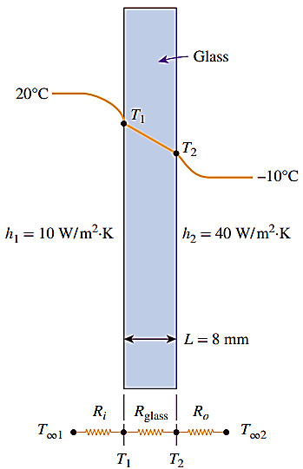  Consider a 0.8m high and 1.5m wide glass window with a thickness of 8mm and a thermal conductivity of k=0.78 W/m⋅K. Determine the steady rate of heat transfer through this glass window and the temperature of its inner surface for a day during which the room is maintained at 20°C while the temperature of the outdoors is −10°C. Take the heat transfer coefficients on the inner and outer surfaces of the window to be h1 = 10 W/m2 ⋅K and h2=40 W/m2 ⋅K, which includes the effects of radiation.
Pr.20 |  | 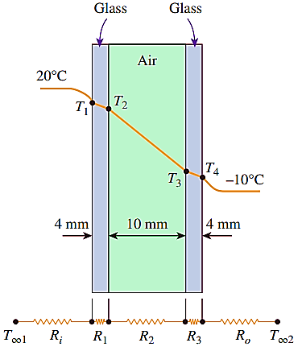  Consider a 0.8m high and 1.5m wide double-pane window consisting of two 4mm thick glass layers k=0.78 W/m⋅K separated by a 10mm wide stagnant airspace k=0.026 W/m⋅K. Determine the steady rate of heat transfer through this double-pane window and the temperature of its inner surface for a day during which the room is maintained at 20°C while the temperature of the outdoors is −10°C. Take the convection heat transfer coefficients on the inner and outer surfaces of the window to be h1=10W/m2 ⋅K and h2=40W/m²⋅K
Pr.21 |  | 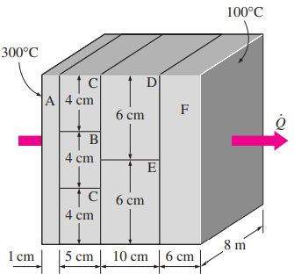  Consider a 5m high, 8m long, and 0.22m thick wall whose representative cross section is as given in the figure. The thermal conductivities of various materials used, in W/m·°C, are kA=kF=2, kB=8, kC=20, kD15, and kE=35. The left and right surfaces of the wall are maintained at uniform temperatures of 300°C and 100°C. Assuming heat transfer through the wall to be one-dimensional, determine (a) the rate of heat transfer through the wall; (b) the temperature at the point where the sections B, D, and E meet; and (c) the temperature drop across the section F. Disregard any contact resistances at the interfaces.
Pr.22 |  | Consider a 1.2-m-high and 2-m-wide double-pane window consisting of two 3mm thick layers of glass (k=0.78W/m·°C) separated by a 12mm wide stagnant air space (k=0.026W/m·°C). Determine the steady rate of heat transfer through this double-pane window and the temperature of its inner surface for a day during which the room is maintained at 24°C while the temperature of the outdoors is 5°C. Take the convection heat transfer coefficients on the inner and outer surfaces of the window to be h1=10W/m2 ·°C and h2=25W/m2 ·°C, and disregard any heat transfer by radiation.
Pr.23 |  | A hot steam pipe having an inside surface temperature of 250◦C has an inside diameter of 8 cm and a wall thickness of 5.5 mm. It is covered with a 9-cm layer of insulation having k=0.5W/m·◦C, followed by a 4-cm layer of insulation having k=0.25W/m·◦C. The outside temperature of the insulation is 20◦C. Calculate the heat lost per meter of length. Assume k=47W/m·◦C for the pipe.
Pr.24 |  | A 50m-long section of a steam pipe whose outer diameter is 10 cm passes through an open space at 15°C. The average temperature of the outer surface of the pipe is measured to be 150°C. If the combined heat transfer coefficient on the outer surface of the pipe is 20W/m2 ·K, determine (a) the rate of heat loss from the steam pipe; (b) the annual cost of this energy lost if steam is generated in a natural gas furnace that has an efficiency of 75 percent and the price of natural gas is $0.52/therm (1 therm = 105,500 kJ); (c) the thickness of fiberglass insulation (k=0.035W/m·K) needed in order to save 90% of the heat lost. Assume the pipe temperature remains constant at 150°C.
 | Pr.25 |  | Steam at T∞1=320°C flows in a cast iron pipe (k=80 W/m·K) its inner and outer diameters are D1=5 cm and D2=5.5 cm, respectively. The pipe is covered with 3cm thick glass wool insulation with k=0.05W/m·K. Heat is lost to the surroundings at T∞2=5°C by natural convection and radiation, with a combined heat transfer coefficient of h2=18 W/m2 ·K. Taking the heat transfer coefficient inside the pipe to be h1=60 W/m2 ·K, determine the rate of heat loss from the steam per unit length of the pipe. Also determine the temperature drops across the pipe shell and the insulation.
 | Pr.26 |  | A long rod 12 mm square section made of low carbon steel protrudes into air at 35°C from a furnace wall at 200°C. The convective heat transfer coefficient is estimated at 22W/m2K. The conductivity of the material is 52 W/m.K. Determine (1) the location from the wall at which the temperature will be 60°C. (2) Calculate the temperature at 80 mm from base. (3) The total heat flow
 | Pr.27 |  | A long rod 10 mm square section made of low carbon steel protrudes into air at 45°C from a furnace wall at 200°C. The convective heat transfer coefficient is estimated at 20W/m2K. The conductivity of the material is 52 W/m.K. Determine (1) the location from the wall at which the temperature will be 50°C. (2) The total heat flow
 | Pr.28 |  | In the Problem 26, if the length of the rod is 160 mm with end insulated conditions. Determine the end temperature, the heat dissipated by a fin and the fin efficiency.
 | Pr.29 |  | In the Problem 26, consider the fin to be 80 mm long and end face convection also exists. Determine the end temperature.
 | Pr.30 |  | Consider the data in Problem 26. The ends of the rod 160 mm long is held at 200°C and 100°C. Determine the temperature at mid location
 | Pr.31 |  | A stainless steel rod has a square cross section measuring 1 by 1 cm. The rod length is 8 cm, and k = 18 W/m · ◦C. The base temperature of the rod is 300◦C. The rod is exposed to a convection environment at 50◦C with h = 45 W/m2 · ◦C. Calculate the heat lost by the rod and the fin efficiency.
 | Pr.32 |  | 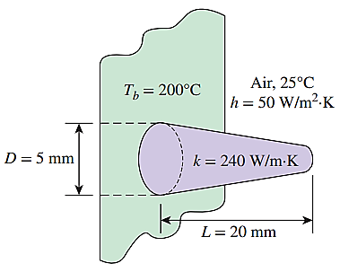  Aluminum pin fins of parabolic profile with blunt tips are attached on a plane wall with surface temperature of 200°C. Each fin has a length of 20mm and a base diameter of 5mm. The fins are exposed to an ambient air condition of 25°C and the convection heat transfer coefficient is 50W/m2 ⋅K. If the thermal conductivity of the fins is 240W/m⋅K, determine the efficiency, heat transfer rate, and effectiveness of each fin.
 | Pr.33 |  | Consider a very long rectangular fin attached to a flat surface such that the temperature at the end of the fin is essentially that of the surrounding air, 20°C. Its width is 5.0 cm; thickness is 1.0 mm; thermal conductivity is 200 W/m⋅K; and base temperature is 40°C. The heat transfer coefficient is 20 W/m2 ⋅K. Estimate the fin temperature at a distance of 5.0 cm from the base and the rate of heat loss from the entire fin.
 | Pr.34 |  | A plane wall with surface temperature of 350°C is attached with straight rectangular fins (k=235W/m⋅K). The fins are exposed to an ambient air condition of 25°C, and the convection heat transfer coefficient is 154 W/m2 ⋅K. Each fin has a length of 50 mm, a base 5 mm thick, and a width of 100 mm. Determine the efficiency, heat transfer rate, and effectiveness of each fin.
 | Pr.35 |  | 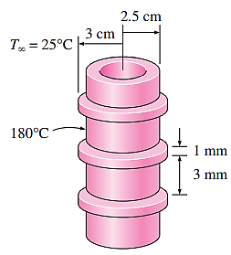  Steam in a heating system flows through tubes whose outer diameter is 5 cm and whose walls are maintained at a temperature of 180°C. Circular aluminum alloy 2024-T6 fins (k =186 W/m·°C) of outer diameter 6 cm and constant thickness 1 mm are attached to the tube. The space between the fins is 3 mm, and thus there are 250 fins per meter length of the tube. Heat is transferred to the surrounding air at T∞= 25°C, with a heat transfer coefficient of 40 W/m2 ·°C. Determine the increase in heat transfer from the tube per meter of its length as a result of adding fins.
 | Pr.36 |  | A 15-cm 20-cm hot surface at 85°C is to be cooled by attaching 4cm-long aluminum k=237 W/m ·°C fins of 2×2-mm square cross section. The temperature of surrounding medium is 25°C and the heat transfer coefficient on the surfaces can be taken to be 20 W/m2 ·°C. If it is desired to triple the rate of heat transfer from the bare hot surface, determine the number of fins that needs to be attached
 | Pr.37 |  | A hot surface at 100°C is to be cooled by attaching 3-cm long, 0.25cm diameter aluminum pin fins (k= 237W/m ·°C) to it, with a center to center distance of 0.6 cm. The temperature of the surrounding medium is 30°C, and the heat transfer coefficient on the surfaces is 35W/m2 ·°C. Calculate the rate of heat transfer from the surface for a 1m×1m section of the plate. Also determine the overall effectiveness of the fins.
 | Pr.38 |  | A 12-m-long and 8-cm-diameter hot-water pipe of a district heating system is buried in the soil 80 cm below the ground surface. The outer surface temperature of the pipe is 60°C. Taking the surface temperature of the earth to be 2°C and the thermal conductivity of the soil at that location to be 0.9 W/m⋅K, determine the rate of heat loss from the pipe.
 | Pr.39 |  | Hot- and cold-water pipes 12 m long run parallel to each other in a thick concrete layer. The diameters of both pipes are 6 cm, and the distance between the centerlines of the pipes is 40 cm. The surface temperatures of the hot and cold pipes are 60°C and 15°C, respectively. Taking the thermal conductivity of the concrete to be k = 0.75 W/m⋅K, determine the rate of heat transfer between the pipes.
 | Pr.40 |  | A horizontal pipe 15 cm in diameter and 4m long is buried in the earth at a depth of 20cm. The pipe-wall temperature is 75◦C, and the earth surface temperature is 5◦C. Assuming that the thermal conductivity of the earth is 0.8W/m·◦C, calculate the heat lost by the pipe.

Chapter Three
Pr.41 | Steady state heat transfer occurs in a straight wall through the x & y-axis. Find the temperature relation with x & y, T(x,y) by using the separation of variables method. The thermal conductivity is constant through the wall and no heat generation in it (wall).
Pr.42 | A transient heat transfer is occurs in a straight wall through the x-axes only. Find the temperature relation with x & t, T(x,t) by using the separation of variables method. The thermal conductivity is constant through the wall and no heat generation in it (wall)
Pr.43 | Consider a large plane wall of thickness L=0.4 m, thermal conductivity k=2.5W/m·°C, and surface area A=12 m². The left side of the wall is maintained at a constant temperature of T₁=80°C while the right side loses heat by convection to the surrounding air at T∞= 15°C with a heat transfer coefficient of h=24W/m²·°C. Assuming constant thermal conductivity and no heat generation in the wall (a) express the differential equation and the boundary conditions for steady one-dimensional heat conduction through the wall, (b) obtain a relation for the variation of temperature in the wall by solving the differential equation, and (c) evaluate the rate of heat transfer through the wall.
Pr.44 | Consider a large plane wall of thickness L=0.3 m, thermal conductivity k=2.5W/m·°C, and surface area A=12 m². The left side of the wall at x=0 is subjected to a net heat flux of q”=700 W/m² while the temperature at that surface is measured to be T1=80°C. Assuming constant thermal conductivity and no heat generation in the wall (a) express the differential equation and the boundary conditions for steady one-dimensional heat conduction through the wall, (b) obtain a relation for the variation of temperature in the wall by solving the differential equation, and (c) evaluate the temperature of the right surface of the wall at x= L.
Pr.45 | Consider a large plane wall of thickness L=0.05 m. The wall surface at x=0 is insulated, while the surface at x=L is maintained at a temperature of 30°C. The thermal conductivity of the wall is k=30 W/m·°C, and heat is generated in the wall at a rate of ġ=g_{o}e^{-0.5x/L} W/m³ where g_{o}=8×10⁶ W/m³. Assuming steady one-dimensional heat transfer, (a) express the differential equation and the boundary conditions for heat conduction through the wall, (b) obtain a relation for the variation of temperature in the wall by solving the differential equation, and (c) determine the temperature of the insulated surface of the wall.
Pr.46 | Consider a 20-cm-thick large concrete plane wall (k=0.77W/m·°C) subjected to convection on both sides with T_{∞1}= 27°C and h₁=5 W/m²·°C on the inside, and T_{∞2}=8°C and h₂=12 W/m²·°C on the outside. Assuming constant thermal conductivity with no heat generation, (a) express the differential equations and the boundary conditions for steady one-dimensional heat conduction through the wall, (b) obtain a relation for the variation of temperature in the wall by solving the differential equation, and (c) evaluate the temperatures at the inner and outer surfaces of the wall.
Pr.47 | The temperature distribution in a certain plane wall is  $$\frac{T-T_{1}}{T_{2}-T_{1}}=C_{1}+C_{2}x^{2}+C_{3}x^{3}$$  Where T₁ and T₂ are the temperatures on each side of the wall. If the thermal conductivity of the wall is constant and the wall thickness is L, derive an expression for the heat generation per unit volume as a function of x , the distance from the plane where T= T₁. Let the heat-generation rate be ${\dot{g}}_{o}$ at x=0. Also derive a relation for the variation of temperature in the wall
Pr.48 | 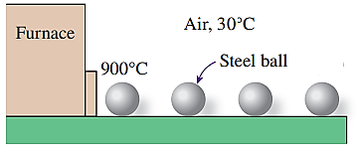  Stainless steel ball bearings (ρ=8085 kg/m³, k=15.1 W/m·°C, and C_{p}=0.480kJ/kg·°C) having a diameter of 1.2 cm are to be quenched in water. The balls leave the oven at a uniform temperature of 900°C and are exposed to air at 30°C for a while before they are dropped into the water. If the temperature of the balls is not to fall below 850°C prior to quenching and the heat transfer coefficient in the air is 125 W/m²·°C, determine how long they can stand in the air before being dropped into the water.
Pr.49 | 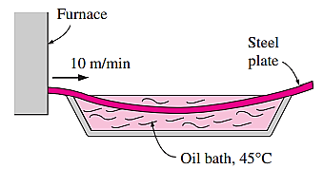  A long roll of 2-m-wide and 0.5-cm-thick 1-Mn manganese steel plate coming off a furnace at 820°C is to be quenched in an oil bath (Cp=2.0 kJ/kg·°C) at 45°C. The metal sheet is moving at a steady velocity of 10m/min, and the oil bath is 5 m long. Taking the convection heat transfer coefficient on both sides of the plate to be 860 W/m²·°C, determine the temperature of the sheet metal when it leaves the oil bath. Also, determine the required rate of heat removal from the oil to keep its temperature constant at 45°C.
Pr.50 | In a production facility, 3-cm-thick large brass plates (k=110 W/m·°C, and α=33.9×10⁻⁶ m²/s) that are initially at a uniform temperature of 25°C are heated by passing them through an oven maintained at 700°C. The plates remain in the oven for a period of 10 min. Taking the convection heat transfer coefficient to be h=80 W/m²·°C, determine the surface temperature of the plates when they come out of the oven.
Pr.51 | Solving the above problem, by transient heat conduction in large plane walls method, then determine the surface temperature of the plates when they come out of the oven.
Pr.52 | A long 35-cm-diameter cylindrical shaft made of stainless steel 304 (k=14.9 W/m·°C, ρ=7900 kg/m³ , C_{p}=447 J/kg·°C, and α=3.95×10⁻⁶ m²/s) comes out of an oven at a uniform temperature of 400°C. The shaft is then allowed to cool slowly in a chamber at 150°C with an average convection heat transfer coefficient of h=60 W/m²·°C. Determine the temperature at the surface of the shaft 20 min after the start of the cooling process. Also, determine the heat transfer per unit length of the shaft during this time period
Pr.53 | A person puts a few apples into the freezer at -15°C to cool them quickly for guests who are about to arrive. Initially, the apples are at a uniform temperature of 20°C, and the heat transfer coefficient on the surfaces is 8 W/m²·°C. Treating the apples as 9-cm-diameter spheres and taking their properties to be (k=0.418 W/m·°C, ρ =8400 kg/m³ , C_{p}=3.81 KJ/kg·°C, and α=1.3×10⁻⁷ m²/s, determine the center and surface temperatures of the apples in 1h. Also, determine the amount of heat transfer from each apple.
Pr.54 | 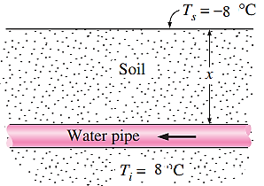  In areas where the air temperature remains below 0°C for prolonged periods of time, the freezing of water in underground pipes is a major concern. Fortunately, the soil remains relatively warm during those periods, and it takes weeks for the subfreezing temperatures to reach the water mains in the ground. Thus, the soil effectively serves as an insulation to protect the water from the freezing atmospheric temperatures in winter. The ground at a particular location is covered with snow pack at -8°C for a continuous period of 60 days, and the average soil properties at that location are k=0.35W/m·°C and α=0.15×80⁻⁶ m²/s. Assuming an initial uniform temperature of 8°C for the ground, determine the minimum burial depth to prevent the water pipes from freezing.
Pr.55 | 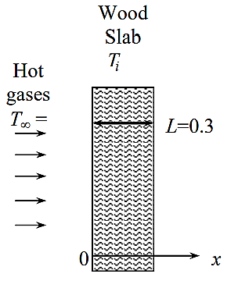  A thick wood slab (k=0.17 W/m·°C and α=1.28×10⁻⁷ m²/s) is initially at a uniform temperature of 25°C is exposed to hot gases at 550°C for a period of 5 minutes. The heat transfer coefficient between the gases and the wood slab is 35W/m²·°C. If the ignition temperature of the wood is 450°C, determine if the wood will ignite.
Pr.56 | 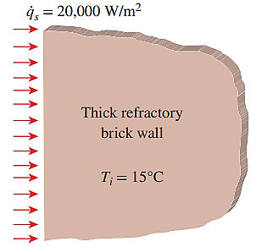  Refractory bricks are used as linings for furnaces, and they generally have low thermal conductivity to minimize heat loss through the furnace walls. A thick furnace wall lined with refractory bricks (k=1.0 W/m.K and α = 5.08×10⁻⁷ m²/s), where initially the wall has a uniform temperature of 15°C. If the wall surface is subjected to uniform heat flux of 20kW/m², determine the temperature at the depth of 10cm from the surface after an hour of heating time
Pr.57 | An aluminum alloy 3m long cylindrical block (ρ=2702 kg/m³, Cp=0.896 kJ/kg⋅K, k=180W/m⋅K, and α=9.75×10⁻⁵m²/s), 15 cm in radius, is initially at a uniform temperature of 20°C. The block is to be heated in a furnace at 1200°C until its center temperature rises to 300°C. If the heat transfer coefficient on all surfaces of the block is 180 W/m²⋅K, determine how long the block should be kept in the furnace. Also, determine the amount of heat transfer from the aluminum block. ((Solve this problem using the analytical one-term approximation method)).
Pr.58 | A long 20-cm-diameter cylindrical shaft made of stainless steel comes out of an oven at a uniform temperature of 600°C. The shaft is then allowed to cool slowly in an environment chamber at 200°C with an average heat transfer coefficient of h 80 W/m2 · °C. Determine the temperature at the center of the shaft 45 min after the start of the cooling process. Also, determine the heat transfer per unit length of the shaft during this time period.
Pr.59 | In a production facility, large brass plates of 4 cm thickness that are initially at a uniform temperature of 20°C are heated by passing them through an oven that is maintained at 500°C. The plates remain in the oven for a period of 7 min. Taking the combined convection and radiation heat transfer coefficient to be h 120 W/m2 · °C, determine the surface temperature of the plates when they come out of the oven.
Pr.60 | An ordinary egg can be approximated as a 5-cm-diameter sphere . The egg is initially at a uniform temperature of 5°C and is dropped into boiling water at 95°C. Taking the convection heat transfer coefficient to be h 1200 W/m2 · °C, determine how long it will take for the center of the egg to reach 70°C.

Chapter Four
Pr.61 | Air at 30°C flows with a velocity of 6 m/s over a 2.5-m×8-m flat plate whose temperature is 120°C. Determine the rate of heat transfer from the plate if the air flows parallel to the (a) 8-m-long side and (b) the 2.5-m side.
Pr.62 | Consider a hot automotive engine, which can be approximated as a 0.5-m-high, 0.40-m-wide, and 0.8-m-long rectangular block. The bottom surface of the block is at a temperature of 80°C and has an emissivity of 0.95. The ambient air is at 20°C, and the road surface is at 25°C. Determine the rate of heat transfer from the bottom surface of the engine block by convection and radiation as the car travels at a velocity of 80 km/h.
Pr.63 | A house is maintained at a constant temperature of 22°C. One of the walls has three single pane glass windows k=0.78W/m·°C that are 1.5m high, 1.2m long and 0.5 cm thick. The inner surface heat transfer coefficient of the glass is 8W/m²C. Winds at 60 km/h blows parallel to the surface of this wall. If the air temperature outside is at 5°C, determine the rate of heat loss through the windows of this wall. Assume radiation heat transfer to be negligible.
Pr.64 | The forming section of a plastics plant puts out a continuous sheet of plastic that is 1.2m wide and 2 mm thick at a rate of 15 m/min. The temperature of the plastic sheet is 90°C when it is exposed to the surrounding air, and the sheet is subjected to air flow at 30°C at a velocity of 3m/s on both sides along its surfaces normal to the direction of motion of the sheet. The width of the air cooling section is such that a fixed point on the plastic sheet passes through that section in 2s. Determine the rate of heat transfer from the plastic sheet to the air
Pr.65 | Solar radiation is incident on the glass cover of a solar collector at a rate of 700 W/m². The glass transmits 88 percent of the incident radiation and has an emissivity of 0.90. The entire hot water needs of a family in summer can be met by two collectors 1.2m high and 1m wide. The two collectors are attached to each other on one side so that they appear like a single collector 1.2m×2m in size. The temperature of the glass cover is measured to be 35°C on a day when the surrounding air temperature is 25°C and the wind is blowing at 30 km/h. The effective sky temperature for radiation exchange between the glass cover and the open sky is 40°C. Water enters the tubes attached to the absorber plate at a rate of 1kg/min. Assuming the back surface of the absorber plate to be heavily insulated and the only heat loss to occur through the glass cover, determine (a) the total rate of heat loss from the collector, (b) the collector efficiency, which is the ratio of the amount of heat transferred to the water to the solar energy incident on the collector, and (c) the temperature rise of water as it flows through the collector.
Pr.66 | A 6-mm-diameter electrical transmission line carries an electric current of 50A and has a resistance of 0.002 ohm per meter length. Determine the surface temperature of the wire during a windy day when the air temperature is 10°C and the wind is blowing across the transmission line at 40 km/h.
Pr.67 | The components of an electronic system are located in a 1.5-m-long horizontal duct whose cross section is 20 cm 20 cm. The components in the duct are not allowed to come into direct contact with cooling air, and thus are cooled by air at 30°C flowing over the duct with a velocity of 200 m/min. If the surface temperature of the duct is not to exceed 65°C, determine the total power rating of the electronic devices that can be mounted into the duct.
Pr.68 | In a geothermal power plant, the used geothermal water at 80°C enters a 15cm diameter and 400m long uninsulated pipe at a rate of 8.5 kg/s and leaves at 70°C before being reinjected back to the ground. Windy air at 15°C flows normal to the pipe. Disregarding radiation, determine the average wind velocity in km/h.
Pr.69 | consider the flow of oil at 10°C in a 40-cm-diameter pipeline at an average velocity of 0.5m/s. A 300m long section of the pipeline passes through icy waters of a lake at 0°C. Measurements indicate that the surface temperature of the pipe is very nearly 0°C. Disregarding the thermal resistance of the pipe material, determine (a) the temperature of the oil when the pipe leaves the lake, (b) the rate of heat transfer from the oil, and (c) the pumping power required to overcome the pressure losses and to maintain the flow oil in the pipe.
Pr.70 | Hot exhaust gases leaving a stationary diesel engine at 450°C enter a 15cm-diameter pipe at an average velocity of 3.6 m/s. The surface temperature of the pipe is 180°C. Determine the pipe length if the exhaust gases are to leave the pipe at 250°C after transferring heat to water in a heat recovery unit. Use properties of air for exhaust gases.
Pr.71 | 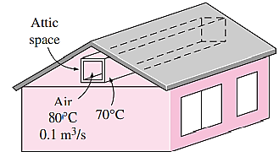  Hot air at atmospheric pressure and temperature of 80°C enters a 10-m-long uninsulated square duct of cross section 0.15m×0.15m that passes through the attic of a house at a rate of 0.10m³/s. The duct is observed to be nearly isothermal at 70°C. Determine the exit temperature of the air and the rate of heat loss from the duct to the air space in the attic.
Pr.72 | Oil at 10°C is to be heated by saturated steam at 1 atm in a double-pipe heat exchanger to a temperature of 30°C. The inner and outer diameters of the annular space are 3cm and 5cm, respectively, and oil enters at with a mean velocity of 0.8m/s. The inner tube may be assumed to be isothermal at 100°C, and the outer tube is well insulated. Assuming fully developed flow for oil, determine the tube length required to heat the oil to the indicated temperature.
Pr.73 | Glycerin is being heated by flowing between two parallel 1-m-wide and 10-m-long plates with 12.5-mm spacing. The glycerin enters the parallel plates with a temperature of 25°C and a mass flow rate of 0.7 kg/s. The plates have a constant surface temperature of 40°C. Determine the outlet mean temperature of the glycerin and the total rate of heat transfer.
Pr.74 | The hot water needs of a household are to be met by heating water at 13°C to 90°C by a parabolic solar collector at a rate of 1.8 kg/s. Water flows through a 3cm-diameter thin aluminum tube whose outer surface is black anodized in order to maximize its solar absorption ability. The centerline of the tube coincides with the focal line of the collector, and a glass sleeve is placed outside the tube to minimize the heat losses. If solar energy is transferred to water at net rate of 103w/m length of the tube determine the required length of the parabolic collector to meet the hot water requirements of this house
Pr.75 | Consider a 15-cm×20-cm printed circuit board (PCB) that has electronic components on one side. The board is placed in a room at 20°C. The heat loss from the back surface of the board is negligible. If the circuit board is dissipating 8 W of power in steady operation, determine the average temperature of the hot surface of the board, assuming the board is (a) vertical, (b) horizontal with hot surface facing up, and (c) horizontal with hot surface facing down. Take the emissivity of the surface of the board to be 0.8 and assume the surrounding surfaces to be at the same temperature as the air in the room.
Pr.76 | 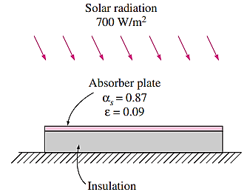  Ex4-17: A manufacturer makes absorber plates that are 1.2 m×0.8 m in size for use in solar collectors. The back side of the plate is heavily insulated, while its front surface is coated with black chrome, which has an absorptivity of 0.87 for solar radiation and an emissivity of 0.09. Consider such a plate placed horizontally outdoors in calm air at 25°C. Solar radiation is incident on the plate at a rate of 700 W/m². Taking the effective sky temperature to be 10°C, determine the equilibrium temperature of the absorber plate. Neglect the conduction effect under the plate
Pr.77 | A 400-W cylindrical resistance heater is 1 m long and 0.5 cm in diameter. The resistance wire is placed horizontally in a fluid at 20°C. Determine the outer surface temperature of the resistance wire in steady operation if the fluid is (a) air and (b) water. Ignore any heat transfer by radiation. Use properties at 500°C for air and 40°C for water
Pr.78 | 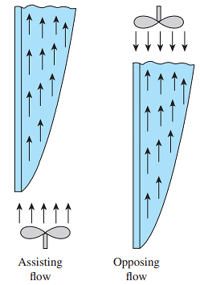  Ex4-19: A 0.2 m × 0.2 m vertical hot plate has a surface temperature that is maintained at 40ºC. Air at 20ºC is flowing in parallel over the plate with a velocity of 0.4m/s. Determine the Nusselt number for assisting flow and opposing flow.
Pr.79 | Flat-plate solar collectors are often tilted up toward the sun in order to intercept greater amount of direct solar radiation. The tilt angle from the horizontal also affects the rate of heat loss from the collector. Consider a 1 m high and 3m wide solar collector that is tilted at an angle θ from the horizontal. The back side of the absorber is heavily insulated. The absorber plate and the glass cover, which are spaced 2.5cm from each other, are maintained at temperatures of 80°C and 40°C, respectively. Determine the rate of heat loss from the absorber plate by natural convection for θ = 0°, 20°.
Pr.80 | A steady state heat transfer is occurs in a straight wall through the x y-axis. Find the temperature relation with x & y, T(x,y) {θ(x,y)}. The thermal conductivity is constant through the wall and no heat generation in it (wall).

