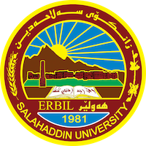
Academic Curriculum Vitae
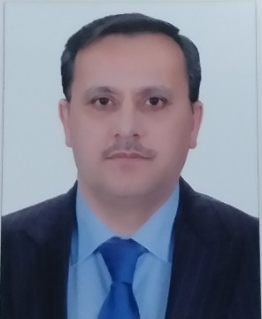
Personal Information:
Full Name: Mahdi Hashim Ibrahim
Academic Title: Assistant Lecturer
Email: (mahdi.ibrahim@su.edu.krd)
Mobile: 009647504753686

Education:
- Department of Biology, College of science, Salahaddin University Erbil, Iraq M.Sc. In biology/plant physiology 2003-2006 Thesis project: Effects of foliar application of zinc, GA3 and their interaction on growth and development of Pepper Capsicum annuum L. plants.
- Department of Biology, College of science, Salahaddin University Erbil, Iraq B.Sc. in Biology 1992-1996 research project: Effects of different light spectra on photosynthesis process.

Employment:
- Biology Assistant, College of science, Salahaddin University Erbil, Iraq Feb.1997- March 2022
- Assistant Lecture, College of science, Salahaddin University Erbil, Iraq 2006- 2023.

Qualifications
- Teaching Methods Salahddin University Erbil, Iraq 2007.
- Computer Training Course salahaddin University Erbil, Iraq 2010.
- English Language Course Salahddin University Erbil, Iraq Directorate of training center 2007.
- International English Language Testing System IELTS British Council 2014.
- Statistics and Statistical Data Analysis with SPSS, GraphPad Mathematics Department, college of science, Salahaddin University Erbil, Iraq 2019.

Teaching experience:
- Practical Entomology course (2006-2007).
- Practical Mycology course (2007-2008).
- Practical Algae and Archegoniate (2009-2014).
- Practical General botany (2013-2015).
- Practical Plant Anatomy and Taxonomy (2014-2015).
- Practical Plant Physiology (2019-2023).
- Practical General Botany (2020-2023).
- Plant growth and development and plant physiology course, Tishik University (2019-2020).
- Plant Anatomy and Plant Taxonomy course, Tishik University (2019-2020).
- Supervision of Lab. 3 (2013- 2015).

Research and publications
- Ibrahim, M.H., Badr Q.I. and Yassin A.R. (2012) Allelopathic Effects of Lisaea heterocarpa shoot Aqueous Extracts on germination and seedlings growth of wheat Triticum aestivum L. and Barley Hordeum vulgare L.

Professional memberships
- Kurdistan Biology Syndicate (2009- present).
- Kurdistan Union of Teachers (2007- present).

Professional Social Network Accounts:

- Researchgate account link:
Mahdi BANNA | Assistant Lecturer | Master of Science | Biology | Research profile (researchgate.net)

