Examination of practical botany
Name :
Group:

Q1l Identify this samples
- Identify root in this picture
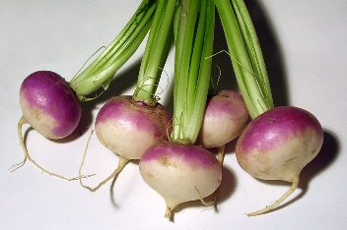
- Identify Phylotaxy in this leaf
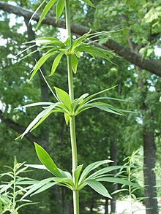
- Identify venation in this leaf
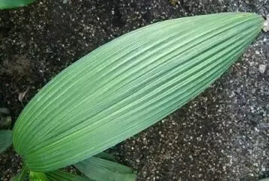
- Identify stem in this picture
- Identify shape of flower

Q2/ Answer the following

- Write differences between tap root and adventtiouse root?

- Define Dioecious plant

- By drawing differ between simple and compound leaf?

- Write two characteristic of stem ?

- Draw and label complet flower

