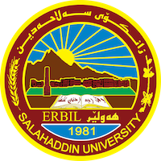
Academic Curriculum Vitae
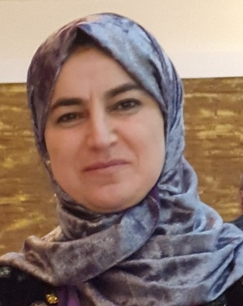
Full Name: Maqsuda Qadir Muhammad
Academic Title: Lecturer
Email: (university email) maqsuda.muhammad@su.edu.krd
Mobile: 07504964958
Education:
- B. Sc. Degree General Biology, Department of Biology, College of
Education, University of Salahaddin–Erbil. Iraq.
Date of attainment July / 1999
- M. Sc. Degree in plant physiology, Department of Biology College of Education, University of Salahaddin – Erbil. Iraq.
Title of thesis “Effect of zinc & its interaction with with two auxins (IAA &NAA) on the growth & development of pea (Pisum sativum L.) Var.Little Marvel ”
Date of attainment June/ 2004.

Employment:
- 21/10/2000 Demonstrator. At Biology Dept., Education College, Salahaddin University – Erbil, Iraq.
- 10/8/2004 Assist. Lecturer.
- 18/1/ 2016 Lecturer

Teaching experience:
- I taught the following courses so far in public and private universities:
  - plant physiology (practical + theory)
  - General Botany (practical)
  - plant Anatomy (practical)

Research and publications
1. Response of Some Bread Wheat Genotypes (Triticum aestivum L.) to Salinity at Early Growth Stage
2023 . Maqsuda Q. Muhammad 1, Mohammed Q. Khursheed 2 and Sirwa A. Qadir 3 . ZANCO Journal of Pure and Applied Sciences . The official scientific journal of Salahaddin University-Erbil
2. Response of Durum Wheat (Triticum durum L.) Genotypes to Drought stress at Early Growth Stage .2022. Maqsuda Qadir Muhammad1, Mohammed Qader Khursheed2 and Sirwa Anwar Qadir3
Al-Qadisiyah Journal For Agriculture Sciences (QJAS) ISSN : 2618-1479 Vol.12, Issue. 2 ,(2022), pp. 121-129
https://scholar.google.com/scholar?hl=en&as_sdt=0%2C5&q=Maqsuda+qadir&btnG=
Qualifications
- Teaching qualifications
- IT qualifications
- Language qualifications such as TOEFL, IELTS or any equivalent
- Any professional qualification
- You could put any professional courses you have attended

Conferences and courses attended
- Give details of any conferences you have attended, and those at which you have presented delivered poster presentations.

Funding and academic awards
- List any bursaries, scholarships, travel grants or other sources of funding that you were awarded for research projects or to attend meetings or conferences.

Professional memberships
- List any membership you hold of any professional body or learned society relevant to your research or other life activities.

Professional Social Network Accounts:

- List your profile links of ReserchGate, LinkedIn, etc.

It is also recommended to create an academic cover letter for your CV, for further information about the cover letter, please visit below link:
https://career-advice.jobs.ac.uk/cv-and-cover-letter-advice/academic-cover-letter/

