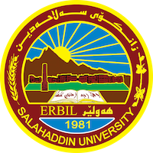
Academic Curriculum Vitae

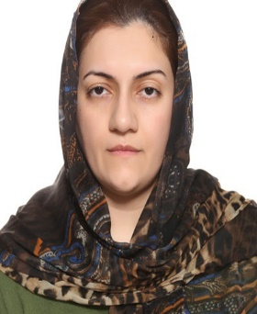
Personal Information:
Full Name:Mardin dlnya M.ali
Academic Title: Assistant Lecturer
Email: mardin.mohhamadali@su.edu.krd
Mobile:07514415712

Education:
- Bachelor degree at Law (2008-2009).
- Master in Administrative Branch (2015).

Employment:
- Had been employed at college of Law / Salaheddin University As teaching Assistant from 31/ 10 / 2009 .
- I continued Working In the same Facility after finishing Master degree as assistant lecturer till now.
Qualifications
- I am Excellent At Arabic, Kurdish language and a level good at English.
- Teaching Methods and Research Methodology (2016)
- ICDL (2010)
- Scored (6) at IELTS (2016)

Teaching experience:
- I have been working as a assistant lecturer for four years under graduated stages .

Research and publications
- Published book addressed (Conflict Of Interest in Public Administration and the legal Mechanisms to address) 2018 Manshurat Zein alhquqya. Beirut. Lebanon.

Conferences and courses attended
- Teaching Methods and Research Methodology / Salahaddin University/ 2015-2016
- English Language course / Salahaddin University /2016
- Computing course (ICDL) Salahaddin University/ 2010
- Tishk 6th International Legal Issues Conference- ILI2021.
Professional memberships
- List any membership you hold of any professional body or learned society relevant to your research or other life activities.

Professional Social Network Accounts:

- Linkedin:// https://www.linkedin.com/in/mardin-ali-700536184/
- Google Scholar :// https://scholar.google.com/citations?hl=en&view_op=list_works&gmla=AJsN-F5XK9UPFjEZWe_hL0yj3BMYQaZxDSY7w0xJASFJd-OqsYn_aYhydTlGBN-EIIp4E
- ResearcheGate :// https://www.researchgate.net/profile/Mardin_Mohhamadali
- Googledrive:// https://drive.google.com/drive/u/0/my-drive

https://career-advice.jobs.ac.uk/cv-and-cover-letter-advice/academic-cover-letter/

