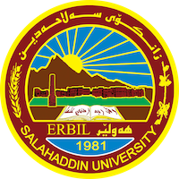
Academic Curriculum Vitae
Personal Information: 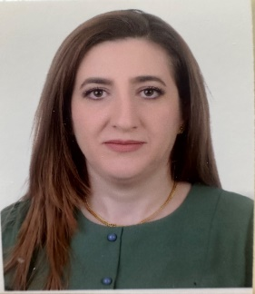
Full Name: Marlin Yousif Azeez
Academic Title: Lecturer
Email: marlin.aziz@su.edu.krd
Mobile: 009647504837935

Education:
- 2008-2011: (MSc. In Organic Chemistry). The title of the thesis is (Synthesis and Spectroscopic Identification of a New Series of 1,2,4- Triazole Derivatives).
Department of Chemistry, College of Education, University of Slahaddin, Erbil.
2004-2005: (B.Sc. in Chemistry). Department of Chemistry, College of Education, University of Slahaddin, Erbil.

Employment:
- 2018 Lecturer of Organic Chemistry, Department of Chemistry, College of Education/ University of Salahaddin.
- 2012 Assist. Lecturer of Organic Chemistry, Department of Chemistry, College of Education/ University of Salahaddin.
- Supervised fourth year under graduation projects.

Qualifications
- Teaching Methods Course 2010
- Language and Translation Center Salahaddin University Erbil

Teaching experience:
- Organic Chemistry 2nd 3rd and 4th stages Practical.
- Viewing and Application 4th stage.
- Micro-analysis.

Research and publications
- - Farouq E. Hawaiz1, Mohammed K. Samad2 and Marlin Y. Aziz3
- (2015) “Synthesis of Some New Heterocyclic Compounds
- Derived From 4-(4-Hydroxy-3-Chlorophenyl)azoacetophenone”
- Journal of Zankoi Sulaimani, JZS (2015) 17-2 (Part-A).

- - Marlin Y. Aziz1, Yousif K. Bayiz1 and Farouq E. Hawaiz1
- One-pot Three Component Synthesis of Some NewAzo-PyrazolineCompounds Derived From 5-((3-chloro-4-methylphenyl)diazenyl)-2-hydroxybenzaldehyde
- ZANCO Journal of Pure and Applied Sciences, ZJPAS (2017), 29 (4); 134--139
- Nabil A. Fakhre and Dashty K. Ali, Determination of Iron (II), Iron (III) and Total Iron in Some β-Thalassemia Patients Using Different Analytical Techniques, J. Environmental Science and Engineering, No. 4, Vol. 5, 2013, 304-307.

Conferences and courses attended
Synthesis and Spectroscopic Identification of a New Series of 1, 2, 4- Triazole Derivatives.
4th International Scientific Conference of Salahaddin University- Erbil, October 18-20, 2011

Funding and academic awards
Professional memberships

-Kurdistan Chemists syndicate -Kurdistan teachers Union 2000- till now member of Kurdistan Chemical Society.
- 2011- till now member of Arabia Saudi Chemical Society.

Research gate: https://www.researchgate.net/profile/Marlin-Aziz
ORCID ID:
Academic Profile: https://academics.su.edu.krd/profile-admin/index.php?p=dashboard
Scholar Account
https://scholar.google.com/citations?hl=en&user=gnqoCscAAAAJ

