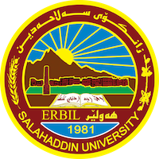
Academic Curriculum Vitae
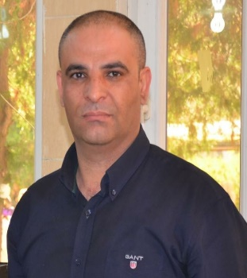
Personal Information:
Full Name:Masoud Hussein Hamed
Academic Title: Lecturer
Email: masoud.hamed@su.edu.krd
Mobile:+9647504476035

Education:
2013; complete PHD. In Environmental Hydrogeology in Salahaddin University
2007; complete M.Sc. In environmental geology (water pollution), Salahaddin University
2002: complete B.Sc. Geology, Geology Department College of Science. Salhaddin University
1998: Took Baccalaureate Rizgary secondary School Erbil Iraq

Employment:
- In23/1/2003 worked as demonstrator and know lecturer in college of science salahaddin university

Qualifications
- Teaching qualifications
- software such as word, excel, rock ware, GIS software (mapinfo, surfare, arc GIS),statigraph. Grapher Using GPS to drawing studied
- Salahadding language center certification in 2009.
- Wide experience in Environmental and waste management field.
- -GRI training course in 2012,2013,2014 training course in hydrology supported by DAD organization in frieberg Germany

Teaching experience:
- Teaching Environmental geology, Advance environmental geology, Hydrology, Hydrogeology, General geology, Remote sensing and GIS, field geology for postgraduate. Environmental hydrology and Hydrogeology (High deploma), Environmental hydrogeology,GIS and remote sensing ,Groundwter pollution,WSM software(Msc.)
- -Teaching practical applied geology in geology department.
- -Teaching applied environmental geology in environmental department.
- -Training and preparing the student for field geology.
- -Training the student to use remote sensing principals.
- -Teaching practical sedimentary rock, Iraq geology, igneous rock, industrial
- mineral and rocks, hydrology and hydrogeology, and field geology.
- -Teaching General geology in Chemistry department
- -Teaching Environmental geology in Environment department

Research and publications
- Investigation of water quality in wet and dry season under climate change.
- Evaluation groundwater quality by using GIS and water quality index techniques for wells in Bard rash area northern Iraq
- Analysis of Gray water recycling by reuse of industrial waste water for agriculture and irrigation purposes
- Groundwater ‘quality in Shamamik subbasin of Erbil- Iraq using various water quality ‘indices

Conferences and courses attended
- Geokurdistan-3 participate by present two research, Geo-Mosul-2

Funding and academic awards
- List any bursaries, scholarships, travel grants or other sources of funding that you were awarded for research projects or to attend meetings or conferences.

Professional memberships
- Member in high commit of geological syndicate.
- Water reservation in Kurdistan organization (NGO)

Professional Social Network Accounts:

- https://academics.su.edu.krd/masoud.hamed
- https://www.linkedin.com/in/masud-hamed-313a6867/
- https://www.researchgate.net/profile/Masoud_Hamed
- https://www.facebook.com/masoud.hussein.7
- https://www.academia.edu/settings
- https://orcid.org/my-orcid?orcid=0000-0003-2358-9324.

