**University of Salahaddin**

**College of Science**

**Department of Earth science &petroleum**

**Hydrogeology Question Bank**

**Dr.Masoud Hussein Hamed**

[**Masoud.hamed@su.edu.krd**](mailto:Masoud.hamed@su.edu.krd)

**Environmental geology Question Bank**

**Academic year 2022-2023**

**1**. For a series of earthquakes the following information is given:

|  |  |
| --- | --- |
| **∆ km** | **A(micr.)** |
| **180** | **0.45** |
| **370** | **0.65** |
| **555** | **0.84** |
| **833** | **1.42** |
| **1000** | **1.55** |

Km: epicenter , A: amplitude

Required: A- Calculation magnitudes of these earthquakes.

B- what is the amount of energy released from each shock

**2.Write chemical formula of the flowing minerals?**

1.Kaolinite 2.Pyrite 3.Copper 4.Chlorite

**3. List the gases cause global warming change ,and how it can be mitigated ?**

**4.** List Seismic Waves?

5. Volcanoes type?

**6**. Determine the distance from the earthquake to each seismograph station we must first determine the time lag for a given distance, say 203 km, knowing the average velocities of the waves. If the average velocity of the p – wave is 9.4 km/sec and the average velocity of the S – wave km / sec is 6.3 km / sec, then the time required for each wave to travel 203 km is:

P – Wave travel 203 km in --------------- seconds

S – Wave travel 203km in --------------- seconds

7.Thus the time lag T(s-p) at 203 km is -------- seconds

8.Write chemical formula of the flowing minerals?

1. Copper 2. Bauxite 3.Hematite 4. Pyrite

**9.. Possible consequences of global warming change effect?**

**10.**  Volcanoes type?

11. The economic and social impact of earthquake?

12. The Main Volcanic hazards?

**13.** Table below is Grain size analysis of two soil samples revealed the following results. Classify two soil samples according to Unified Soil Classification System (USCS).

|  |  |  |  |  |  |  |  |  |  |  |  |
| --- | --- | --- | --- | --- | --- | --- | --- | --- | --- | --- | --- |
| **Sample.**  **No.** | **Grain size %wt.** | **%weight of each size grade** | | | | | | | | | |
| **clay** | **Silt** | | | **Sand** | | | **Gravel** | | |
|  | **<.002** | **.002-.006**  **F** | **.006-.020**  **M** | **0.02-0.06**  **C** | **0.06-.20**  **F** | **0.2-.6**  **M** | **0.6-2.0**  **C** | **2-6.0** | **6-20** | **20-60** |
| **1** | **-** | | **2** | **4** | **3** | **9** | **15** | **23** | **24** | **7** | **13** |
| **2** | **-** | | **-** | **-** | **-** | **-** | **-** | **-** | **-** | **36** | **61** |

14. Volcanoes is one of natural hazards, how can predict before eruption ?

15. Where do earthquakes occur?

16. What is direct effect of global warming change on climate?

17. Possible consequences of global warming change effect?

18. Long -term methods of earthquake prediction?

19. Types of volcano according to their morphology?

**20.** An automobile is driven 20000 miles per year get 50miles per gallon, how many gallons of gasoline does the car use per year?



**21**. **The point beneath Earth’s surface where rock breaks under stress and triggers an earthquake is called the**

A. Syncline. B. Footwall. C. Epicenter. D. Focus.

**22. What are strategies used for reduction of greenhouse gases?**

A. Tree Plantation/ Alternative Sources of energy B. less carbon dioxide emission

C. Use of Renewable energy D. Sustainable use of resources

**23. A point on the crust immediately above a hot plume within the mantle.**

A. Hot spot B. Great divide C. Subduction zone D. Lava canyon

**24. Which of the following sequences correctly lists the different arrivals from first to last?**

A. P waves ... S waves.... Surface waves B. Surface waves ... P waves.... S waves

C. P waves ... Surface waves ... S waves D.S waves ... P waves.... Surface waves

**25. CH4 remains in atmosphere for how many years?**

A. More than 1000 years B. less than 1000 years C.10years D.100 years

**26. Great earthquakes, on average, occur**

A. 30,000 times annually B. 500 times annually C. 100 times annually D. once every 5 to 10 years

**27. This term describe molten rock fragments of any size that are ejected from a volcano.**

A. Lapilli B. Ash C. Tephra D. All of the above

**28. A seismograph is a device used to:**

A. Sound alarm B. Prevent earthquakes from occurring. C. Record the vibrations produced during earthquake D. calm the seismologist during an earthquake

**29. When magma reaches the earth’s surface, it is called:**

A. rock B. lava C. caldera D. magma

**30. What can you do about climate change?**

A. Drive your car less and use public transport B. Turn off the lights when not in need

C. Increasing green area D. All of the above the above

**31.** For a series of earthquakes the following information is given:

|  |  |  |
| --- | --- | --- |
| **∆ km** | **A (micr.)** | **M** |
| 180 | 0.45 |  |
| 370 | 0.65 |  |
| 555 | 0.84 |  |
| 833 | 1.42 |  |
| 1000 | 1.55 |  |

Km: epicenter

A: amplitude

Calculate magnitudes of these earthquakes.

**32. Complete label the cross section volcano**

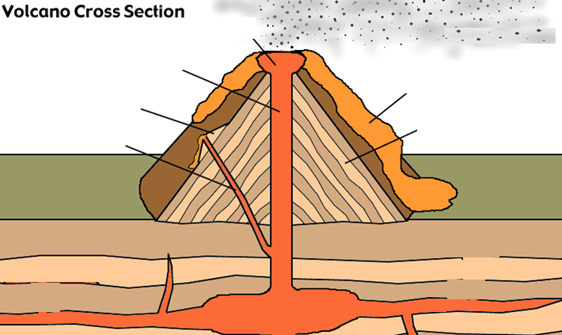

**33.Write chemical compositions of the flowing minerals?**

|  |  |
| --- | --- |
| **Minerals** | **Chemical composition** |
| Hematite |  |
| Galena |  |
| Pyrite |  |
| Gypsum |  |
| Sulfur |  |

**34.**An automobile is driven10000 miles per year get 25miles per gallon, how many gallons of gasoline does the car use per year?

**35. Briefly (define, list, and describe) of the followings**

36. Mitigation of global warming change?

37. Volcanoes are one of natural hazards, how can predict before eruption?

38. Type of earthquake?

39.Get help with your Global warming homework. Access the answers to hundreds of Global warming questions that are explained in a way that's easy for you to understand. Can't find the question you're looking for? Go ahead and submit it to our experts to be answered.

40.How does forest management help to tackle climate change?

41.How does afforestation reduce global warming?

42.According to Griffith, what temperature increase should we choose to stabilize at? a. 2 degrees b. 4 degrees c. 6 degrees d. 1 degree

43.Explain what an individual can do to minimize his/her contribution to global warming.

44.How are population and community ecology related to global warming?

45.A reduction in anthropogenic contamination to a level that is "acceptable" to society. A. 46.Anthropogenic quality B. Anthropogenic quantity C. Environmental quality D. Environmental quantity

48. Kyoto Protocol

49.Current estimates suggest that to halt an increase in levels of greenhouse gases in the atmosphere, we would have to reduce emissions by what percentage? A. 80-90% B. 10-20% C. 60-70% D. 5-10%

50. How does carbon dioxide contribute to global warming? A. It is less dense, leaving less space in the atmosphere for oxygen. B. It absorbs heat from the sun, preventing it from escaping into space...

51.Which of the following can occur as a result of global warming? A. Famine B. Floods C. Drought D. All of the above

52.How does utilitarianism support the ecological ethic?

53.Does global warming amplify interannual climate variability?

54.Which of the following statements best describes why ecologists are currently concerned with global warming and the thawing of permafrost in many areas of the tundra biome? a. 55.Migratory species of...

55.How are climate models used to predict future climate?

56.Why are climate models important when studying global warming?

57.How are models used in climate science?

58.Why are other planet climate models studied?

59.What does climatology have to do with climate change?

60What is outgassing as it relates to Earth and climatology?

61.Are atmospheric trace gases involved in global change?