Department of Chemistry
College of Science
Salahaddin University-Erbil
Subject: Kinetics of chemical reactions
Course Book : 3rd stage undergraduate students
Lecturer's name : Assist. Prof. Dr. Mazin A. Othman
Academic Year: 2022/2023

Course Book
Chemical Kinetics |  |  | 1-Course name
Assist. Prof. Dr. Mazin Abdulkhaliq Othman |  |  | 2. Lecturer in charge
Chemistry |  |  | 3. Department/ College
e-mail: mazin.othman@su.edu.krd  Tel: (optional):009647504826214 |  |  | 4. Contact
Theory: 2 hours  Practical: 3 hours |  |  | 5. Time (in hours) per week
6 hours |  |  | 6. Office hours
 |  |  | 7. Course code
2020- Assistant professor at chemistry department, college of science, university of Salahaddin-Erbil  2011 –Lecturer at chemistry department, college of science, university of Salahaddin.  20011: complete Ph.D. in physical chemistry, School of chemistry, Cardiff university, UK.  2004: complete M.Sc. in inorganic chemistry, department of chemistry, college of science, university of salahaddin, Iraq."Synthesis and characterization of dioxouranium (vi) complexes with some Schiff bases".  1998: complete B.Sc. in chemistry, department of chemistry, college of science, university of salahaddin, Iraq.  1994: Took baccalaureate, Shekh Mahmmudi Namer secondary school, Arbil/Iraq. |  |  | 8. Teacher's academic profile
physical chemistry, Catalysis , Nanoparticles, kinetic |  |  | 9. Keywords.
10. Course overview:
The field of Chemical kinetics seek to provide a rigorous description of chemical processes at its most fundamental level. For ordinary chemical processes, the most fundamental and underlying theory of reaction kinetics is well presented in this course. However, types of rate laws, reaction order and determination of rate constant are the core of the objectives of this course. In fact, most of what we do in chemical kinetics is to develop the students understanding of steps of chemical reactions, how fast the reaction occurs and what are the factors affecting the reaction rate. In this course, we will dive deeply into the underlying reaction kinetic theories. Students will learn how to solve some elementary problems and apply these to not so elementary examples.
Finally the ultimate goal of this course is understanding reaction mechanism and reaction pathways, what is the rate determining step and what are the factors that affects the rate of the reaction.
11. Course objective:
The course is at the level of High Diploma degree students of chemistry. The course emphasizes conceptual understanding rather than a heavily mathematical approach, but some amount of mathematics is essential for understanding and using chemical kinetics. The course presumes a mathematics background that includes basic algebra ordinary differential and integral calculus, and ordinary and partial differential equations.
Students should understand reaction kinetics, reaction rate, order of reaction and rate constant. Reaction mechanism and reaction profile are the objectives of this course.
12. Student's obligation

The student must attend the lectures 2 hours a week. The students are required to do at least two closed exam at the course besides other assignments and each student must prepare full report at the end of the course.
Some class periods will be devoted to in-class problems and discussion. In-class problem days may include class discussions and problem presentation students.
In class every week, the students should already have knowledge of subject tacked before, and ready for any quizzes.
Problem solving skills are very important to chemists. We will have several "endurance problems". The solving of some endurance problems must be done in" In class problem and discussion"

13. Forms of teaching
Lectures are presented through computer data Showing program. For more explanations of Equations and of the Subject the writing on the whiteboard will be used.

14. Assessment scheme
The students are required to do at least two closed exam at the course besides other assignments and each student must prepare full report at the end of the year.
This course is part of the physical chemistry subject.
Quantum chemistry for fourth stage=quantum mechanesm%60 +spectroscopy %40.
End grad: 40%only theoretical
Final: 60% for theoretical
--Full report has 5 mark.
-Seminar presentation 5 marks
-quiz tests have 5 marks.
-classroom activities 5 marks.‌
-Exam 20 Marks
15. Student learning outcome:
The major goals for this course are centered on acquiring a conceptual understanding of, chemical kinetics and reaction mechanism.
This course aims to teach kinetics of Chemical reactions to master students in chemistry department with a reasonable Msc-level understanding of reaction mechanism.. Now the concepts and techniques of chemical kinetics is essential in many areas of chemistry and science such as materials science, nanotechnology, electronic devices, and photonics. This course is a substantial introduction to Chemical kinetics and using it for proposing mechanism for chemical reactions. The factors affecting reaction rate and theories of reactions rates will be taught during this course.

16. Course Reading List and References‌:
▪ Key references: Chemical Kinetics, Kinetics of chemical reactions
▪ Useful references:
- An Introduction to Chemical Kinetics
by Margaret Robson Wright, 2004 John Wiley & Sons, Ltd.
- ATKINS’PHYSICALCHEMISTRY
Peter Atkins 1978, 1982, 1986, 1990, 1994, 1998 and © Peter Atkins & Iulio de Paula 2002,2006 The moral rights of the authors have been asserted Database right Oxford University Press (maker).
- Any Other related books...
▪ Magazines and review (internet):

Lecturer's name |  | 17. The Topics
Assist. Prof. Dr. Mazin A. Othman |  | - Expression of rates. Stoichiometric relationships of rates of different substances in a reaction.  - Determination of reaction orders, rate laws, and rate constant by method of initial rate.  - Determination of rate laws by graphical or integration method.  - Determination of half-lives  - Determination of activation energy  - Elementary steps and reaction mechanism  - Effect of catalysts
only theoretical |  | 18. Practical Topics (If there is any)
19. Examinations:
1. Compositional:

Q1- Answer the following (use graphs, equations, schemes and give examples when necessary)
(30 marks)
- Explain collision theory for reaction rates?
Collision theory is a theory proposed independently by Max Trautz in 1916 and William Lewis in 1918, that qualitatively explains how chemical reactions occur and why reaction rates differ for different reactions. The collision theory states that when suitable particles of the reactant hit each other, only a certain percentage of the collisions cause any noticeable or significant chemical change; these successful changes are called successful collisions. The successful collisions have enough energy, also known as activation energy, at the moment of impact to break the pre-existing bonds and form all new bonds. This results in the products of the reaction. Increasing the concentration of the reactant particles or raising the temperature, thus bringing about more collisions and therefore many more successful collisions, increases the rate of reaction.
When a catalyst is involved in the collision between the reactant molecules, less energy is required for the chemical change to take place, and hence more collisions have sufficient energy for reaction to occur. The reaction rate therefore increases.
Collision theory is closely related to chemical kinetics.
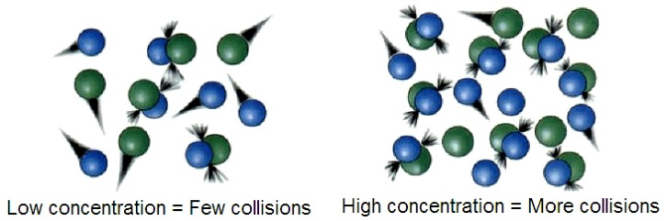
The rate constant for a bimolecular gas phase reaction, as predicted by collision theory is:
.
where:
- Z is the collision frequency.
- is the steric factor.
- E_{a} is the activation energy of the reaction.
- T is the temperature.
- R is the gas constant.
The collision frequency is:

where:
- N_{A} is the Avogadro constant
- σ_{AB} is the reaction cross section
- k_{B} is the Boltzmann's constant
- μ_{AB} is the reduced mass of the reactants.

- Explain the effect of temperature on reaction rate and rate constant?
Rate depends on the fraction of “effective collisions” per unit time.
  - (Effective collisions are those with proper orientation and sufficient energy to overcome activation energy E_{a} barrier.
Thus rate depends on the activation energy and temperature, such that,
  - Higher activation energy implies high barrier and fewer reactant molecules will form the transition-state complex. This leads to a slower rate of reaction;
  - Higher temperature results in a larger fraction of reactant molecules with sufficient energy to overcome the energy barrier. This leads to a faster rate of reaction.
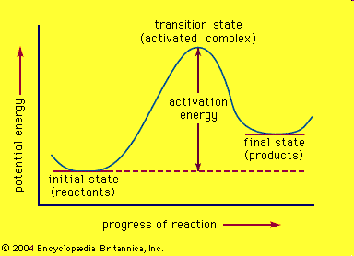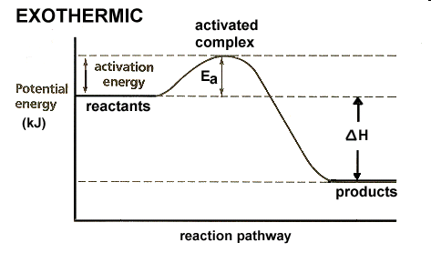
- Rate is dependent on rate constant, which is the proportionality constant that relates rate to concentrations (as depicted in the rate law).
- While rate constant is related to activation energy and temperature by the Arrhenius equation:
    - k = Ae^{-Ea/RT}
    - where A is Arrhenius collisional frequency factor, T is the Kelvin temperature, and R is gas constant (R = 8.314 J/K.mol)
- From Arrhenius equation: k = Ae^{-Ea/RT}
ln(k) = ln(A) – (E_{a}/R)(1/T)
- The plot of ln(k) versus 1/T yields a straight line with the slope = -(E_{a}/R), or E_{a} = -slope x R
- If k values are determined at two different temperatures, such that at k₁ at T₁ and k₂ at T₂, then
ln(k₂/k₁) =
- Explain the types of rates for chemical reactions?
Initial Rates
  - Rates measured at the beginning of the reaction, which is dependent on the initial concentrations of reactants.
Instantaneous Rates
  - Rates measured at any point during the reaction.
Average Rates
  - An overall rate measured over a period or time interval.

- What is reaction order and explain the methods of its determination?
The power or exponent of the concentration of a given reactant in the rate law. It indicates the degree in which the rate depends on the concentration of that particular reactant.
The sum of the powers of the concentrations is referred to as the overall order for the reaction.
- For a general reaction,
aA + bB + eE → Products
- The rate law for this reaction takes the form:
- where k is called the "rate constant."
- x, y, and z, are small whole numbers or simple fractions and they are the rate order with respect to [A], [B], and [E]. The sum of x + y + z + . . . is called the “overall order" of the reaction.
  - Integrated rate equation (trial method) from rate lows
  - graphical method from the shape of the plots of concentration and time
  - half life time from the concentration effect and time of half of the selected concentration
  - differential method using the differential equations of rate lows and applying the data and the plots of concentration with time.
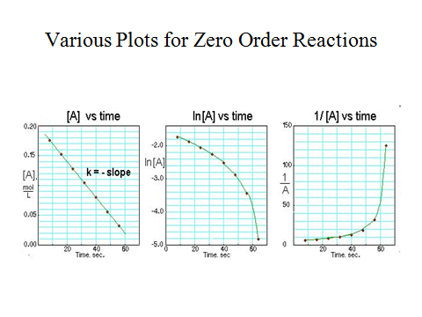
- Define catalyst and explain its role in chemical reactions showing whether it changes the mechanism of the reaction or not?
Catalysts are substances that are added to reaction mixtures to make the reactions go faster, but do not get used up by the reactions.
A catalyst functions by providing an alternative reaction pathways with lower activation energy.
It increases the reaction rate, but does not affect the reaction enthalpy or the equilibrium position.
It do not alter the reaction yields at equilibrium
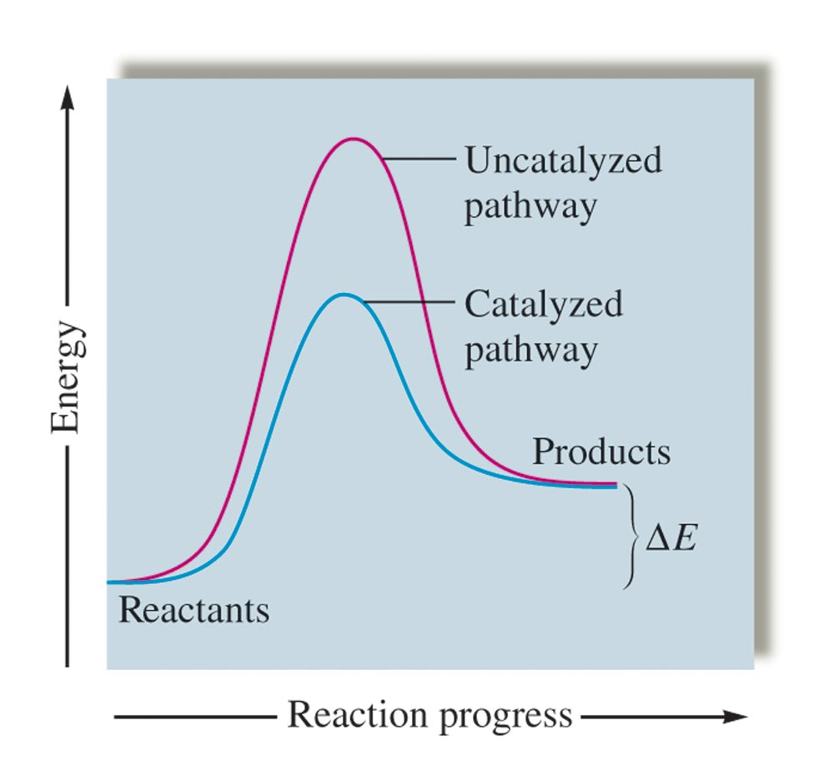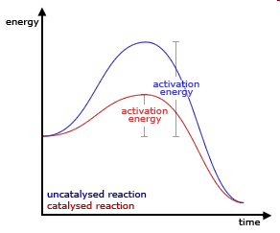
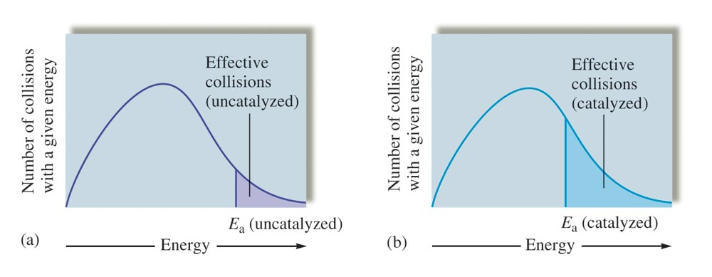

Q2- Explain the following graph and write the steps of catalytic process showing the rate determining step? (8 marks)
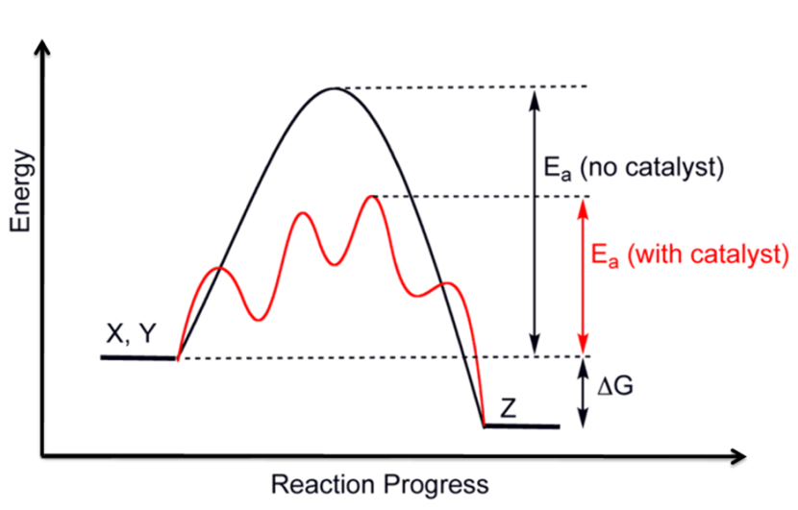
No catalyst curve shows the reaction pathway of uncatalysed reaxtion of x, y to give z as products which goes through a specific mechanism and the rate limmiring step has specific activation energy Ea.
With catalyst curve shows the reaction of x,y in the presence of catalyst to form z as product, its clear from the curve that the reaction goes through different pathway and the mechanism changes with different rate limiting step which has lower activation energy than the one without catalyst. The steps of the reaction will be as follows:
- X,y ...................>A (1st activated complex)
- A .......> I1 (1st intermediate )
- I1 ................> B (2nd activated complex)
- B.................> I2 (2nd intermediate)
- I2 ...................> C (3rd activated complex) this step is rate limiting step highest Ea
- C..........................> I3 (third intermediate)
- 13............................>D (4th activated complex)
- D.....................> Z

Q3- Given the following data, for the following reaction at 25ºC:
NH⁴⁺_{(aq)} + NO^{2–}_{(aq)} N2_{(g)} + 2H₂O

Experiment [NH⁴⁺] (M) [NO^{2–}] (M) Rate .
1 0.2500 0.2500 1.25 ⋅ 10^{–3}
2 0.5000 0.2500 2.50 ⋅ 10^{–3}
3 0.2500 0.1250 6.25 ⋅ 10⁻⁴
Calculate the reaction order, rate constant, half life and Ea ?
(Arrhenius factor = 4x10⁻¹¹ )
(12 marks)

20. Extra notes:
21. Peer review

