The Analytical Classification of the Metal Ions (Cations)

Groups | Ions of Groups | Group reagent (precipitating agent) | Formula of precipitate
Silver group | Ag⁺,Pb⁺²,Hg₂⁺² | dilute HCl | Agcl,Pbcl₂,Hg₂cl₂
Cupper and arsenic group | Hg⁺²,Cu⁺²,Cd⁺²,Pb⁺²,Bi⁺³ As⁺³,Sb⁺³,Sn^{+2 or +4} | H₂S in presence of dilute HCl | HgS,CuS,CdS,PbS,Bi₂S₃ As₂S₃,Sb₂S₃,SnS₂
Iron group | Fe⁺³,Cr⁺³,Al⁺³ | aqueous NH₃ in presence of NH₄Cl | Fe(OH)₃,Cr(OH)₃,Al(OH)₃
Zinc group | Zn^{+2,}Mn⁺²,Co⁺²,Ni⁺² | H₂S in presence of aqueousNH₃ and NH₄Cl | ZnS ,MnS ,CoS, NiS
Calcium group | Ca⁺²,Ba⁺²,Sr⁺² | (NH₄)₂CO₃ in the presence of aqueousNH₃ and NH₄Cl | CaCO₃,BaCO₃,SrCO₃
Alkali group | Mg⁺²,K⁺,Na⁺,NH4⁺ | no particular reagent | Mg⁺²,K^{+,}Na⁺,NH4⁺ in solution

(The Silver group) (groupI)

Silver, Lead, Mercury(ous)

Ag⁺, Pb⁺², Hg₂⁺²

The compound of these metals are characterized by their precipitation as chloride by dilute (HCL) .Lead chloride PbCl₂ is slightly soluble in water and hence is not completely precipitated as chloride in this group, it is therefore also found in group11,where it is precipitated as highly in soluble sulphide.

Note: We use dilute HCL as group reagent for precipitation and we do not use concentration HCL?

Because using conc. HCL will form a soluble chloro- complex.

PbCl₂ +2Cl⁻ [PbCl₄]⁻²

AgCl +Cl⁻ [AgCl₂]⁻

Identification of Group 1

Put 1ml of (Ag⁺¹, Pb⁺²and Hg₂⁺²) in a centrifuge tube
1N dilute HCL (5 drops), stir centrifuge (1-2) mint

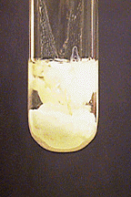

^{Residue} ^{Filtrate}
^{AgCl,PbCl}₂^{,Hg}₂^{Cl}₂ ^{may Contain Metal}
^{White ppt.} ^{Ion of other groups}
^{(REJECT)}
^{1ml boiling D.W}
Put the test tube in boiling water bath (2min)
And stir continuously, Centrifuge

^{Residue} ^{Filtrate}
^{AgCl, Hg}₂^{Cl}₂ ^{PbCl}₂

^{5drops}
^{Dilute NH}₄^{OH(1N)} ^{2drop CH}₃^{COONH}₄
^{Stir, Centrifuge} ^{1drop K}₂^{CrO}₄
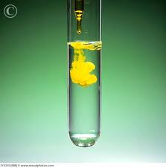

^{Residue} ^{Filtrate} ^{Yellow ppt.}
^{Hg(black)+HgNH}₂^{Cl(s)} ^{Ag(NH}₃⁾₂^{Cl} _ ^{(PbCrO}₄⁾
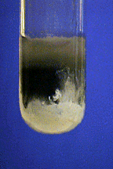
^{(white)} ^{it means that}
2drop dilute Pb+2 is present
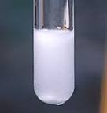
^{HCl or HNO}₃
^{AgCl white ppt.}

Reactions:
----------------
AgNO₃ + HCl AgCl + HNO₃
Pb(NO₃)₂ + 2HCl PbCl₂ +2HNO₃
Hg2(NO₃)₂ + 2HCl Hg₂Cl₂ + 2HNO₃

Detection of Pb⁺²
-------------------------
Pb(NO₃)₂ + K₂CrO₄ PbCrO₄ + 2KNO₃
Yellow ppt.

Detection of Hg₂⁺²
-------------------------
Hg₂Cl₂ + 2NH₃ HgNH₂ Cl(s) +Hg(s)+ NH₄Cl(aq)
Mercury (II)amidochloride
White ppt. Black
Detection of Ag⁺
------------------------
AgCl +2NH₃ Ag(NH₃)₂⁺Cl⁻

Ag(NH₃)₂⁺Cl⁻ +2HNO₃ AgCl +2NH₄NO₃

White ppt.

