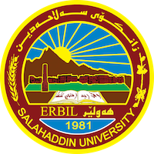
Academic Curriculum Vitae

Personal Information:
Full Name: Media Salah Yaba Ali
Academic Title: Assistant Lecturer
Email: Media.Yaba@su.edu.krd
Mobile :0750736569

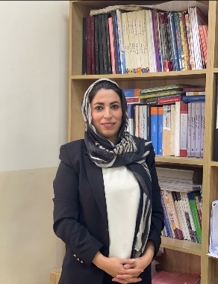
Education:
- Salahaddin University-Erbil, Collage of Administration and Economics, Iraq-Erbil
Master's Degree in Economics 2016
- Salahaddin University-Erbil, Collage of Administration and Economics, Iraq-Erbil
Bachelor's degree in Economics. 2009-2010

Employment:
-Assistant of Research at Salahaddin University-Erbil Apr 2011
-Salahaddin Uni. College of Admin. & Eco- Finance and banking Dept. Assist. Lecturer.2019

Qualifications
- As an Assist. Lecturer in Banking and finance department I am responsible for: -
Teaching theoretical lecture to the students in international banking , consumer behavior and international finance
- IT qualifications
Word Microsoft, Excel, Access, Powerpoint, Spss.
- Language qualifications such as TOEFL, IELTS or any equivalent
English such as IELTS (5), language center- salahaddin university (Intermediate)

Teaching experience:
- Teaching theoretical lecture to the students in international banking, consumer behavior and international finance
- Computer skills.
- Principle of economics

Research and publications

Conferences and courses attended
- Best student research conference.

Funding and academic awards
- List any bursaries, scholarships, travel grants or other sources of funding that you were awarded for research projects or to attend meetings or conferences.

Professional memberships
- Kurdistan Teachers Union
- Kurdistan Economist Syndicate2011

Professional Social Network Accounts:

- List your profile links of ReserchGate, LinkedIn, etc.

